SCSA

Santa Clara Stadium Authority

SANTA CLARA STADIUM AUTHORITY
FINANCIAL STATUS REPORT

Quarter Ending September 30, 2024

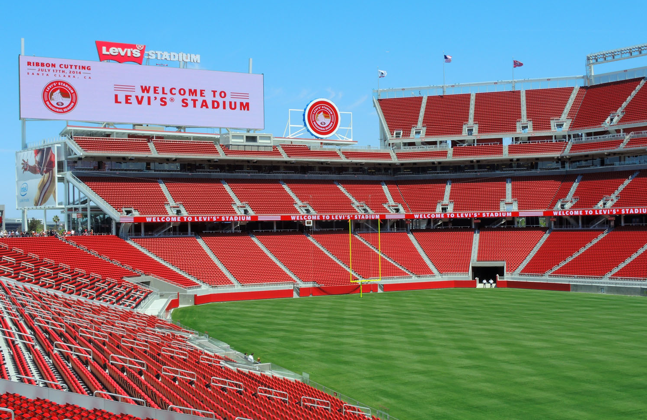

January 14, 2025

Table of Contents
Introduction 2
NFL Events 3
Non-NFL Events 6
Discretionary Fund 11
Stadium Builder Licenses 11
Santa Clara Stadium Authority Budget Status Reports 14
Operating Budget 14
Debt Service Budget 16
Capital Improvement Project Budget 19
CIP Budget – Recommended Budget Adjustments 21
City of Santa Clara Net General Fund Impact 23
Public Safety and Administrative Cost Reimbursement 23
Rents and Senior and Youth Fee 24
Other Revenue Impacts 24
Glossary 25
Appendix 29

Introduction
This Santa Clara Stadium Authority (“Stadium Authority”) Financial Status Report provides information covering the second quarter of the Stadium Authority’s 2024/25 fiscal year (“FY”) which ended on September 30, 2024. Comparative data from prior fiscal years is also included.

In addition to these quarterly reports, the Stadium Authority produces annual financial statements. The FY 2023/24 financial statements were audited by an external audit firm and presented to the Stadium Authority’s Audit Committee (Audit Committee) on September 3, 2024 and September 17, 2024 and approved by the Stadium Authority Board (Board) on September 24, 2024. The financial statements are published on the Stadium Authority’s website.
The Stadium Authority also prepares a detailed budget prior to the beginning of each fiscal year. The FY 2024/25 budget was adopted by the Board on March 12, 2024.
Stadium Authority finances are structured so that the City of Santa Clara (“City”) is not liable for the debts or obligations of the Stadium Authority. All services provided by the City, including administrative and public safety, to the Forty Niners Stadium Management Company, LLC (“Stadium Manager”) or the Stadium Authority are fully reimbursed by the Stadium Manager or with Stadium Authority funds.
Methodology
Information provided in this report was based in part on documentation submitted by the Stadium Manager. Specifically, National Football League (NFL) and Non-NFL event statistics and financial information relating to the Stadium Manager expenses are provided by the Stadium Manager. Stadium Authority staff has access to select financial information submitted by the Stadium Manager provided through the Stadium Authority’s Financial Management System and event reports received for Non-NFL events. These reports are received 45 days after each event for events with attendance greater than 25,000. More detailed documents are received within 90 days after the close of the quarter. For all other financial information, a full detailed review and/or audit of source documentation has not been completed by the Stadium Authority for this report.

The information provided reflects the best known and available at the time of the writing of this report and is subject to further revision and review. Revisions may occur based on the timing of revenue and expenditure activity for events in this quarter that continue beyond the timing of this report. Consequently, the Board’s notation and filing of this report should not be considered an approval of the accuracy of the information in the report.

NFL Events
This section provides year to date and comparative data for NFL games categorized as pre-season and regular season games.

The San Francisco Forty-Niners (“49ers”) played a total of three NFL games (one pre-season game and two regular season games) at Levi’s® Stadium through quarter ending September 30, 2024. There was a total of 208,318 tickets sold to these NFL games, an average of 69,439 per game. This is up by 3,427 or 5% when compared to the same period in the prior fiscal year. The ticket sales resulted in $3 million in NFL ticket surcharge revenue (10% of ticket sales) to the Stadium Authority. The average NFL ticket surcharge revenue was $1 million per game in the current year which is up by $113,000 or 13% from the same period in the prior fiscal year. A total of $73,000 of Senior and Youth Program Fees, which is based on $0.35 per NFL ticket sold, were collected through the end of the second quarter of the fiscal year. These fees were transferred to the City’s General Fund in support of such programs.

A total of 23,649 cars were parked in the permitted offsite parking lots generating $159,000 in offsite parking fees derived from the $6.71 per parking space for all NFL events. The revenues earned from this offsite parking fee supports public safety costs for NFL events. The overall number of cars parked in the permitted offsite lots increased by an average of 1,934 cars per game or 33% when compared to the prior fiscal year.

There was $1.5 million of NFL event public safety costs in the current reporting period which is an average of $502,000 per game. This is an increase from the prior year average (through September 30, 2023) of $474,000. Of the $1.5 million NFL event public safety costs, $1.2 million or 82% are direct City costs and $265,000 or 18% are outside agency costs. $159,000 of the total NFL event public safety costs are covered by the offsite parking fees that were collected and the remaining are invoiced to the Stadium Manager.

Statistics for the NFL games held at Levi’s® Stadium in the first two quarters of the 2024/25 fiscal year are shown in Table 1 and comparative data from the last five years of operations can be found in Table 2. Additional historical data can be found in the Appendix.

Table 1

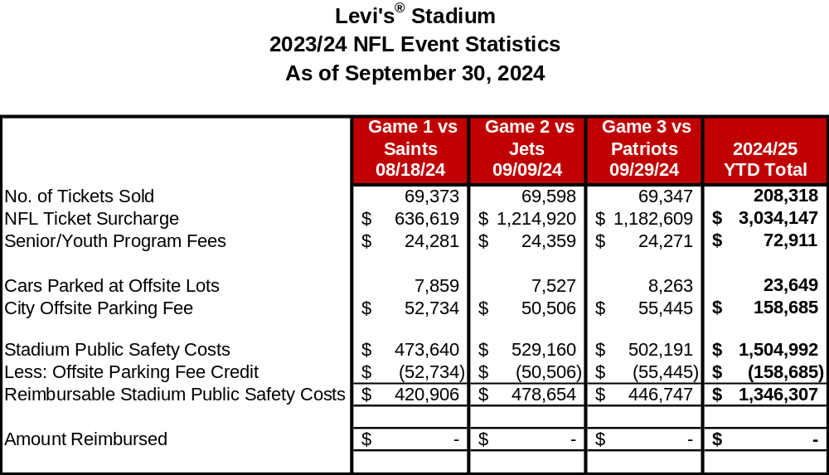

Table 2

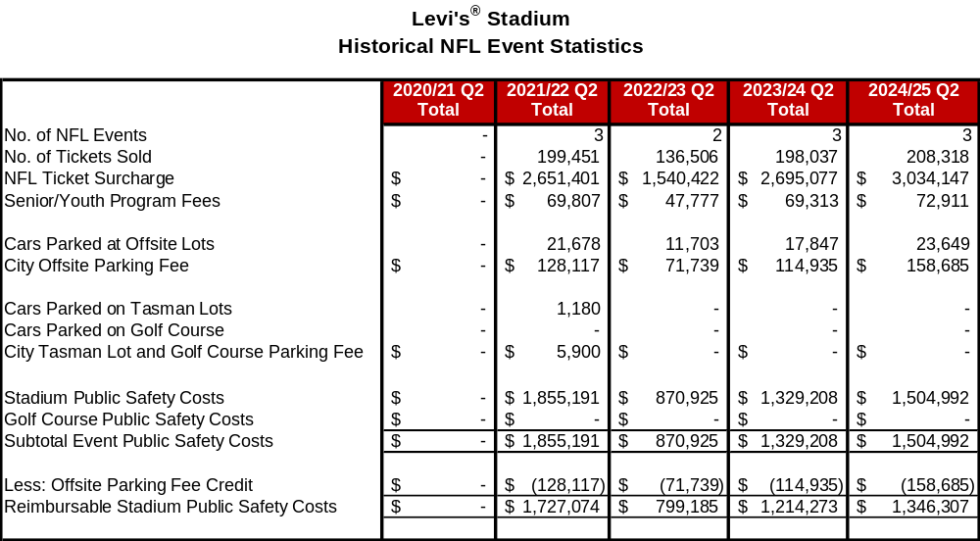

Non-NFL Events
This section provides year to date and comparative data for Non-NFL events categorized as events ranging from high school and college football games, international soccer matches, concerts, wedding fairs, and special events. During the current reporting period, there were a total of 348,480 tickets sold for the eight ticketed Non-NFL events that were held, resulting in $1.4 million Non-NFL event ticket surcharge revenue (from the $4 per ticket Non-NFL event surcharge). This is a decrease in ticket surcharge revenue of $198,000 or 12.4% over the same period in the prior year. Smaller scale Non-NFL events were held in the current period when compared to the same period in the prior year resulting in the decrease in the ticket surcharge revenue.

Stadium Manager reports that there were also 30 smaller special events held at Levi’s® Stadium which is five events more than the same period of the prior fiscal year. The attendance at these events also increased from 14,546 in the prior period to 15,656 in the current year, an 8% increase. Examples of these special events include corporate events of various sizes, weddings, holiday parties, high school dances, etc.

In correlation with the Non-NFL events held during the current reporting period, there were 37,341 cars parked at offsite lots and the City earned a total of $246,000 in related offsite parking fees, which is derived from the $6.44 per parking space fee for events taking place prior to July 2024 and $6.71 per parking space for all events thereafter. The revenues earned from this offsite parking fee supports public safety costs for Non-NFL events.

Total Non-NFL event public safety costs were $3.1 million, a decrease of $148,000 from the prior year. As noted previously, this decrease in cost is due to smaller scale events being held in the current year when compared to the prior year. Of these costs, $246,000 was covered by the offsite parking fee. The remaining $2.8 million was invoiced to the Stadium Manager and has been reimbursed to the City.

Statistics for FY 2024/25 events are shown in Table 3 and comparative data from the last five years of operations are shown in Table 4.
Table 3

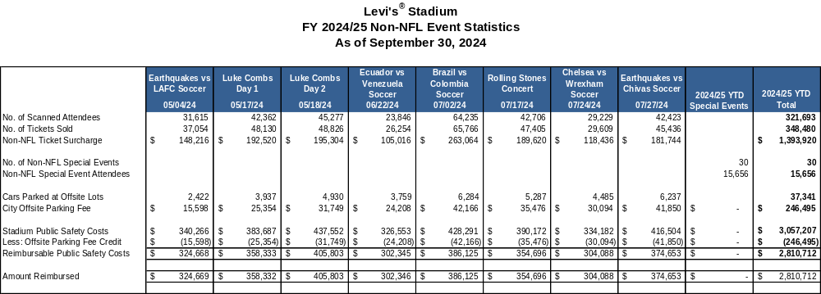

Table 4

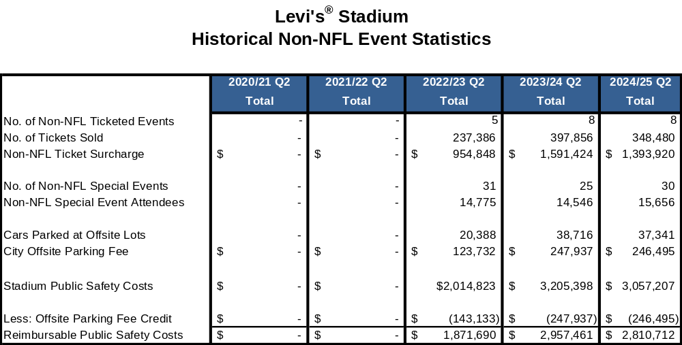

Table 5 summarizes ticketed Non-NFL revenues and expenditures by event. There were 8 ticketed Non-NFL events held in FY 2024/25 and generated an average net revenue of $933,000 per event. The inclusion of this information is to provide a greater level of transparency and provide the overall financial results of the Non-NFL events.

Table 5

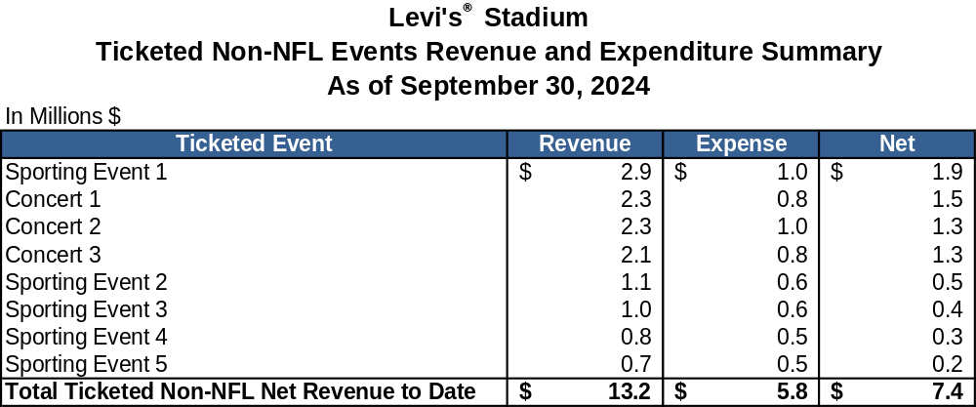

Table 6 and 7 show Non-NFL net revenue by event type and event revenue and expenses by category. For FY 2024/25, the Stadium Manager had projected Non-NFL events to result in estimated net revenues of $6 million, as cited in the FY 2024/25 Adopted Stadium Authority Budget. In the second quarter of FY 2024/25, ticketed events and non-ticketed special events contributed $7.5 million and $1.2 million in net revenues, respectively. There was also additional interest income of $1 million earned on Non-NFL events cash reserves offset by $1.2 million of non-event specific other expenses. Stadium Manager reported a net revenue of $8.5 million for the current reporting period.

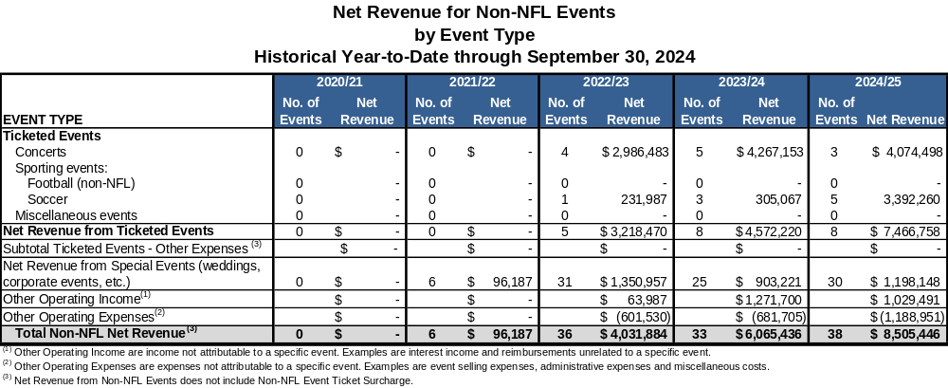
Table 6

Table 7
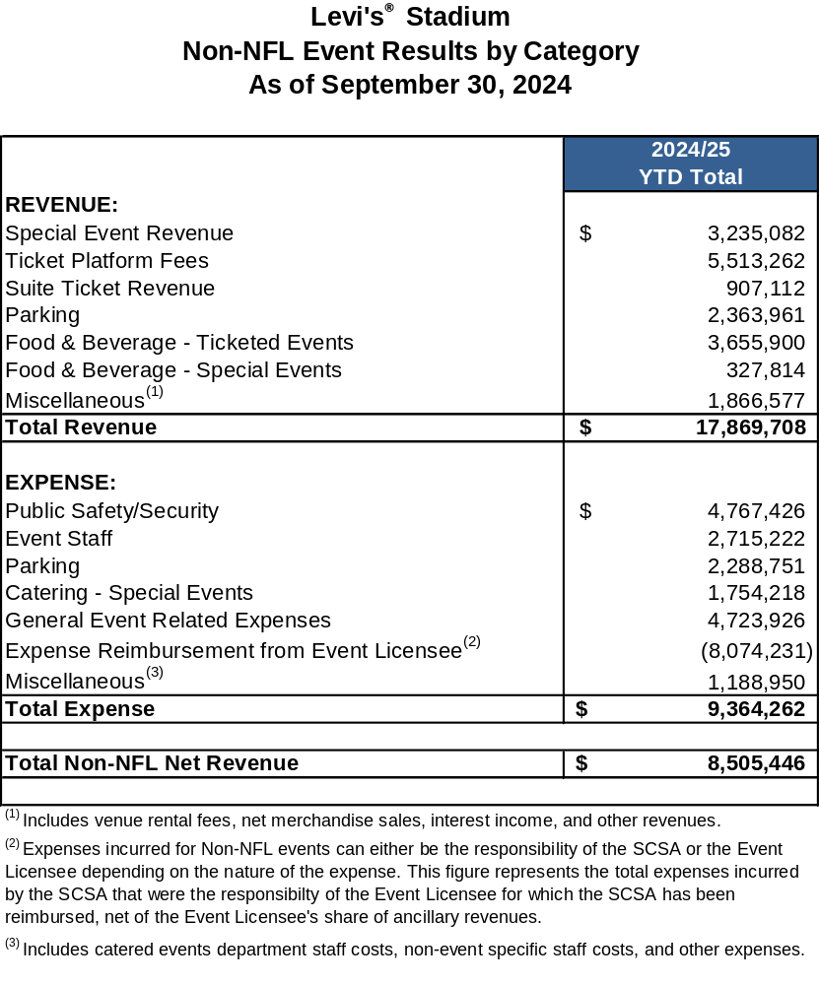

Discretionary Fund
The Discretionary Fund is funded by revenue equal to 50% of the Non-NFL event ticket surcharge of $4 per ticket. The eight ticketed Non-NFL events contributed $697,000 to the Discretionary Fund in the reporting period which has been collected for the current fiscal year. This is based on the estimated attendance provided by the Stadium Manager. Table 8 shows the revenues and expenses in the Discretionary Fund for the last five years. Additional historical data can be found in the Appendix. The balance at the end of this reporting period was $3.2 million.

Table 8

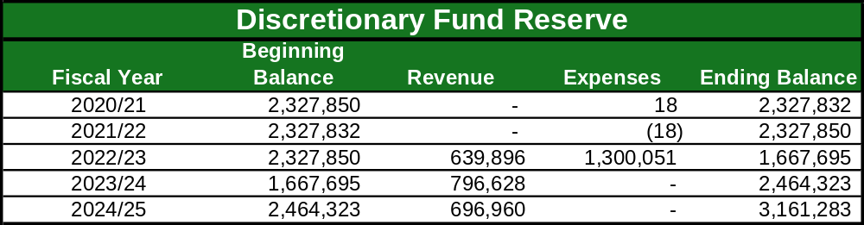

Stadium Builder Licenses
The total principal value of currently active Stadium Builder Licenses (“SBLs”) is $559.9 million and, as of September 30, 2024, 94.8% of the total principal value of all SBLs sold (i.e., $530.7 million) had been collected. Payment for the sale of SBLs are financed over 10 years.

SBL holders that finance their purchase pay an annual interest rate of 8.5% and payments are due by March 1st each year. The majority of SBL holders make their payments on time. For those that do not pay on time, SBL service staff, working for Stadium Manager on the Stadium Authority’s behalf, contact the SBL holders and attempt to collect the full amounts owed. Ultimately, a SBL can be defaulted for non-payment. Once a SBL is defaulted, the SBL holder in default loses their right to buy season tickets as well as their priority rights to tickets to Non-NFL events, and forfeits any money they had invested in the SBL. Defaulted SBLs are then available for resale.

When SBL holders do not purchase NFL season tickets, their SBL is not defaulted, however they lose exclusive rights to their seats and their seats may be sold to another SBL holder. This results in cases where a seat may have more than one SBL associated with it and why there are currently more active SBLs than there are available SBL seats. If the original SBL holder decides to purchase season tickets in the future, they can relocate to a new seat in the same or higher price level, subject to availability. If the relocation results in a change in price level, they need to pay for the difference between their original SBL and the new one. If they chose not to relocate, they must wait for their seat to be available again before they can purchase NFL season tickets.

There is a total of 66,256 currently active SBLs. This is an increase of 1,263 from the total active SBLs at the end of the prior fiscal year (March 31, 2024). The main reasons for the increase are due to sale of new SBLs and customer seat relocation program offset by default buy back. The customer seat relocation program allows customers to trade in their SBLs in return for others in a different location as long as the total face value of the new seats is equal to or greater than the original seats.

During the current reporting period, 1,080 SBLs were sold for a total face value of $7.1 million. The customer seat relocation program resulted in an increase of $1.1 million to the SBL face value, while netting 667 more SBLs. There were also 484 SBL defaulted during the quarter with a face value of $3.2 million.

Additional details regarding currently active SBLs are noted in Table 9.

Table 9

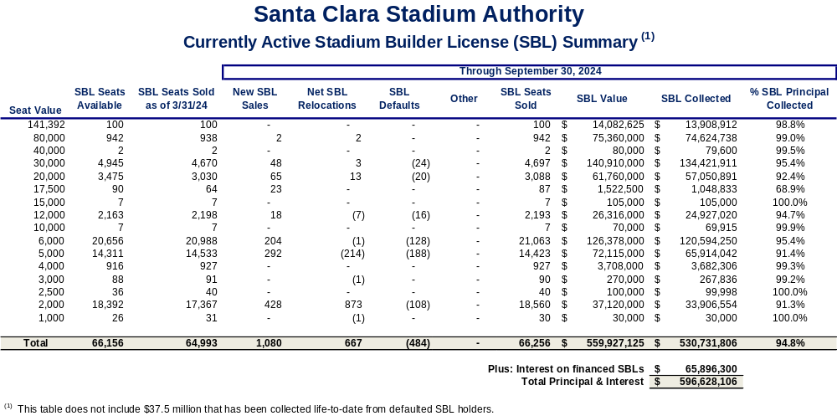

Santa Clara Stadium Authority Budget Status Reports

Operating Budget

With 50% of the fiscal year complete, total operating revenues for the second quarter of the 2024/25 Fiscal Year were $25.5 million representing 41% of the overall budget for revenues. During the current reporting period, the Stadium Authority collected $4 million in SBL proceeds or 80% of what was budgeted. All SBL proceeds are to be transferred to the debt service fund per applicable loan agreements. Stadium Authority also recognized $13.8 million in rent from Forty Niners SC Stadium Company, LLC (StadCo), $1.4 million in Non-NFL ticket surcharge, and $319,000 in sponsorship (STR) revenue all of which are expected to meet budget this fiscal year.

Total Operating expenses were $12.3 million, or 28% of the annual budget. Shared Stadium Manager expenses were at 49% of the budget, or $6.6 million of the $13.6 million budgeted amount and SBL Sales and Service expenses were 47% of the budget or $1.6 million. The Stadium Authority pays for all utility costs from February 1st through July 31st and the tenant (StadCo) pays for utility costs from August 1st through January 31st (Tenant Season). Therefore, utility costs are 67% of the budget for the year, or $992,000. The current period covers 67% (four out of the six months) that the Stadium Authority is responsible for utility costs. Lastly, Stadium Authority G&A costs were tracking below budgeted levels at $1.5 million or 34% of the budget.

Additional details are shown in Table 10.
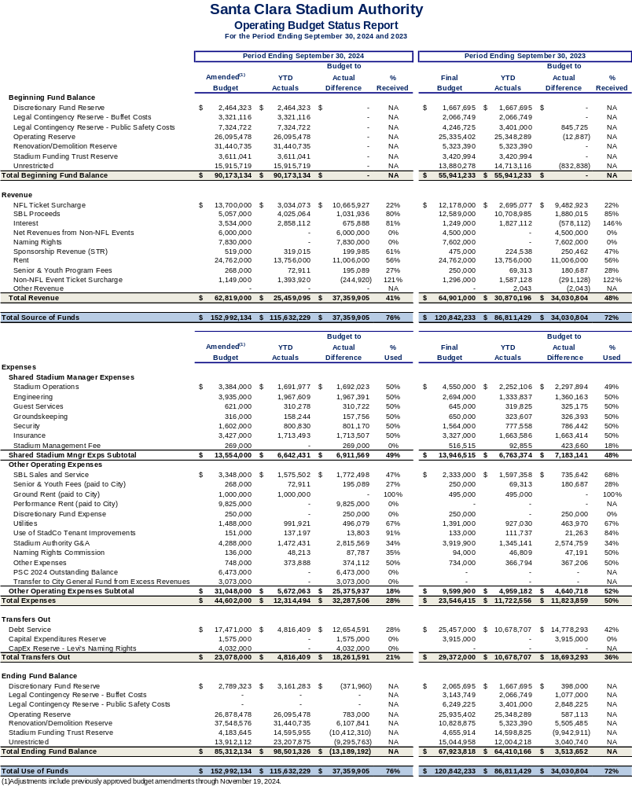
Table 10

Debt Service Budget
The Stadium Authority’s FY 2024/25 debt service revenue budget of $2.8 million represents anticipated contributions from the Community Facilities District (CFD). The CFD levies and collects a special hotel tax on hotel rooms within the CFD. All collections from the special CFD hotel taxes are contributed to Stadium Authority to pay down the CFD Advance. The CFD Advance is payable solely from amounts received by the Stadium Authority from the CFD. During the first two quarters, $1.7 million was contributed by the CFD, or 61% of the annual budget. Of this amount, $1.7 million was collected and used to pay down the CFD Advance.

Total Stadium Authority debt service expenses for the current reporting period were
$13.8 million, or 70% of the budgeted amount. The debt service expenses for the CFD Advance and the Term A Loan were $1.7 million and $12.1 million, respectively.

As of September 30, 2024, the total outstanding amount of Stadium Authority debt had declined to $220.5 million. This is a reduction in principal of $8.2 million from the March 31, 2024 outstanding debt amount of $228.7 million.

Additional details are shown in Tables 11 and 12 and Chart 1.

Table 11

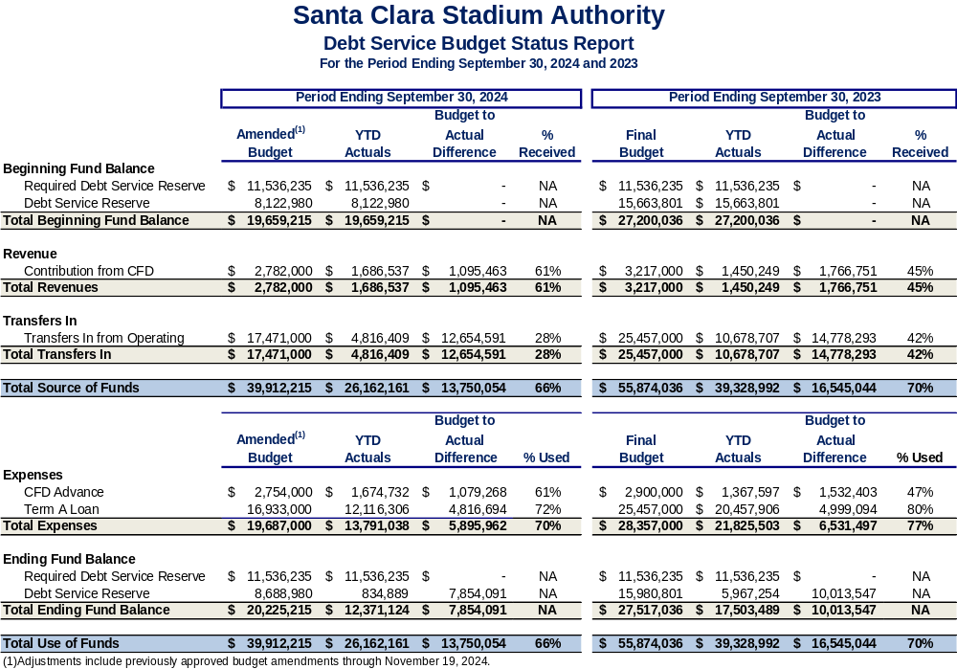

Table 12

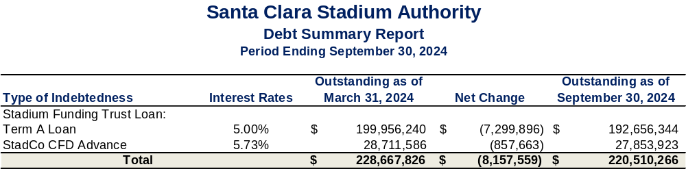

Chart 1

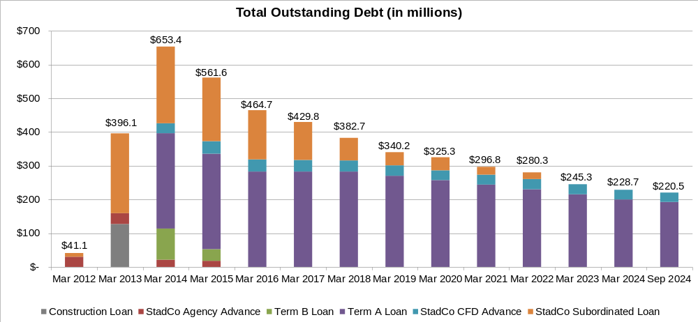

Capital Improvement Project (CIP) Budget

As part of the Capital Expense (“CapEx”) Plan, the following projects have been completed as of the current reporting period:
      - Street Signage

The following projects were underway during the current reporting period:
      - Aesthetic Improvements – Premium Areas/Special Event Spaces
      - Blackline Combustible Gas Indicators
      - CO2 Monitoring & Sensors for Code Compliance
      - Command Post Video Wall Upgrade
      - Concrete Replacements
      - D7 Tactical Decon Spray
      - Enhance Stadium Security Coverage
      - Field Turf Equipment
      - Fingerprinting Equipment
      - Fire Station 9 Storage Cabinets
      - General Areas/Coating Main Deck
      - Kawasaki Mules
      - Levi’s Naming Rights Signage Refurbishment
      - Lighting System – Field / Sport Lighting LED Retrofit
      - Main Kitchen Equipment
      - Overhead Doors, Motors, Sensors and Track Replacements
      - Plumbing and Plumbing Fixtures
      - Radio Booth Cabling
      - RAID 8 Multi Agent Detection Kit
      - Replacement of end of life IT Network equipment (2022/23 Carryover)
      - Security General Allowance
      - Smoke Evacuation System – Fire Smoke Curtain Replacement
      - Women’s Locker Room

The CIP Budget increased from $22 million to $24 million in the current reporting period. A total of $3.0 million has been spent during the first two quarters of FY 2024/25, which amounts to 13% of the budget. The main reason that this is below budget is due to the timing of activity for Capital Expenditure projects. There has also been little activity on warranty work which makes up 6% of the CIP Budget.

Additional details are shown below in Table 13.

Table 13
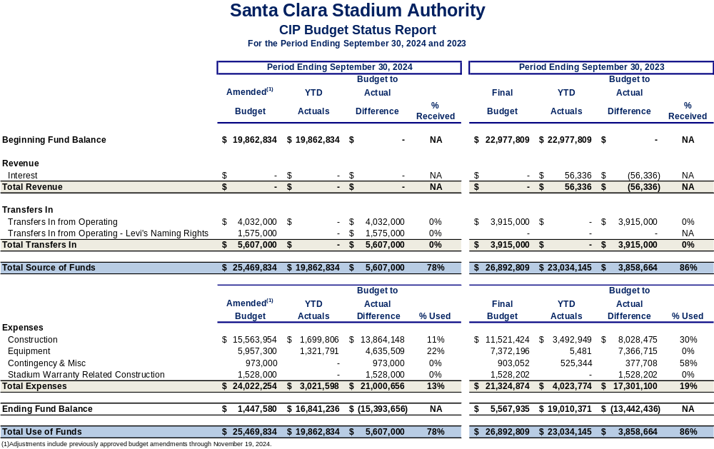

CIP Budget – Recommended Budget Adjustments
From time to time, budget adjustments may be necessary to align revenues or expenditures to actual or unexpected activity during the course of a fiscal year, known after the adoption of the Stadium Authority Budget. The budget amendments recommended in this report include two CapEx projects that were anticipated to be completed in FY 2023/24, so the remaining budgets were not requested to be carried forward to the FY 2024/25 Operating, Debt Service, and Capital Budget. The Stadium Manager notified staff that due to several factors with the vendor, the work was delayed and completed in FY 2024/25.

- Stadium Event Signage (2019/20 Carryover) - This project funds the design, furnishing and installation of new stadium event signage including, but not limited to, tunnel awnings, accessible seating reference areas, lower bowl sections placards, security, mobile signage, and additional fire and building code signage. A budget adjustment of $6,035 is needed to pay for the final contract retention.

- Updated Stadium Wayfinding Signage - This project funds the design, furnishing and installation of new wayfinding and information signage to include, but not limited to, new premium/club wayfinding, suite wayfinding, smoking section signs, no smoking signs for around the main and upper concourses, section numbers/floor decals, ADA accessibility signs, Tunnel signs for "no photos/no autographs", etc. A budget adjustment of $97,736 is needed to pay for labor and the final contract retention.

Additional details are shown in Table 14.

Table 14

Santa Clara Stadium Authority
2024/25 CIP Budget Adjustment

Item # | Line Item | Source of Funds | Use of Funds | Explanation
1 | Stadium Event Signage |  | $6,035 | This action increases the Capital Expenditure Budget for construction by $6,035.
1 | Updated Stadium Wayfinding Signage |  | $97,736 | This action increases the Capital Expenditure Budget for construction by $97,736.
1 | Ending Fund Balance |  | $(103,771) | This action decreases the Ending Fund Balance to offset action taken for the Stadium Event Signage and Updated Stadium Wayfinding Signage.
 | Total | $0 | $0

City of Santa Clara Net General Fund Impact
During the current reporting period there was a total of $1.4 million that was contributed to the General Fund as shown in Table 15. This section of the report also provides information on General Fund revenue and expenditure impacts resulting from the stadium.

Table 15

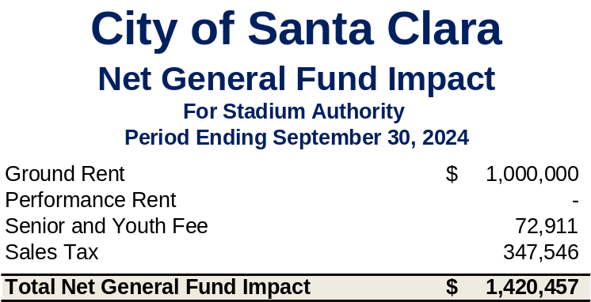

Public Safety and Administrative Cost Reimbursement
As described in earlier sections of this report, costs incurred by the City on NFL and Non- NFL events are tracked and billed to the Stadium Manager. Reimbursement is monitored and included in this report. A total of $3.1 million in public safety costs were incurred in support of Non-NFL events that were held at Levi’s® Stadium in the current reporting period. These reimbursements come from a combination of payments from the Stadium Manager and the offsite parking fees that were collected. The City has received $2.8 million in reimbursements from the Stadium Manager as of the date of this report.

Public safety costs for NFL events continue to be above the annual public safety cap. Pursuant to the Amended and Restated Lease, the Stadium Authority was in discussion with StadCo to adjust the annual public safety cap to reflect the true cost of service, which is higher than the cap. On May 23, 2024, the Stadium Authority entered into a settlement agreement with StadCo and ManCo over disputes regarding public safety and buffet costs. As a result of the settlement, the public safety cap will be adjusted to increase the per game and annual threshold beginning in FY 2024/25. Under the settlement agreement, credits that were issued from public safety costs paid in excess of the annual public safety costs threshold were redefined as Public Safety Costs 2024 Outstanding Balance and will be partially reimbursed to StadCo with litigation contingency funds and partially over time through excess revenues.

In addition to public safety costs, administrative costs are also tracked and billed to the Stadium Authority. These include the cost of providing overall stadium management, financial, human resource, legal, and other services to the Stadium Authority. In the second quarter of FY 2024/25, a total of $1.1 million of administrative costs were incurred by the General Fund, which have been reimbursed to the City.

Rents and Senior and Youth Fee
As noted above, the City’s General Fund collected ground rent of $1 million. Additionally, the Senior and Youth Fee generated $73,000, of which the entire amount forwarded to the City in support of senior and youth programs. See the Glossary for more information on these revenues and how they are calculated.

Other Revenue Impacts
General Fund sales tax, property tax, and transient occupancy tax (TOT) collections have benefited from the direct and indirect economic activity related to stadium events.

Food and beverage concession sales and merchandise sales at Levi’s® Stadium are taxable, resulting in sales tax revenue for the City. The last quarter of sales tax collections from Levi’s® Stadium transactions generated $348,000 for the City’s General Fund. In addition to the direct sellers at the Stadium, other businesses in Santa Clara are benefiting from the influx of people coming to attend one or more events at Levi’s® Stadium, resulting in potentially more sales tax collections for the General Fund.

In accordance with State Law, StadCo must pay possessory interest property tax based on their lease of Levi’s® Stadium from the Stadium Authority. This revenue is collected by the county and placed into the Redevelopment Property Tax Trust Fund (RPTTF). Amounts remaining in the RPTTF after paying any enforceable obligations of the Successor Agency are distributed to taxing entities in the same proportion as secured property taxes. The City’s proportion is approximately 10%.

Many stadium events bring travelers to the region, resulting in hotel stays which generate TOT collections for the City’s General Fund. Although it is impossible to say exactly what portion of the City’s TOT collections is due to the stadium, it is clear that hotels both inside and outside the City have benefited, resulting in increases in TOT collections in Santa Clara and our neighboring cities.

Glossary
This section of the report provides details behind key terms that are used in the body of this report.

Discretionary Fund – The Amended and Restated Stadium Lease Agreement describes the Non-NFL event ticket surcharge which is imposed by the Stadium Authority. All promotors or sponsors of ticketed Non-NFL events are required to collect a Non-NFL event ticket surcharge of $4 per ticket on behalf of the Stadium Authority. One-half of these proceeds are used to cover Stadium Authority operating and maintenance costs. The other one-half of the proceeds are deposited in the Stadium Authority’s discretionary fund. If at any time the discretionary fund balance exceeds $1 million, then in consultation with the Stadium Manager, the Stadium Authority will determine if provision has been made for replacement and improvement of capital improvements contemplated under the public safety plan. If not, then funds will be reserved in the discretionary fund for such purposes. If adequate provision has been made for these items and the balance of the discretionary fund still exceeds $1 million, then up to half of the amount over $1 million can be transferred to the General Fund, in which event an equal amount will also be transferred from the discretionary fund to the Stadium Authority operating fund and will be included as revenue available to pay Stadium Authority expenses.

Ground Lease – The Ground Lease Agreement has an initial term of 40 years commencing on the date of substantial completion which was July 31, 2014. The amount of annual base ground rent that is payable by the Stadium Authority to the City is noted in the Table 16.

Table 16

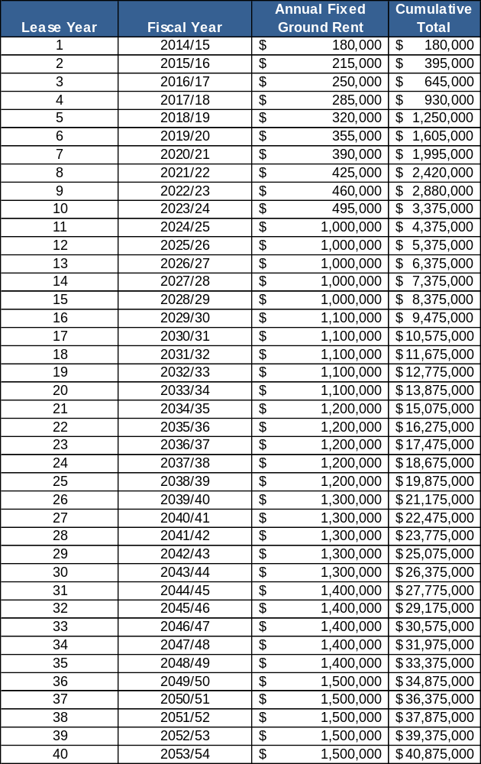

Net Non-NFL Event Revenue – Net Non-NFL event revenue is remitted by Stadium Manager to the Stadium Authority on a yearly basis. This is done annually because the final reconciliation of the Non-NFL event revenues and expenses does not occur until after the conclusion of each fiscal year.

NFL Ticket Surcharge – The Amended and Restated Non-Relocation Agreement states that the Team will collect a 10% NFL ticket surcharge on the price of admission to all NFL games on behalf of Stadium Authority.

Non-NFL Event Ticket Surcharge – The Stadium Lease Agreement requires that the promoter or sponsor of any Non-NFL event collect a Non-NFL event ticket surcharge of
$4 per ticket. The Lease Agreement sets aside one-half of the Non-NFL event ticket surcharge for stadium operating and maintenance costs and one-half for discretionary expenses of the Stadium Authority.

Offsite Parking Fees – Parking lot operators who wish to operate a parking lot for sports or entertainment venues are required to go through the City’s permitting process. If approved, per the City’s Municipal Fee Schedule, these operators remit an offsite parking fee for each car that is parked for sports or entertainment events. This fee is designed to recover the public safety costs associated with these permitted offsite parking lots. Therefore, when invoicing for NFL or Non-NFL public safety costs for a particular event held at Levi’s® Stadium, the offsite parking fee that is collected for said event partly offsets the total public safety costs owed for that event. In the City’s FY 2024/25 (July 1, 2024 through June 30, 2025) the offsite parking fee is $6.71.

Performance-Based Rent – The Amended and Restated Stadium Lease Agreement and the Ground Lease Agreement both describe the performance-based rent that is due to the City. (It is calculated as 50% of the net income from Non-NFL events less performance-based rent credits. The performance-based rent credits include 50% of the fixed ground rent for the current lease year.)

Public Safety Costs – For each NFL and Non-NFL event held at Levi’s® Stadium, a public safety plan is developed and implemented. Multiple City departments provide staffing, materials, and supplies to support the public safety plan. Services are provided through a combination of City staff, contracts with other agencies (California Highway Patrol, County Sheriff’s Office, and City of Sunnyvale) and some vendor provided services.

The Amended and Restated Stadium Lease Agreement section 7.5 states that the tenant is responsible for reimbursing the City for the public safety costs attributed to NFL events at Levi’s® Stadium. Additionally, Article 5 of the Stadium Management Agreement notes that the Stadium Manager is responsible for paying Non-NFL event expenses on behalf of the Stadium Authority. Therefore, the cost of providing public safety services are tracked through the City’s financial system and invoices are sent to the Stadium Manager. All of these costs are reimbursed to the City of Santa Clara.

Senior and Youth Program Fees – The Amended and Restated Stadium Lease Agreement requires that StadCo collect a Senior and Youth Program Fee of $0.35 per NFL ticket sold on behalf of the Stadium Authority. Per section 8.2 of the Ground Lease Agreement between the City and the Stadium Authority, the Stadium Authority remits this fee to the City as additional rent to support senior and youth programs in the City.

Stadium Management Fee – The Stadium Manager receives an annual base management fee to manage Levi’s® Stadium. The fee was $400,000 in the first lease year and increases by 3% annually as detailed in the table below. This annual base management fee is split 50/50 between StadCo and the Stadium Authority since the Stadium Manager manages the stadium year-round for both entities. In addition to the base management fee, the Stadium Manager also receives a stadium marketing and booking fee (incentive fee) which is based on a percentage of the amount that the net income from Non-NFL events exceeds the marketing and booking fee benchmark. The marketing and booking fee benchmark was $5 million in the first lease year and also increases by 3% annually as detailed in the table below. The annual stadium management fee for each of the first ten lease years are noted in the Table 16 below.

Table 17
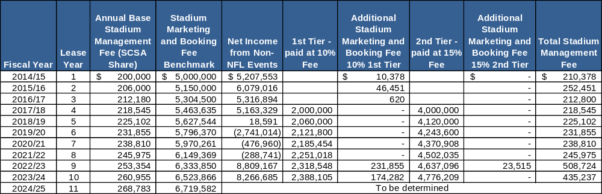

Appendix
This section of the report provides additional historical data for the tables referenced in the body of this report.

Table 18

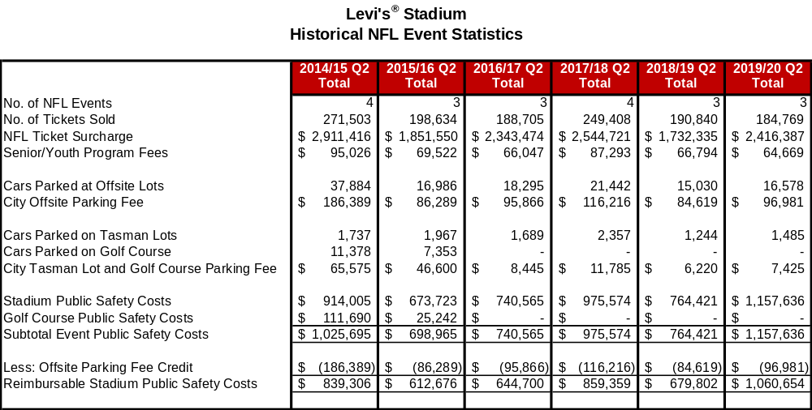

Table 19

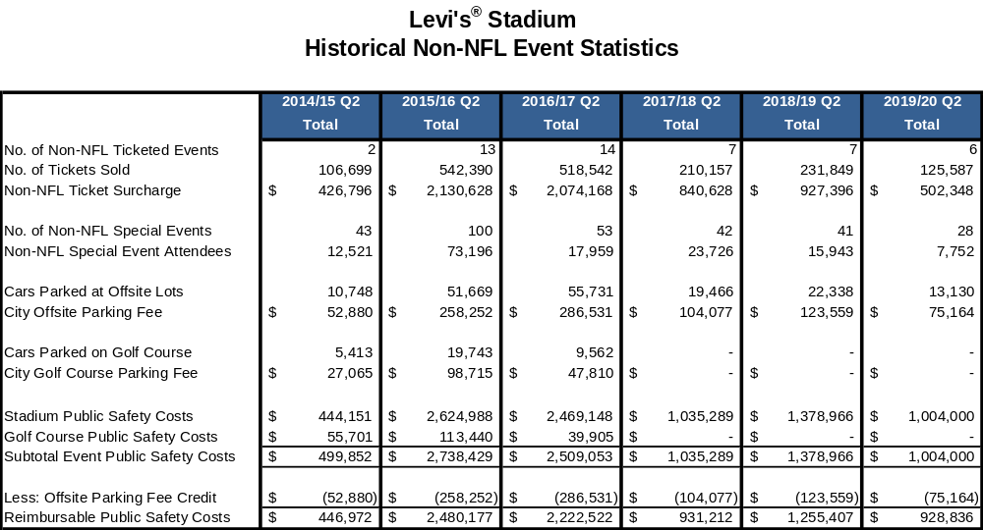

Table 20

