ORDINANCE NO. _____

AN ORDINANCE OF THE CITY OF SANTA CLARA, CALIFORNIA, MAKING “CLEANUP” AMENDMENTS TO THE ZONING CODE UPDATE, INCLUDING UPDATING THE CITY’S WIRELESS PROVISIONS TO BE CONSISTENT WITH FEDERAL LAW, UPDATING THE DENSITY BONUS PROVISIONS TO INCORPORATE RECENT CHANGES TO THE GOVERNMENT CODE, REVISING THE REASONABLE ACCOMMODATION PROVISIONS AS A PART OF THE HOUSING ELEMENT UPDATE, ADDING SMOKE SHOPS AS AN ENUMERATED USE, MODIFYING USE TABLES TO REFLECT THE RANGE OF USES EXISTING IN COMMERCIAL AND INDUSTRIAL DISTRICTS, INCORPORATING THE NON-RESIDENTIAL USE PROVISIONS OF THE TN TRANSIT NEIGHBORHOOD DISTRICT INTO THE CODE, UPDATING FIGURES, AND MAKING TERMS INTERNALLY CONSISTENT IN TITLE 18 (“ZONING”) OF “THE CODE OF THE CITY OF SANTA CLARA, CALIFORNIA”

WHEREAS, on January 9, 2024 the City of Santa Clara (the “City”) adopted the first comprehensive update of the City’s Zoning Code in over 50 years (the “Zoning Code Update”); and
WHEREAS, the 2010-2035 General Plan is the City’s vision for future development; and
WHEREAS, the City’s Zoning Code is the primary regulatory tool that implements the General Plan; and
WHEREAS, under Government Code Section 65860, the General Plan and Zoning Ordinance of a jurisdiction are required to be consistent with each other; and
WHEREAS, on August 20, 2024, the City Council adopted the First Zoning Code “Clean-Up” Ordinance;
WHEREAS, there is now a need to adopt a second clean-up ordinance to the recently adopted Zoning Code Update to address errata and omissions from the original approval, including updating the City’s wireless provisions to be consistent with recent changes to federal law: and
WHEREAS, the City is proposing to amend the City’s density bonus provisions to incorporate recent changes to the state’s Government Code; and
WHEREAS, the City also wishes to add “Smoke Shops” as an enumerated use with an associated definition, and
WHEREAS, the City is including changes to the Zoning code requested by the state Department of Housing and Community Development through the Housing Element Update process, including focusing the Reasonable Accommodation process on the consistency with the Federal Fair Housing Act; and
WHEREAS, the City is proposing to incorporate the provisions of the HT Historic Combining District into the updated Zoning Code; and
WHEREAS, the City is proposing to also incorporate the non-residential use provisions of the former TN Transit Neighborhood District into the updated Zoning Code; and
WHEREAS, the City is proposing to update figures and terms for the purpose of internal consistency in the zoning; and
WHEREAS, the City Council has reviewed the proposed second Zoning Code cleanup ordinance; and
WHEREAS, on December 19, 2023, before acting on the Zoning Code Update, the City reviewed and considered the potential environmental impacts of the Zoning Code Update and determined that as the primary implementation tool of the General Plan, the environmental effects of the proposed Zoning Code Update were consistent with 2010-2035 General Plan EIR, as addended, and that the proposed Zoning Code Update did not alter the conclusions of the adopted General Plan EIR, as addended create new environmental impacts; and
WHEREAS, as an implementing action of the Zoning Code Update, the proposed second Zoning Code cleanup ordinance falls within the scope of the December 19, 2023 Addendum;
WHEREAS, on April 16, 2025, the Planning Commission conducted a duly noticed public hearing to consider the Zoning Code cleanup ordinance, at the conclusion of which, the Planning Commission voted to recommend adoption of the Zoning Code cleanup ordinance; and
WHEREAS, on May 27, 2025, the City Council conducted a duly noticed public hearing to consider the Zoning Code cleanup ordinance, at which time all interested persons were given an opportunity to give testimony and provide evidence in support of and in opposition to the proposed amendments.
NOW THEREFORE, BE IT ORDAINED BY THE CITY OF SANTA CLARA AS FOLLOWS:
SECTION 1: That Table 1-1, “Zones Implementing the General Plan”, of Chapter 18.06, “Zoning Map and Zones”, of Title 18, “Zoning”, of “The Code of the City of Santa Clara, California” (“SCCC”) is hereby amended to read as follows:

Table 1-1
ZONES IMPLEMENTING THE GENERAL PLAN
Zoning Map Symbol | Zone Name | Allowable Density or Intensity | Corresponding General Plan Land Use Designations
Residential Zones
R1-6L | Single-Family Residential | 0.1 - 10 DU/AC | Very Low Density Residential
R1-8L | Single-Family Residential, Larger Parcel | 0.1 - 10 DU/AC | Very Low Density Residential
R2 | Low-Density Residential | 8 - 19 DU/AC | Low Density Residential
R3 | Medium-Density Residential | 20 - 36 DU/AC | Medium Density Residential
R4 | High-Density Residential | 37 - 50 DU/AC | Medium Density Residential
R5 | Very-High-Density Residential | 51 - 100 DU/AC | Very High Density Residential
PH-R5 | Patrick Henry Very-High-Density Residential | 51 – 100 DU/AC | Very High Density Residential
R6 | Transit Neighborhood Residential | 60 - 350 DU/AC | Transit Neighborhood
UV | Urban Village | 100-149 DU/AC | Urban Village (Patrick Henry Drive Plan)
VR | Village Residential | 60 - 149 DU/AC | Village Residential (Patrick Henry Drive Plan)
UC | Urban Center | 120 - 250 DU/AC | Urban Center (Patrick Henry Drive Plan)
HD-Flex | High Density Flex | 60 - 149 DU/AC | High Density Flex (Patrick Henry Drive Plan)
HD-Flex | High Density Flex | 2.0 FAR | High Density Flex (Patrick Henry Drive Plan)
Commercial Zones
C-C | Commercial-Community | 0.5 FAR | Community Commercial
C-N | Commercial-Neighborhood | 0.4 FAR | Neighborhood Commercial
C-R | Commercial-Regional | 0.6 FAR | Regional Commercial
Mixed-Use Zones
MUNC | Mixed Use-Neighborhood Commercial | 20 - 36 DU/AC | Neighborhood Mixed Use
MUNC | Mixed Use-Neighborhood Commercial | 0.1 FAR minimum | Neighborhood Mixed Use
MUCC | Mixed Use Community Commercial | 20 - 36 DU/AC | Community Mixed Use
MUCC | Mixed Use Community Commercial | 0.1 FAR minimum | Community Mixed Use
MURC | Mixed Use-Regional Commercial | 37 - 50 DU/AC | Regional Mixed Use
MURC | Mixed Use-Regional Commercial | 0.15 FAR minimum | Regional Mixed Use
MU-VHD | Mixed Use-Very High Density Residential | 51-120 DU/AC | Very High Density Mixed Use; Santa Clara Station Very High Density Residential
MU-VHD | Mixed Use-Very High Density Residential | 0.2 FAR minimum
Office and Industrial Zones
LO-RD | Low-Intensity Office/R&D | 1.0 FAR | Low-Intensity Office/R&D
HO-RD | Office/R&D-High Intensity | 2.0 FAR | High-Intensity Office/R&D
LI | Industrial-Light | 0.6 FAR | Light Industrial
HI | Industrial-Heavy | 0.45 FAR | Heavy Industrial
Special Purpose Zones
OS | Parks/Open Space | N/A | Parks/Open Space
PQP | Public/Quasi Public | N/A | Public/Quasi Public
HT | Historic Combining | N/A | N/A
PD | Planned Development | N/A | N/A
PD | Planned Development – Master Community | N/A | N/A
LSAP | Lawrence Station Area Plan | 8 - 19 DU/AC | Low Density Residential
LSAP | Lawrence Station Area Plan | 20 - 36 DU/AC | Medium Density Residential
LSAP | Lawrence Station Area Plan | 37 - 50 DU/AC | High Density Residential
LSAP | Lawrence Station Area Plan | 51-100 DU/AC | Very High Density Residential
LSAP | Lawrence Station Area Plan | N/A | Parks/Open Space
LSAP | Lawrence Station Area Plan | N/A | Public/Quasi Public

SECTION 2: That Table 2-2, “Patrick Henry Drive Residential Zones Allowed Uses and Permit Requirements”, of Chapter 18.10, “Residential Zones”, of Title 18, “Zoning”, of “The Code of the City of Santa Clara, California” (“SCCC”) is hereby amended to read as follows:

Table 2-2
Patrick Henry Drive Residential Zones Allowed Uses and Permit Requirements
Residential Zones
Permit Requirements
P  MUP  CUP  TUP  - | Allowed by Right  Minor Use Permit (Chapter 18.114)  Conditional Use Permit (Chapter 18.114)  Temporary Use Permit (Chapter 18.122)  Not allowed
Land Use  (see Article 8 for land use definitions). | PH-R5 | UV  HD-Flex | VR | UC | Additional Regulations
Residential Uses
Dwelling, Accessory Units | P | P | P | P | Chapter 18.60.020
Dwelling, Multifamily | P | P | P | P
Dwelling, Single-Family | - | - | - | -
Dwelling, Two-Family | - | - | - | - | Chapter 18.24
Employee Housing | P | P | P | P
Home Occupations | P | P | P | P | Chapter 18.60.120
Live-Work Facilities | MUP | MUP | MUP | MUP | Chapter 18.60.130
Mobile Home Park | - | - | - | -
Organizational Houses | - | - | - | -
Rooming and/or Boarding Houses | - | - | - | -
Supportive Housing | P | P | P | P
Transitional Housing | P | P | P | P
Human Services Uses
Assisted Living Facilities | CUP | CUP | CUP | CUP | Chapter 18.60.080
Day Care Homes, Up to 14 Children | P | P | P | P
Community Care Facility, Small | P | P | P | P
Community Care Facility, Large | CUP | CUP | CUP | CUP
Emergency Shelters | - | - | - | - | Chapter 18.60.110
Recreation, Education, and Public Assembly Uses
Community Gardens | P | P | P | P
Parks and Public Plazas | P | P | P | P
Places of Assembly | CUP | CUP | CUP | CUP
Public Schools | CUP | CUP | CUP | CUP
Private Schools | CUP | CUP | CUP | CUP
Utility, Transportation, and Communication Uses
Public Safety Facilities | P | P | P | P
Wireless Telecommunications Facilities, Co-location/Small Cell | P | P | P | P | Chapter 18.66
Retail, Service, and Office Uses
Bed and Breakfast Inns | - | - | - | - | Chapter 18.60.050
Retail | P | P | P | P
Off-sale of alcohol | P | P | P | P
Restaurants, including on-sale of alcohol | P | P | P | P
Bars | CUP | CUP | CUP | CUP
Office | P | P | P | P | For Office Uses in the HD-Flex zone, see Table 2-5

SECTION 3: That Table 2-3, “Residential Zone Development Standards”, of Chapter 18.10, “Residential Zones”, of Title 18, “Zoning”, of the SCCC is hereby amended as follows:
Table 2-3
Residential Zone Development Standards

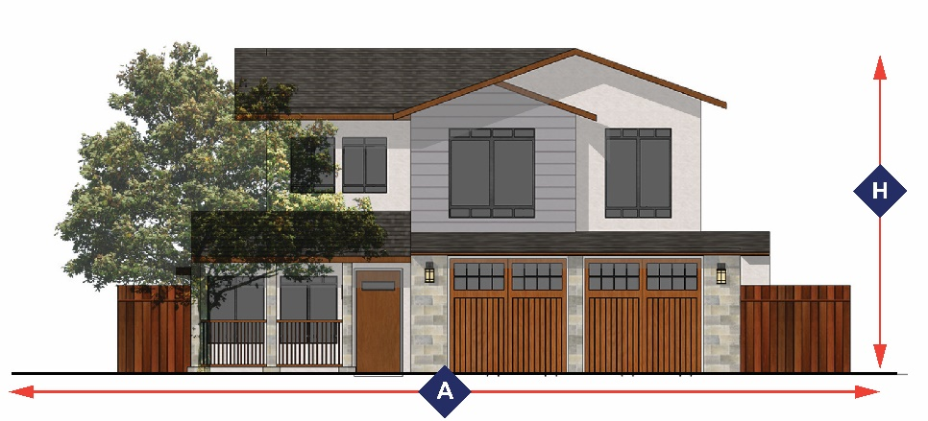 |  |  |  |  |  | 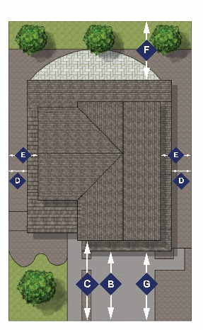
Development Feature  (minimum unless otherwise indicated) |  | R1-6L | R1-8L | R2 | R3 | R4 | R5 | R6 | Additional Regulations
Parcel Area (minimum) area required for each NEWLY CREATED parcel.
Parcel Area |  | 6,000 | 8,000 | 7,000 | 8,500 | 8,500 | 10,000 | None
 | Street Frontage (feet) | 60 | 70 | 50 | 60 | 70 | 70 | None
Structure Coverage (maximum percentage)
Parcel Area (less than 10,000 sq. ft.) |  | 40% | 40% | 45% | 60% | 80% | None | None
Parcel Area (10,000 sq. ft. or greater) |  | 40% | 40% | 45% | None | None | None | None
Setbacks (minimum) -Property lines are measured in feet, with those adjacent to the street measured from the face of the curb., adopted plan line, or edge of right-of-way.
 | Front | 20 | 20 | 15 | 10 | 10 | 10 | 10 | Section 18.30.050
 | Front, second story | 25 | 25 | n/a | n/a | n/a | n/a | n/a
Side, Corner |  | 10 | 10 | 10 | 10 | 15 | 15 | 15
Side, corner second story |  | 15 | 15 | n/a | n/a | n/a | n/a | n/a
 | Side, Interior | 5 | 6 and 9 | 5 | 5 | 10 | 10 | 10 | Section 18.10.040(B)  Section 18.30.050
 | Side, interior, second story | 10 | 11 and 14 | n/a | n/a | n/a | n/a | n/a
 | Rear, single-story | 20 | 20 | 10 | 10 | 20 | 20 | 20 | Section 18.30.050
 | Rear, multi-story | 20 | 20 | 15 | 15 | 20 | 20 | 20 | Section 18.30.050
 | Length of driveway approach | 20 | 20 | 20 | 20 | 20 | 20 | 20
Height (maximum) measured in feet
 | Height (within 20 feet of the R1-6L, R1-8L, and R2 zones) | 25 | 25 | 32 | 32 | 32 | 32 | 32 | Section 18.30.040
 | Height (all other zones) | 25 | 25 | 32 | 40 | 80 | 100 | 200 | Section 18.30.040
Number of Stories (maximum)
Number of Stories and the Daylight Plane |  | All structures adjacent to R1 and R2 zones shall include a 45-degree daylight plan off the property line to implement a compatible transition between structures.
Number of Stories |  | 2 | 2 | 2 | 4 | 8 | 10 | 20
Gross Residential Density (minimum to maximum) shown in number of dwelling units per acre
Allowable Density |  | 0.1-10 | 0.1-10 | 8-19 | 20-36 | 37-50 | 51-99 | 85-350
Recreation Space for Multi-Family Dwellings (minimum) measured in square feet per dwelling unit
Private Recreation Space (required for a minimum of 50 percent of units) |  | None | None | None | 60 | 60 | 40 | 40
Common Recreation Space (per unit) |  | None | None | None | 200 | 200 | 200 | 200
Additional Regulations
Residential Accessory Structures |  | Chapter 18.32
Density Bonus and Affordable Housing |  | Chapter 18.64
Fences, Walls, Hedges, and Screens |  | Chapter 18.34
Landscaping Standards |  | Chapter 18.36
Off-Street Parking Regulations and Design Standards |  | Chapter 18.38
Performance Standards |  | Chapter 18.40
Sign Standards |  | Chapter 18.42

SECTION 4: That Table 2-5, “Office and Industrial Uses, HD Flex Zone Allowed Uses and Permit Requirements”, of Chapter 18.10, “Residential Zones”, of Title 18, “Zoning”, of the SCCC is hereby amended as follows:
Table 2-5
Office and Industrial Uses, HD Flex Zone Allowed Uses and Permit Requirements
Office and Industrial Uses, HD Flex Zone
Permit Requirements
P  MUP  CUP  TUP  - | Allowed by Right  Minor Use Permit (Chapter 18.124)  Conditional Use Permit (Chapter 18.124)  Temporary Use Permit (Chapter 18.122)  Not allowed
Land Use  (see Article 8 for land use definitions). | HD-Flex | Additional Regulations
Residential Uses
Caretaker housing | CUP
Transitional housing facilities | -
Human Services Uses
Community care facilities, small | -
Community care facilities, large | -
Emergency shelters | - | Section 18.60.110
Recreation, Education, and Public Assembly Uses
Cemeteries and mausoleums | –
Crematories | –
Fitness facilities | P
Parks and public plazas | P
Public schools | CUP
Private schools | CUP
Public/private colleges and universities | –
Equipment/machine/vehicle training facilities | CUP
Vocational/trade schools | –
Vehicle Oriented Uses
Mobile Fueling Delivery | -
Utility, Transportation, and Communication Uses
Parking facilities | CUP
Wireless telecommunications facilities and towers, co-location/small cell | P | Chapter 18.66
Wireless telecommunication facilities and towers, minor (less than 70 feet) | MUP | Chapter 18.66
Wireless telecommunication facilities and towers, major (70 feet or higher) | CUP | Chapter 18.66
Park and ride facilities | P
Broadcasting and recording studios | -
Fuel storage and distribution centers | -
Transit stations and terminals | P
Utility facilities and infrastructure | CUP
Retail, Service, and Office Uses
Ambulance Services | P
Banks and Financial Establishments, General | P
Banks and Financial Establishments, Stand-alone ATM | P
Business Support Centers | P
Call Centers | P
Data Centers | CUP | Section 18.60.090
Data Centers, Ancillary | P | Section 18.60.090
Equipment Sales and Rental Facilities | P
Hotels and Motels | P
Kennels | -
Maintenance and Repair Services | P
Medical Services | P
Mobile Food Vendors | P/MUP | 18.60.280
Offices | P
Outdoor Dining and Seating (Ancillary) | P | Section 18.16.040(B)  Section 18.60.140
Personal Services (Ancillary) | P | Section 18.16.040(B)
Restaurants (Ancillary) | P | Section 18.16.040(B)
Retail Establishments (Ancillary) | P | Section 18.16.040(B)

SECTION 5: That a new Subparagraph c, “Attached Accessory Structure Setbacks”, is added to Paragraph 2, “Accessory Structures”, of Subsection B, “Specific Residential Regulations”, of Section 18.10.040, “Other Applicable Regulations”, of Chapter 18.10, “Residential Zones”, of Title 18, “Zoning”, of the SCCC to read as follows:
“c. Attached Accessory Structure Setbacks. Attached accessory structures are subject to the same setbacks as the primary structure.”

SECTION 6: That Tables 2-7 through 2-18 of Article 2, “Article 2 – Zones, Allowable Uses, and Development Standards”, are re-numbered to Tables 2-8 through 2-18 respectively.
SECTION 7: That a new Subsection D, “R6 Transit Neighborhood District Non-Residential Ground Floor Uses”, is added to Section 18.10.040, “Other Applicable Regulations”, of Chapter 18.10, “Residential Zones”, of Title 18, “Zoning”, of the SCCC as follows:
D. R6 Non-Residential Ground Floor Uses
Table 2-7
R6 Transit Neighborhood District Non-Residential Ground Floor Uses
R6 Non-Residential Uses
Permit Requirements
P  MUP  CUP  TUP  - |  | Allowed by Right  Minor Use Permit (Chapter 18.114)  Conditional Use Permit (Chapter 18.114)  Temporary Use Permit (Chapter 18.122)  Not allowed
Land Use  (see Article 8 for land use definitions). | R6 |  | Additional Regulations
Human Services Uses
Child Day Care Facilities | P |  | Section 18.60.070, Note 1
Child Day Care Homes, Up to 14 Children | P |  | Note 1
Recreation, Education, and Public Assembly Uses
Commercial Recreation Facilities, Indoor | P
Commercial Recreation Facilities, Outdoor | P
Fitness Facilities | P
Libraries | P
Museums | P
Parks and Public Plazas | P
Places of Assembly | P
Pre-schools, Nursery Schools | P |  | Note 1
Public Schools | P
Private Schools | CUP
Public/Private Colleges and Universities | P
Theaters and Auditoriums | P
Vocational/Trade Schools | P
Utility, Transportation, and Communication Uses
Parking Structures | CUP
Diesel Back-up Generators | P |  | Section 18.60.260
Photovoltaic Systems | P
Retail, Service, and Office Uses
Alcoholic Beverage Sales and Service |  | P | Section 18.60.040
Ambulance Services |  | CUP
Animal Sales and Grooming Facilities |  | P
Banks and Financial Establishments, General |  | P
Banks and Financial Establishments, Stand-alone ATM |  | P
Bars |  | CUP
Business Support Centers |  | P
Catering Companies |  | P
Co-working space |  | P | Note 1
Equipment Sales and Rentals |  | P
Garden Centers/Plant Nurseries |  | P
Hotels and Motels |  | CUP
Kennels |  | CUP
Live Entertainment, Incidental |  | P
Live Entertainment, Standalone Uses |  | CUP | Section 18.12.040(A)(5)
Maintenance and Repair Services |  | P
Medical Services, General |  | P
Mobile Food Vendors |  | P/MUP | 18.60.280
Nightclubs |  | CUP
Offices |  | P | Note 1
Outdoor Displays and Sales |  | CUP | Section 18.60.150
Outdoor Dining and Seating |  | P | Section 18.60.140
Outdoor Walk-up Facility |  | P | Appurtenant to a retail use
Personal Services |  | P
Personal Services, Restricted |  | MUP | Section 18.60.170
Restaurants |  | P
Retail Establishments
General, Small Format |  | P
General, Medium Format |  | MUP
General, Large Format |  | CUP
Smoke Shops |  | CUP
Smoking Lounges |  | MUP | Chapter 8.37
Veterinary Facilities |  | MUP
Neighborhood Light Industrial Uses
Printing and Publishing Facilities |  | P
Wineries, Distilleries, Breweries, and Micro-Breweries |  | P
Garment manufacturing |  | P
Artists’ Studios |  | P
Note 1: This use is also allowed on the second and third floors of mixed-use buildings.”
SECTION 8: That Figure 2-1, “Vertical Mixed-Use”, and Figure 2-2, “Horizontal Mixed-Use”, of Chapter 18.14, “Mixed Use Zones”, of Title 18, “Zoning”, of the SCCC are re-numbered to Figures 2-3 and 2-4, respectively.
SECTION 9: That a new Subsection D, “Transition Standards”, and Associated Figures 2-1, “Rear Property Line Daylight Plane”, and Figure 2-2, “Side Property Line Daylight Plane” is added to Section 18.10.040, “Other Applicable Regulations”, of Chapter 18.10, “Residential Zones”, of Title 18, “Zoning”, of the SCCC to read as follows:
“D. Transition Standards.
1. Maximum Height Adjacent to Residential. Building Height Limits Abutting Residential Zoning Districts, 45-degree Daylight Plane height transitions are required for any new development adjacent to single family and duplex residential zoning districts, measured from the property line. Rear property line daylight planes extend 40 feet from the rear property line; side property line daylight planes start at 15 feet above grade and extend the full height of the building. See Figures 2-1 and 2-2.”
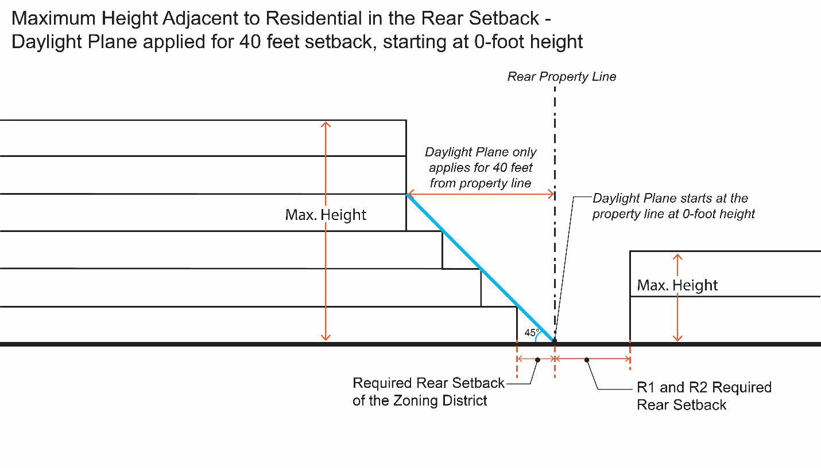
Figure 2-1. Rear Daylight Plane.
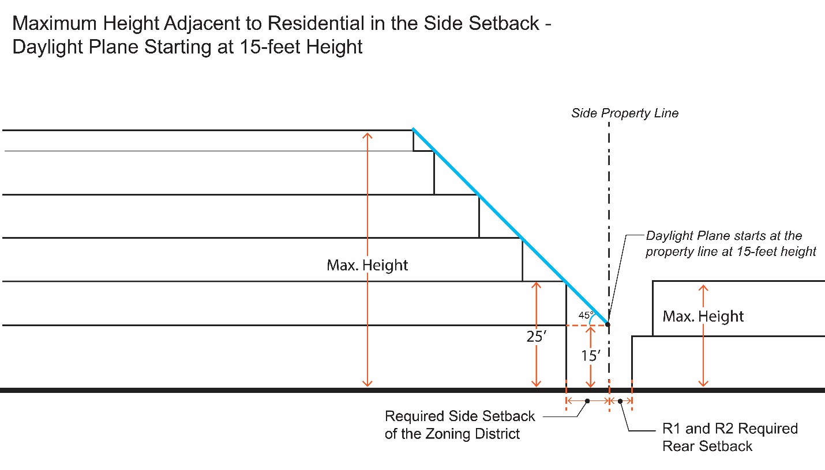
Figure 2-2. Side Daylight Plane.”

SECTION 10: That Table 2-8, “Commercial Zones Allowed Uses and Permit Requirements”, of Chapter 18.12, “Commercial Zones”, of Title 18, “Zoning”, of the SCCC is hereby amended to read as follows:
Table 2-8
Commercial Zones Allowed Uses and Permit Requirements
Commercial Zones
Permit Requirements
P  MUP  CUP  TUP  - |  | Allowed by Right  Minor Use Permit (Chapter 18.114)  Conditional Use Permit (Chapter 18.114)  Temporary Use Permit (Chapter 18.122)  Not allowed
Land Use  (see Article 8 for land use definitions). | C-N |  | C-C | C-R | Additional Regulations
Residential Uses
Caretaker Housing | - |  | P | P | Section 18.60.060
Dwelling, Multifamily | MUP |  | MUP | MUP | Section 18.12.040(A)(7)
Employee Housing | - |  | - | -
Home Occupations | - |  | - | - | Section 18.60.120
Live-Work Facilities | MUP |  | MUP | MUP | Section 18.60.130
Single-Room Occupancy (SRO) Facilities | - |  | P | P
Supportive Housing | - |  | - | P
Transitional Housing Facilities | - |  | - | P
Human Services Uses
Assisted Living Facilities | - |  | CUP | - | Section 18.60.080
Child Day Care Facilities | P |  | P | P | Section 18.60.070
Residential Care Facilities, six or fewer residents | P |  | P | P
Residential Care Facilities, seven or more residents | MUP |  | MUP | MUP
Community Care Facilities | CUP |  | CUP | CUP
Child Day Care Homes, Up to 14 Children | - |  | - | -
Low-barrier Navigation Centers |  |  | P | P
Emergency Shelters | - |  | P | P | Section 18.60.110
Recreation, Education, and Public Assembly Uses
Cemeteries and Mausoleums | - |  | CUP | -
Commercial Recreation Facilities, Indoor | CUP |  | P | P
Commercial Recreation Facilities, Outdoor | - |  | P | P
Fitness Facilities | MUP |  | P | P
Libraries | P |  | P | P
Mortuaries and Funeral Homes | - |  | P | P
Museums | - |  | P | P
Parks and Public Plazas | P |  | P | P
Recreational Vehicle Parks | - |  | - | CUP
Places of Assembly | P |  | P | P
Public Schools | P |  | P | P
Private Schools | CUP |  | CUP | CUP
Public/Private Colleges and Universities | P |  | P | P
Theaters and Auditoriums | - |  | P | P
Vocational/Trade Schools | P |  | P | P
Utility, Transportation, and Communication Uses
Broadcasting and Recording Studios | - |  | P | P
Parking Structures | - |  | CUP | CUP
Public Safety Facilities | P |  | P | P
Wireless Telecommunication Facilities and Towers, Co-location/Small Cell | P |  | P | P | Chapter 18.66
Wireless Telecommunication Facilities and Towers, Minor (less than 70 feet) | MUP |  | MUP | MUP | Chapter 18.66
Wireless Telecommunication Facilities and Towers, Major (70 feet or higher) | CUP |  | CUP | CUP | Chapter 18.66
Transit Stations and Terminals | - |  | CUP | CUP
Utility Facilities and Infrastructures | CUP |  | CUP | CUP
Diesel Back-up Generators | P |  | P | P | Section 18.60.260
Photovoltaic Systems | P |  | P | P
Retail, Service, and Office Uses
Adult Businesses Uses |  | - | - | CUP | Chapter 18.62
Alcoholic Beverage Sales and Service |  | P | P | P | Section 18.60.040
Ambulance Services |  | - | CUP | CUP
Animal Sales and Grooming Facilities |  | P | P | P
Banks and Financial Establishments, General |  | P | P | P
Banks and Financial Establishments, Stand-alone ATM |  | P | P | P
Bars |  | CUP | CUP | CUP
Bed and Breakfast Inns |  | CUP | - | - | Chapter 18.60.050
Building Material Stores and Yards |  | - | P | P
Business Support Centers |  | P | P | P
Drive-in/Drive-through Establishments |  | CUP | CUP | CUP | Section 18.60.100
Equipment Sales and Rentals |  | - | P | P
Garden Centers/Plant Nurseries |  | - | P | P
Hotels and Motels |  | CUP | CUP | CUP
Kennels |  | - | CUP | CUP
Live Entertainment, Incidental |  | P | P | P
Live Entertainment, Standalone Uses |  | MUP/CUP | MUP/CUP | MUP/CUP | Section 18.12.040(A)(5)
Maintenance and Repair Services |  | - | P | P
Medical Services, General |  | P | P | P
Mobile Food Vendors |  | P/MUP | P/MUP | P/MUP | 18.60.280
Nightclubs |  | CUP | CUP | CUP
Offices |  | P | P | P
Outdoor Displays and Sales |  | MUP | CUP | CUP | Section 18.60.150
Outdoor Dining and Seating |  | MUP | MUP | MUP | Section 18.60.140
Personal Services |  | P | P | P
Personal Services, Restricted |  | - | MUP | MUP | Section 18.60.170
Restaurants |  | P | P | P
Retail Establishments
General, Small Format |  | P | P | P
General, Medium Format |  | - | MUP | MUP
General, Large Format |  | - | CUP | CUP
Smoke Shops |  | - | CUP | CUP
Smoking Lounges |  | - | MUP | CUP | Chapter 8.37
Veterinary Facilities |  | - | MUP | P
Vehicle Oriented Uses
Car Wash and Detailing Facilities, Full-Service |  | - | CUP | MUP
Car Wash and Detailing Facilities, Self-Service |  | - | MUP | P
Mobile Fueling Delivery |  | P | P | P
Vehicle Service Stations |  | - | MUP | CUP | Section 18.60.220
Vehicle Rental Facilities, General |  | - | CUP | MUP
Vehicle Rental Facilities, Limited |  | - | P | P
Vehicle Rental Facilities, Office Only |  | P | P | P
Vehicle Sales Facilities, General |  | - | - | CUP | Section 18.60.210
Vehicle Sales Facilities, Wholesale |  | - | CUP | CUP | Section 18.60.210
Vehicle Repair Facilities, Minor |  | - | - | P | Section 18.60.200
Vehicle Repair Facilities, Major |  | - | CUP | CUP | Section 18.60.200
Vehicle Parts Sales |  | - | P | P
Industrial, Manufacturing, and Processing Uses
Personal Storage Facilities |  | - | - | CUP
Printing and Publishing Facilities |  | - | P | P
Wineries, Distilleries, Breweries, and Micro-Breweries |  | - | MUP | MUP

SECTION 11: That Subparagraph a, “Maximum Height Adjacent to Residential” of Paragraph 2, “Transition Standards”, of Subsection A, “General Commercial Regulations,” of Section 18.12.040, “Other Applicable Regulations” of Chapter 18.12, “Commercial Zones”, of Title 18, “Zoning”, of the SCCC is hereby amended to read as follows:
“a. Maximum Height Adjacent to Residential. Building Height Limits Abutting Residential Zoning Districts, 45-degree Daylight Plane height transitions are required for any new development adjacent to single family and duplex residential zoning districts, measured from the property line. Rear property line daylight planes extend 40 feet from the rear property line; side property line daylight planes start at 15 feet above grade and extend the full height of the building. See Figures 2-1 and 2-2.”

SECTION 12: That Table 2-11, “Mixed Use Zones Allowed Uses and Permit Requirements” of Chapter 18.14, “Mixed Use Zones”, of Title 18, “Zoning”, of the SCCC is hereby amended to read as follows:
Table 2-11
Mixed Use Zones Allowed Uses and Permit Requirements
Mixed Use Zones
Permit Requirements
P  MUP  CUP  TUP  - | Allowed by Right  Minor Use Permit (Chapter 18.114)  Conditional Use Permit (Chapter 18.114)  Temporary Use Permit (Chapter 18.122)  Not allowed
Land Use  (see Article 8 for land use definitions). | MU-NC | MU-CC | MU-RC | MU-VHD | Additional Regulations
Residential Uses
Caretaker Housing | CUP | - | - | P | Section 18.60.060
Dwelling, Multifamily | P | P | P | P
Employee Housing | P | - | - | -
Home Occupations | P | P | P | P | Section 18.60.120
Live-Work | P | P | P | P | Section 18.60.130
Single-Room Occupancy (SRO) Facilities | - | P | P | -
Supportive Housing | P | P | P | P
Transitional Housing | - | - | - | P
Human Services Uses
Assisted Living Facilities | - | CUP | - | CUP | Section 18.60.080
Child Day Care Facilities | P | P | P | P | Section 18.60.070
Community Care Facilities | CUP | CUP | - | CUP
Residential Care Facilities, six or fewer residents | P | P | - | P
Residential Care Facilities, seven or more residents | MUP | MUP | - | MUP
Day Care Homes, Up to 14 Children | P | P | P | -
Low Barrier Navigation Centers | P | P | P | P
Emergency Shelters | - | - | - | P | Section 18.60.110
Recreation, Education, and Public Assembly Uses
Cemeteries and Mausoleums | - | - | - | CUP
Community Gardens | MUP | MUP | MUP | -
Commercial Recreation Facilities, Indoor | MUP | P | P | CUP
Commercial Recreation Facilities, Indoor Outdoor | - | - | - | P
Fitness Facilities | P | P | P | P
Libraries | P | P | - | P
Museums | P | P | P | P
Parks and Public Plazas | P | P | P | P
Places of Assembly | MUP | CUP | CUP | P
Public Schools | P | P | P | P
Private Schools | CUP | CUP | CUP | CUP
Public/Private Colleges and Universities | P | P | P | P
Theaters and Auditoriums | P | P | P | P
Vocational/Trade Schools | - | P | P | P
Utility, Transportation, and Communication Uses
Broadcasting and Recording Studios | - | - | - | P
Park and Ride Facilities | P | P | P | -
Parking Structures | MUP | MUP | MUP | P | Section 18.14.040 (I)
Public Safety Facilities | P | P | P | P
Wireless Telecommunications Facilities and Towers, Co-location/Small Cell | P | P | P | P | Chapter 18.66
Wireless Telecommunication Facilities and Towers, Minor (less than 70 feet) | MUP | MUP | MUP | MUP | Chapter 18.66
Wireless Telecommunication Facilities and Towers, Major (70 feet or higher) | - | CUP | CUP | CUP | Chapter 18.66
Transit Stations and Terminals | P | P | P | CUP
Utility Facilities and Infrastructure | CUP | CUP | CUP | CUP | Section 18.14.040 (M)
Photovoltaic Systems | P | P | P | P
Retail, Service, and Office Uses
Alcoholic Beverage Sales and Service | P | P | P | P | Section 18.60.040
Ambulance Services | CUP | CUP | - | CUP
Animal Sales and Grooming Facilities | P | P | P | P
Banks and Financial Establishments, General | P | P | P | P
Banks and Financial Establishments, Stand-alone ATM | P | P | P | P
Bars | CUP | CUP | CUP | CUP
Bed and Breakfast Inns | - | - | - | CUP
Business Support Centers | P | P | MUP | P
Drive-in/Drive-through Establishments | CUP | - | - | CUP | Section 18.60.100
Equipment Sales and Rentals | - | - | - | P
Garden Centers/Plant Nurseries | - | - | - | P
Hotels and Motels | P | P | P | CUP | Section 18.14.040 (O)(2)
Kennels | MUP | MUP | - | -
Live Entertainment, Incidental | P | P | P | P
Live Entertainment, Standalone | MUP/CUP | MUP/CUP | MUP/CUP | MUP/CUP | Section 18.14.040 (K)
Maintenance and Repair Services | P | P | P | P
Medical Services, General | P | P | P | P
Mobile Food Vendors | P/MUP | P/MUP | P/MUP | P/MUP | 18.60.280
Nightclubs | CUP | - | CUP | CUP
Offices | P | P | P | P
Outdoor Dining and Seating | MUP | MUP | MUP | MUP | Section 18.60.140
Outdoor Displays and Sales | CUP | CUP | CUP | CUP | Section 18.60.150
Personal Services | P | P | P | P
Personal Services, Restricted | MUP | MUP | MUP | MUP | Section 18.60.170
Restaurants | P | P | P | P
Retail Establishments:
General, Small Format | P | P | P | P
General, Medium Format | P | MUP | P | MUP
General, Large Format | CUP | - | CUP | CUP
Smoke Shops | - | CUP | CUP | -
Veterinary Facilities | P | P | P | MUP
Vehicle Oriented Uses
Vehicle Service Stations | - | CUP | CUP | -
Vehicle Rental Facilities, Limited | MUP | - | - | -
Vehicle Rental Facilities, Office Only | P | - | - | -
Vehicle Repair Facilities, Minor | MUP | - | - | - | Section 18.60.200
Industrial, Manufacturing, and Processing Uses
Printing and Publishing Facilities | P | P | P | P
Wineries, Distilleries, Breweries, and Micro-Breweries | MUP | MUP | MUP | MUP

SECTION 13: That Table 2-12, “Mixed-Use Zone Development Standards” of Chapter 18.14, “Mixed Use Zones”, of Title 18, “Zoning”, of the SCCC is hereby amended to read as follows:

Table 2-12
Mixed-Use Zone Development Standards

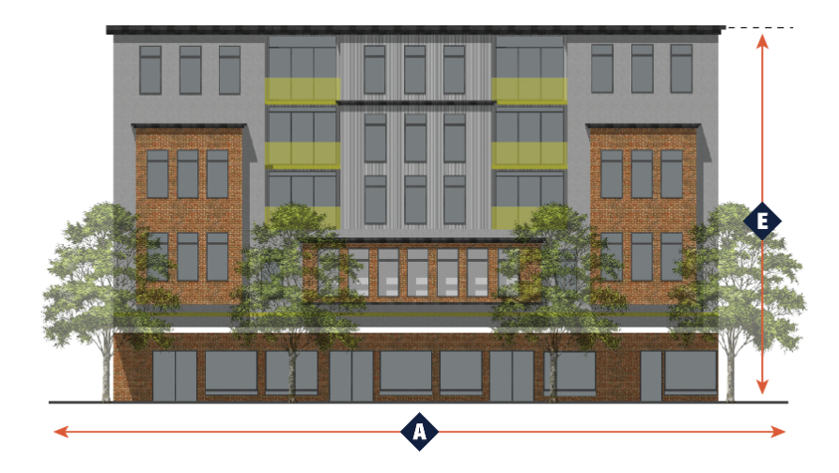 |  |  |  |  |  |  |  | 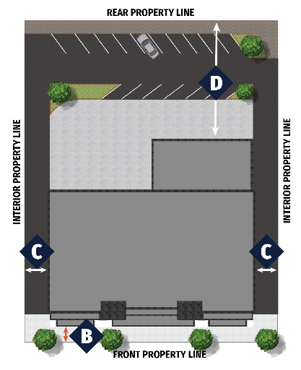
Development Feature  (minimum unless otherwise indicated) |  | MU-NC |  | MU-CC | MU-RC | MU_VHD | Additional Regulations
Parcel Area - area required for each NEWLY CREATED parcel.
Parcel Area (min) |  | None |  | None | None | None
 | Street Frontage (feet) | None |  | None | 100 | None
Density (where residential is proposed)
Minimum Density (units/acre) |  | 19 |  | 20 | 37 | 50
Maximum Density (units/acre) |  | 36 |  | 36 | 50 | 120
Setbacks -Setback lines are measured in feet, from the back of walk.
 | Front setback (min/max) | 0 |  | 0* or 5  10 | 0* or 5  10 | None | Section 18.14.040(A)  Section 18.30.050  *Can be reduced to 0 feet if the total area is less than 20 feet
 | Front setback for other ground floor uses (min/max) | 0 |  | 10/15 | 10/15 | None
Side, Corner |  | 0 |  | 0 | 0 | None | Section 18.14.040(J)  Section 18.30.050
 | Side, Interior (adjacent to R1 and R2 zones) | 10 |  | 10 | 10 | None | Section 18.14.040(J)  Section 18.30.050
 | Side, Interior (adjacent to all other zones) | None |  | None | None | None | Section 18.14.040(J)  Section 18.30.050
 | Rear, Single-Story (adjacent to R1 and R2 zones) | 10 |  | 10 | 10 | None | Section 18.30.050
 | Rear (adjacent to all other zones) | 10 |  | 10 | 10 | None
 | Rear, Multi-Story (adjacent to R1 and R2 zones) | 15 |  | 15 | 15 | None
Height (maximum) measured in feet
 | Height (within 20 feet of the R1 and R2 zones) | 32 |  | 32 | 32 | None, limited by FAA restrictions | Section 18.30.040
 | Height (all other zones) | 32 |  | 40 | 60 | None, limited by FAA restrictions | Section 18.30.040
Maximum Number of Stories |  | 3 |  | 4 | 6 | None, limited by FAA restrictions
Commercial Floor Area Ratio (FAR)
Minimum Floor Area Ratio (FAR) |  | 0.1 |  | 0.1 | 0.2 | 0.2
Additional Regulations
Residential Accessory Structures |  | Chapter 18.32
Density Bonus and Affordable Housing |  | Chapter 18.64
Fences, Walls, Hedges, and Screens |  | Chapter 18.34
Landscaping Standards |  | Chapter 18.36
Multi-Story Step-backs |  | Section 18.14.040(F)
Off-Street Parking Regulations and Design Standards |  | Chapter 18.38
Performance Standards |  | Chapter 18.40
Sign Standards |  | Chapter 18.42
Solid Waste Enclosures |  | Section 18.30.060

SECTION 14: That Paragraph 1, “Maximum Height Adjacent to Residential” of Subsection G, “Transition Standards”, of Section 18.14.040, “Other Applicable Regulations” of Chapter 18.14, “Mixed Use Zones”, of Title 18, “Zoning”, of the SCCC is hereby amended to read as follows:
“1. Maximum Height Adjacent to Residential. Building Height Limits Abutting Residential Zoning Districts, 45-degree Daylight Plane height transitions are required for any new development adjacent to single family and duplex residential zoning districts, measured from the property line. Rear property line daylight planes extend 40 feet from the rear property line; side property line daylight planes start at 15 feet above grade and extend the full height of the building. See Figures 2-1 and 2-2.”

SECTION 15: That Subsection A, “Table 2-14 Office and Industrial Zone Allowed Uses and Permit Requirements” of Section 18.16.020, “Office and Industrial Land Uses and Permit Requirements”, of Chapter 18.16, “Office and Industrial Zones”, of Title 18, “Zoning”, of the SCCC to read as follows:
“A. Table 2-14 Office and Industrial Zone Allowed Uses and Permit Requirements. Table 2-14 indicates the Principal Uses allowed within each office and industrial zone and any permits required to establish the use, in compliance with Article 6 (Permit Processing Procedures) and Article 7 (Zoning Ordinance Administration).”
SECTION 16: That Table 2-14, “Office and Industrial Zones Allowed Uses and Permit Requirements”, of Chapter 18.16, “Office and Industrial Zones” of Title 18, “Zoning”, of the SCCC is hereby amended to read as follows:
Table 2-14
Office and Industrial Zones
Allowed Uses and Permit Requirements
Office and Industrial Zones
Permit Requirements
P  MUP  CUP  TUP  - | Allowed by Right  Minor Use Permit (Chapter 18.114)  Conditional Use Permit (Chapter 18.124)  Temporary Use Permit (Chapter 18.122)  Not allowed
Land Use  (see Article 8 for land use definitions). | LO-RD |  | HO-RD | LI | HI | Additional Regulations
Residential Uses
Caretaker Housing | CUP |  | CUP | CUP | CUP | Section 18.60.060
Transitional Housing Facilities | - |  | - | MUP | -
Human Services Uses
Community Care Facilities | MUP |  | - | - | -
Low-barrier Navigation Centers | - |  | - | MUP | -
Emergency Shelters | - |  | - | MUP | - | Section 18.60.110
Recreation, Education, and Public Assembly Uses
Cemeteries and Mausoleums | - |  | - | CUP | CUP
Commercial Recreation Facilities, Indoor | MUP |  | MUP | - | - | Required to be located in a General Plan Exception Area
Commercial Recreation Facilities, Outdoor | MUP |  | MUP | - | - | Required to be located in a General Plan Exception Area
Commercial recreation Facilities, Outdoor Ancillary | P |  | P | - | -
Crematories | - |  | - | CUP | CUP
Fitness Facilities | P |  | P | - | -
Parks and Public Plazas | P |  | P | P | P
Public Schools | P |  | - | - | -
Private Schools | CUP |  | - | - | -
Public/Private Colleges and Universities | CUP |  | - | - | -
Equipment/Machine/Vehicle Training Facilities | CUP |  | CUP | P | -
Vocational/Trade Schools | CUP |  | - | - | -
Utility, Transportation, and Communication Uses
Broadcasting and Recording Studios | P |  | - | - | -
Fuel Storage and Distribution Centers | - |  | - | - | CUP
Park and Ride Facilities | P |  | P | P | P
Parking Facilities | CUP |  | CUP | CUP | CUP
Wireless Telecommunications Facilities and Towers, Co-location/Small Cell | P |  | P | P | P | Chapter 18.66
Wireless Telecommunication Facilities and Towers, Minor (less than 70 feet) | MUP |  | MUP | MUP | MUP | Chapter 18.66
Wireless Telecommunication Facilities and Towers, Major (70 feet or higher) | CUP |  | CUP | CUP | CUP | Chapter 18.66
Transit Stations and Terminals | P |  | P | P | P
Utility Facilities and Infrastructure | CUP |  | CUP | CUP | CUP
Electric Power Plants | MUP |  | MUP | MUP | MUP | Section 18.60.260
Diesel Back-up Generators | P |  | P | P | P | Section 18.60.260
Water Wells | MUP |  | MUP | MUP | MUP
Photovoltaic Systems | P |  | P | P | P
Fuel Cells | P |  | P | P | P
Retail, Service, and Office Uses
Ambulance Services |  | P | P | P | -
Banks and Financial Establishments, General |  | P | P | - | -
Banks and Financial Establishments, Stand-alone ATM |  | P | P | - | -
Business Support Centers |  | P | P | P | P
Call Centers |  | P | P | CUP | -
Data Centers |  | CUP | CUP | CUP | CUP | Section 18.60.090
Data Centers, Ancillary |  | P | P | P |  | Section 18.60.090
Hotels and Motels |  | P | P | CUP | CUP
Kennels |  | P | - | P | -
Maintenance and Repair Services |  | P | P | P | -
Medical Services |  | P | P | - | -
Mobile Food Vendors |  | P/MUP | P/MUP | P/MUP | P/MUP | 18.60.280
Offices |  | P | P | - | -
Outdoor Dining and Seating (Ancillary) |  | P | P | CUP | - | Section 18.16.040(B)  Section 18.60.140
Personal Services (Ancillary) |  | P | P | - | - | Section 18.16.040(B)
Restaurants (Ancillary) |  | P | P | MUP | MUP | Section 18.16.040(B)
Retail Establishments (Ancillary) |  | P | P | P | P | Section 18.16.040(B)
Vehicle Oriented Uses
Mobile Fueling Delivery |  | P | P | P | P
Transit Services and Dispatch |  | MUP | - | MUP | MUP
Vehicle Service Stations |  | - | - | - | CUP | Section 18.60.220
Vehicle Rental, General |  | MUP | - | P | -
Vehicle Repair Facilities, Minor |  | - | - | P | - | Section 18.60.200
Vehicle Repair Facilities, Major |  | - | - | CUP | P | Section 18.60.200
Vehicle Storage Facilities |  | MUP | P | MUP | MUP
Vehicle Dismantling Facilities |  | - | - | - | CUP
Vehicle Impound Facility |  | - | - | - | CUP
Industrial, Manufacturing, and Processing Uses
Freight Yards/Truck Terminals |  | - | - | CUP | CUP
Hazardous Material Storage Facilities |  | - | - | - | CUP
Equipment Sales and Rental Facilities |  | P | P | P | P
Industrial, Minor |  | P | P | P | P
Industrial, Major |  | - | - | CUP | P
Outdoor Storage, no on-site building |  | - | - | CUP | MUP | Section 18.16.040.  C.3.e.(4), C.4.c  Section 18.60.160
Laundry and Dry-Cleaning Plants |  | - | - | P | P
Printing and Publishing Facilities |  | P | P | P | P
Recycling Facilities
Reverse Vending and Collection Boxes |  | - | - | P | P | Section 18.60.180
Collection Small |  | - | - | P | P | Section 18.60.180
Collection, Processing, and Transfer |  | - | - | MUP | MUP | Section 18.60.180
Research and Development Facilities |  | P | P | P | P
Storage
Personal Storage Facilities |  | CUP | - | CUP | -
Warehouse |  | P | P | P | P
Wholesaling and Distribution Centers |  | - | CUP | P | P

SECTION 17: That Paragraph 1, “Commercial Ancillary Uses” of Subsection B, “General Office and Industrial Regulations,” of Section 18.16.040, “Other Applicable Regulations”, of Chapter 18.16, “Office and Industrial Zones”, of Title 18, “Zoning”, of the SCCC to read as follows:
“18.16.040 – Other Applicable Regulations
A. In addition to the standards specified in Article 3 (Regulations Applicable to All Zones) and Article 4 (Standards for Specific Land Uses), the following other applicable mixed-use regulations shall be applicable in the specific office and industrial zones:
B. General Office and Industrial Regulations.
1. Commercial Ancillary Uses. Commercial support ancillary uses are allowed in the LO-RD and HO-RD zones. In the LI and HI zones, commercial ancillary uses and may be granted with approval of a Minor Use Permit by the Zoning Administrator in the LI and HI zones when the uses are found to comply with all of the following provisions:
a. The uses are intended to support and serve employees and visitors in the immediate area.
b. Uses shall be located entirely within structures occupied by the primary use.
c. Ancillary uses shall occupy no more than 10 percent of the gross floor area of any structure or a maximum of 20,000 square feet, whichever is less.
d. Ancillary uses are limited to the following:
(1) Retail Establishments.
(2) Personal Services Establishments.
(3) Restaurants.
(4) Alcohol service incidental to a restaurant.
(5) Drinking Establishments, subject to a Conditional Use Permit.
(6) Outdoor Seating, ancillary to a restaurant.
(7) Banks and Financial Establishments.”

SECTION 18: That Subparagraph a, “Maximum Height Adjacent to Residential”, of Paragraph 3, “Transition Standards”, of Subsection B, “General Office and Industrial Regulations,” of Section 18.16.040, “Other Applicable Regulations”, of Chapter 18.16, “Office and Industrial Zones”, of Title 18, “Zoning”, of the SCCC is amended to read as follows:
“3. Transition Standards.
a. Maximum Height Adjacent to Residential. Shall be located a minimum of 150 feet from all residential. Building Height Limits Abutting Residential Zoning Districts, 45-degree Daylight Plane height transitions are required for any new development adjacent to single family and duplex residential zoning districts, measured from the property line. Rear property daylight planes extend 40 feet from the rear property line; side property line daylight planes start at 15 feet above grade and extend the full height of the building. See Figures 2-1 and 2-2.”
SECTION 19: That Paragraph 3, “Light Industrial Zone”, of Subsection C, “Specific Office and Industrial Regulations”, of Section 18.16.040, “Other Applicable Regulations”, of Chapter 18.16, “Office and Industrial Zones”, of Title 18, “Zoning”, of the SCCC is amended to read as follows:
“3. Light Industrial Zone (LI).
a. Height. Low-intensity uses such as Data Centers are allowed a maximum height of 90 feet.
b. Development Review. Any structure with an FAR greater than the General Plan allows shall be occupied by a lower intensity use in the Light Industrial Zone as determined by the Review Authority.
c. Offices. Offices may occupy no more than 20 percent of the structure floor area
d. Medical offices are not allowed.
e. The following uses are only allowed as ancillary to the primary use:
(1) Equipment Sales and Rental Facilities;
(2) Maintenance and Service Repairs;
(3) Offices; and
(4) Outdoor Storage on up to and including 25% of the lot area, subject to the development standards of Code Section 18.60.160. Outdoor storage occupying more than 25% of the site is subject to the approval of a Minor Use Permit.”
SECTION 20: That Paragraph 4, “Heavy Industrial Zone”, of Subsection C, “Specific Office and Industrial Regulations”, of Section 18.16.040, “Other Applicable Regulations”, of Chapter 18.16, “Office and Industrial Zones”, of Title 18, “Zoning”, of the SCCC is amended to read as follows:
4. Heavy Industrial Zone (HI).
a. Offices. Offices may occupy no more than 10 percent of the structure floor area.
b. Medical offices are not allowed.
c. Outdoor Storage on up to and including 50% of the lot area is allowed, subject to the development standards of Code Section 18.60.160. Outdoor storage occupying more than 50% of the site is subject to the approval of a Minor Use Permit.”
SECTION 21: That Table 2-17, “Special Purpose Zones Allowed Uses and Permit Requirements”, of Chapter 18.18, “Special Purpose Zones” of Title 18, “Zoning”, of the SCCC is hereby amended to read as follows:
Table 2-17
Special Purpose Zones Allowed Uses and Permit Requirements
Special Purpose Zones
Permit Requirements
P  MUP  CUP  TUP  - | Allowed by Right  Minor Use Permit (Chapter 18.124)  Conditional Use Permit (Chapter 18.124)  Temporary Use Permit (Chapter 18.122)  Not allowed
Land Use  (see Article 8 for land use definitions). | OS | PQP | Additional Regulations
Residential Uses
Supportive Housing Facilities | - | CUP
Transitional Housing Facilities | - | CUP
Human Services Uses
Child Day Care Facilities | - | MUP | Section 18.60.070
Community Care Facilities | - | MUP
Low-barrier Navigation Centers | - | MUP
Emergency Shelters | - | MUP | Section 18.60.110
Medical Services, Hospitals | - | CUP
Medical Services, General | - | P
Recreation, Education, and Public Assembly Uses
Cemeteries and Mausoleums | - | CUP
Community Gardens | MUP | P | Section 18.18.040
Libraries | P | P
Museums | - | P
Parks and Public Plazas | P | P
Commercial Recreation Facilities, Outdoor | P | CUP | Section 18.18.040(B)
Places of Assembly | - | CUP
Public Schools | - | P
Private Schools | - | CUP
Public/Private Colleges and Universities | - | CUP
Theaters and Auditoriums | - | CUP
Vehicle Oriented Uses
Mobile Fueling Delivery | - | P
Utility, Transportation, and Communication Uses
Public Safety Facilities | - | P
Wireless Telecommunications Facilities and Towers, Co-location | - | P | Chapter 18.66
Wireless Telecommunication Facilities and Towers, Minor (less than 70 feet) | MUP | MUP | Chapter 18.66
Wireless Telecommunication Facilities and Towers, Major (70 feet or higher) | - | CUP | Chapter 18.66
Transit Stations and Terminals | - | P
Utility Facilities and Infrastructure | CUP | CUP
Electric Power Plants | - | MUP | Section 18.60.260
Diesel Back-up Generators | - | MUP | Section 18.60.260
Water Wells | - | MUP
Photovoltaic Systems | - | P
Fuel Cells | - | P
Retail, Service, and Office Uses
Mobile Food Vendors | - | P/MUP | 18.60.280
Offices | - | P
Outdoor Dining and Seating | - | MUP
Retail Establishments, Ancillary | - | MUP

SECTION 22: That Section 18.30.020, “Permitted Projections Into Required Setback Areas” of Chapter 18.30, “Site Planning and General Development Standards”, of Title 18, “Zoning”, of the SCCC is amended as follows:
“18.30.020 – Permitted Projections into Required Setback Areas
In applying the regulations of this Section, the following features of a structure shall not be included in the parcel coverage and may project into a required setback to the extent specified. None of the identified exceptions shall be permitted if they encroach into an adopted plan line, right-of-way, or public use easement.
A. Bay windows, Chimneys, Cornices, canopies, eaves or other projections that do not increase the volume of space enclosed by the structure may project up to two feet into a required side yard setback or three feet into a required front or rear yard setback.
B. Fire escapes may project into a required setback up to four feet, six inches.
C. Covered front porches including architectural features and roof projections, patios, decks, stairs, ramps, railings and landings may project up to six feet into a required front or corner side yard setback and may project up to three feet from the parcel line in any rear yard setback.
D. In order to qualify for this exception, bay window and chimney projections may not occupy more than 33 percent the length of the structure wall on which they are located.
E. Equipment and/or structures enclosing equipment (e.g., solar panels, water storage tanks, heating equipment, or similar mechanical equipment that does not emit noise) that are attached to a primary structure or an accessory structure shall be permitted to encroach into a required rear or side setback area of the primary building, provided they do not encroach more than 50 percent of the depth of the rear or side setback.”
F. Decks limited to maximum 3 feet in height may project up to 10 feet into any required rear setback, provided they maintain a minimum 3-foot interior side setback.

SECTION 23: That Code Section 18.30.030, “Sight-Distance Triangle” and Figure 3-1, “Sight-Distance Triangle”, of Chapter 18.30, “Site Planning and General Development Standards”, of Title 18, “Zoning”, of the SCCC is hereby renamed “Visibility Clearance Areas”, and amended as follows:
“18.30.030 – Sight-Distance Triangle Visibility Clearance Areas
No fence, wall, hedge or shrubbery higher than three feet above the top of the grade shall be installed or maintained within the sight distance triangles visibility clearance areas, at public roadway intersections and private driveways. The dimensions of these Visibility Clearance Areas sight distance triangles, and any exceptions, shall be determined by the Director of Public Works. See Figure 3-1. (Sight-Distance Triangle Visibility Clearance Area) (illustrative, based on speed of the roadway)..
Figure 3-1. Visibility Clearance Areas
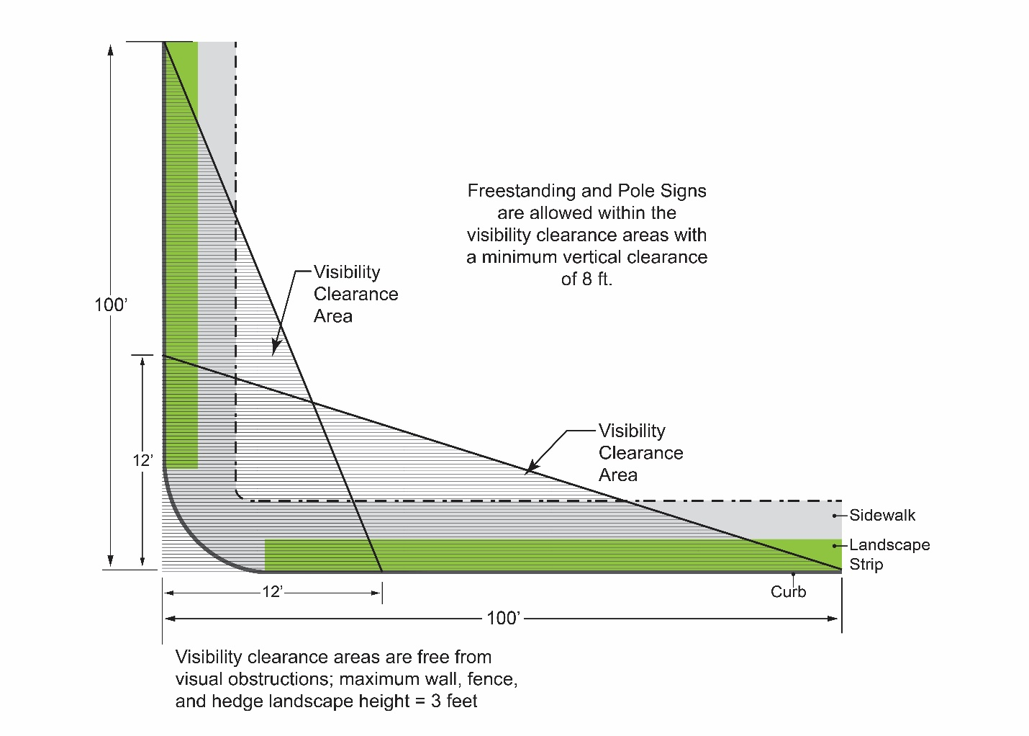

SECTION 24: That Figure 3-3, “Setback Measurements” of Chapter 18.30, “Site Planning and General Development Standards”, of Title 18, “Zoning”, of the SCCC is hereby amended to read as follows:
“Figure 3-3. Setback Measurements
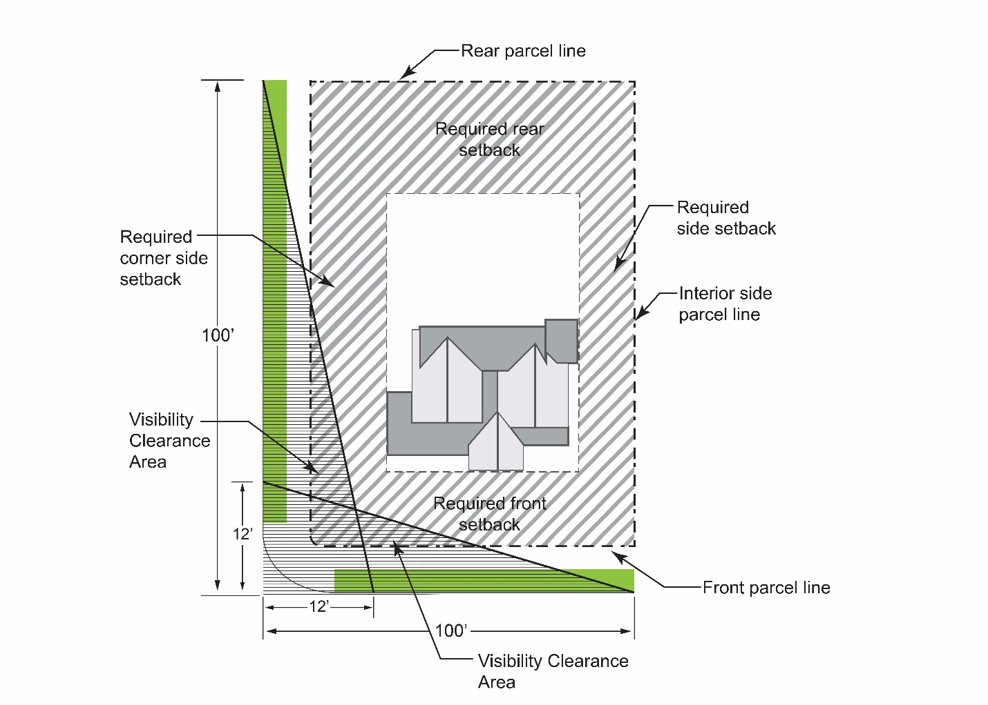

SECTION 25: That Subsection B (“No Parking Required Near Major Transit Stops”) of Section 18.38.030 (“Off-Street Vehicle Parking Requirements”) of Chapter 18.38 (“Off-Street Parking Regulations and Design Standards”) of Title 18 (“Zoning”) of “The Code of the City of Santa Clara, California” (“SCCC”) is hereby amended to read as follows:
“B. No Parking Required Near Major Transit Stops. Notwithstanding any other provision of this Code, no parking is required for any use within one-half mile of a major transit stop, unless the Director of Community Development makes any of the following written findings, supported by substantial evidence, within 30 days of an application becoming complete, in which case the City’s standard parking requirements shall apply:
- Not imposing the City’s parking requirements would have a substantial negative impact on the City’s ability to meet its share of the regional housing need in accordance with Government Code Section 65584 for low- and very low income households;
- Not imposing the City’s parking requirements would have a substantial negative impact on the City’s ability to meet any special housing needs for the elderly or persons with disabilities identified in the Housing Element’s analysis required by Government Code Section 65583(a)(7); or
- Not imposing the City’s parking requirements would have a substantial negative impact on the existing residential or commercial parking within one-half mile of the development project.”

SECTION 26: That Paragraph 1, “Parking within Sight Distance Triangle”, of Subsection A, “Location and Design”, of Section 18.38.060, “General Parking Standards” of Chapter 18.38, “Off-Street Parking Regulations and Design Standards”, of Title 18, “Zoning”, of the SCCC, is hereby retitled “Parking within the Vision Clearance Area”, and amended to read:
“1. Parking within Sight Distance Triangle the Vision Clearance Area. Parking is prohibited within the required sight distance triangle vision clearance area (Section 18.30.030).”
SECTION 27: That Figure 3-13, “Motorcycle Parking Configuration”, through Figure 3-30, “Window Sign”, of Article 3, “Site Planning and General Development Standards,” of Title 18, “Zoning”, of the SCCC, are hereby renumbered as Figure 3-14 through 3-31, respectively.

SECTION 27: That a new Subsection D, “Single- and Two-Family Dwellings”, of Section 18.38.060, “General Parking Standards” of Chapter 18.38, “Off-Street Parking Regulations and Design Standards”, of Title 18, “Zoning”, of the SCCC, is amended to read:
“D. Single- and Two-Family Dwellings. Off-street parking and driveways for single-family attached and attached dwellings, and two-family attached dwellings shall meet the following requirements:
1. All vehicles, including motor vehicles, trailers, or vessels which are inoperable or incapable of movement under their own power and/or without current registration, shall be stored entirely within an enclosed structure and shall not be parked or stored in any required front yard within a residential zone.
2. Each parking space shall be at least 8.5 feet wide by 18 feet deep.
3. The minimum driveway width shall be 10 feet.
4. Minimum driveway length between parking and any public right-of-way line, not including alleys, shall be a minimum of 20 feet.
5. Parking shall be provided on the same lot as the dwelling.
6. Parking shall not be located within the required setbacks, except for Approved accessory structures may be allowed in setbacks where authorized by Section 18.60.030 (Accessory Structures and Uses).
7. The required parking shall not be located within the required yard area, except the required parking may be provided in the rear yard only when an alley is available for access.
8. All vehicles are required to be parked on a continuously paved surface. Driveways and driveway approaches shall be paved.
9. For single family dwellings, the interior dimensions of the garage or carport are required to be 20’ x 20’. See Figure 3-13.
10. All vehicles, boats, and trailers, in the required front yard shall be parked perpendicular to the street, unless the legal driveway configuration dictates otherwise.
Figure 3-13
Single-Family Garage Dimensions.
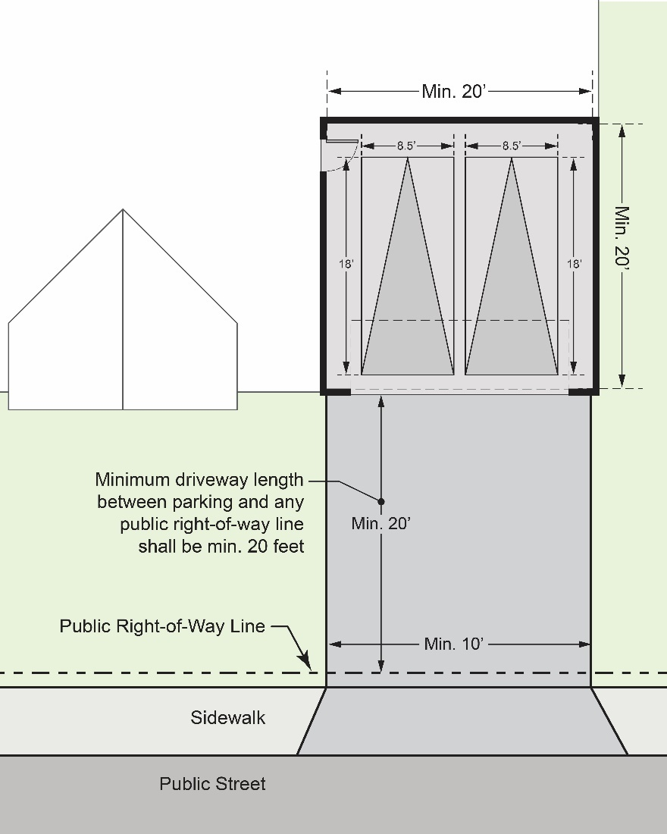”
SECTION 28: That the definition of the term, “Temporary Sign” in Section 18.42.030, “Definitions”, of Chapter 18.42, “Sign Standards”, of Title 18, “Zoning”, of the SCCC is hereby amended to read as follows:
“Temporary Sign. A sign intended to be displayed for a limited period only, including, but not limited to, any sign, display board, handbill, poster, banner, pennant, streamer, whirligig, valance or advertising display constructed of plastic, paper, cloth, canvas, light fabric, cardboard, wallboard or other light materials (with or without structural frame). of time.”
SECTION 29: That Paragraph 3 of Subsection A, “Exempt Signs”, of Section 18.42.070, “Exempt Signs”, of Chapter 18.42, “Sign Standards”, of Title 18, “Zoning”, of the SCCC is hereby amended to read as follows:
“3. Holiday displays and decorations, only when not creating a traffic hazard or located within any visual setback area in the sight distance triangle vision clearance area;”
SECTION 30: That Paragraph 1, “On-site Subdivision Signs” of Subsection C, “Temporary On-site Commercial Signs”, of Section 18.42.100, “Temporary Signs”, of Chapter 18.42, “Sign Standards”, of Title 18, “Zoning”, of the SCCC is hereby amended to read as follows:
“1. On-site Subdivision Signs.
a. Sign Permits for on-site subdivision signs may be issued at any time after recordation of the final subdivision map and shall be removed following the sale of the final home or parcel. All signs shall then be removed upon expiration of the Sign Permit, unless renewal of the permit for a period of not more than one additional 12-month period is approved by the Director; and
(1) On-site subdivision signs shall be continuously maintained, not adversely affect the use and appearance of existing structures or landscaping and shall not create hazardous traffic conditions. On-site subdivision signs are subject to all the following standards: The construction of any sign shall be in strict compliance with the provisions of this Chapter and all other laws of the City.
(2) All signs shall be removed from the property prior to the sale of the final parcel.
(3) All signs shall be located on the subdivision site which they advertise.
(4) Signs shall not exceed 10 feet in height.
(5) No sign shall exceed 32 square feet in area.
(6) Identification signs are allowed provided no more than one sign for every five parcels with a maximum of four signs. Signs shall not exceed six square feet in area.
(7) If the on-site subdivision sign is within the sight distance triangle vision clearance area of any driveway or intersection, it shall not exceed two feet, six inches in height.
(8) Signs are allowed on parcels with a model home, provided they do not exceed four in number and six square feet each in area. Signs shall be removed immediately after the sale of the final parcel or home.
(9) Illuminated residential signs are prohibited.”
SECTION 31: That Subsection C, “Directional and Directory Signs”, of Section 18.42.120, “Standards for Specific Sign Types”, of Chapter 18.42, “Sign Standards”, of Title 18, “Zoning”, of the SCCC is hereby amended to read as follows:
“C. Directional and Directory Signs.
1. Directional Signs. See Figure 3-20 (Directional Sign).
a. Directional signs shall not be counted against allowable sign area, unless the signs include business logo, name, or advertising. If a business logo, name, or advertising is a component of a directional sign, then the area of the sign devoted to the logo, name, or advertising will be counted toward the allowable sign square footage.
b. If the directional sign is located within the sight distance triangle vision clearance area of any driveway or intersection, it shall not exceed three feet in height.
c. Directional signs shall not exceed six square feet of sign area.
d. External illumination is permitted.
e. Freestanding signs shall not be located on the subject property and not within a dedicated utility easement.
//
//
//

Figure 3-20
Directional Sign
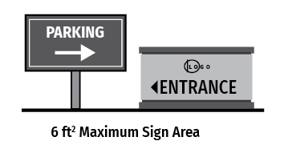
2. Directory Signs. See Figure 3-21 (Directory Sign).
a. Directory signs shall not be counted in the allowable sign area based on frontage, unless the business logo, name, or advertising is used. If a logo is a component of a directory sign, then the square footage of the portion of the sign that is advertising the specific establishment will be counted toward the total allowable square footage of sign area.
b. Directory signs shall not exceed 16 square feet of sign area.
c. Directory signs shall not exceed six feet in height.
d. If the directory sign is located within the sight distance triangle vision clearance area of any driveway or intersection, it shall not exceed three feet in height.
e. Directory signs shall be placed in a landscaped bed and shall have a minimum of two square feet of landscaping for every square foot of sign area measured at the base of the sign.
f. External or internal illumination is permitted. External illumination by downward lighting is prohibited.
Figure 3-21
Directory sign
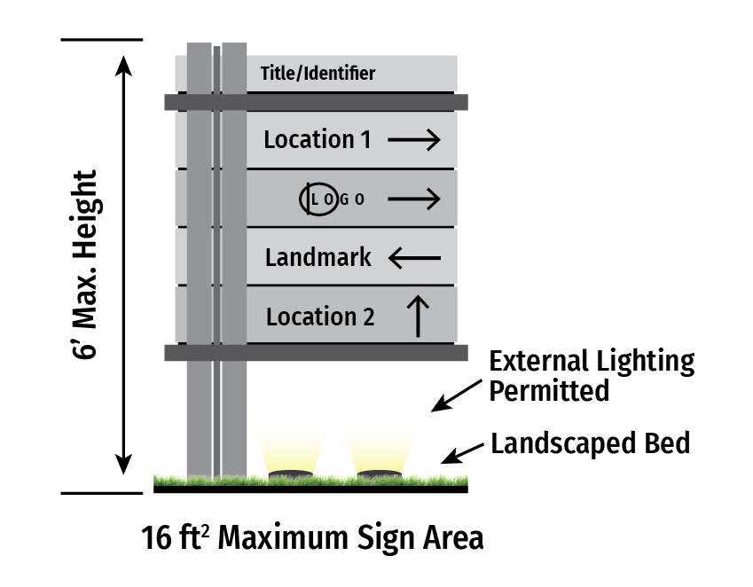
SECTION 32: That of Subsection E, “Freestanding and Monument Signs”, of Section 18.42.120, “Standards for Specific Sign Types”, of Chapter 18.42, “Sign Standards”, of Title 18, “Zoning”, of the SCCC is hereby amended to read as follows:
“E. Freestanding and Monument Signs.
1. Freestanding Signs.
a. A freestanding sign is allowed by the provisions of this Chapter provided the freestanding sign complies with the provisions of this Chapter.
b. Freestanding signs may not exceed 150 square feet of sign area per individual sign (a double-sided freestanding sign would equal 75 square feet per side).
c. Freestanding signs not exceeding six feet in height and thirty 30 square feet in total sign area are allowed, at a minimum setback of four feet behind parcel line.
d. Freestanding signs shall not exceed a height of 20 feet.
e. If the freestanding sign is within the sight distance triangle vision clearance area of any driveway or intersection, it shall not exceed three feet in height.
f. Freestanding signs shall not be located within a dedicated utility easement.
g. To ensure the readability, the minimum letter size required on all freestanding signs shall be 10 inches. Sign copy shall not be located closer than one half-letter height to the sign edge or other line of copy.
h. External illumination with a hooded floodlight is prohibited. Internal illumination is permitted.
i. Freestanding signs shall be placed in a landscaped bed and shall have a minimum of two square feet of landscaping for every square foot of sign area measured at the base of the sign.
2. Monument Signs. See Figure 3-22 (Monument Sign).
a. A Monument sign is allowed by the provisions of this Chapter provided the monument sign complies with the provisions of this Chapter.
b. Monument signs may not exceed 100 square feet of sign area per individual sign (a double-sided freestanding sign would equal 50 square feet per side).
c. Monument signs not exceeding four feet in height and thirty (30) 20 square feet in total sign area are allowed, at a minimum setback of four feet behind parcel line.
d. Monument signs shall not exceed a height of 12 feet.
e. If the monument sign is within the sight distance triangle vision clearance area of any driveway or intersection, it shall not exceed three feet in height.
f. Monument signs shall not be located within a dedicated utility easement.
g. To ensure the readability, the minimum letter size required on all monument signs shall be six inches. Sign copy shall not be located closer than one half-letter height to the sign edge or other line of copy.
h. External illumination with a hooded floodlight is permitted. Internal illumination is permitted.
i. Monument signs shall be placed in a landscaped bed and shall have a minimum of two square feet of landscaping for every square foot of sign area measured at the base of the sign.
Figure 3-22
Monument Signs
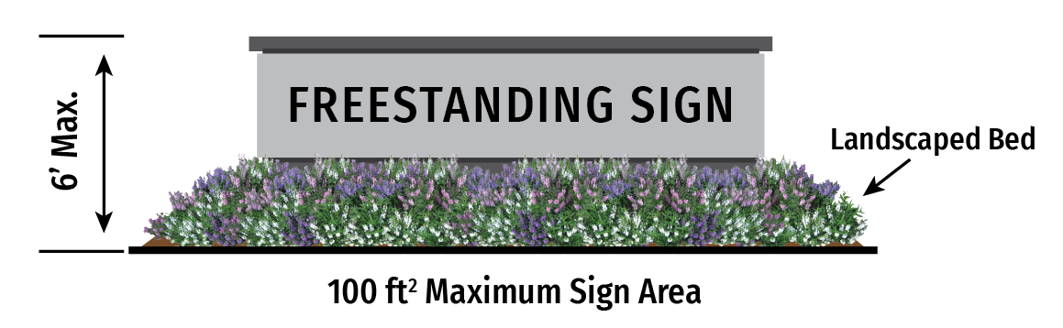

SECTION 33: That Paragraph 3, “Service Station Gas Price Sign”, of Subsection I, “Price and Menu Boards”, of Section 18.42.120, “Standards for Specific Sign Types”, of Chapter 18.42, “Sign Standards”, of Title 18, “Zoning”, of the SCCC is hereby amended to read as follows:
“3. Service Station Gas Price Sign. See Figure 3-27 (Service Station Gas Price Sign).
a. Service station gas price sign shall not exceed 25 square feet of sign area for each side of a double-sided sign.
b. The service station gas price sign is not allowed to be located within the sight distance triangle vision clearance area of any driveway or intersection.
c. No more than two service station gas price signs are permitted per service station. Each of the allowed two service station gas price signs is permitted to have two sides.
d. External illumination is prohibited.
e. Static LED price figure displays are permitted.
f. Service Station Gas Price Sign shall be placed within a landscaped bed and shall have two square feet of landscaping for every square foot of sign area measured at the base of the menu board.
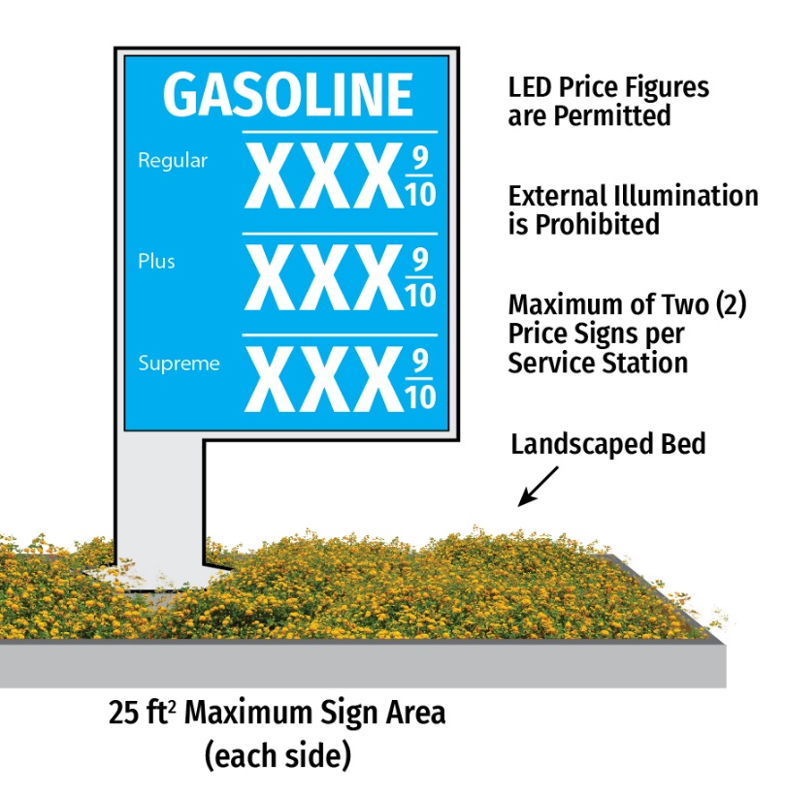
Figure 3-28
Service Station Gas Price Sign”

SECTION 34: That Paragraph 2, “Additional development standards for detached ADUs greater than one story and 18 feet in height”, of Subsection E, “Development Standards for ADUs and JADUs on Single-Family, Multi-Family, and Mixed-Use Parcels”, of Section 18.60.020, “Accessory Dwelling Units”, of Chapter 18.60, “Standards for Specific Land Uses”, of Title 18, “Zoning” of the SCCC is hereby amended to read as follows:
“2. Additional development standards for detached ADUs greater than one story and 18 feet in height.
a. Height limit: 1.5 stories, 25 feet
b. Setback, rear, one-story elements: 4 feet.
c. Setback, rear, multi-story elements: 15 feet.
d. Setback, side, one- and one-and-a-half-story elements: 4 feet
e. Setback, side, multi two-story elements: 9 feet
f. Maximum width for dormers: 40 percent of the subject building elevation.
g. Egress windows: Egress windows shall face the primary residence, as opposed to the neighboring properties.”
SECTION 35: That Subsection G, “ADUs subject to Parcel Coverage, Floor Area Ratio (FAR), and Open Space Requirements”, of Section 18.60.020, “Accessory Dwelling Units”, of Chapter 18.60, “Standards for Specific Land Uses”, of Title 18, “Zoning” of the SCCC is hereby amended to read as follows:
“G. ADUs subject to Parcel Coverage, Floor Area Ratio (FAR), and Open Space Requirements. ADUs and JADUs are subject to front setback requirements, parcel coverage, FAR, and open space requirements, but only to the extent that such requirements would still allow for:
“1. A detached or attached ADU of 800 square feet, that is at least 18 feet in height with four-foot rear yard and four-foot side yard setbacks. Setbacks and side yard setbacks to be constructed in compliance with all other applicable City development standards.”
2. An attached ADU, staying within the existing Building Space, and constructed in compliance with all other applicable City development standards.

SECTION 36: That Subsection A, “Purpose”, of Section 18.60.250, “Short-Term Rentals of Residential Property”, of Chapter 18.60, “Standards for Specific Land Uses”, of Title 18, “Zoning” of the SCCC is hereby amended to read as follows:
“A. Purpose. The purpose of this Section is to allow limited short-term rental of residential property, which are rentals of 30 days or less in length, while preserving housing stock and the residential character of neighborhoods, through the use of registration, regulations, and standards, in order to reduce potential impacts on adjacent properties and to ensure the collection of Transient Occupancy Taxes under SCCC Chapter 3.25.”

SECTION 37: That Paragraph 6 (“Student Housing”) of Subsection A (“Resident Requirements”) of Section 18.64.020 (“Eligibility for Bonus, Incentives, or Concessions”) of Chapter 18.64 (“Density Bonus and Affordable Housing”) of Title 18 (“Zoning”) of the SCCC is hereby amended to read as follows:
“6. Student Housing. Twenty percent of the dwelling units are for lower income students in a student housing development, subject to the provisions specified in Subsection 18.64.030.A.6 (Bonus for Student Housing Development), below, and which meets the following requirements:
- All units in the student housing development will be used exclusively for undergraduate, graduate, or professional students who are currently enrolled in at least six credit-hours, or who within the past six months were enrolled in at least six credit-hours, at an institution of higher education accredited by the Western Association of Schools and Colleges or the Accrediting Commission for Community and Junior Colleges. In order to be eligible under this Subparagraph, the developer shall, as a condition of receiving a Certificate of Occupancy, provide evidence to the City that the developer has done either of the following:
  - entered into an operating agreement or master lease with one or more institutions of higher education for the institution(s) to occupy all units of the student housing development with students or recent former students from such institution(s). Such an operating agreement or master lease is not violated or breached if, in any subsequent year, there are not sufficient students enrolled or previously enrolled in an institution of higher education to fill all units in the student housing development; or
  - Established a system for confirming its renters' status as students to ensure that all units of the student housing development are occupied with students from an institution of higher education.
- The applicable units in the student housing development for lower income students will be used for, and occupied by, lower income students. For purposes of this clause, “lower income students” means students who have a household income and asset level that does not exceed the level for Cal Grant A or Cal Grant B award recipients as specified in subdivision (k) of Section 69432.7 of the Education Code. The eligibility of a student under this subparagraph shall be verified by an affidavit, award letter, or letter of eligibility provided by the institution of higher education that the student is enrolled in, or by the California Student Aid Commission that the student receives or is eligible for financial aid, including an institutional grant or fee waiver, from the college or university, the California Student Aid Commission, or the federal government;
- The rent provided in the applicable units of the development for lower income students shall be calculated at 30 percent of 65 percent of the area median income for a single-room occupancy unit type.
- The development will provide priority for the applicable affordable units for lower income students experiencing homelessness. A homeless service provider, as defined in paragraph (3) of subdivision (d) of Section 103577 of the Health and Safety Code, or institution of higher education that has knowledge of a person’s homeless status may verify a person’s status as homeless for purposes of this Subparagraph.
- No rental bed reserved for lower income students shall be tied to a specific bedroom. No property management policy shall prevent a lower income student from sharing a room or unit with a non-lower income student.”
SECTION 38: That Paragraph 4 (“Moderate Income Households in a Common Interest Development”) of Subsection A (“Resident Requirements”) of Section 18.64.020 (“Eligibility for Bonus, Incentives, or Concessions”) of Chapter 18.64 (“Density Bonus and Affordable Housing”) of Title 18 (“Zoning”) of the SCCC is amended to read as follows:
“4. Moderate Income Households in a For-Sale Development. Ten percent of the dwelling units in a for-sale development are for persons and families of moderate income, as defined in Health and Safety Code Section 50093, provided that all units in the development are offered to the public for purchase;”

SECTION 39: That a new Subsection G is hereby added to 18.64.020 (“Eligibility for Bonus, Incentives, or Concessions”) of Chapter 18.64 ( “Density Bonus and Affordable Housing”) of Title 18 (“Zoning”) of the SCCC to read as follows:
“G. Residential Care Facilities for the Elderly. A Residential Care Facility for the Elderly, as defined in Section 1569.2 of the Health and Safety Code, which meets the residency requirements of subsection A and the eligibility requirements of Section 18.64.030, qualifies as a housing development subject to this Chapter.”

SECTION 40: That Table 4-5 (“Bonus for Lower Income Households”) of Paragraph 1 (“Bonus for Lower Income Household Units”) of Subsection A (“Density Bonus”) of Section 18.64.030 (“Allowed Density Bonuses”) of Chapter 18.64 (“Density Bonus and Affordable Housing”) of Title 18 (“Zoning”) of the SCCC is amended to read as follows:
Table 4-5
Bonus for Lower Income Households
Percentage of Low-Income Units Proposed | Percentage of Density Bonus
10 | 20
11 | 21.5
12 | 23
13 | 24.5
14 | 26
15 | 27.5
16 | 29
17 | 30.5
18 | 32
19 | 33.5
20 | 35
21 | 38.75
22 | 42.5
23 | 46.25
24 | 50

SECTION 41: That Table 4-6 (“Bonus for Very Low-Income Households”) of Paragraph 2 (“Bonus for Very-Low Income Household Units”) of Subsection A (“Density Bonus”) of Section 18.64.030 (“Allowed Density Bonuses”) of Chapter 18.64 (“Density Bonus and Affordable Housing”) of Title 18 (“Zoning”) of the SCCC is amended to read as follows:
Table 4-6
Bonus for Very-Low Income Households
Percentage of Very-Low Income Units Proposed | Percentage of Density Bonus
5 | 20
6 | 22.5
7 | 25
8 | 27.5
9 | 30
10 | 32.5
11 | 35
12 | 38.75
13 | 42.5
14 | 46.25
15 | 50

SECTION 42: That Paragraph 4 (“Bonus for Moderate Income Units in Common Interest Development”) and Table 4-7 (“Bonus for Moderate-Income Households”) of Subsection A (“Density Bonus”) of Section 18.64.030 (“Allowed Density Bonuses”) of Chapter 18.64 (“Density Bonus and Affordable Housing”) of Title 18 (“Zoning”) of the SCCC is amended to read as follows:
“4. Bonus for Moderate Income Units in a Common-Interest For-Sale Development. A housing development that is eligible for a bonus in compliance with the criteria specified in Subparagraph 18.64.020.A.4 (Moderate Income Households in a Common-Interest For-Sale Development) shall be entitled to a density bonus calculated in compliance with Table 4-7 (Bonus for Moderate-Income Households):
Table 4-7
Bonus for Moderate-Income Households
Percentage of Moderate-Income Units Proposed | Percentage of Density Bonus
10 | 5
11 | 6
12 | 7
13 | 8
14 | 9
15 | 10
16 | 11
17 | 12
18 | 13
19 | 14
20 | 15
21 | 16
22 | 17
23 | 18
24 | 19
25 | 20
26 | 21
27 | 22
28 | 23
29 | 24
30 | 25
31 | 26
32 | 27
33 | 28
34 | 29
35 | 30
36 | 31
37 | 32
38 | 33
39 | 34
40 | 35
41 | 38.75
42 | 42.5
43 | 46.25
44 | 50

SECTION 43: That Table 4-8 (“Basic Bonus”) of subparagraph a (“Basic Bonus”) of Paragraph 12 (“Density Bonus for Land Donation”) of Subsection A (“Density Bonus”) of Section 18.64.030 (“Allowed Density Bonuses”) of Chapter 18.64 (“Density Bonus and Affordable Housing”) of Title 18 (“Zoning”) of the SCCC is hereby renumbered as Table 4-11.
SECTION 44: That Paragraph 6 (“Bonus for Student Housing Development with Low-Income Units”) of Subsection A (“Density Bonus”) of Section 18.64.030 (“Allowed Density Bonuses”) of Chapter 18.64 (“Density Bonus and Affordable Housing”) of Title 18 (“Zoning”) of the SCCC, as well as subparagraph a, including clauses 1 through 4, and subparagraph b, are hereby deleted and replaced with the following:
“6. Bonus for Student Housing Development with Low-Income Units. A housing development that is eligible for a bonus in compliance with the criteria specified in Subparagraph 18.64.020.A.6 (Student Housing) shall be entitled to a density bonus calculated in compliance with Table 4-8 (Bonus for Low-Income Student Housing). For purposes of calculating a density bonus granted pursuant to this paragraph, the term “unit” as used in this section means one rental bed and its pro rata share of associated common area facilities:
Table 4-8
Bonus for Low-Income Student Housing
Percentage of Low Income Units Proposed | Percentage of Density Bonus
20 | 35
21 | 38.75
22 | 42.5
23 | 46.25
24 | 50

SECTION 45: That a new Subsection F is hereby added to Section 18.64.030 (“Allowed Density Bonuses”) of Chapter 18.64 (“Density Bonus and Affordable Housing”) of Title 18 (“Zoning”) of the SCCC to read as follows:
“F. Additional Density Bonus Pursuant to AB 1287 (2023). A project that provides sufficient affordable units to qualify for a 50% density bonus pursuant to paragraphs 1, 2, or 4 of subsection A, which also commits to providing additional affordable units, shall be eligible for an additional density bonus as follows, unless a lesser percentage is proposed by the applicant:
- Additional Bonus for Very-Low Income Units. A housing development that provides additional units for Very Low-Income Households meeting the requirements of Section 18.64.020.A.2 shall be entitled to an additional density bonus calculated in compliance with Table 4-9 (Additional Bonus for Very Low-Income Households):
Table 4-9
Additional Bonus for Very Low-Income Households
Additional Percentage of Very Low-Income Units Proposed | Percentage of Additional Density Bonus
5 | 20
6 | 23.75
7 | 27.5
8 | 31.25
9 | 35
10 | 38.75

- Additional Bonus for Moderate-Income Units. A housing development that provides additional for-sale units for Moderate Income Households meeting the requirements of Section 18.64.020.A.4 shall be entitled to an additional density bonus calculated in compliance with Table 4-10 (Additional Bonus for Moderate-Income Households):
Table 4-10
Additional Bonus for Moderate-Income Households
Percentage of Additional Moderate-Income Units Proposed | Percentage of Additional  Density Bonus
5 | 20
6 | 22.5
7 | 25
8 | 27.5
9 | 30
10 | 32.5
11 | 35
12 | 38.75
13 | 42.5
14 | 46.25
15 | 50

SECTION 46: That Subsection B (“Number of Incentives”) of Section 18.64.040 (“Allowed Incentives or Concessions”) of Chapter 18.64 (“Density Bonus and Affordable Housing”) of Title 18 (“Zoning”) of the SCCC is amended to read as follows:
“B. Number of Incentives. The applicant shall receive the following number of incentives or concessions:
- One Incentive or Concession. One incentive or concession for a project that includes at least 10 percent of the dwelling units for lower income households, at least five percent for very low-income households, at least 10 percent for persons and families of moderate income in a common interest for-sale development, or at least 20 percent for lower income students in a student housing development.
- Two Incentives or Concessions. Two incentives or concessions for a project that includes at least 20 17 percent of the dwelling units for lower income households, at least 10 percent for very low-income households, at least 20 percent for persons and families of moderate income in a common interest for-sale development, or at least 23 percent of the total units for lower income students in a student housing project.
- Three Incentives or Concessions. Three incentives or concessions for a project that includes at least 30 24 percent of the dwelling units for lower income households, at least 15 percent for very low-income households, or at least 30 percent for persons and families of moderate income in a common interest for-sale development.
- Four Incentives or Concessions. Four incentives or concessions for projects that include at least 16 percent of the units for very low income households or at least 45 percent for persons and families of moderate income in a development in which the units are for sale.
- Five Incentives or Concessions. Five incentives or concessions for a 100 percent affordable project that is eligible for a bonus under paragraph 18.64.020.A.7. In addition, if such a project is located within one-half mile of a major transit stop, or is located in a very low vehicle travel area as defined in Government Code Section 65915, the applicant shall also receive a height increase of up to three additional stories, or 33 feet.”
SECTION 47: That Subsection B (“Number of Parking Spaces Required”) of Section 18.64.050 (“Parking Requirements in Density Bonus Projects”) of Chapter 18.64 (“Density Bonus and Affordable Housing”) of Title 18 (“Zoning”) of the SCCC is hereby amended to read as follows:
“B. Number of Parking Spaces Required.
- Default Parking Ratio. At the request of the applicant, the City shall not require vehicular parking for a project that complies with the requirements of Section 18.64.020 (Eligibility for Bonus, Incentives, and Concessions), above, inclusive of handicapped and guest parking, that exceeds the following ratios:
a. Zero or one bedroom: One on-site parking space per unit.
b. Two or three bedrooms: Two 1.5 on-site parking spaces per unit.
c. Four or more bedrooms: Two- and one-half on-site parking spaces per unit.
d. Student Housing Developments: Zero parking spaces.
2. Notwithstanding paragraph 1, above, if a development is located within one-half mile of a major transit stop and there is unobstructed access to the major transit stop from the development, then, upon the request of the applicant, the City shall not impose a vehicular parking requirement.”
3. Notwithstanding paragraph 1, above, if a development consists solely of rental units, exclusive of a manager’s unit(s), with an affordable housing cost to lower income families, as specified in Health and Safety Code Section 50052.5, then, upon the request of the applicant, the City shall not impose a vehicular parking ratio, if the development meets any of the following conditions:
a. The development is located within one-half mile of a major transit stop, and there is unobstructed access to the major transit stop from the development.
b. The development is a for-rent housing development for individuals who are 55 years of age or older that complies with Sections 51.2 and 51.3 of the Civil Code, and the development has either paratransit service or unobstructed access, within one-half mile, to fixed bus route service that operates at least eight times per day.
c. The development is a special needs housing development, as defined in Health and Safety Code Section 51312, and the development has either paratransit service or unobstructed access, within one-half mile, to fixed bus route service that operates at least eight times per day.
d. The development is a supportive housing development, as defined in Health and Safety Code Section 50675.14.
4. Parking Study. Notwithstanding paragraphs 2. and 3., above, if the City, or an independent consultant, has conducted an areawide or citywide parking study in the last seven years, then the City may impose a higher vehicular parking ratio not to exceed the ratio described in Subparagraph B.1 (Default Parking Ratio) above, based upon substantial evidence found in the parking study, that includes, but is not limited to, an analysis of parking availability, differing levels of transit access, walkability access to transit services, the potential for shared parking, the effect of parking requirements on the cost of market-rate and subsidized developments, and the lower rates of car ownership for low-income and very low income individuals, including seniors and special needs individuals. The City shall pay the costs of any new study. The City shall make findings, based on a parking study completed in compliance with this Paragraph, supporting the need for the higher parking ratio.”
SECTION 48: That Paragraph 2 (“Moderate Income Dwelling Units in Common Interest Developments – 10 Years”) of Subsection A (“Duration of Affordability”) of Section 18.64.070 (“Continued Affordability”) of Chapter 18.64 (“Density Bonus and Affordable Housing”) of Title 18 (“Zoning”) of the SCCC is hereby amended to read as follows:
“2. Moderate Income Dwelling Units in Common Interest For-Sale Developments – 10 Years. The continued availability of moderate-income dwelling units in a common interest for-sale development shall be maintained for a minimum of 10 years, or a longer time if required by City policy or ordinance.”
SECTION 49: That Chapter 18.66 (“Wireless Telecommunications Facilities”) of Title 18 (“Zoning”) of “The Code of the City of Santa Clara, California” (“SCCC”) is hereby amended to read as follows:

"18.66.010 – Purpose and Applicability
- Purpose. This Chapter establishes locational, developmental, and operational standards and permit requirements consistent with Federal law to: regulate the placement and design of wireless telecommunication facilities so as to preserve the unique visual character of the City, promote the aesthetic appearance of the City, and to ensure public safety and welfare; and to acknowledge and provide the community benefit associated with the provision of advanced wireless telecommunication services within the City.
- Applicability. The requirements of this Chapter shall apply to all wireless telecommunications facilities located within the City, except for the following:
  - Telecommunications facilities placed in the public rights of way, which are governed by Chapter 12.65 (Telecommunications Facilities In Public Rights-of-Way).
  - Handheld devices (i.e., cell phones, business-band mobile radios, walkie-talkies, cordless telephones, garage door openers), and similar devices.
  - A consumer-end antenna described in 47 C.F.R. § 1.4000, including but not limited to a satellite dish that is one meter (39 inches) or less in diameter or diagonal measurement located in a residential or mixed-use zone, subject to the following :
    - If mounted on a mast, the antenna is mounted no higher than needed to receive or transmit an acceptable quality signal and in no event higher than 12 feet above roofline; or
    - Consumer-end antennas proposed for properties located on the Historic Resources Inventory or the California Register of Historic Resources shall apply to the Director for a Significant Property Alteration (SPA) permit for small projects.
  - A satellite earth station (SES) antenna of two meters (78 inches) or less in diameter or diagonal measurement, located in a non-residential or mixed-use zone, that is designed to transmit or receive radio communications by satellite or terrestrial communications antenna. These antennas shall require a Building Permit and approval of the placement by the Director to ensure safety, and to avoid tripping hazards and the creation of an attractive nuisance, shall be placed whenever possible, on the top of structures as far from the edge of rooftops towards the rear of the structure to minimize the view from the public rights-of-way.
  - Wireless telecommunication facilities and/or components of these facilities used solely for public safety purposes, installed and operated by authorized public safety agencies (e.g., City 911 emergency services, police, and/or fire department, first responder medical services, hospitals, etc.), are exempt from the provisions of this Chapter.

18.66.020 – Definitions
The following definitions shall apply to this Chapter.
Antennas. An apparatus designed for the purpose of emitting or receiving radiofrequency (RF) radiation, to be operated or operating from a fixed location pursuant to Federal Communications Commission (Commission or FCC) authorization, for the transmission or reception of writing, signs, signals, data, images, pictures, and sounds of all kinds. For purposes of this definition, the term “antenna” does not include an unintentional radiator, mobile station, or device authorized under 47 CFR Subpart G, as may be amended
Base Station. The term “base station” shall have the same meaning as in 47 C.F.R. Section 1.6100, as may be amended.
Co-location or Co-Located Facility. The mounting or installation of transmission equipment on an existing wireless tower or base station for the purpose of transmitting and/or receiving radio frequency signals for communication purposes.
Concealed Facility. A wireless telecommunications facility that is integrated as an architectural feature of an existing supporting structure or any new wireless telecommunications facility that is camouflaged or concealed so that the presence of the facility is either: (1) virtually imperceptible to the casual observer, such as an antenna behind louvers on a building, or inside a steeple or similar structure; or (2) camouflaged so as to blend in with its surroundings to such an extent that, to a casual observer, it does not appear to be a wireless telecommunications facility. To qualify as a concealed facility, the facility in question must match the character of its surroundings and the type of item that it is mimicking in size, scale, shape, dimensions, color, materials, function, and other attributes as closely as possible. The elements that make a facility a concealed facility are concealment elements.
Concealment Element. Any design feature, including but not limited to painting, landscaping, shielding requirements and restrictions on location, proportions, or physical dimensions in relation to the surrounding area or supporting structures that are intended to and do make a wireless telecommunications facility or its supporting structure less visible or obtrusive to the casual observer.
Consumer-end antennas. Antennas which are either: subject to the Federal Communications Commission (FCC) Over-the-Air-Receiving Devices Rule (47 C.F.R. § 1.4000) placed at an end user’s premises used solely for the purpose of the provision of services to that end user; or solely for amateur radio communications.
DAS. Distributed Antenna System.
Dish Antenna. Any device incorporating a reflective surface that is solid, open mesh, or bar configured that is shallow dish, cone, horn, or cornucopia-shaped and is used to transmit and/or receive electromagnetic signals.
Eligible Facilities Request. As defined in 47 C.F.R. § 1.6100(b)(3), as may be amended.
FCC. Federal Communications Commission, or the Federal successor agency, responsible for regulating telecommunications in the United States.
Monopole. A single unguyed pole-structure erected on the ground (e.g., bare ground, concrete slab or footing), to support one or more wireless telecommunication antennas and connecting appurtenances.)
Radiofrequency (RF) Radiation. Radiation from the portion of the electromagnetic spectrum with frequencies between 3 kilohertz (3 kHz) and 300 gigahertz (GHz), including microwaves, television VHF and UHF signals, radio signals, and low to ultra-low frequencies.
Radome. A dome or other structure protecting radar equipment.
Repeater. Small receiver/relay transmitter of relatively low power output designed to provide service to areas that are not able to receive adequate coverage directly from a base or primary station. “Repeater” as used in this ordinance does not include Wi-Fi range extenders and boosters intended for in-home use.
Slimline Monopole. A monopole with a maximum allowable height of 75 feet, including the antenna, that uses antennas shielded by a radome projecting less than three feet from the center of the pole,.
Stealth Technology/Techniques. Camouflaging methods applied to wireless telecommunication towers, antennas and/or other facilities, which result in the facilities appearing to be something else (for example, a clock tower).
Substantial Change. A modification to an eligible support structure meeting the criteria of 47 C.F.R. § 1.6100(b)(7), as may be amended.
Transmission Equipment. Equipment that facilitates transmission of any FCC-licensed or authorized wireless service, as described in more detail in 47 C.F.R. § 1.6100(b)(8), as may be amended.
Visual Impact. An adverse effect on the visual and/or aesthetic environment. This may derive from blocking of a view, or introduction of elements that are incompatible with the scale, texture, form or color of the existing natural or human-made landscape, including the existing character surrounding the proposed wireless telecommunication facility site.
Wireless Telecommunication (or Telecommunications) Facility. A facility at a fixed location, including all associated equipment, which supports the FCC-licensed transmission and/or receipt of electromagnetic/radio signals. Wireless telecommunication facilities include cellular radiotelephone service facilities, personal communications service facilities (including wireless Internet), specialized mobile radio service facilities, and commercial paging service facilities. Components of these types of facilities can consist of the following: antennas, repeaters, microwave dishes, horns, and other types of equipment for the transmission or receipt of signals, telecommunication towers or similar structures supporting the equipment, equipment structures, parking area, and other accessory development.
Wireless Telecommunication Tower (Cell Tower/Tower). Any structure built for the sole or primary purpose of supporting any FCC-licensed or authorized antennas and their associated facilities. It includes, but is not limited to, masts, poles, monopoles, guyed towers, lattice towers, and freestanding towers.
18.66.030 – Exemptions from Discretionary Permits
The following wireless telecommunication facilities are exempt from the discretionary permit requirements of this Chapter. However, each wireless telecommunication facility shall comply with all applicable requirements of State and Federal law, the remaining requirements of this Chapter, and the issuance of a nondiscretionary Zoning Clearance.
- Replacement or modification of a previously allowed facility or equipment, or collocation of new transmission equipment, that does not substantially change the physical dimensions of the existing facility or equipment and qualifies as an “eligible facilities request” under 47 CFR § 1.6100, as may be amended.
- Temporary mobile wireless facilities intended or used to provide wireless services on a temporary or emergency basis, such as a large-scale special event in which more users than usual gather in a confined location or when a disaster requires additional service capabilities. Temporary wireless telecommunications facilities include, without limitation, cells on wheels (COW), sites on wheels (SOW), cells on light trucks (COLTs), or other similar wireless telecommunications facilities: (1) that will be in place for less than two weeks in duration (or such other longer time as the City may allow in light of the event or emergency); (2) for which any required notice is provided to the FAA; (3) that do not require marking or lighting under FAA regulations; (4) that will be less than 100 feet in height; and (5) that will either involve no excavation or involve excavation only as required to safely anchor the facility, where the depth of previous disturbance exceeds the proposed construction depth (excluding footings and other anchoring mechanisms) by at least two feet. Applicants may seek an extension for any such installation, which extension shall be subject to the discretion of the Director, based upon a review of the ongoing need for the temporary facility, as well as any relevant impact assessments, and provided that any such extension requests are accompanied by detailed justification and other documentation deemed necessary by the Director.
- Any modification or maintenance activities carried out as part of the routine operation of wireless telecommunication facilities that do not result in substantial change.
- Any other facilities that are exempt from City approval by State or Federal statute.

18.66.040 – Permits Required
No wireless telecommunication facility except those designated in Section 18.66.030 (Exemptions from Discretionary Permits) shall be installed, erected, or modified in the City without the approval of either a Conditional Use Permit or Minor Use Permit, in addition to a Zoning Clearance, in compliance with the list of allowable land uses specified in Article 2 (Zones, Allowable Uses, and Development Standards) and the following.
- Conditional Use Permit. Conditional Use Permit approval is required for all new wireless telecommunication facilities and wireless telecommunication towers that exceed 70 feet in height, or do not meet the definition of slimline monopole subject to this Chapter.
- Minor Use Permit. Minor Use Permit approval is required for the extension of an existing wireless telecommunication facility and if the existing wireless telecommunications tower will be 70 feet or less feet in height and meets the definition of slimline monopole. A Minor Use Permit is also required for a Concealed Facility of any height.
- Conditions. In approving a Conditional Use Permit or Minor Use Permit, the appropriate Review Authority may impose conditions as it deems reasonable, necessary, and appropriate to further the purposes of this Chapter, including, but not limited to, redesign or relocation of the proposed facility and resubmittal of a revised proposal for further consideration.
- Zoning Clearance. A nondiscretionary Zoning Clearance is required for co-location of new transmission equipment on an existing permitted wireless telecommunication tower or facility, where the co-location does not substantially change the physical dimensions of the existing facility or equipment and qualifies as an “eligible facilities request” under 47 CFR § 1.6100, as may be amended. Multiple service providers may submit one application for all intended co-located facilities. Prior to the issuance of a Zoning Clearance all the following requirements shall be met for the proposed facility. The wireless telecommunications facility:
  - Shall be consistent with current zoning regulations; and
  - Was previously granted discretionary review approval.

18.66.050 – Application Requirements
- Requirements. In addition to the information required for a Conditional Use Permit, Minor Use Permit, or Zoning Clearance application in Article 6 (Permit Processing Procedures) the application for a wireless telecommunication facility subject to discretionary permitting shall also include all the following:
  - Boundary Map. A map with locations and boundaries of the coverage areas and a search ring analysis for all of the applicant’s tower sites existing, approved but not yet constructed, applicant submitted but not yet approved, and planned future sites. The Boundary Map shall also include all of the following:
    - Indicate any existing communication towers located within a four-mile radius of the proposed site(s), the operators of each tower, the tower heights, and attempts to colocate.
    - Identify any airport facility located within a four-mile radius of the proposed site(s).
  - Site Specific Map. The applicant shall submit a detailed map for each proposed site coverage area including all the following:
    - Identify all structures, roads, highways, and residences; and
    - Identify all feasible locations for comparable facilities within each coverage area.
  - Service Map Required. The applicant shall provide a vicinity map of the geographic service area for the proposed facility, including the service area of the applicant’s existing sites in the local service network. The documentation shall provide a detailed description of the coverage or capacity demand that the facility is intended to address.
  - Parcel Specific Information. The applicant shall provide copies of any land use easements or lease restrictions which would prohibit co-location (on existing wireless telecommunication facilities) or share locations (next to an existing wireless telecommunication facilities) by other service providers.
  - Explanation of Technology. The applicant shall provide a detailed explanation of the type of technology to be used and types of services to be provided by each wireless telecommunication facility site/installation.
  - Health Certification. The applicant shall supply detailed information regarding general and occupation radio frequency exposure and mitigation measures acceptable to the Director for the proposed facility; shall certify compliance with applicable FCC standards for radio frequency radiation; and shall comply at all times with all applicable health requirements and standards pertaining to electromagnetic and/or radio frequency radiation.
  - Co-Location. All new towers shall allow for co-location of public safety transmission equipment when deemed feasible by the Director. Such co-location shall be considered feasible if there is a mutual agreement between the tower owner and the public safety entity, ensuring that technical compatibility, structural capacity, and the potential for interference with existing services have been addressed to the satisfaction of each party.
- Information required Before Issuance of Building Permits. The applicant shall provide the City with all the following items before the issuance of a Building Permit:
  - An acceptable type of financial security (i.e., a letter of credit), to ensure that the approved facility is properly maintained and to guarantee that the facility is dismantled and removed if non-operative or abandoned for a minimum 30-day period or upon expiration of the permit from the City, whichever first occurs;
  - A proposed wireless telecommunication tower lighting plan; and

18.66.060 – Location Requirements
- Tower Placement in Commercial Zones. Wireless telecommunication towers located within a Commercial zone shall be separated by a minimum distance of 200 feet from any other wireless telecommunication towers, and there shall be no more than two towers on a single parcel, unless the towers are located on a publicly owned parcel.
- Facility Placement Near Residential and Mixed-Use Structures. In all zones, wireless communications facilities shall be separated by a minimum distance of 300 feet of any residential or mixed-use structure or any other existing wireless communications facility except as follows.
  - When located on any existing nonresidential structure or on any existing utility pole, provided the location complies with all the following:
    - The co-location is in full compliance with the California Public Utilities Commission Joint Pole Association General Order 95, Rule 94, and any other applicable State or Federal regulations.
    - Existing wireless communications facilities to be used for co-location shall have been previously approved for a Conditional Use Permit or a Minor Use Permit, including modification of an existing Conditional Use Permit or Minor Use Permit. Legal nonconforming facilities do not qualify for co-location.
    - All new accessory equipment and enclosures are located underground or screened from public view as approved by the Director.
    - Unless shown in the submitted application documentation to the satisfaction of the Director to not be technically feasible, all antennas and/or antenna panels shall be flush mounted and limited in number to that amount necessary to achieve the required coverage or service objective described in the project application.
  - The proposed wireless telecommunication facility will replace or modify an existing wireless telecommunication facility for purposes of co-location, or qualifies as an Eligible Facilities Request.

18.66.070 – Facility Design and Developmental Standards
All wireless telecommunication facilities shall be located, developed, and operated in compliance with all of the following standards:
- Height and Separation Requirements.
  - The height of a wireless telecommunication tower shall be measured from the natural undisturbed ground surface below the center of the base of the tower to the top of the tower or to the point of the highest piece of equipment attached to the tower.
  - Wireless telecommunications facilities and related equipment shall be safely erected and maintained at a height which does not exceed the surrounding conditions, improvements, and circumstances.
  - Wireless telecommunications facilities shall maintain at least one foot of separation to residential uses (located on or off-site) for each one foot of tower height.
- Colors and Materials. All antennas, poles, towers, or related equipment, including ancillary support equipment, shall have a nonreflective finish and shall be painted or otherwise treated to match or blend with the primary background and minimize visual impacts. Antennas attached to a structure shall be painted or otherwise treated to match the exterior of the structure or the antenna's background color.
- Concealment Elements and Stealth Features. Wireless telecommunications facilities shall incorporate concealment elements and stealth features to blend the tower and other elements of the wireless telecommunications facility into its natural surroundings to the maximum extent possible. This is typically achieved through camouflaging the tower to look like trees or other similar natural-looking features in the vicinity, but for building façades or rooftops, could include design elements appropriate in size, proportion and design to the building itself. After installation, concealment elements may be modified and/or enlarged if they do not result in a different degree of concealment. After installation, stealth features may not be modified if the modifications would defeat the stealth effect.
- Equipment Cabinets. A wireless telecommunication facility shall not exceed four equipment cabinets.
- Screening, Landscaping. All ground mounted equipment, antennas, poles, or towers shall be sited to be screened by existing development, topography, or vegetation. Ground mounted facilities shall be screened with structures or located underground or in areas where substantial screening by existing structures or vegetation can be achieved. Additional new vegetation or other screening may be required by the Review Authority. The applicant shall use the smallest and least visible antennas possible to accomplish the owner/operator's coverage objectives.
- Additional Screening and Landscaping. As part of project review and the imposition of conditions of approval, the Review Authority may require additional screening and/or landscaping, under-grounding, an alternative color scheme, or relocation of a tower or ancillary equipment to a less obtrusive area of the site where it would have a less prominent visual presence due to slope, topography, size, or relationship to the public rights-of-way.
- Lighting. If required by the City or State or Federal regulations, wireless telecommunication towers shall be lighted, with lighting hooded/shielded and directed downward and away from adjoining properties and the public rights-of-way. No blinking or flashing lights shall be allowed unless required by State or Federal regulations. Lighting may be permitted where part of an appropriate stealth design.
- Power. The provision of power to and within a communication facility site shall be installed underground, unless, in the determination of the Review Authority, conditions on the site render undergrounding infeasible.
- Backup Power Supply. Any backup power supply (i.e., generator) and associated fuel storage tanks to support the backup power supply shall be enclosed within a structure and screened to the satisfaction of the Director.
- Signs. No advertising signs or logos other than a maximum three-square foot nameplate shall be allowed on a tower and related facilities, and no other signage shall be permitted except as part of an approved stealth or concealment design, or as required by federal or state law.
- HRI Properties. If a proposed facility would be located on, or within 200 feet of, a property listed on the City’s Historic Resource Inventory, then a Significant Property Alteration Permit shall be required
18.66.080 – Operation and Maintenance Standards
- Contact and Site Information. The owner or operator of any wireless facility shall submit and maintain current at all times basic contact and site information. The owner or operator shall notify the City of any changes to the information submitted within 30 days of any change, including change of the name or legal status of the owner or operator. At a minimum this information shall include all the following:
  - Name, address, telephone numbers and legal status of the owner of the facility, including official identification numbers and FCC certification, and if different from the owner, the identity and legal status of the person or entity responsible for operating the facility;
  - Name, address, and telephone numbers (land line(s) and mobile) of a local contact person for emergencies;
  - Type of service provided; and
  - Identification signs, including emergency phone numbers (land line(s) and mobile) of the utility provider, shall be posted at all communication facility sites.
- Facility Maintenance. All wireless telecommunication facilities and related equipment, including lighting, fencing, screening, shields, cabinets, yards, and poles shall be maintained in good repair, free from trash, debris, litter, graffiti, and other forms of vandalism, and any damage from any cause shall be repaired as soon as reasonably possible to minimize occurrences of dangerous conditions or visual blight. Coloration, stealth elements and other elements designed to conceal the facility shall be maintained and replaced as necessary to serve the purposes for which the conditions were established.
- Landscaping Maintenance. All trees, foliage, and other landscaping elements on a wireless telecommunication facility site, whether or not used as screening, shall be maintained in good condition at all times in compliance with the approved landscape plan. The facility owner or operator shall be responsible for replacing any damaged, dead, or decayed landscaping as promptly as reasonably possible. Amendments or modifications to the landscape plan shall require approval by the Director. The Review Authority may also require a landscape maintenance agreement.
- Noise. Each wireless telecommunication facility shall be operated to minimize the generation of noise that is audible from off the site. Backup generators shall only be operated during periods of power outages and shall not be tested on weekends or holidays. At no time shall equipment noise from any source exceed the noise standards in Chapter 9.10 of the SCCC (Regulation of Noise and Vibration).
- Exterior Lighting. Any exterior lighting shall be manually operated and used only during night maintenance or emergencies, unless otherwise required by applicable Federal law or FCC rules. The lighting shall be constructed or located so that only the intended area is illuminated, and off-site glare is fully controlled. Light fixtures shall be low wattage, hooded, and directed downward and away from adjoining properties.
- Site Inspection Required. Each owner or operator of a facility shall routinely and regularly inspect each site to ensure compliance with the standards identified in this Section.
18.66.090 – Discontinuance and Site Restoration
- All equipment exclusively associated with the wireless telecommunication facility shall be removed from the site within 30 days of the discontinuance of the use and the site shall be restored to its original preconstruction condition or better, subject to the approval of the Director.
- The service provider shall provide the City with a notice of intent to vacate a site a minimum of 30 days before site vacation.
- This removal requirement, and appropriate bonding requirements, shall be included in the terms of a lease for a facility on public property.
- A private lease for a facility located on private property is encouraged to include terms for equipment removal, since the property owner shall be ultimately responsible for removal of the equipment.”
SECTION 50: That Paragraph 1, “One-car Garages”, of Subsection A, “Residential Expansions,” of Section 18.92.040, “Allowed Improvements and Expansions of Nonconforming Structures”, of Chapter 18.92, “Nonconforming Structures” of Title 18, “Zoning” of the SCCC is hereby amended to read as follows:
“1. One-car garages Residences with legal nonconforming parking. Expansions of single-family dwellings and duplexes retaining only a one-car garage for each unit, with legal nonconforming parking are allowed up to a maximum 1,000 square foot expansion of floor area. For purposes of this Subparagraph, a “maximum 1,000 square foot expansion” includes all expansions in the aggregate since the parcel or structure became nonconforming.”
SECTION 51: That Subsection A, “Parking Spaces and Improvements” of Section 18.98.020, “Nonconformities Regarding Off-Street Parking and Loading” of Chapter 18.98, “Other Specific Nonconforming Provisions” of Title 18, “Zoning” of the SCCC is hereby amended to read as follows:
“A. Parking Spaces and Improvements.
1. Any nonconformity with respect to off-street parking spaces or improvements may continue indefinitely, except that with any change, expansion, or intensification of use, the additional off-street parking required for the change, expansion, or intensification shall be provided in compliance with Chapter 18.38 (Off-Street Parking Regulations and Design Standards).
2. The only exception to this provision is found in Subsection 18.92.040 A.1. (Residences with legal nonconforming parking One-car Garages), which allows retention of a one-car garage legal nonconforming parking in certain specified circumstances.”
SECTION 52: That Table 6-1, “Review Authority”, of Chapter 18.112, “Application Processing Procedures”, of Title 18, “Zoning”, of the SCCC is hereby amended to read as follows:
Table 6-1
Review Authority
Type of Action | Applicable  Code  Citation | Role of Review Authority⁽¹⁾⁽²⁾
Type of Action | Applicable  Code  Citation | Director | Planning  Commission | Council
A. Administrative Permits and Actions
Architectural Review
Review of Single-Family Res. | 18.120 | Decision | Appeal | Appeal
Review of All Other Items | 18.120 | Decision |  | Appeal
Density Bonus for Affordable Housing | 18.64 | Decision | Appeal
Minor Modifications | 18.124 | Decision | Appeal
Minor Use Permits | 18.114 | Decision | Appeal
Off-Site Parking Permit | 18.116 | Decision | Appeal
Reasonable Accommodation | 18.118 | Decision | Appeal
Sign Permits/Comprehensive Sign Programs | 18.42 | Decision | Appeal
Temporary Use Permits | 18.122 | Decision | Appeal
Zoning Clearances | 18.126 | Issuance | Appeal
B. Quasi-Judicial Permits and Actions
Conditional Use Permits | 18.114 |  | Decision | Appeal
Major Modifications | 18.114 |  | Decision | Appeal
Minor Modifications | 18.114 | Decision | Appeal
Historic Preservation – SPAs for Small Projects | 18.130 | Decision | Appeal
Historic Preservation – SPAs for Major Alterations | 18.130 | Decision | Appeal
Variances | 18.124 |  | Decision | Appeal
C. Legislative Actions
General Plan Text/Map Amendments | 18.142 |  | Recommend | Decision
Specific Plans and Amendments | 18.142 |  | Recommend | Decision
Zoning Code Text/Zoning Map Amendments | 18.142 |  | Recommend | Decision
D. Subdivision Maps and Other Approvals
Tentative Maps, Final and Parcel Maps | See Title 17 (Development), Chapter 17.05 (Subdivisions)
Lot Line Adjustments, Mergers, and Approvals | See Title 17 (Development), Chapter 17.05 (Subdivisions)
Notes:
1. "Decision" means that the Review Authority makes the final decision on the matter; "Appeal" means that the Review Authority may consider and decide upon appeals to the decision of an earlier decision making body, in compliance with Chapter 18.144 (Appeals); “Issuance” means that the Review Authority may consider and grant the request in compliance with this Zoning Code; “Recommend” means that the Review Authority should provide preliminary review and forward input to the decision-making Review Authority for consideration.
2. Any Review Authority may defer action and refer the request to the next higher Review Authority level for consideration and final action. In cases where the Council is specified as the Review Authority, the Council shall be the final level of review.

SECTION 53: That Chapter 18.118, “Reasonable Accommodation,” of Title 18, Zoning, of the SCCC is hereby amended to read as follows:
“18.118.010 - Purpose
A. Provides Procedures.
1. This Chapter provides a procedure to request Reasonable Accommodation for individuals with disabilities seeking equal access to housing pursuant to the Federal Fair Housing Amendments Act of 1988 and the California Fair Employment and Housing Act (hereafter “fair housing laws”), to provide individuals with disabilities reasonable accommodation in rules, policies, practices and procedures to ensure equal access to housing and facilitate the development of housing for individuals with disabilities, under State and Federal law, in the application of zoning laws and other land use regulations, policies, and procedures.
2. It is a further purpose of this Chapter to provide a procedure for individuals with disabilities to make requests for, and be provided, reasonable accommodation with respect to development standards, building regulations, rules, policies, practices, and/or procedures of the City, including land use and zoning regulations, policies, practices and procedures of the jurisdiction to comply fully with the intent and purpose of fair housing laws. when reasonable accommodation is warranted based upon substantial evidence.
B. Typical Adjustment. A Reasonable Accommodation is typically an adjustment to physical design standards (e.g., setbacks) to accommodate the placement of wheelchair ramps or other exterior modifications to a dwelling in response to the needs of a disabled resident.
18.118.020 – Applicability
A. Eligible Applicants.
1. A request for Reasonable Accommodation may be made by any individual with a disability, their representative, or any entity, when the application of a zoning law or other land use regulation, policy, or practice acts as a barrier to fair housing opportunities.
2. An individual with a disability is an individual who has a physical or mental impairment that limits one or more major life activities, anyone who is regarded as having this type of impairment, or anyone who has a record of this type of impairment; but not including an individual’s current, illegal use of a controlled substance, unless an individual has a separate disability.
B. Eligible Request.
1. A request for Reasonable Accommodation may include a modification or exception to the practices, rules, and standards for the development, siting, and use of housing or housing-related facilities that would eliminate regulatory barriers and provide an individual with a disability equal opportunity to housing of their choice.
2. A request for Reasonable Accommodation shall comply with Section 18.118.030 (Application Filing, Processing, and Review), below.
3. Reasonable Accommodation does not include an accommodation that would:
(a) Impose an undue financial or administrative burden on the City; or
(b) Require a fundamental alteration in the nature of the City’s land use policies or zoning regulations.
C. Department Notice.
1. Notice of the availability of Reasonable Accommodation shall be prominently displayed at public information counters in the Department advising the public of the availability of the procedure for eligible individuals.
2. Forms for requesting Reasonable Accommodation shall be available to the public in the Department.
D. Assistance with Request. If an individual with a disability or representative needs assistance in making a request for Reasonable Accommodation, or appealing a determination regarding Reasonable Accommodation, the Department will endeavor to provide the assistance necessary to ensure that the process is accessible to the applicant or representative. The applicant may be represented at all stages of the proceeding by an individual designated by the applicant as his or her representative or a developer or provider of housing for individuals with disabilities.
E. Other Obligations Not Affected. A Reasonable Accommodation does not affect an individual’s obligations to comply with other applicable regulations not at issue in the requested accommodation.
F. Laws Remain in Effect During Processing. While a request for Reasonable Accommodation is pending, all laws and regulations otherwise applicable to the property that is the subject of the request shall remain in full force and effect.
18.118.030 – Application Filing, Processing, and Review
A. Application. An application for a Reasonable Accommodation shall be filed and processed in compliance with Chapter 18.112 (Application Processing Procedures). The application shall include the information and materials specified in the most up-to-date Department handout for Reasonable Accommodation applications, together with the required fee in compliance with the Fee Schedule. Initial review of the application, including time requirements and requests for information, shall be as provided in Section 18.112.060 (Initial Review of Application). The applicant shall sign the application under penalty of perjury, attesting to the accuracy of the application and all of the accompanying materials.
B. Filing with Other Land Use Applications. If the project involves both a request for Reasonable Accommodation and some other discretionary approval (e.g., Architectural Review, Conditional Use Permit, etc.), the applicant shall file the information required by Subsection A. (Application), above, together with the materials required for the other discretionary approval.
C. Responsibility of the Applicant. It is the responsibility of the applicant to provide evidence sufficient to support each of the findings required by Section 18.118.060 (Findings and Decision), below.
18.118.040 – Review Authority
A. Director. A request for Reasonable Accommodation shall be reviewed, and a decision shall be made, by the Director if no approval is sought other than the request for Reasonable Accommodation.
B. Other Review Authority. A request for Reasonable Accommodation submitted for concurrent review with another discretionary land use application shall be reviewed (and approved or denied) by the Review Authority reviewing the discretionary land use application.
C. Available Actions. The applicable Review Authority shall take one of the following actions regarding a request for Reasonable Accommodation:
1. Grant the Reasonable Accommodation request, based upon the findings specified in Section 18.118.060 (Findings and Decision), below;
2. Grant the Reasonable Accommodation request, subject to specified conditions;
3. Deny the Reasonable Accommodation request; or
4. Refer the determination of the Reasonable Accommodation request to the Planning Commission who shall render a determination on the application.
18.118.050 – Review Procedures
A. Review Authority.
1. For applications only for a request for Reasonable Accommodation, the Director shall make a written decision and either approve, conditionally approve, approve with modifications, or deny a request for Reasonable Accommodation in compliance with Section 18.118.060 (Findings and Decision), below.

2. For applications for other permits accompanying a request for Reasonable Accommodation, the written decision on whether to approve, conditionally approve, approve with modifications, or deny the request for Reasonable Accommodation shall be made by the Review Authority responsible for reviewing the other discretionary land use permit application(s) in compliance with the applicable review procedure for the discretionary review. The decision to approve or deny the request for Reasonable Accommodation shall be made in compliance with Section 18.118.060 (Findings and Decision), below.
B. Notice of City’s Intent. Upon submittal of a completed application for Reasonable Accommodation and subsequent to an application being deemed complete, the Department shall prepare a notice of City’s intent to approve, deny, or refer the Reasonable Accommodation request in compliance with this Chapter. The notice of City’s intent shall be prepared and disseminated as follows:
1. Content of Notice. The notice of City’s intent shall provide a detailed description of the subject property, the Reasonable Accommodation request, and the findings in compliance with Section 18.118.060 (Findings and Decision), below. Additionally, the notice of City’s intent shall include information on the public comment period for the request.
2. Mailing of Notice. The notice of City’s intent shall be mailed to the applicant and the property owner of record of the property that is the subject of the Reasonable Accommodation request, and all neighboring properties abutting the subject property within 30 days from the submittal of a completed application for Reasonable Accommodation.
C. Applicability. A Reasonable Accommodation request that is granted in compliance with this Chapter shall not, in and of itself, require the approval of a Variance. The Reasonable Accommodation shall be subject to the following provisions:
1. The Reasonable Accommodation shall only be applicable to a residential structure occupied by one or more individuals with a disability.
2. The Reasonable Accommodation shall only be applicable to the specific use for which an application is made.
3. The Reasonable Accommodation is subject to any and all Building Code permit and inspection requirements of the City and all other applicable zoning regulations and procedures.
4. The applicable Review Authority may impose additional conditions on the approval of a Reasonable Accommodation request that are consistent with the purposes of this Chapter.
18.118.060 – Findings and Decision
The written decision to approve, conditionally approve, approve with modifications, or deny a request for Reasonable Accommodation shall be based on consideration of all of the following factors:
A. The physical attributes of the property and structures;
B. Whether the housing, which is the subject of the request, will be used by an individual with disabilities protected under fair housing laws; with a disability;
C. Whether the request for Reasonable Accommodation is necessary to make specific housing available to an individual with disabilities protected under the fair housing laws; to an individual with a disability;
D. Whether the requested Reasonable Accommodation would impose an undue financial or administrative burden on the City;
E. Whether the requested Reasonable Accommodation would require a fundamental alteration in the nature of a City program, policy, procedure, or law, including but not limited to land use and zoning; and
F. Whether alternative Reasonable Accommodations may provide an equivalent level of benefit.
18.118.070 – Rescission of Approval of Reasonable Accommodation
A. Rescission. An approval or conditional approval of an application made in compliance with this Chapter shall be conditioned to provide for its rescission or automatic expiration under appropriate circumstances (e.g., the disabled individual vacates the subject site), unless allowed to remain in compliance with Subsection B. (Discontinuance and Exceptions), below.
B. Discontinuance and Exceptions.
1. Any change in use or circumstances that negate the basis for the approval of the Reasonable Accommodation shall require its termination and removal within 180 days.
2. Notwithstanding Subparagraph 1, the applicable Review Authority may allow a Reasonable Accommodation to apply to subsequent occupants, if the Review Authority makes all of the findings specified in Section 18.118.060 (Findings and Decision), above, in any of the following circumstances:

a. The modification is physically integrated into the residential structure and cannot easily be removed or altered to comply with this Zoning Code; or
b. The accommodation is to be used by another qualifying individual with a disability, and the Review Authority makes the findings in Section 18.118.060 (Findings and Decision).
3. The Review Authority may request the applicant or the successor(s)-in-interest to the property to provide documentation that subsequent occupants are qualifying individuals with disabilities. Failure to provide the documentation within 10 30 days of the date of a request by the Review Authority shall constitute grounds for discontinuance by the City of a previously approved Reasonable Accommodation.
18.118.080 – Information identified as confidential.
Any information identified by an applicant as confidential shall be retained in a manner so as to respect the privacy rights of the applicant and shall not be made available for public inspection.
18.118.090 – Deemed Granted
If the Review Authority fails to render a written decision on the request for reasonable accommodation within the thirty (30) day time period allotted, the request shall be deemed granted.
18.118.080 18.118.100 - Post-Decision Procedures
The procedures and requirements in Chapter 18.128 (Permit Implementation, Time Limits, and Extensions), and those related to appeals and revocation in Article 7 (Zoning Code Administration) shall apply following the decision on a Reasonable Accommodation application.”
SECTION 54: That Subsection B, “Minor Modifications”, of Section 18.124.020, “Applicability”, of Chapter 18.124, “Variances and Minor Modifications”, of Title 18, “Zoning”, of the SCCC is hereby amended to read as follows:
“B. Minor Modifications.
1. The Director shall have the authority to grant only the following Minor Modifications in compliance with this Chapter, and only after first making the findings specified in Section 18.124.050 (Findings and Decision), below:
a. Minor Modifications of the vehicle parking space and loading space requirements;
b. Minor Modifications of height, area, and yard regulations;
c. Minor Modifications of fence, wall, and hedge regulations;
d. Minor Modifications of other requirements of this Zoning Code not specifically required to be referred to the Planning Commission.”
SECTION 55: That Subsection C, “Approval of Permits When Designation is Pending”, of Section 18.130.040, “HRI Property Designation” of Chapter 18.130, “Historic Preservation”, of Title 18, “Zoning”, of the SCCC is hereby amended to read as follows:
“Approval of Permits When Designation is Pending. Except as provided in Section 18.130.080 (Unsafe or Dangerous Conditions), no Building Permit, Demolition Permit, or other permit that would result in a major alteration of the property shall be issued for any property when an HRI designation application has been initiated with the Department as specified in Subsection B. (Initiation of Designation) until all hearings on the matter are concluded. Minor alterations and small Small projects may still be approved.”
SECTION 56: That Subsection B, “Timing and Form of Appeal”, of Section 18.144.030, “Filing and Processing of Appeals,” of Chapter 18.144, “Appeals,” of Title 18, “Zoning”, of the SCCC is hereby amended to read as follows:
“B. Timing and Form of Appeal. An appeal shall be submitted in writing and shall specifically state the pertinent facts and the basis for the appeal.
1. The pertinent facts and the basis for the appeal shall include, at a minimum, the specific grounds for the appeal, where there was an error or abuse of discretion by the previous Review Authority in the consideration and action on the matter being appealed, and/or where the decision was not supported by the evidence on the record.
2. The appeal shall be filed with the Department or City Clerk, as applicable, within seven days following the actual date the decision was rendered.
a. An appeal addressed to the Planning Commission shall be filed with the Department; and
b. An appeal addressed to the Council shall be filed with the City Clerk.
3. The appeal shall be accompanied by the filing fee identified in the Fee Schedule.
a. The appeal fees are established to cover the cost of the following items as are required for the particular case: field investigation; preparation of necessary reports; preparation of site maps; mailing notices; printing and posting notices and legal publications.
b. These fees, no part of which shall be refundable, shall be paid to the Department or City Clerk, as applicable, at the time the appeal is filed.
4. The appeal shall be accompanied by a written verification by at least one of the petitioners attesting to the truth and correctness of all facts and maps and other graphic materials presented with the appeal petition. The verification shall be signed before a notary public or other officer authorized to administer oaths.
5. Once an appeal is filed, any approval of the subject project is stayed until the appeal is processed and a final decision is rendered by the applicable Review Authority.”
SECTION 57: That Subsection B, “Method of Notice Distribution,” of Section 18.146.020, “Notice of Hearing,” of Chapter 18.146, “Public Notices and Hearings,” of Title 18, “Zoning”, of the SCCC is hereby amended as follows:
“Method of Notice Distribution. Notice of a public hearing required by this Chapter for a planning permit, amendment, appeal, or other approval shall be given as follows.
1. Mailing for a Hearing Before the Director or Planning Commission - With a Public Hearing. Notice shall be mailed, postage prepaid, or delivered at least 10 days before the scheduled hearing date to all of the following. If mailed, the notice shall be deemed delivered two days after being mailed.
a. Project Site Owner(s) and the Applicant. The owner(s) of the property being considered in the application or the owner’s authorized agent, the applicant (at the addresses designated on the application), and any appellant(s).
b. Local Agencies – Only for Development Agreements, General Plan Amendments, and Specific Plans and Amendments. Each local agency expected to provide roads, schools, streets, water, wastewater collection, or other essential facilities or services to the property which is the subject of the application, whose ability to provide those facilities and services may be significantly affected.
c. Affected Owners.
(1) All Public Hearings – 300 feet. Except as otherwise provided in Subparagraph c. (2), below, all owners of real property, as shown on the latest tax assessor’s records, located within a radius of 300 feet of the exterior boundaries of the property that is the subject of a public hearing. The radius may be increased as determined to be necessary and desirable by the Director based on the nature of the proposed project.
(2) Alternative to Mailing. If the number of property owners to whom notice would be mailed in compliance with Subsection c. (1)., above is greater than or equal to 1,000, the Director may choose instead to provide a one-eighth page newspaper advertisement in one newspaper of general circulation within the City.
d. Persons Requesting Notice. Any person who has filed a written request for notice with the Director and has paid the required fee to cover the cost of this mailing.
e. Exceptions to the 10-day Notice Provision. The only exceptions to the 10-day notice provision shall be for Off-Site Parking Permits and Temporary Use Permits which shall only require a 24-hour notice.
2. Alternative Notice for the Director’s Decision - Without a Public Hearing. If approval is by the Director without a public hearing, the following requirements shall apply:
a. Except as otherwise provided in Subparagraph b., notice shall be given by electronic notice only to the owner/applicant and the abutting property owners (i.e., abutting and across the street).
b. Notice is not required to be given to abutting property owners in applications for minor modifications to permits where there are no significant issues, as determined by the Director.
c. A newspaper notice is not required.
d. A notice of Architectural Review decisions by the Director without a public hearing shall also be posted on the City’s website at the same time notice is provided to the owner/applicant.
3. Publication.
a. Publication for Development Agreements, General Plan Amendments, and Specific Plans. Notice of a public hearing for a development agreement, development agreement amendment, General Plan amendment, or specific plan shall be published at least once in a newspaper of general circulation in the City at least 10 days before the scheduled hearing date.
b. No publications shall be required for approvals not listed in Subparagraph a.
4. Posting Notices. Notices of public hearing shall be posted as follows:
a. For development agreements, at least one additional paper notice shall also be posted on the project site, fronting on an improved public street.
b. Each paper notice shall be headed by the word "Notice," in letters not less than one inch in height.
c. The person posting the notices shall file a Certificate of Posting together with a copy of the notice with the City Clerk.
d. The notice shall be posted in at least three public places.
e. All notices shall be posted at least five days, but 10 days for development agreements, before the public hearing.
f. A notice of all public hearings shall also be posted on the City’s website.
5.4. Additional Notice. In addition to the types of notice required above, the Director may provide any additional notice with content or using a distribution method as the Director determines is necessary or desirable.
6.5. Errors. Any substantive defect or error appearing in any notice shall not divest the Director, Planning Commission, or Council of jurisdiction nor invalidate any proceedings.”
SECTION 58: That the definition “Accessory Dwelling Unit (ADU)”, of Section 18.160.010, “’A’ Definitions”, of Article 8, “Definitions”, of Title 18, “Zoning”, of the SCCC is revised to read as follows:
“Accessory Dwelling Unit (ADU). Residential dwelling unit with permanent provisions for living, sleeping, eating, cooking, and sanitation that is located on the same lot as an existing single-family or multi-family dwelling. An ADU is intended for the habitation by one or more persons, and may take one of the following two (2) forms:
- Detached. The unit is separated from the primary single-family dwelling.
- Attached. The unit is attached to the primary single-family dwelling (i.e., an addition). This includes converted ADUs (i.e., a garage conversion) and Junior Accessory Dwelling Units.”
SECTION 59: That the definition “Basement”, of Section 18.160.020, “’B’ Definitions”, of Article 8, “Definitions”, of Title 18, “Zoning”, of the SCCC is revised to read as follows:
“Basement. The portion of a structure between the floor and ceiling that is partly below and partly above grade, but so located that the vertical distance from grade to floor of the basement below is less than the vertical distance from grade to ceiling.”
SECTION 60: That the definition “Industrial, Major”, of Section 18.160.090, “’I’ Definitions”, of Article 8, “Definitions”, of Title 18, “Zoning”, of the SCCC is revised to read as follows:
“Industrial, Major. Manufacturing, fabrication, processing, and assembly of materials in a raw form. Uses in this category typically create substantial amounts of smoke, gas, odor, dust, sound, or other objectionable influences that might be obnoxious to persons on an adjacent site. Uses include but are not limited to, product assembly and distribution, vehicle and boat assembly, corporation yards, aggregate processing facilities, plastics and rubber products manufacturing, chemical product manufacturing, lumber and wood product manufacturing, petroleum refining, and pulp and pulp product industries.”
SECTION 61: That a new definition “Smoke Shop”, us added to Section 18.160.190, “’S’ Definitions”, of Article 8, “Definitions”, of Title 18, “Zoning”, of the SCCC to read as follows:
“Smoke Shop: Any premises dedicated to the display, sale, distribution, delivery, offering, furnishing, or marketing of tobacco, tobacco products, or tobacco, vaping, compressed gas (i.e. nitrous oxide), or cannabis paraphernalia. Any grocery store, supermarket, convenience store or similar retail use that only sells conventional cigars, cigarettes or tobacco as an ancillary sale shall not be defined as a “smoke shop” and is not subject to the restrictions in this chapter.”
SECTION 62: That a new definition for “Student Housing Development” is hereby added to Section 18.160.190 (“‘S’ Definitions”) of Article 8 (“Definitions”) of Title 18 (“Zoning”) of the SCCC to read as follows:
“‘Student housing development’ means a development that contains bedrooms containing two or more bedspaces that have a shared or private bathroom, access to a shared or private living room and laundry facilities, and access to a shared or private kitchen.”
SECTION 63: That a new definition entitled “Transit Services and Dispatch” is added to Section 18.160.200 (“‘T’ Definitions”) of Article 8 (“Definitions”) of Title 18 (“Zoning”) of the SCCC to read as follows:
“Transit Services and Dispatch. Facility where buses, limousines, airporters and shuttles are stored and dispatched from.”
SECTION 64: That the definition for Sight Distance Triangle is deleted from Section 18.160.190 (“S” Definitions), renamed “Visibility Clearance Area”, and is added to Section 18.160.220 (“‘V’ Definitions”) of Article 8 (“Definitions”) of Title 18 (“Zoning”) of the SCCC to read as follows:
“Visibility Clearance Area. A space on a corner parcel and any driveway or alley in which all visual obstructions (e.g., structures and plantings), that inhibit visibility and thus cause a hazard to traffic and pedestrian safety are prohibited. (See also Site Planning and General Development Standards, Section 18.30.030).”
SECTION 65: That the cross-references to other sections of the code are updated to reflect the correct target destination.
SECTION 66: Ordinances Repealed. With exception of the provisions protected by the savings clause, all ordinances (or parts of ordinances) in conflict with or inconsistent with this ordinance are hereby repealed.
SECTION 67: Savings clause. The changes provided for in this ordinance shall not affect any offense or act committed or done or any penalty or forfeiture incurred or any right established or accruing before the effective date of this ordinance; nor shall it affect any prosecution, suit or proceeding pending or any judgment rendered prior to the effective date of this ordinance. All fee schedules shall remain in force until superseded by the fee schedules adopted by the City Council.
SECTION 68: Effective date. This ordinance shall take effect thirty (30) days after its final adoption; however, prior to its final adoption it shall be published in accordance with the requirements of Section 808 and 812 of “The Charter of the City of Santa Clara, California.”
PASSED FOR THE PURPOSE OF PUBLICATION this 27th day of May, 2025, by the following vote:
AYES: COUNCILORS:
NOES: COUNCILORS:
ABSENT: COUNCILORS:
ABSTAINED: COUNCILORS:
ATTEST:

___________________________
Nora Pimentel, MMC
Assistant City Clerk
CITY OF SANTA CLARA

Attachments incorporated by reference: None

