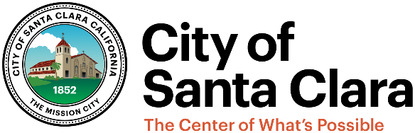
Prepared by Housing & Community Services Division
1500 Warburton Avenue
Santa Clara, CA 95050
408-615-2490

HOUSING SUCCESSOR

ANNUAL REPORT

REGARDING THE LOW- AND MODERATE-INCOME HOUSING ASSET FUND
FOR FISCAL YEAR 2021-22 PURSUANT TO
CALIFORNIA HEALTH AND SAFETY CODE SECTION 34176.1(f)
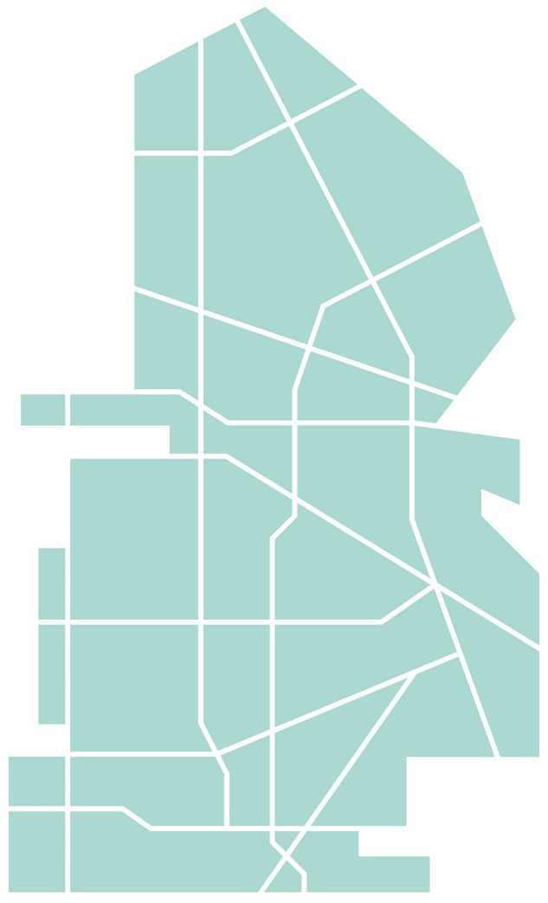
FOR THE CITY OF SANTA CLARA

Submission Date: March 31, 2023

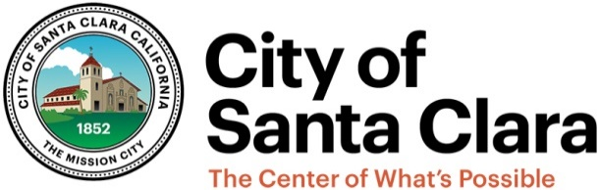

HOUSING SUCCESSOR ANNUAL REPORT

REGARDING THE

LOW- AND MODERATE-INCOME HOUSING ASSET FUND

FOR FISCAL YEAR 2021-22 PURSUANT TO

CALIFORNIA HEALTH AND SAFETY CODE SECTION 34176.1(f)

FOR THE City of SANTA CLARA

The Housing Successor Annual Report (Report) regarding the Low- and Moderate-Income Housing Asset Fund (LMIHAF) has been prepared pursuant to California Health and Safety Code Section 34176.1(f) and describes the current status of the LMIHAF as of June 30, 2022. The Report further provides certain details regarding the City of Santa Clara, as Housing Successor (“Housing Successor” or “City”), and its activities during Fiscal Year 2021-22 (Fiscal Year). The purpose of this Report is to provide the governing body of the Housing Successor, the Santa Clara City Council, an annual report on the housing assets and activities of the Housing Successor under Part 1.85, Division 24 of the California Health and Safety Code, in particular sections 34176 and 34176.1 (Dissolution Law).

The following Report is based upon information prepared by staff and information contained within the financial records of the Low- and Moderate-Income Housing Asset Fund 169 for Fiscal Year 2021-22. The Report conforms with and is organized into Sections I through XI, inclusive, pursuant to Section 34176.1(f) of the Dissolution Law:

- Amount Deposited into LMIHAF: This section provides the total amount of funds deposited into the LMIHAF during the Fiscal Year. Any amounts deposited for items listed on the Recognized Obligation Payment Schedule (ROPS) must be distinguished from the other amounts deposited. This section also includes a reporting on the amount the Housing Successor received pursuant to Health and Safety Code Section 34191.4(b)(3)(A) for sponsoring community loan repayments.

- Ending Balance of LMIHAF: This section provides a statement of the balance in the LMIHAF as of the close of the Fiscal Year. Any amounts deposited for items listed on the ROPS must be distinguished from the other amounts deposited.

- Description of Expenditures from LMIHAF: This section provides a description of the expenditures made from the LMIHAF during the Fiscal Year. The expenditures are to be categorized.

- Statutory Value Of Assets Owned By Housing Successor In LMIHAF: Under the Dissolution Law, and for purposes of this Report, the “statutory value of real property” means the value of properties formerly held by the former redevelopment agency, as listed on the housing asset transfer schedule approved by the Department of Finance, as listed in such schedule under Section 34176(a)(2), the value of the properties transferred to the Housing Successor pursuant to Section 34181(f), and the purchase price of property(ies) purchased by the Housing Successor. Further, the value of loans and grants receivable is included in these reported assets held in the LMIHAF.

- Description of Transfers: This section describes transfers, if any, to another housing successor agency made in previous Fiscal Year(s), including whether the funds are unencumbered and the status of projects, if any, for which the transferred LMIHAF will be used. The sole purpose of the transfers must be for the development of transit priority projects, permanent supportive housing, housing for agricultural employees or special needs housing.
- Project Descriptions: This section describes any project for which the Housing Successor receives or holds property tax revenue pursuant to the ROPS and the status of that project.

- Status of Compliance with Section 34176.1: This section provides a status update on compliance with Section 34176.1 (amending the dates to initiate activities consistent with development of affordable housing under Section 33334.16). For interests in real property acquired on or after February 1, 2012, this section provides a status update on the project.

- Description of Outstanding Obligations under Section 33413: This section describes the outstanding inclusionary and replacement housing obligations, if any, under Section 33413 that remained outstanding prior to dissolution of the former redevelopment agency as of February 1, 2012, along with the Housing Successor’s progress in meeting those prior obligations of the former redevelopment agency and how the Housing Successor plans to meet any unmet obligations.

- Income Test: This section provides the information required by Section 34176.1(a)(3)(B), or a description of expenditures by income restriction for five-year period, with the time period beginning January 1, 2014 and whether the statutory thresholds have been met. However, reporting of the Income Test was reported in 2019 and will be reported again in 2024.

- Senior Housing Test: This section provides the percentage of units of deed-restricted rental housing restricted to seniors and assisted individually or jointly by the Housing Successor, its former redevelopment agency, and its host jurisdiction within the previous 10 years in relation to the aggregate number of units of deed-restricted rental housing assisted individually or jointly by the Housing Successor, its former redevelopment agency and its host jurisdiction within the same time period. For this Report the ten-year period is July 1, 2012- June 30, 2022.

- Excess Surplus Test: This section provides the amount of excess surplus in the LMIHAF, if any, the length of time that the Housing Successor has had excess surplus, and the Housing Successor’s plan for eliminating the excess surplus.

- Inventory of Assisted Homeownership Units: An inventory of homeownership units assisted by the former redevelopment agency or the housing successor that are subject to covenants or restrictions or to an adopted program that protects the former redevelopment agency's investment of moneys from the Low and Moderate Income Housing Fund pursuant to subdivision (f) of Section 33334.3.

This Report is to be provided to the California Department of Housing and Community Development by April 1, 2023. In addition, this Report and the former redevelopment agency’s pre-dissolution Implementation Plans are to be made available to the public on the City’s website, www.santaclaraca.gov.

AMOUNT DEPOSITED INTO LMIHAF (Inclusive of deposits made pursuant to section 34191.4(b)(3)(a))

Source | Amount
First Time Homebuyer Loan Repayment (Principal & Interest) | $325,101
Housing Rehab Loans-NCIP (Principal & Interest) | $0
AH Development Loans Repayment (Principal & Interest) | $809,181
Use of Money & Assets (Interest, Rent, Misc. Other Revenue) | $188,616
20% Set Aside on Sponsoring Community Loan Repayments Pursuant to Safety Code Section 34191.4(b)(3)(A) | -
Developer Fees | $5,200,000
Land Sale Proceeds | $
Total from all sources deposited in Fiscal Year | $6,522,898

A total of $6,522,898 was deposited into the LMIHAF during the Fiscal Year. Of the total funds deposited into the LMIHAF, a total of $0 was held for items listed on the ROPS. The City did not receive any loan repayments under Section 34191.4(b)(3)(A) from the Successor Agency for funds borrowed from the City by the former redevelopment agency. Because no payments were made, no deposits were required to be made into the City’s LMIHAF that were associated with sponsoring community loan repayments under Health and Safety Code Section 34191.4(b)(3)(A).

ENDING BALANCE OF LMIHAF

Balance of LMIHAF as of 6/30/22
Subject | Balance
Previous balance + Current Deposits - Expenditures | $8,218,747

At the close of the Fiscal Year, the ending balance in the LMIHAF was $8,218,747 of which $0 is held for items listed on the ROPS.

DESCRIPTION OF EXPENDITURES FROM LMIHAF

Subject | Amount
Monitoring & Administration | $252,123
Homeless Prevention and Rapid Rehousing Services Expenditures | $360,000
Housing Development Expenditures for pre-development expenses | $11,700,000
Total Expenditures | $12,312,123

The primary expenditures from the LMIHAF was for Housing Developments for the 2330 Monroe affordable housing project. The other expenditures from the LMIHAF were for the Homeless Prevention, Case Management services for the Tenant Based Rental Assistance (TBRA) program, and Rapid Rehousing Services and expenditures and administrative costs associated with monitoring the portfolio’s long-term affordability restrictions. The City entered into two separate agreements with program service providers totaling $250,000 from LMIHAF funds. The TBRA program is administered by two service providers: Abode Services and Bill Wilson Center. The City allocated LMIHAF funds in the amount of $70,000 to both Abode Services and Bill Wilson Center to provide case management services and general program administration services for the TBRA program. Federal Home Investment Partnerships Act (HOME) funds in the amount of $1,759,591 were allocated for subsidies and deposits, and $160,697 from City Affordable Housing funds were allocated to supplement the LMIHAF funds. The TBRA program provides housing and case management services to individual and families who are homeless or at risk of homelessness. The second agreement is with the County of Santa Clara to provide intensive case management and other supportive services for homeless individuals in order to obtain and maintain permanent housing. The agreement is for $110,000 from LMIHAF funds.

The City Council approved two amendments to the Agreement for Services with HouseKeys Inc. for administration of the City’s Affordable Rental Program to continue to strengthen the City’s ability to administer and maintain its affordable rental program. The Amendment No. 1 was approved on August 18, 2020 and Amendment No. 2, approved on July 31, 2021 both had a total compensation with a not-to-exceed amount of $166,000 ($156,000 for program administration and an additional $10,000 for special projects). The full amount of these agreements were funded by the LMIHAF funds.

STATUTORY VALUE OF ASSETS OWNED BY HOUSING SUCCESSOR IN LMIHAF

Under the Dissolution Law and for purposes of this Report, the “statutory value of real property” means the value of properties formerly held by the former redevelopment agency as listed on the housing asset transfer schedule approved by the Department of Finance as listed in such schedule under Section 34176(a)(2), the value of the properties transferred to the Housing Successor pursuant to Section 34181(f), and the purchase price of property(ies) purchased by the Housing Successor. Further, the value of loans and grants receivable is included in these reported assets held in the LMIHAF.

The following provides the statutory value of assets owned by the Housing Successor.

Asset Category - Loans | # of Loans | Statutory Value
First Time Home Buyers | 24 | $ 1,004,971
Housing Rehab- NCIP | 2 | $ 93,324
Development Loans | 32 | $96,284,645
Total Loan Balances |  | $ 97,382,940
Asset Category - Land |  | Statutory Value
Land Held for Development
2330 Monroe St & San Tomas Expressway |  | $ 5,400,270
3575 De La Cruz Boulevard |  | $ 1,703,500
Land Developed with Affordable Housing
Presidio El Camino Affordable Housing |  | $ 2,694,997
Charities Housing |  | $ 1,479,897
76 N Winchester Boulevard (formerly 90 N Winchester Blvd) |  | $7,596*
Total Land Balances |  | $ 11,286,260
Total Statutory Value of Assets Owned by Housing Successor |  | $ 108,669,200
*The affordable senior housing project land (APN 303-17-054) has a cost of $7,596.

DESCRIPTION OF TRANSFERS
The Housing Successor did not make any LMIHAF transfers to other Housing Successor(s) under Section 34176.1(c)(2) during the Fiscal Year.
No previous projects required LMIHAF transfers during the fiscal year.

PROJECT DESCRIPTIONS
This section describes any project for which the Housing Successor receives or holds property tax revenue pursuant to the ROPS and the status of that project.

The Housing Successor does not receive or hold property tax revenue pursuant to the ROPS.

STATUS OF COMPLIANCE WITH SECTION 34176.1

Section 34176.1 provides that the deadlines in Section 33334.16 do not apply to interests in real property acquired by the Housing Successor on or after February 1, 2012; however, this Report presents a status update on the project related to such real property.

With respect to interests in real property acquired by the former redevelopment agency prior to February 1, 2012, the time periods described in Section 33334.16 shall be deemed to have commenced on the date that the Department of Finance approved the property as a housing asset in the LMIHAF; thus, as to real property acquired by the former redevelopment agency now held by the Housing Successor in the LMIHAF, the Housing Successor must initiate activities consistent with the development of the real property for the purpose for which it was acquired within five years of the date the DOF approved such property as a housing asset.

The following provides a status update on the project(s) for property or properties that have been acquired by the Housing Successor using LMIHAF on or after February 1, 2012:

Address | Date of Transfer approval from DOF | Deadline to initiate activity | Current Status
2330 Monroe St &  San Tomas Expressway | 7/16/2013 | 7/16/2018 | Executed DDA, Approved Entitlements, and Encumbered Funds (Closed April 2022)
3575 De La Cruz Boulevard | 7/16/2013 | 7/16/2018 | Awarded and  Executed ENA (ENA Extended to June 2023)
90 N. Winchester Boulevard | 7/16/2013 | 7/16/2018 | Executed DDA, Approved Entitlements, and Encumbered Funds (Closed June 2021)

2330 Monroe Street:
On December 7, 2017, the Housing and Community Services Division held a Community Engagement Meeting at City Hall to discuss plans for the future development of the City-owned site at 2330 Monroe Street. The RFP was issued on March 2018 and on November 11, 2018, Santa Clara’s City Council authorized the City Manager to execute an Exclusive Negotiation Agreement (ENA) with Freebird Development Company for the development of 2330 Monroe Street. On January 28, 2020, Santa Clara’s City Council approved all land use entitlements for the project and adopted a resolution approving and authorizing the City Manager to negotiate and execute a Disposition and Development Agreement (DDA) with Freebird Development LLC and further authorizing the City Manager to execute all other agreements (including a Ground Lease, Loan Agreements, Deeds of Trust, Promissory Notes, and Affordable Housing Agreement). Freebird Development Company applied for tax-exempt bonds and tax credits in December 2020 but was not awarded in that round. In December 2021, Freebird’s application for tax-exempt bonds and tax credits was successful and the project closed financing in April 2022. The project is currently under construction.

3575 De La Cruz Boulevard:
On January 29, 2018, the Housing and Community Services Division held a Community Engagement Meeting at the Northside Library to discuss plans for the future development of the City-owned site at 3575 De La Cruz Boulevard. The RFP was issued in June 2018 and on April 9, 2019, Santa Clara’s City Council approved an Exclusive Negotiation Agreement (ENA) with Habitat for Humanity Company for the development of 3575 De La Cruz Boulevard. The ENA provided an initial negotiating period of 18 months, commencing on the date of the Agreement was fully executed, which could be extended for two additional periods of six months each by the City Manager upon presentation of a written request from the Developer together with a schedule of tasks to be accomplished during the additional period. Both six-month extensions were authorized by the City Manager. As allowed under the ENA, the City Manager granted two six-month extensions for the ENA on December 14, 2020 and the second on July 12, 2021. Since that time, three additional extensions were signed extending the ENA until June 30, 2023 to allow Habitat for Humanity additional time to prepare a Disposition and Development Agreement (DDA) for Council consideration.

90 North Winchester Boulevard:
On February 27, 2015, the Housing Successor issued a Request for Proposals for 90 North Winchester Boulevard (referred to as the "BAREC Site") for the development of affordable senior housing. On January 29, 2019, Santa Clara’s City Council approved all land use entitlements for the project and adopted a resolution approving and authorizing the City Manager to negotiate and execute a Disposition and Development Agreement (DDA) with Core Affordable Housing LLC for the development of the Agrihood Project located at 90 North Winchester Boulevard/ 1834 Worthington Circle and further authorizing the City Manager to execute all other agreements (including a Ground Lease, Loan Agreements, Deeds of Trust, Promissory Notes, and Affordable Housing Agreement). The Core Companies announced in September 2020 that the Agrihood Project has been awarded $50,000,000 in tax-exempt bonds by the California Debt Limit Allocation Committee (CDLAC). The project closed financing in June 2021 and is expected to receive its certificate of occupancy in May 2023.

2904 Corvin Drive:
On February 19, 2019, Santa Clara’s City Council approved a loan agreement with Allied 2904 Corvin, LP for a loan of up to $5,000,000 Housing Successor Funds to support the construction of a 100% affordable residential development at 2904 Corvin Drive. The project, Corvin Apartments, will contain 145 units consisting of 80 units for formerly chronically homeless residents with income levels at or below 30% of Area Median Income (AMI), 64 units for residents with income levels at or below 60% AMI, and 1 unrestricted two-bedroom manager’s unit. The project started leasing up in June 2021 and was expected to reach full occupancy by February 2022, however the project did not reach full occupancy until the end of 2022.

DESCRIPTION OF OUTSTANDING OBLIGATIONS PURSUANT TO SECTION 33413

Replacement Housing: According to the FY2009/10 - FY2015/16 Implementation Plan for the former redevelopment agency, no Section 33413(a) replacement housing obligations were transferred to the Housing Successor. The former redevelopment agency’s Implementation Plans are posted on the City’s website at www.santaclaraca.gov

There are no existing replacement housing obligations.

Inclusionary/Production Housing: According to the FY2009/10 - FY2015/16 Implementation Plan for the former redevelopment agency, no Section 33413(b) inclusionary/production housing obligations were transferred to the Housing Successor. The former redevelopment agency’s Implementation Plans are posted on the City’s website at www.santaclaraca.gov

There are no existing inclusionary production obligations.

EXTREMELY-LOW INCOME TEST

Section 34176.1(a)(3)(B) requires that the Housing Successor must require at least 30% of the LMIHAF be expended for development of rental housing affordable to and occupied by households earning 30% or less of the AMI. If the Housing Successor fails to comply with the Extremely-Low Income requirement in any five-year report, then the Housing Successor must ensure that at least 50% of the funds remaining in the LMIHAF be expended in each fiscal year following the latest fiscal year following the report on households earning 30% or less of the AMI until the Housing Successor demonstrates compliance with the Extremely-Low Income requirement.

This information will be reported in 2024 and every five years thereafter.

SENIOR HOUSING TEST

The Housing Successor is to calculate the percentage of units of deed-restricted rental housing restricted to seniors and assisted by the Housing Successor, the former redevelopment agency and/or the City within the previous 10 years in relation to the aggregate number of units of deed-restricted rental housing assisted by the Housing Successor, the former redevelopment agency and/or City within the same period. If this percentage exceeds 50%, then the Housing Successor cannot expend future funds in the LMIHAF to assist additional senior housing units until the Housing Successor or City assists and construction has commenced on a number of restricted rental units that is equal to 50% of the total amount of deed-restricted rental units.

The following provides the Housing Successor’s Senior Housing Test for the 10-year period of 7/1/2012-6/30/2022. The aggregate number of units of deed-restricted rental housing restricted to seniors and assisted individually or jointly by the housing successor, its former redevelopment agency, and its host jurisdiction within the previous 10 years did not exceed 50 percent of the aggregate number of units of deed-restricted rental housing assisted individually or jointly by the housing successor, its former redevelopment agency, and its host jurisdiction within the same time period. Therefore, the restrictions under Section 34176.1(b) do not apply.

Senior Housing Test | 10 Year Test
July 1, 2012 - June 30, 2022
# of Assisted Senior Rental Units by Former RDA | 47
# of Assisted Senior Rental Units by City | 79
# of Assisted Senior Rental Units by Housing Successor | 164
Total # of Assisted Senior Rental Units | 290
# of Assisted Rental Units by Former RDA | 47
# of Assisted Rental Units by City | 424
# of Assisted Rental Units by Housing Successor | 372
Total # of Assisted Rental Units | 843
Assisted Senior Housing Percentage | 34.40%

EXCESS SURPLUS TEST
Excess Surplus is defined in Section 34176.1(d) as an unencumbered amount in the LMIHAF account that exceeds the greater of one million dollars ($1,000,000) or the aggregate amount deposited into the account during the Housing Successor’s preceding four Fiscal Years, whichever is greater.
The Housing Successor created the LMIHAF account on February 1, 2012. The LMIHAF Balance on Deposit of $13,893,463 less the encumbered amount of $11,500,000 for two affordable housing developments, equals $2,393,463. This amount is less than the sum of the annual deposits made in the preceding four fiscal years of $6,923,463. As a result, the LMIHAF does not have an Excess Surplus. The City encumbered the funds in the previous reporting period and have fully disbursed $11.5 million for two affordable housing projects as noted below.

Annual Deposits | Amount Deposited
FY 2017-18 LMIHAF Deposits | $1,799,709
FY 2018-19 LMIHAF Deposits | $2,227,849
FY 2019-20 LMIHAF Deposits | $1,343,393
FY 2020-21 LMIHAF Deposits | $1,552,257
Aggregate Deposits for 4 preceding fiscal years | $6,923,208
LMIHAF Balance on Deposit | $13,893,463
Encumbered Funds | ($11,500,000)
Unencumbered LMIHAF Balance on Deposit | $2,393,463
Excess Surplus | $0

Encumbered Funds for Affordable Developments (as of June 30, 2021)
Allied 2904 Corvin (3311 Kifer Road) – Fully Disbursed 12/19/2022 | $ 5,000,000
Freebird (2330 Monroe Street) – Fully Disbursed 4/11/2022 | $ 6,500,000
Total | $ 11,500,000

Homeownership inventory
This section contains an inventory of homeownership units assisted by the former redevelopment agency or the housing successor that are subject to covenants or restrictions or to an adopted program that protects the former redevelopment agency's investment of moneys from the Low and Moderate Income Housing Fund pursuant to subdivision (f) of Section 33334.3.
There are a total 62 of assisted homeownership units being monitored by the housing successor. No units were lost from the portfolio during the fiscal year and no units have been lost from the portfolio since February 1, 2012. A total of 4 units have been removed from the housing successor’s portfolio during the fiscal year because the homeowners have satisfied the terms of the recorded affordability covenants.

No funds were returned as part of a program that protects the former agency's investment of funds from the LMIHAF. The Housing Successor did receive $325,101 of program income associated with the housing successor's homeownership portfolio.

The Housing Successor did not contract with any outside entity for the management of the housing successor's homeownership portfolio.

Actions Needed

This report must be submitted to the California Department of Housing and Community Development by April 1st. This report and the former redevelopment agency’s Implementation Plans are posted on the City’s website at www.santaclaraca.gov

