Ebix Insurance No. S200004639

AMENDMENT NO. 1
TO THE AGREEMENT FOR SERVICES
between the
CITY OF SANTA CLARA, CALIFORNIA,
and
AECOM TECHNICAL SERVICES, INC.

PREAMBLE
This agreement (“Amendment No. 1”) is entered into between the City of Santa Clara, California, a chartered California municipal corporation (City) and AECOM Technical Services, Inc., a California corporation (Contractor). City and Contractor may be referred to individually as a “Party” or collectively as the “Parties” or the “Parties to this Agreement.”

RECITALS
- The Parties previously entered into an agreement entitled “Agreement for Design Professional Services between the City of Santa Clara, California, and AECOM Technical Services, Inc., dated February 12, 2021 (Agreement); and
- The Parties entered into the Agreement for the purpose of having Contractor provide plan implementation/project management services as requested by the City to support capital, operations, and maintenance projects; and
- The Parties now wish to amend the Agreement to include Program Management Services for Silicon Valley Power’s (SVP) System Expansion Plan Program.
NOW, THEREFORE, the Parties agree as follows:

AMENDMENT TERMS AND CONDITIONS
- Section 2 of the Agreement, entitled “Term of Agreement”, is amended in its entirety to read as follows:
“TERM OF AGREEMENT

Unless otherwise set forth in this Agreement or unless this paragraph is subsequently modified by a written amendment to this Agreement, the term of this Agreement shall begin on December 1, 2020, and terminate on June 30, 2027.”

- Section 6 of the Agreement, entitled Compensation and Payment is amended in its entirety to read as follows:
“COMPENSATION AND PAYMENT
In consideration for Contractor's complete performance of Services, City shall pay Contractor for all materials provided and Services rendered by Contractor in accordance with Exhibit B, entitled "SCHEDULE OF FEES AND PAYMENT PROVISIONS." The maximum compensation of this Agreement is eleven million dollars ($11,000,000), subject to budget appropriations, which includes all payments that may be authorized for Services and for expenses, supplies, materials and equipment required to perform the Services. All work performed or materials provided in excess of the maximum compensation shall be at Contractor's expense. Contractor shall not be entitled to any payment above the maximum compensation under any circumstance without an amendment to this Agreement.
- Exhibit A – Scope of Services shall be deleted in its entirety and replaced with the attached Exhibit A – Scope of Services – Amended April 30, 2022, which is hereby incorporated into the Agreement.
- Exhibit B – Schedule of Fees shall be deleted in its entirety and replaced with the attached Exhibit B – Compensation and Fee Schedule – Amended April 30, 2022, which is hereby incorporated into the Agreement.
- Except as set forth herein, all other terms and conditions of the Agreement shall remain in full force and effect. In case of a conflict in the terms of the Agreement and this Amendment No. 1, the provisions of this Amendment No. 1 shall control.

The Parties acknowledge and accept the terms and conditions of this Amendment No. 1 as evidenced by the following signatures of their duly authorized representatives.

CITY OF SANTA CLARA, CALIFORNIA,
a chartered California municipal corporation

Approved as to Form: | Dated:
Office of the City Attorney  City of Santa Clara |  | Rajeev Batra  City Manager  1500 Warburton Avenue  Santa Clara, CA 95050  Telephone: (408) 615-2210  Fax: (408) 241-6771

“City”

aecom technical services, INC.,
a California corporation

Dated:
By (Signature):
Name: | Robert K. Turley, P.E.
Title: | Vice President
Principal Place of Business Address: | (to be filled in by City staff)
Email Address: | Bob.turley@aecom.com
Telephone: | (925) 989-9797

“CONTRACTOR”

AGREEMENT FOR DESIGN PROFESSIONAL SERVICES
between the
CITY OF SANTA CLARA, CALIFORNIA and

aecom technical services

EXHIBIT A - SCOPE OF SERVICES
Amended April 30, 2022
- The Contractor shall perform plan implementation/project management services as requested by the City to support capital, operations, and maintenance projects including but not limited to:
  - As Needed Services:
    - Act as project manager for additional projects including the following activities:
      - Project permitting including support of CEQA determinations
      - Land acquisition
      - Project design and preparation of Plans, Specifications and Engineer’s Estimate
      - Bid support
      - Construction support
      - Record drawings and Project Closeout
    - System planning for electric utility distribution and transmission systems
    - Distribution and transmission line conceptual design, feasibility, and permitting.
    - Substation conceptual and/or detail design, feasibility, and permitting.
    - Support with substation communications, protection and control systems.
    - Assist with third party plan submissions such as WECC, CAISO, and PG&E.
    - Conduct load flow, short circuit studies and arc flash studies as needed.
    - Conduct Distributed Energy Resource interconnection studies as needed.
    - Assess existing design standards and recommend revisions or new standards.
    - Assess existing maintenance practices or standards and recommend revisions or create new standards.
    - Provide drafting support as needed.
  - Program Management Services: Contractor shall provide Program Management Services for Silicon Valley Power’s (SVP) System Expansion Plan Program (SEP) including (1) SEP Program Management, (2) Program Wide Technical Support, and (3) Project Management for SEP Projects as further detailed in this Exhibit A-1 – Scope of Work for Program Management Services.
- Authorization of Work:
  - Work may be assigned to Contractor through the evaluation of a Call for Proposal (CFP) or via direct assignment. The Contractor shall not begin any work unless a Purchase Order (PO) has been issued by the City for that particular work.
  - The Contractor shall conduct all necessary meetings and interviews, keep minutes and interview summaries as requested, and provide copies to SVP.
  - At the conclusion of each project, the Contractor shall provide electronic copies of all final reports, worksheets, system studies and data associated with this project to SVP in (but not limited to) .pdf, .docx, .xlsx, .xml, .dwf, .dwg, .sav formats as applicable and that are not proprietary in nature. If work is complete in PowerWorld, Contractor to ensure the deliverable is provided in proper and functional GE PSLF format as well.
- e-BUILDER
  - Contractor shall use e-Builder for submission of data and documents throughout the term of this agreement, as requested by the City.
    - e-Builder is a web-based construction management application hosted by e-Builder, Inc. For certain projects to be defined by the City, e-Builder shall be the primary means of project information submission and management or as otherwise agreed upon with the City.
  - The City will establish Contractor's access to e-Builder by providing licenses to Contractor’s personnel at City’s cost. The Contractor’s designated users will be required to set up their computers/systems to use e-Builder in accordance to the e-Builder User Training Guider-2015. The City reserves the right to limit the licenses issued to Contractor in the future.
  - Contractor is required to obtain all necessary training to use the software. The City will provide one classroom training or a web-based seminar. A training session is 1 - 2 hours.
  - e-Builder is a web-based environment and therefore it is subject to the inherent speed and connectivity limitations of the Internet. The Contractor is responsible for its own connectivity to the Internet. e-Builder’s response time is dependent on the Contractor's equipment, including processor speed, Internet access speed, etc. and current traffic on the Internet. The City will not be liable for any delays associated from the usage of e-Builder including, but not limited to: slow response time, down time periods, connectivity problems, or loss of information. The Contractor shall ensure connectivity to the e-Builder system whether at the home office or job site. Under no circumstances will usage of e-Builder be grounds for a time extension or cost adjustment to the Contract.
  - Data entered in a collaborative mode (entered with the intent to share as determined by permissions and workflows within the e-Builder system) by the City and the Contractor will be jointly owned.
  - The Contractor is responsible for managing, tracking, and documenting the Work to comply with the requirements of this Agreement. The City's acceptance via automated system notifications or audit logs extends only to the face value of the submitted documentation and does not constitute validation of the Contractor's submitted information.
  - At the City’s sole discretion, project documents may be processed and distributed digitally over the internet or may be required to be presented in hard copy format.
  - While regular email may still be used for communication, when requested by the City, e-Builder shall be utilized as much as possible in connection with all document and information management required in the performance of projects where City has directed the use of e-Builder. Contractor shall be responsible for scanning or otherwise converting to electronic format all project submittals and Contractor correspondence, drawings, sketches, etc., and uploading them to the e-Builder web site and shall be responsible for the validity of its information placed in e-Builder. The Contractor shall use the existing forms and processes in e-Builder to the maximum extent possible. If a required form does not exist in e-Builder, the Contractor shall include a form of its own or one provided by the City (if available) as an attachment to a submittal or process. Documents and information to be submitted electronically include, but are not limited to:
    - Correspondence;
    - Meeting Minutes;
    - Submittals and Shop Drawings;
    - Product Data, reports, certifications, etc. must be submitted in PDF format. (If a sample is able to be scanned, it is requested a scanned PDF copy is submitted with the sample.);
    - Requests for Information (RFI’s);
    - Change Order requests and documentation, including record copies of Change Orders, Proposals, Modifications;
    - Pay Applications;
    - “Official” correspondence (such as letters) including informal correspondence, such as e-mail;
    - Pre-Task Plans (PTPs);
    - Daily Construction Reports and other Daily Reports including Contractor Quality Control (CQC) Reports;
    - Quality Control (QC) Documentation
    - All official reports, such as Commissioning reports;
      - Notices and Claims;
      - Operations and Maintenance Manuals;
      - All Close-out documents; and
      - All testing results.
    - Archive Copies: When requested by City, Contractor shall keep an archive copy of all digital data created by Contractor, or submitted to Contractor via e- mail, or resident on the e-Builder for the duration of the Project. Such data shall be available to City, authorities with jurisdiction (including funding agencies or representatives) on demand.

AGREEMENT FOR DESIGN PROFESSIONAL SERVICES
between the
CITY OF SANTA CLARA, CALIFORNIA and

aecom technical services

EXHIBIT A – 1 SCOPE OF SERVICES for system expansion plan
- TASK 1 – SEP PROGRAM MANAGEMENT
  - Task 1.1 – Develop Program Management Plan
    - Contractor will develop an overall Program Management Plan (PMP), including a programmatic execution strategy, to support the timely completion of projects required to achieve the SEP program objectives. The PMP will be developed in concert with SVP and will include input from key SVP staff/stakeholders related to their applicable scopes of work and inherent roles and responsibilities.
    - Contractor will assign a Program Management Consultant Team (PMC) generally structured as depicted in Appendix A.
      - Contractor shall inform the City immediately of any change in key personnel assigned to the City.
      - When requested by City, Contractor shall submit the resumes and other information supporting qualifications of the proposed replacement employee(s) to the City for review and approval. The City shall not unreasonably withhold approval.
    - The PMP will include an SEP program overview summarizing the main components and strategy of the program including program description / summary and a comprehensive mission statement for the program. The PMP will also include program objectives, goals, risks, critical success factors, and major milestones so that from a high level outcomes can be measured against the overview to measure success.
    - As part of this task, Contractor will evaluate, leverage, and recommend improvements to existing SVP program/project management policies, protocols, and procedures where appropriate to help:
      - Streamline communications,
      - Optimize performance and quality,
      - Enhance oversight and controls, and
      - Expedite project delivery.
      - Where new SVP program/project management policies and procedures are needed to guide SVP’s program, the PMC team will leverage past project experience and PMP documents developed for other clients on other programs.
    - The PMP will provide program implementation protocols and processes for critical program management functions and is envisioned to include the following sections:
      - 01 – Program Description/Objectives and Project Management Office (PMO) Mission
      - 02 – Organization and Governance
      - 03 – Communications Management
      - 04 – Document Management
      - 05 – Schedule and Cost Management
      - 06 – Change Management
      - 07 – Quality Management
      - 08 – Risk Management
      - 09 – Engineering and Design Management
      - 10 – Procurement and Contracts Management
      - 11 – Permitting and Regulatory Management
      - 12 – Safety Health and Environment
      - 13 – Public Information and Stakeholder Management
      - 14 – Construction Management
      - 15 – Program Design Manual
      - 16 – Electrical Equipment
      - 17 – e‐Builder
    - Task 1.1 Deliverable: Draft and Final Program Management Plan documents (pdf and word format).
  - Task 1.2 – Develop Staffing Plan
    - The staffing plan is a major item in the overall PMP and will include appropriate details on the Division of Responsibilities (DOR) and level of effort/support required of each individual on the program and project teams.
    - Contractor will develop a recommended overall program organization with subsequent details regarding the overall core personnel as well as an organizational chart depicting the reporting structure and interdependency of the program organization and other key personnel.
    - The staffing plan will aim to identify how the SEP program organization structure (or PMC team) is embedded into overall SVP organization structure, and how best to establish clear lines of communication, along with definitive roles/responsibilities.
    - The staffing plan(s) developed by the PMC will include program and project level staffing needs/ assignments and clearly define SVP, PMC, and other SEP project staff roles and responsibility.
    - Preparation of the staffing plan will help in the allocation of adequate staff resources to support the various program/project needs.
    - Contractor will present recommended updates to the Staffing Plan at least once per quarter.
    - Task 1.2 Deliverables:
      - Draft and final staffing plan (Organization Chart) in pdf and editable format.
      - Regular quarterly updates to the Staffing Plan to reflect new roles, responsibilities, and staff that may arise during execution of the program/projects.
  - Task 1.3 – Program Management/Coordination
    - As part of this task, the PMC team’s program manager and deputy program manager will perform day to day management and coordination functions necessary to help the program progress efficiently and in line with the program management plan objectives and requirements. As part of this task, the PMC program manager and deputy program manager will coordinate with SVP and PMC staff so that the necessary resources are in place for required activities and that each resource/staff member is successfully fulfilling their necessary roles and responsibilities.
    - As part of this task the PMC team will also define, document and communicate SEP project development procedures and processes specifying the required steps (flow path) to be followed during the implementation of each phase of the projects (planning, design, construction, testing/ commissioning). The goals and outcomes of the project development procedures include:
      - Help to identify, document, and communicate required review checkpoints/gates necessary to obtain approvals and help establish that required prerequisites have been satisfactorily addressed prior to moving on to the next phase of the project.
      - Help establish realistic timeframes and durations are understood by the PMC team and SVP staff and appropriately accounted for in the overall program schedule.
    - As part of this task the PMC program manager and deputy program manager will monitor the overall progress and implementation of the program and update various sections of the program management plan. The PMC team will modify existing sections of the PMP and or add new sections to help the program (and projects) meet their milestones and objectives.
    - Task 1.3 Deliverables:
      - Perform day to day management and coordination of critical SEP program activities.
      - Monitor and assess progress of overall SEP program and projects (scope, schedule, budget) and report out to SVP management staff on a monthly basis.
      - Identify and develop mitigation plans for existing/potential program and project risks/issues.
      - Monitor progress of SEP program/projects to help establish adequate resources are in place and that staff are successfully fulfilling their roles and responsibilities.
      - Attend and facilitate PMC team and SVP staff coordination meetings and disseminate program/project information and direction to appropriate staff resources.
      - Regularly evaluate PMP sections and update and amend PMP as needed on a quarterly basis.
  - Task 1.4 – Program Level Cost & Schedule Management/Tracking & Reporting
    - As part of this task the PMC team will develop and implement standard reporting requirements for projects under the SEP program that roll up to a standard monthly program report.
      - The PMC team will use e‐Builder capabilities to streamline report generation and provide access to real time program/project cost, financial and schedule data to the greatest extent practical.
      - Major key performance indicators (KPI's) will be developed at the program level and implemented at the project level to view the overall program health and progress on a regular basis.
    - Task 1.4 Deliverables:
      - Prepare program schedule and update on a monthly basis.
      - Develop Key Performance Indicators (KPIs) and assess performance on a monthly basis.
      - Prepare and distribute monthly program status summary report.
      - Identify and implement up to two (2) e‐Builder dashboards.
  - Task 1.5 – Risk Management
    - The PMC team will develop comprehensive risk register for the overall SEP program in collaboration with SVP staff.
      - The risk register included in this task will summarize the major risks associated with the program at a programmatic level and will be independent from project level risk registers that should be held and reviewed normally by project teams for each specific project/task.
      - The PMC team will identify and document potential risks to the timely completion of individual SEP projects and the overall program.
      - The PMC team will develop risk avoidance, mitigation measures, and or alternative implementation plans where feasible/appropriate for SVP staff consideration.
    - Program and project risk registers will be reviewed on a regular basis with key project stakeholders.
      - The PMC team will communicate limitations to SVP operations that could possibly occur due to potential impacts that cannot be sufficiently mitigated.
      - After initial development of the noted risk registers, Contractor will review the overall program risk register with SVP on a quarterly basis.
      - Contractor will review project-specific risk registers with SVP on a monthly basis.
    - Task 1.5 Deliverables:
      - Prepare initial risk register listing existing/potential program risks.
      - Regular monitoring and tracking of existing/potential program risks listed in register.
      - Prepare quarterly updates to risk register to capture status of existing risks and add/remove risks as appropriate.
  - Task 1.6 – Contract/Change Management
    - The PMC team will work with SVP staff as needed to support management of Engineering Procurement Construction (EPC) or developer contracts for the program.
      - The PMC team will evaluate and make recommendations to enhance SVP's current Potential Change Order form as needed to meet best practices.
      - The PMC team will recommend additional standard forms and procedures as appropriate/required to best fit SVP’s requirements and the SEP Program requirements.
    - As part of this task the PMC team will create, track and maintain a program and project level Change Order (CO) log to better inform SVP with real time updates on the potential impacts to the program and specific projects as a result of cumulative changes.
      - The PMC team will evaluate and verify designer and contractor change proposals (scope and cost) and supporting justification.
      - The PMC team will use e‐ Builder capabilities to provide real time access to CO status and associated financial metrics and streamline and verify/document CO reviews and approvals.
    - Task 1.6 Deliverables:
      - Facilitate the development and tracking of bid packages.
      - Document and implement change management procedures/processes.
      - Review/ approve SEP project invoices.
  - Task 1.7 – Programmatic Health and Safety Requirements
    - As part of this task, the PMC health and safety manager will set up and structure the programmatic health and safety plan requirements to be used and followed by each of the SEP project design consultants and construction contractors. In development of the programmatic health and safety plan, the PMC health and safety manager will leverage AECOM best practices and existing SVP health and safety requirements to identify additional requirements and best practices used by other clients on other projects.
    - While Contractor will be providing program level safety support, SVP’s design consultants and construction contractors are responsible for the safety of their operations and control of the site. Contractor will support actions needed to assign health and safety responsibility to design and construction contractors such as contract terms and recommendations to evaluate and monitor compliance by design and construction contractors.
    - Task 1.7 Deliverables:
      - Develop programmatic health and safety plan.
      - Track and monitor SEP project’s implementation and compliance with required health and safety protocols.
  - Task 1.8 – Schedule Oversight
    - At the program level, the PMC team scheduler will use Primavera P6 (P6) to create an overall program schedule (based on each Contractor's individual project schedules) and then implement the overall program schedule into e‐builder.
      - This will allow the PMC team scheduler to better control the schedule ties and critical path providing better insight into the logic and required sequencing of the overall program schedule.
      - The PMC team scheduler will develop the program schedule to account for external factors/influences such as equipment procurement and other project stakeholders including, but not limited to, PG&E, Santa Clara City Council, and Developers.
    - At the project level, the design consultants and construction contractors will own and be responsible for their project's design phase and construction schedules.
      - The project level schedule format will likely be similar to the format of the program schedule.
      - The PMC team scheduler will use P6 in the background and then implement a customized schedule into e‐builder. For example, PMC will develop a level 2 project schedule rolled up from the contractor’s schedule for high level review by the PMC team and SVP.
    - The PMC team will also develop recommended specific schedule requirements to be followed by the design consultant and contractor, and implement these schedule requirements into a standard contractual Exhibit that can be included contracts with design consultant’s and contractor's to help the PMC team and SVP staff have better control on the necessary schedule data received by others.
    - The PMC team will provide program schedule critical path analysis and recommendations to expedite completion and mitigate delays, on a regular basis through the periodical schedule analysis and schedule update report.
      - Where specific projects within the program fall behind schedule, the PMC team will work with the design consultants to adjust critical path items.
      - During construction, the PMC team will also help track and monitor the delivery of key product materials and electrical equipment procurement.
      - The PMC team’s schedule performance analysis will be communicated effectively in accordance with the job specific report frequency matrix, which will include: contract and execution milestones, work force and progress charts, updated summary and control schedules, look‐ahead and specialty schedules, critical path and variance analysis, total float, and regular status meetings.
    - Task 1.8 Deliverables:
      - Develop and maintain project and program schedules.
      - Review/ make recommendations to standard schedule templates in e‐Builder.
      - Standardize design consultant and contractor schedule input.
  - Task 1.9 – Cost Control/Estimating
    - As part of this task, the PMC team will monitor and evaluate the performance of the overall SEP program and each project within the program.
    - Program and project financial budget status, schedule, and associated cash flow projections as well as required budget authorizations will be evaluated on a regular basis. Budget reporting shall include appropriations budgets, encumbrance budgets, and contract budgets.
    - The PMC team will monitor the financial budget status through a list of applicable cost performance reports on the job‐specific report frequency matrix, including due dates.
    - Cost performance will be periodically reported to SVP quarterly and will be reconciled to the metrics compiled in the cost database processor. The PMC team will produce standard slides to report cost performance in a consistent format, such as PMC team standard client weekly report and updated resource/spend‐out plans, in addition to the project cash flow and forecast.
    - The cost control process will be developed and documented by the PMC team including input from SVP staff to monitor budgets. The process will include provisional allowances for the project and preparing useful reports for use by the PMC team and SVP staff.
    - The cost control measures will use cost data from SVP, the design consultants, contractors, and the PMC team. The generated reports will indicate program and project costs aspects, and are envisioned to include the following:
      - Potential and pending changes;
      - Variances between actual and budgeted costs;
      - Anticipated / Unforeseen costs;
      - Use of SVP in‐house forces;
      - Use of allowances or contingencies in contractor contract.
    - Budget revisions will be incorporated into the cost control system. Payment requests from the contractor will be reviewed by the PMC team and recommendations for approval will be presented to SVP.
    - The PMC team will process and monitor contractor use of allowances within the construction contract. The PMC team will track costs within the cost control system.
    - The PMC team will also work through e‐Builder (in coordination with SVP) to initiate a program level cost reporting visible by all and based on key program and project level performance indicators to manage, analyze, and communicate the costs at the program level on a regular basis.
    - Task 1.9 Deliverables:
      - Review/ validate project budgets.
      - Perform cash flow analysis.
      - Manage and analyze actual vs. planned budget and address needs for additional budget approvals where needed.
      - Perform earned value analysis for SEP program and associated projects.
      - Generate SEP program/ projects cost reports.
      - Review and evaluate contractor pricing.
      - Review and evaluate change order requests.
  - Task 1.10 – Records Management
    - The PMC team records manager will identify and use an optimal centralized electronic filing system to retain/archive and access appropriate program/project documents. Contractor shall evaluate the use of the City’s existing laserfiche program where applicable.
    - The PMC team will consider both SVP network‐based filing location, and online/shared electronic file retention/management sites.
    - The PMC team will also recommend and document standardized requirements and procedures for retention and archiving of appropriate project documents, and define and list required project documents to be retained and archived, such as design packages, shop drawings, equipment and material submittals, testing and commissioning plans, RFIs, change orders, design changes, as‐builts.
    - The PMC team records manager will work with SVP staff to develop and or enhance the program and project standard folder structure and help implement consistent utilization of structure throughout SEP projects. The PMC team’s record manager will also work across all the projects in the portfolio to upload, download, rename files and keep version control of project records.
    - Task 1.10 Deliverables:
      - Identify and use an optimal centralized electronic filing system to retain/archive and access appropriate program/project documents.
      - Establish and document standardized requirements and procedures for retention and archiving of appropriate project documents.
  - Task 1.11 – e‐Builder Support
    - The PMC team’s e‐Builder lead will assist the PMC team staff in expediting their understanding of e‐ Builder, enhancing PMC staff capabilities and seamlessly integrate PMC team’s use of SVP’s e‐Builder platform.
    - The PMC will
      - Analyze "system adoption" type reports and process workflow usage to identify extent of system usage.
      - Develop strategies plans to increase e-Builder usage accordingly.
      - Evaluate SVP’s e‐Builder platform and setup to see where optimization and enhancement/additions may be desirable.
    - Assumption: For year 2 and beyond it is assumed that there are no e‐Builder services
    - Task 1.11 Deliverables:
      - Evaluate and develop schedule templates.
      - Enhance user interface with outside Contractors/ Vendors where possible.
      - Evaluate and improve workflow improvements where possible.
      - Develop or optimize document archiving processes.
      - Develop and or enhance dashboards (for project team vs. executive/management team, etc.).
  - Task 1.12 – Public Outreach
    - Public outreach for the SEP program is not currently envisioned to require significant support from the PMC team. As requested by SVP staff, the PMC team can provide limited public outreach support for the new 115kV T‐line from Northern Receiving Station (NRS) to Kifer Receiving Station (KRS) project and the Reconfigure 60kV T‐line NW and Center Loop project.
    - Task 1.12 Deliverables may include:
      - Prepare project information for council meetings.
      - Eminent domain queries.
      - Status report out to customers such as major data centers two to three times per year using SVP standard template/approach.
- TASK 2 – PROGRAM WIDE TECHNICAL SUPPORT
  - Task 2.1 – General Technical/Engineering Support
AECOM’s general technical/engineering support will include the following subtasks:
    - Task 2.1.1 – Organize, review, and support development of SVP standards and libraries
      - Contractor will leverage its experience working for other agencies to develop program‐wide engineering design criteria and standards.
      - The PMC technical support team will assist with updating of SVP’s engineering design standards.
      - As part of this task, the PMC technical team will engage SVP management, engineering, and operations staff to better understand current SVP preferences and requirements, and to support the development of established program‐level design requirements that will apply to every SVP System Expansion Plan Capital Program project.
      - Contractor will leverage and enhance existing SVP design standards and specifications developed to date. Where required, contractor will develop new SVP design standards and specifications pertaining to substations to support implementation of SEP Program (and other SVP) projects.
      - Contractor will update SVP standard engineering specifications including:
        - Update specifications to CSI standard numbers and format for consistency with industry standards and to differentiate specifications from SVP design standards/processes/procedures.
        - Inventory and assess existing specifications, identify specifications that may be missing, and recommend specifications fill in gaps.
        - Create specification libraries with standard Table of Contents (TOC) for each type of project SVP does including: distribution substation (SVP owned, typical 60KV‐12KV); junction substation (dedicated customer, typ. Customer-owned); and transmission and distribution line extensions or rebuilds.
        - Identify and organize specifications by type or use, such as Procurement, Construction, Prescriptive, Performance, etc.
      - Develop inventory of standard engineering design drawings and identify where improvement may be needed.
        - Review SVP's Substation Design & Construction Manual Index (SD‐5000).
        - Identify design standards, processes, or procedures that may be missing or needed.
        - Develop missing or incomplete design standards for review by SVP based on best industry standards, SVP preferences/requirements, etc.
    - Task 2.1.2 – As‐built support – standards, cleanup of existing drawings
      - The PMC team will establish and document standardized requirements and procedures for preparation of as‐built drawing package, including required file format (.pdf and .dwg), level of detail, supporting backup (e.g. redline hardcopies), etc.
      - The PMC team will support SVP to implement as‐built standards and requirements consistently throughout SEP projects.
      - The PMC technical team will coordinate with SVP staff to obtain and compile available final design and as‐built drawings associated with the SEP Program projects. The PMC technical team will review the final design/as‐built plans, and help identify which drawings should be retained/archived and which drawings are outdated and/or superseded and may be discarded. The PMC team will conduct site visits, if needed, and interviews with SVP O&M staff to identify, confirm and document as‐built existing conditions.
    - Task 2.1.3 – Transformer/GIS procurement specifications/packages
      - The PMC team will support SVP’s procurement process for capital equipment purchases by organizing technical specifications and/or technical packages that may be required for bidding or vendor procurement. Technical specifications may require meetings with the PMC team, SVP and vendors to confirm technology details.
      - The PMC team understands that SVP intends to procure a significant amount of large power transformers and GIS equipment for projects in the SEP Program. The PMC team will evaluate and support (if requested by SVP) the purchase of all (or most) transformers and or GIS in a single purchase order to one vendor. The PMC technical team will assist SVP to develop procurement specifications for this equipment. Specifically, the PMC team proposes to:
        - Review technical content of one power transformer procurement specification, including up to one technical data sheet specific to each project in the SEP program.
        - Review technical content of one gas‐insulated substation (GIS) procurement specification, including content related to gas‐insulated bus/line (GIB/GIL), and up to one technical data sheet specific to each project in the SEP program.
        - Review SVP proposed solicitation document and contract terms.
        - Review vendor proposals and assist SVP in identifying a preferred vendor.
        - Review vendor design and shop drawings, test plans, Operations and Maintenance (O&M) manuals, etc.
        - Provide comments for each review based on SVP stated project needs and applicable industry standards.
        - Assumptions for task 2.1.3 include the following:
          - SVP will provide a current draft of related specifications and solicitation documents previously developed by SVP for the PMC team’s review. The PMC team does not anticipate a need to originate these documents and will work with SVP to develop content.
          - The PMC technical team will provide review of the technical aspects, and the general contract terms and requirements.
  - Tasks 2.2 thru 2.10 – Engineering/Technical Support for SEP Projects
    - Contractor will provide engineering/technical support as shown in the project summary attached as Table 2. Additional details about scope are defined in the subsequent sections. Engineering/technical support of project 2124-000 has been removed from the Contractor’s scope of services.
    - Subtask – Review planning package
The PMC technical team will review SVP’s Planning Package for each SEP Program project. Review is anticipated to include: general project scope, schedule, risks, and required resources (including roles and responsibilities of internal SVP departments and staff, and consultants or contractor’s roles and responsibilities), and accompanying concept plans/diagrams illustrating proposed and/or required improvements.
    - Subtask – Develop design scope of work
      - To help expedite procurement of design consultants for specific SEP Program projects, the PMC technical team will develop design scope document that can be used in SVP’s call for proposals (CFPs).
      - It is anticipated that the design scopes of work would include, proposed/planned project description / improvements, design criteria, schedule requirements, design consultant’s scope of work, DIR requirements, and a preliminary concept plan illustrating the project site/proposed improvements.
    - Subtask – Design package reviews
      - As part of this task, the PMC team’s technical staff will provide Quality Assurance (QA) reviews of design consultants’ work products.
      - This task will include technical review of the design consultant’s work products, including conformance with SVP standards and program‐wide design criteria, and coordinating meetings with the design consultant and appropriate group(s) within SVP to address unresolved issues. Contractor’s team of specialized technical staff can be used to review design plans and specifications and assist SVP in providing thorough technical evaluations.
      - In addition, the PMC team’s technical review of the detailed design package for each SEP Program project will check for compliance with the contract scope of work, specific project requirements, and applicable codes and standards. The PMC technical team will assign discipline specific leads to review each design package and provide a consolidated set of review comments to SVP for consideration at each submittal stage. The PMC team will then meet with SVP and the Engineer of Record (EOR)/designer at each design submittal stage to clarify and resolve outstanding comments.
      - Assumptions for this Subtask include the following:
        - The number and quantity of review documents may vary based on project specific needs and contract requirements. Design documents are anticipated to include on the order of 200 drawings and 20 design specifications at the 100% stage.
        - PMC technical team review comments would typically be consolidated and returned in a spreadsheet, redline markup, and/or other standardized comment tracking format, with comment/response tracked through the 100%/Issued For Construction (IFC) design phase.
        - Review comment responses will typically be delivered in 2‐4 weeks depending on the project size, submittal stage, and schedule requirements, to be mutually agreed upon per specific project needs.
    - Subtask – Engineering support during construction
      - It is anticipated that the design consultant/EOR for each project will primarily be responsible to perform engineering support during construction.
      - If requested by SVP, the PMC team can provide engineering support during construction to assist SVP in responding to construction contractor Request for Information (RFI), reviewing and commenting on contractor submittals, and evaluating pros/cons of design and construction options. It is anticipated that this as-needed support will primarily occur for on major submittals or specific issue resolution.
    - Subtask – Environmental/CEQA support
      - As part of this task, the PMC team will provide as‐needed programmatic environmental support services to SVP to facilitate compliance with applicable environmental requirements of the program.
      - The PMC team’s environmental lead will work with Contractor’s broader program management team to identify environmental compliance requirements on each project.
      - Additional environmental support services may include:
        - Evaluating California Environmental Quality Act (CEQA) compliance needs for each project, including whether projects qualify for Categorical Exemptions or require CEQA environmental review.
        - For those projects that will not qualify for a Categorical Exemption, Contractor will evaluate and recommend the appropriate level of environmental review that is appropriate. Contractor expects that most projects to qualify for Categorical Exemptions, but recognizes that some capacity‐increasing or new infrastructure projects may require some level of CEQA review and public noticing. For those projects that will not qualify for Categorical Exemptions, we would expect that Initial Studies accompanied by either a Negative Declaration or Mitigated Negative Declaration are the most likely types of CEQA review that would be necessary. Where appropriate, recommendations will also be made to streamline CEQA compliance at a program level.
        - Providing recommendations for technical studies to support CEQA environmental review or documentation of a Categorical Exemption.
        - Evaluating regulatory permitting requirements related to potential impacts to wetlands, waters of the United States, cultural resources, listed species, or other resources.
        - Developing recommendations or guidance to assist projects in minimizing or avoiding potential regulatory permitting triggers or other impacts.
        - Providing guidance on the handling, management, and disposal of hazardous materials.
        - Developing a framework for documenting environmental compliance on each project.
        - While not specifically included in this scope, AECOM has local teams and expertise to prepare CEQA documents and perform the appropriate public noticing, as well as related technical studies (e.g. biology, cultural resources, air quality, noise) or regulatory permitting, should SVP require additional assistance.
    - Subtask – Right‐of‐Way Engineering and Acquisitions
If required by SVP, Contractor can mobilize staff to support Right of Way (ROW) engineering, reviews and acquisition tasks which may include field surveying. Contractor can support SVP’s evaluation or negotiation with other stakeholders. Required scope of services and associated costs will be developed at a future date if/when needed.
- TASK 3 – PROJECT MANAGEMENT FOR SEP PROJECTS
  - Contractor will provide project management services for the following Capital Projects:
    - Task 3.1 –Project 2124‐0000 (Rebuild 60 kV T‐line Fiberglass and Walsh Substation) – Management of this project 2124-000 has been removed from the Contractor’s scope of services.
    - Task 3.2 –Project 2445‐0000 (NRS 392 breaker mitigation)
    - Task 3.3 –Project 2430‐0000 (NRS Transformer 2, spare transformer)
    - Task 3.4 –Project 0000‐5001 (Rebuild 60 kV T‐line Walsh and Uranium Substations)
    - Task 3.5 –Project 2456‐0000 (Rebuild Scott Receiving Station, SRS)
    - Task 3.6 –Project 2453‐0000 (Rebuild Kifer Receiving Station, KRS)
    - Task 3.7 –Project 2454‐0000 (NRS transformer upgrade)
    - Task 3.8 –Project 2455‐0000 (New 115 kV T‐line connecting NRS to KRS)
    - Task 3.9 –Project 0000‐5003 (Reconfigure 60kV T‐line Northwest and Center Loop)
    - Task 3.10 – The following Substation Projects
      - Project 2451‐0000 (Freedom Circle Junction Substation 49MVA)
      - Project 2443‐0000 (Laurelwood Junction Substation 99MVA)
      - Project 2442‐0000 (San Tomas Junction Substation 99MVA)
      - Pacific Substation
      - Bowers Area Junction
  - For the SVP Capital Program projects (SEP and substation projects identified in Table 3), Contractor will support SVP by providing project management services in order to drive progress on the projects and maintain project schedules. Contractor PMs support projects by:
    - Providing a consistent contact person for each project who can interface between SVP, developers, stakeholders, contractors, EPC’s, EOR, Authority Having Jurisdiction (AHJ), California Independent System Operator (CAISO),
    - Monitoring communications so that key information is distributed to the correct group of people and
    - Managing action items so that project contributors, stakeholders and EORs meet their delivery date commitments.
- Background:
  - The development of this scope and cost proposal to perform program management services is largely based on SVP’s Program Management Services Call for Proposal and the SEP Program “gap analysis” work performed by AECOM under Task Order No.1. (TO1) Issued under the Original Agreement.
  - The TO1 “gap analysis” work performed in late 2021 was instrumental in helping AECOM’s program management team better understand the SEP program objectives, the status of various SEP Program projects, typical SVP processes and design standards, typical SVP staff roles and responsibilities, and the organizational structure and availability of SVP staff resources.
  - Contractor’s PMs will focus on and execute detailed services that were identified in AECOM’s Gap Analysis (discussed with SVP) such as:
    - For development projects, Contractor will prepare a project fact sheet including, but not limited to: summary of development project scope, interconnection details, point of contact, status of key project milestones. Contractor will regularly update project fact sheet on at least a monthly basis.
    - For PG&E projects, Contractor will prepare project fact sheet summarizing PG&E project scope and includes, but is not limited to: interconnection details, PG&E project manager/point of contact, status of key project milestones. Contractor will regularly update project fact sheet on at least a monthly basis.
    - Contractor will complete project‐level reports for SVP on a monthly basis.
    - Develop project‐specific budgets, staffing plans (including construction management and quality assurance), and schedules.
    - Facilitate and coordinate the engineering support services described in this Exhibit A.
    - Implement program management procedures to individual projects described in this Exhibit A.
  - Generally, Contractor project managers will also:
    - Serve as the primary (or secondary) point of contact for the project to support the SVP project manager.
    - Coordinate with SVP departments.
    - Manage project implementation.
    - Coordinate project work with PG&E.
    - Manage Public Works Contract Scope of Work (SOW) and equipment with long lead time procurement.
    - Plan and coordinate system energization with other projects (e.g. KRS project manager must coordinate with adjacent NRS and SRS project).
    - Manage environmental permitting process (if required for project).
    - Coordinate technical inquiries between the SVP’s team, leads or engineers.
    - Coordinate Contractor’s review of Engineering Planning Packages, Design Scope Packages, and Design Packages including:
      - Deliver Contractor’s review comments to SVP.
      - Organize discussions/conference calls between key technical staff and EOR’s if needed.
      - Facilitate resolution of review comments and responses.
    - Oversee or distribute (if needed) key communications from SVP or developer to so that the key information is cascaded fully throughout the project team and relevant stakeholders. Organize conference calls where needed to complement email communications between parties.
    - Review billing invoices from other SVP contractors (EPC, EOR, AHJ permit fees) including: validate that invoiced work has been received and accepted by SVP, accurate rates are charged, and that the contractor has complied with any prevailing wage requirements.
    - Regularly validate that the Contractor team activities are within the approved scope of work.
    - Identify tasks where Contractor could provide added value to SVP (such as tasks that could generate a time savings or cost savings).
    - Be available to SVP for troubleshooting and regulatory guidance and participate in negotiations and contracting.
    - Engage previously identified Subject Matter Experts (SMEs) for individual projects if discipline‐specific questions arise (such as right‐of‐way access, environmental permitting, etc.).
    - Execute the projects in accordance with Contractor’s Quality Management System and Project Delivery System, thus bringing influence from Contractor’s ISO9001 certification.
    - Respond to other ad hoc requests from SVP as feasible within the proposed Time and Materials budget.
    - This Agreement as Amended does not include any field activities. In the event additional services are added that include field activities, Contractor may be required to execute a labor compliance addendum and comply with associated prevailing wage provisions.
- Schedule:
  - The SEP Program will be implemented over approximately (e.g. five (5) years from the effective date of Amendment No. 1).
  - The scope of services in this Exhibit A reflects all services that are currently anticipated to be provided by Contractor in support of SVP’s SEP Program over the approximate 5‐year period.

AGREEMENT FOR DESIGN PROFESSIONAL SERVICES
between the
CITY OF SANTA CLARA, CALIFORNIA and

aecom technical services

EXHIBIT B - COMPENSATION AND FEE SCHEDULE
AMENDED APRIL 30, 2022
- Compensation
  - This is a time and materials agreement.
  - Cost Estimates:
    - Task Order 1: Estimated costs for Task Order 1 in the amount of $328,095 by this Amendment. Tables 1A - 1E provide a detailed breakdown of the annual cost per task and staff for Task 1 for each of the 5 years.
    - Task Order 2 and 3:
      - Estimated labor costs to provide support services included in Exhibit A, for a 5‐year duration as part of Task Order No. 2 is estimated to be $9,968,447.
      - Additional detail on the estimated cost by task and staff can be found in the attached cost tables.
        - Exhibit B - Table 1 - provides a summary of the annualized costs for each task over the entire 5‐year duration.
        - Tables 2A – 2E provide a detailed breakdown of the annual cost per task and staff for Task 2 for each of the 5 years.
        - Tables 3A – 3E provide a detailed breakdown of the annual cost per task and staff for Task 3 for each of the 5 years.
      - Subject to written approval of the City, Contractor may transition costs between categories within each cost estimate but only to the extent that these transitions leave sufficient funding to complete the projects identified in each cost estimate.
  - Contractor shall notify City as soon as practical if there is a risk that cost estimates will be exceeded and shall not perform work that will result in costs exceeding the estimate without an executed amendment to this Agreement.
- Rates
  - Services shall be provided according to the rates in Table B2 – Hourly Rates: Services performed prior to this Amendment shall be invoiced at the rates in place at the time of the service.
Table B2 – Hourly Rates
Position | Hourly Rates
Principal | $280.50
Senior Project Manager | $273.76
Lead Engineer | $253.98
Program Manager | $245.00
Senior Technical Advisor | $244.40
Deputy Program Manager | $188.50
Project Manager | $188.50
Public Outreach | $180.00
e-Builder SME | $178.50
Lead Cost Estimator | $172.38
Cost Estimator | $172.38
Senior Project Analyst | $172.38
Project Controls/Contract Manager | $158.10
Cost Analyst | $158.10
Scheduler | $158.10
Environmental Compliance | $158.10
Project Engineer | $147.90
Records Manager | $134.64
Technical Writer | $134.64

  - Overtime for exempt employees will be billed at 1.5 times hourly rate. Any work requiring overtime rates shall be expressly identified and approved in writing by the City prior to commencing work.
  - Rate Adjustments. Table B2 - Hourly Rates shall have an annual escalation of 2% from December 1, 2020, to December 1, 2025. No later than 30 days before the commencement of the sixth year of the term of the Agreement, Contractor may request by written notice to the City further adjustments to the Table B2 - Hourly Rates; provided, Contractor shall provide justification for the proposed adjustment for the subsequent years. City my approve or deny such adjustment request in its sole discretion which will be provided in writing (e-mail acceptable).
- Authorization for Work:
  - In the event that Contractor is requested to perform additional work not included in the scope of this Agreement or if a task exceeds the Budget outlined in the exhibits, Contractor shall submit a proposal for such additional work. If contingency funds are available in the Agreement to complete the project quoted, Contractor may perform such additional work upon written authorization of the City (e-mail acceptable).
  - If insufficient contingency funds are available to complete proposed work, an Amendment to this Agreement shall be executed in advance of starting work. No products or services that will commit or authorize funds in excess of the contingency funds outlined in will be provided unless both Parties execute an Amendment to this Agreement.
- Reimbursable Expenses
  - City Requested Expenses. Outside services such as, but not limited to outside reprographic services, materials and equipment, will be invoiced at cost plus 3%. Subcontractor services will be invoiced at cost plus 5%.
  - Expenses shall be reimbursable only to the extent that CONTRACTOR submits sufficient documentation to the City that the expenses were directly incurred in providing the requested services and that such costs are not already included in the fee or hourly rate.
  - Travel and Per Diem. Travel and Per Diem will be invoiced at cost.
    - Unless approved in writing (e-mail acceptable) in advance, meals, lodging, and related Per Diem shall not exceed the rates outlined by United States General Services Administration (GSA) https://www.gsa.gov/travel-resources
    - Mileage. Personal automobile travel from portal to portal or between locations will be charged at IRS mileage rates per mile in place at the time of travel.
    - Travel Expenses. Airfare, car rental, taxi, parking, tolls, and incidental expenses will be invoices at cost, with receipts provided for any expenses. Airfare, if required, shall be at economy class.
  - An estimate for any anticipated reimbursable expenses shall be included in Contractor’s response to any CFP or other proposal to perform additional work.
  - Contractor shall provide supporting documentation such as invoices or receipts for all Pass-Through costs.
- Invoicing and Payments:
  - Contractor will invoice City on a monthly basis for Services provided by Contractor during the preceding month on an invoice and in a format approved by City and subject to verification and approval by City. City will pay Contractor within thirty (30) days of City’s receipt of an approved invoice.
  - All monthly invoices shall include
    - PO number,
    - Itemization of the authorized expenses incurred, if any, with a detail listing the cost and source of such expenses and when they were incurred in a formal that will permit City to verify rates are the same as those authorized in the Agreement.
    - Amount paid to date and remaining Agreement amount.
  - If City disputes an expense in an invoice, City may deduct the disputed expense from the payment of that invoice, provided that City submits to Contractor a written explanation of why the expense is being disputed.
  - If there are no discrepancies or deficiencies in the submitted invoice and Contractor has submitted all required Certified Payroll, City shall process the invoice for payment.
  - Contractor shall maintain documentation of such time and costs for City inspection for a period of three (3) years from the date of termination of this Agreement.

Table 1: Summary of Total and Annual Estimated Costs
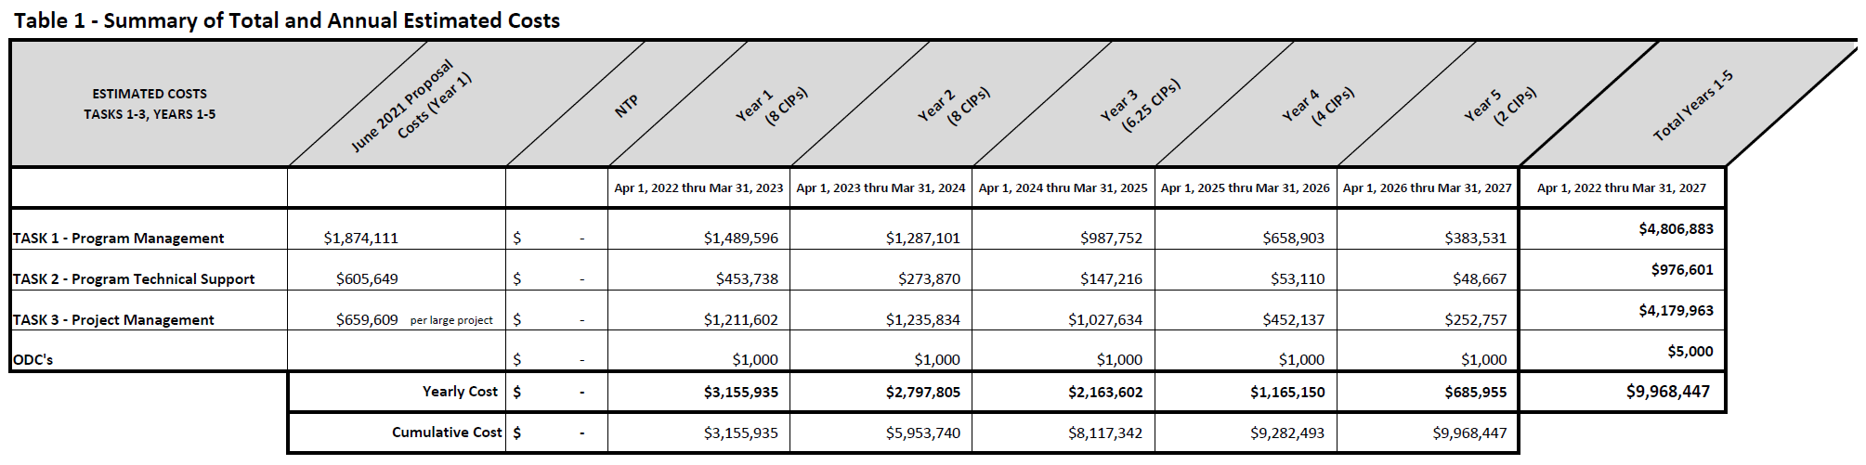

Table 1A: Detailed Breakdown of AECOM's Estimated Labor Costs for Task 1 (Year 1)
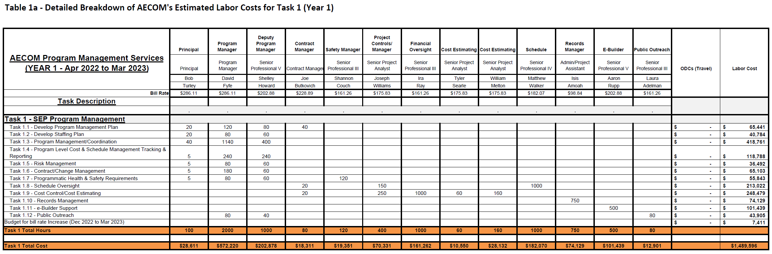

Table 1B: Detailed Breakdown of AECOM's Estimated Labor Costs for Task 1 (Year 2)
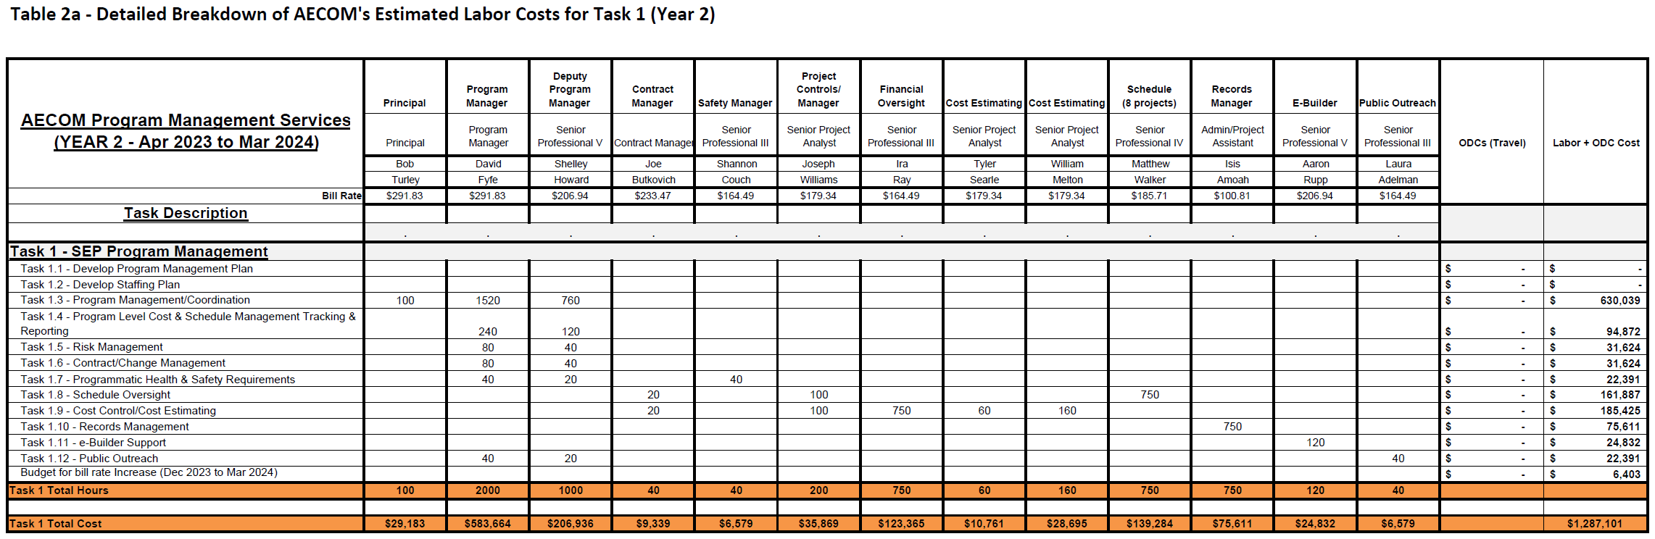
Table 1C: Detailed Breakdown of AECOM's Estimated Labor Costs for Task 1 (Year 3)
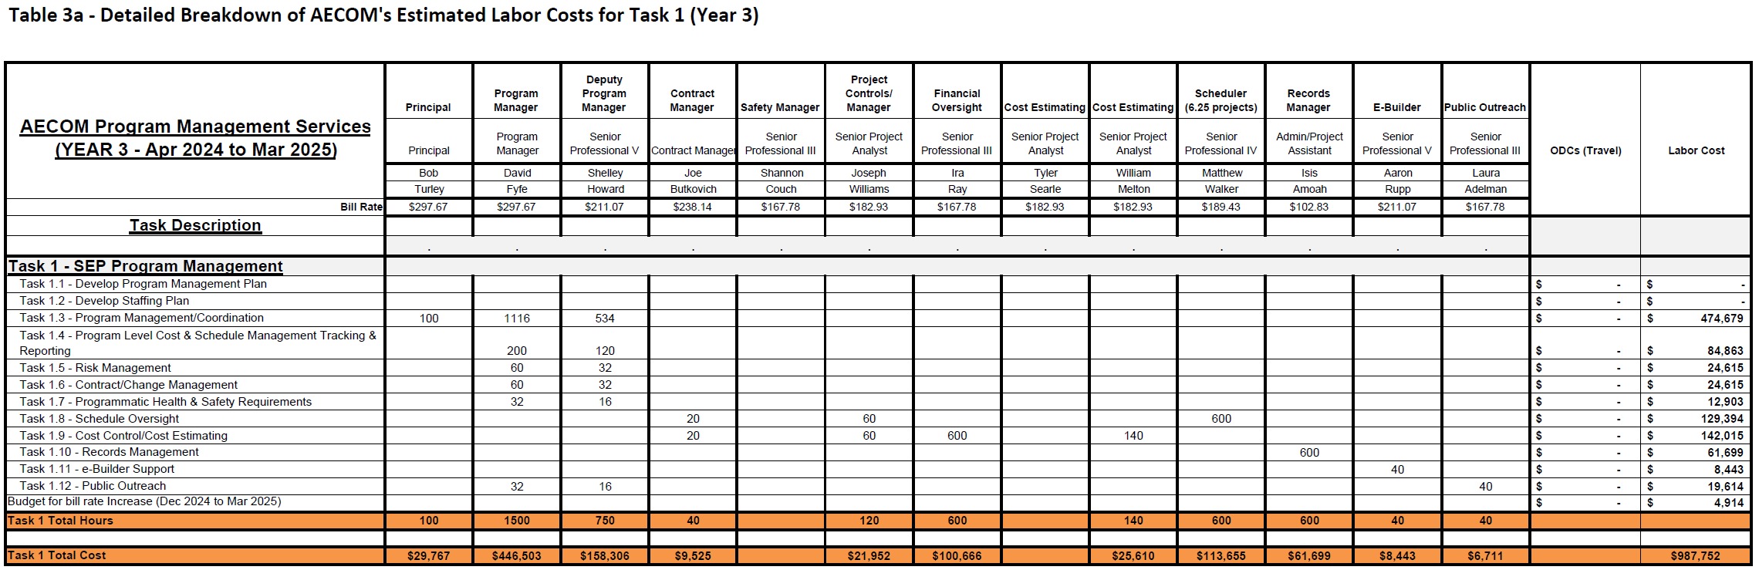

Table 1D: Detailed Breakdown of AECOM's Estimated Labor Costs for Task 1 (Year 4)
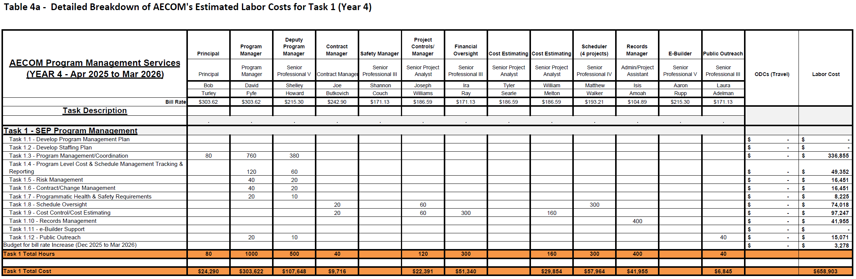
Table 1E: Detailed Breakdown of AECOM's Estimated Labor Costs for Task 1 (Year 5)
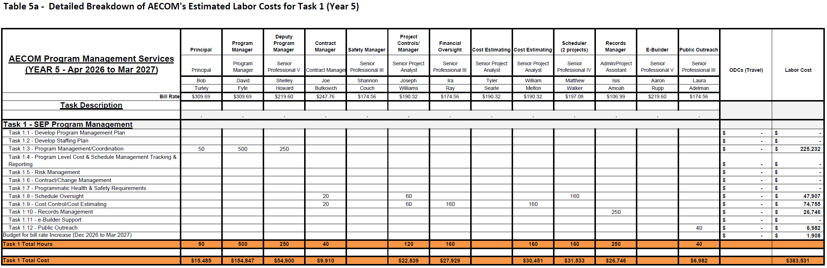

Table 2A: Detailed Breakdown of AECOM's Estimated Labor Costs for Task 2 (Year 1)
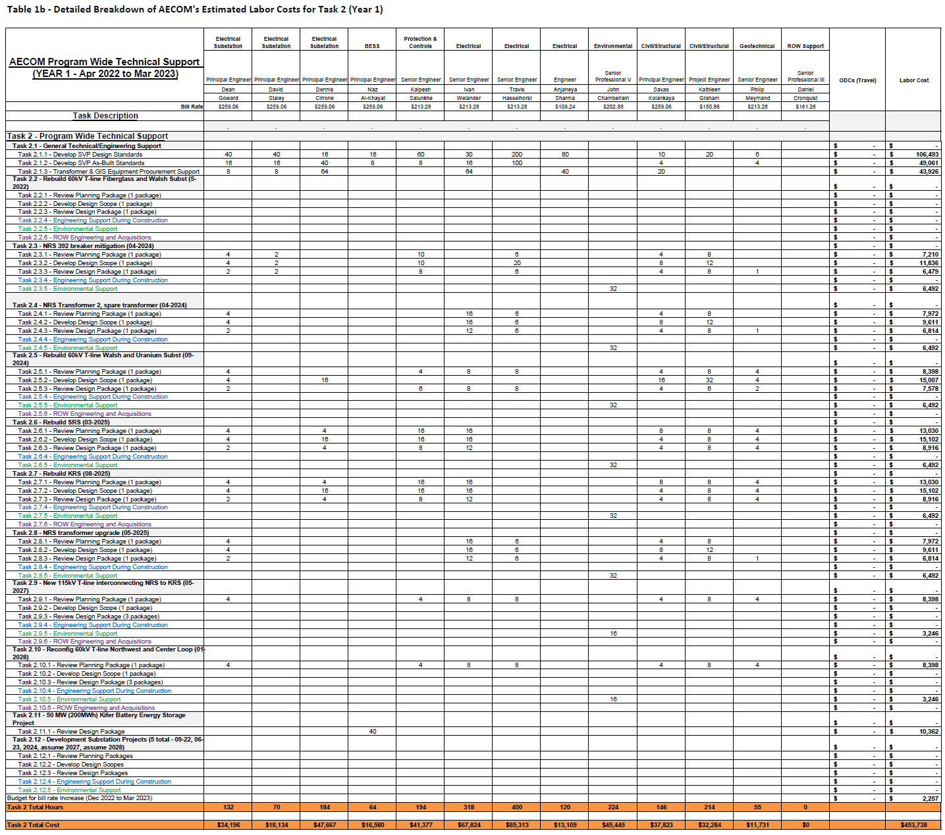

Table 2B: Detailed Breakdown of AECOM's Estimated Labor Costs for Task 2 (Year 2)
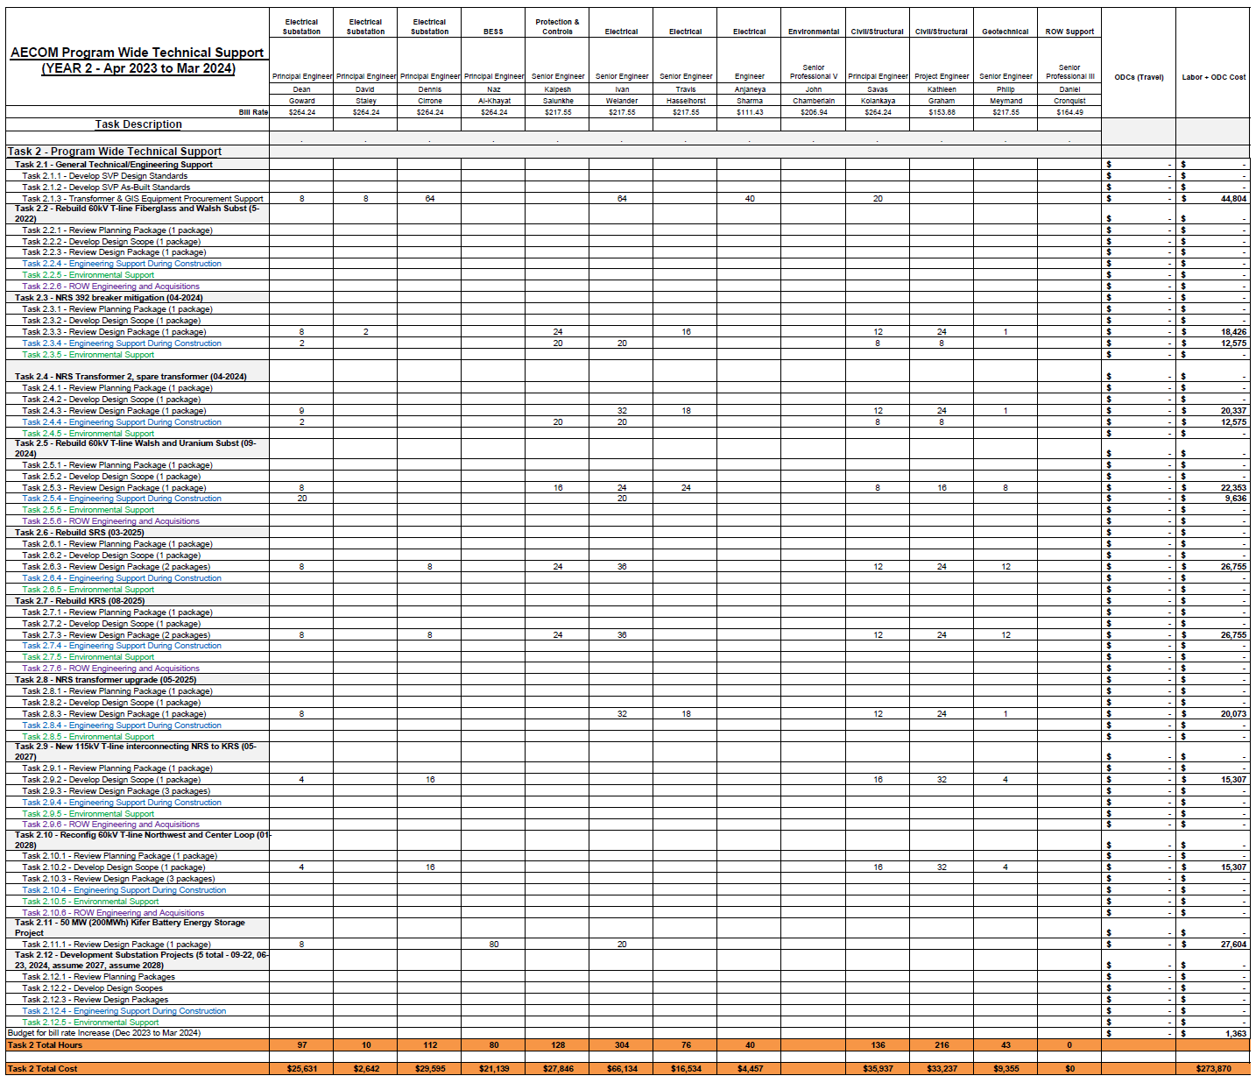

Table 2C: Detailed Breakdown of AECOM's Estimated Labor Costs for Task 2 (Year 3)
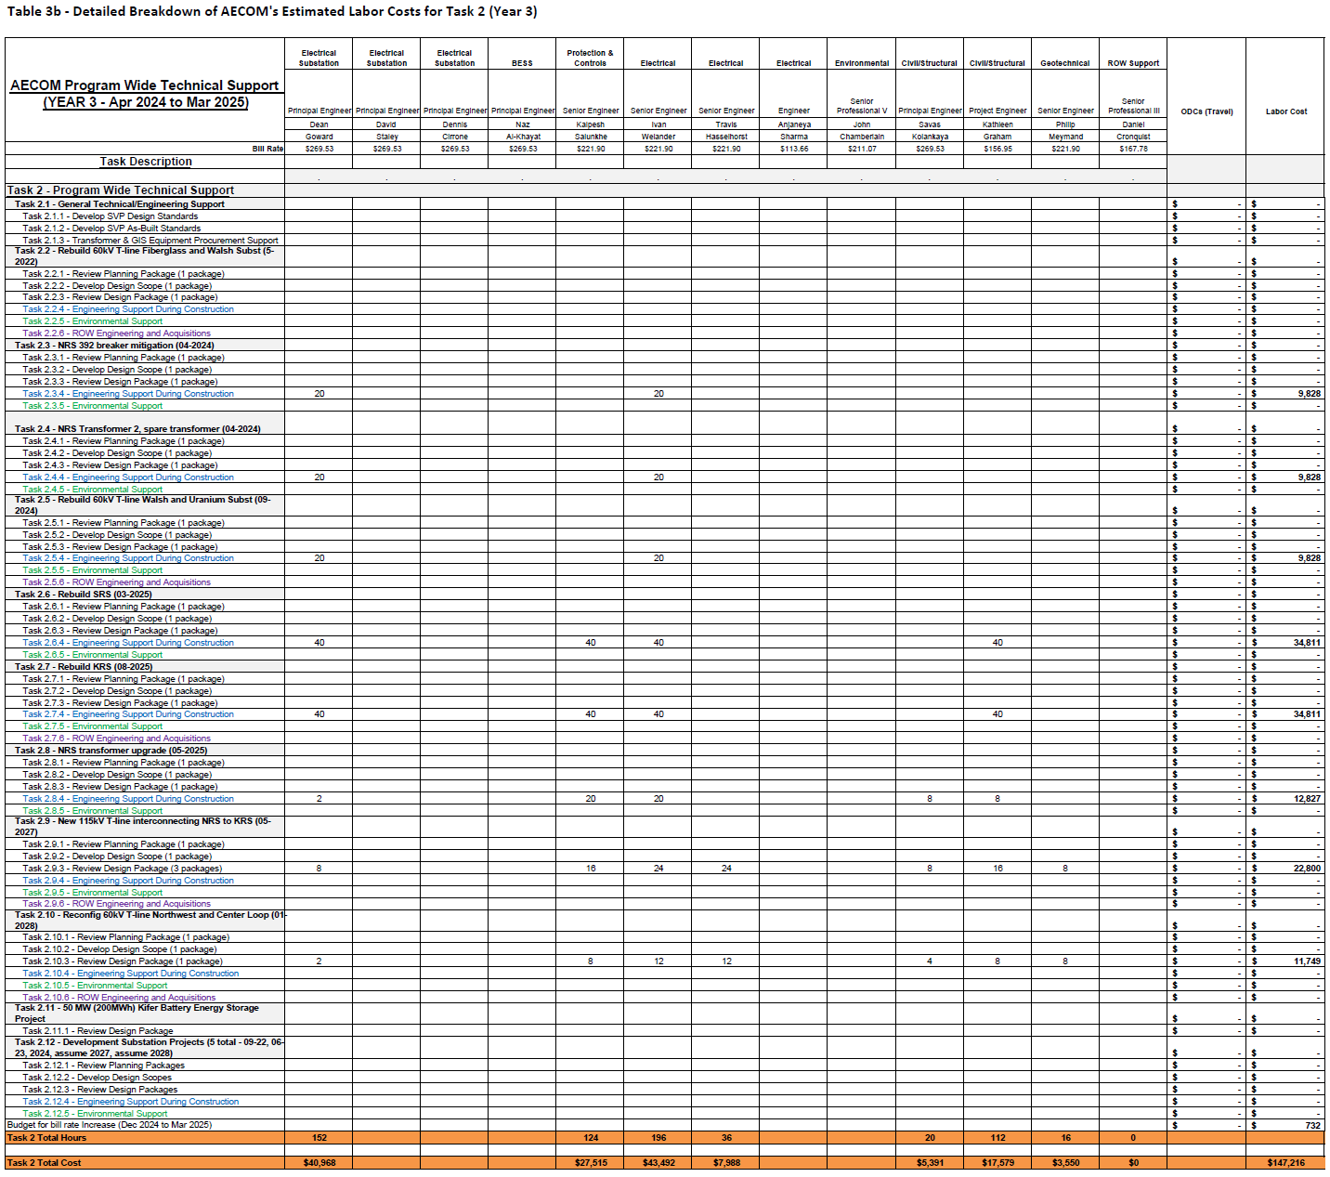

Table 2D: Detailed Breakdown of AECOM's Estimated Labor Costs for Task 2 (Year 4)
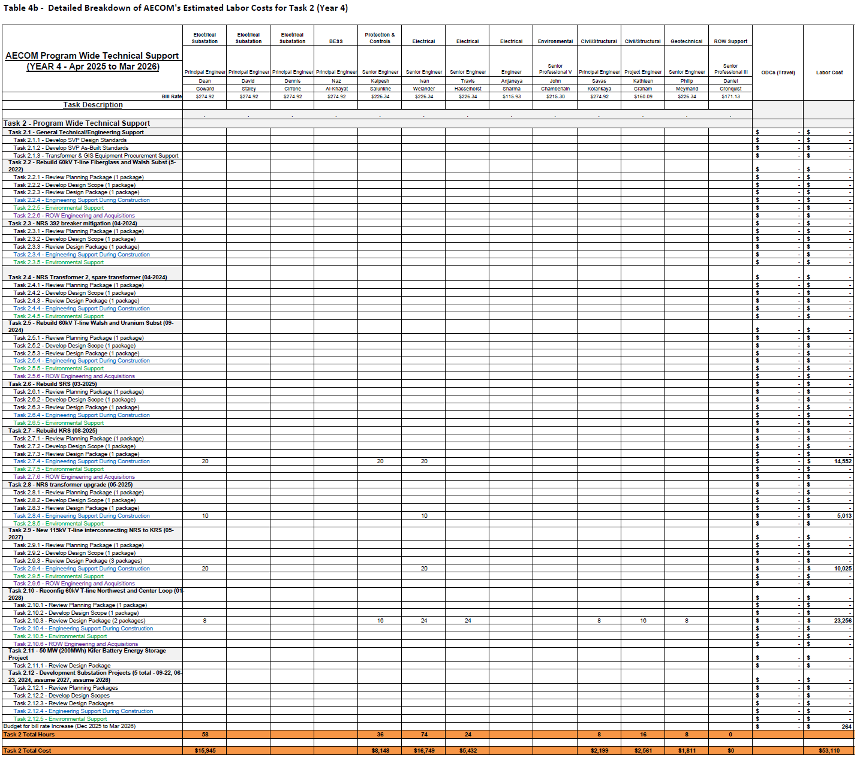

Table 2E: Detailed Breakdown of AECOM's Estimated Labor Costs for Task 2 (Year 5)
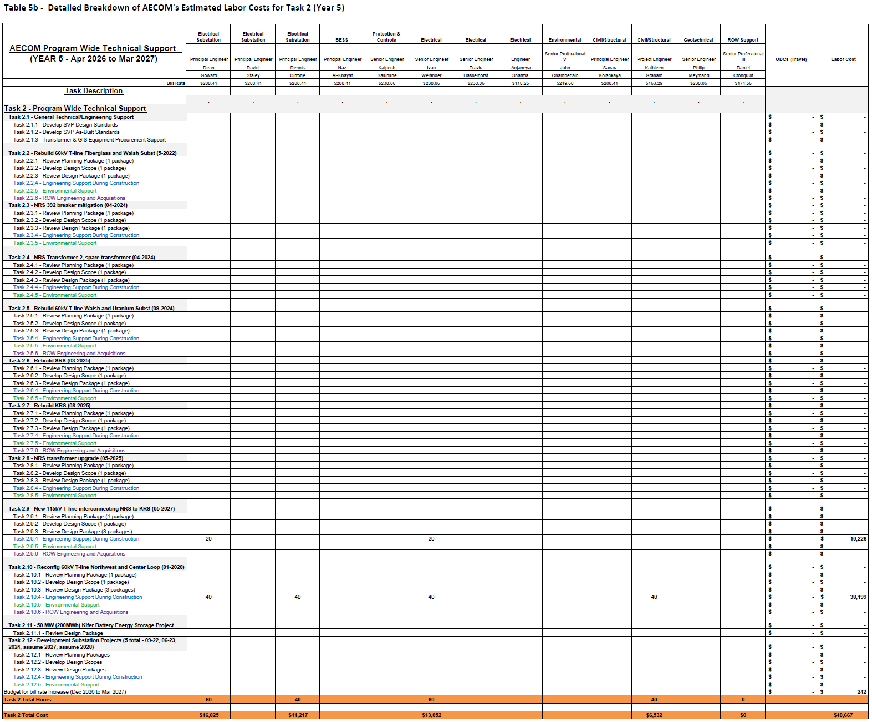

Table 3A: Detailed Breakdown of AECOM's Estimated Labor Costs for Task 3 (Year 1)
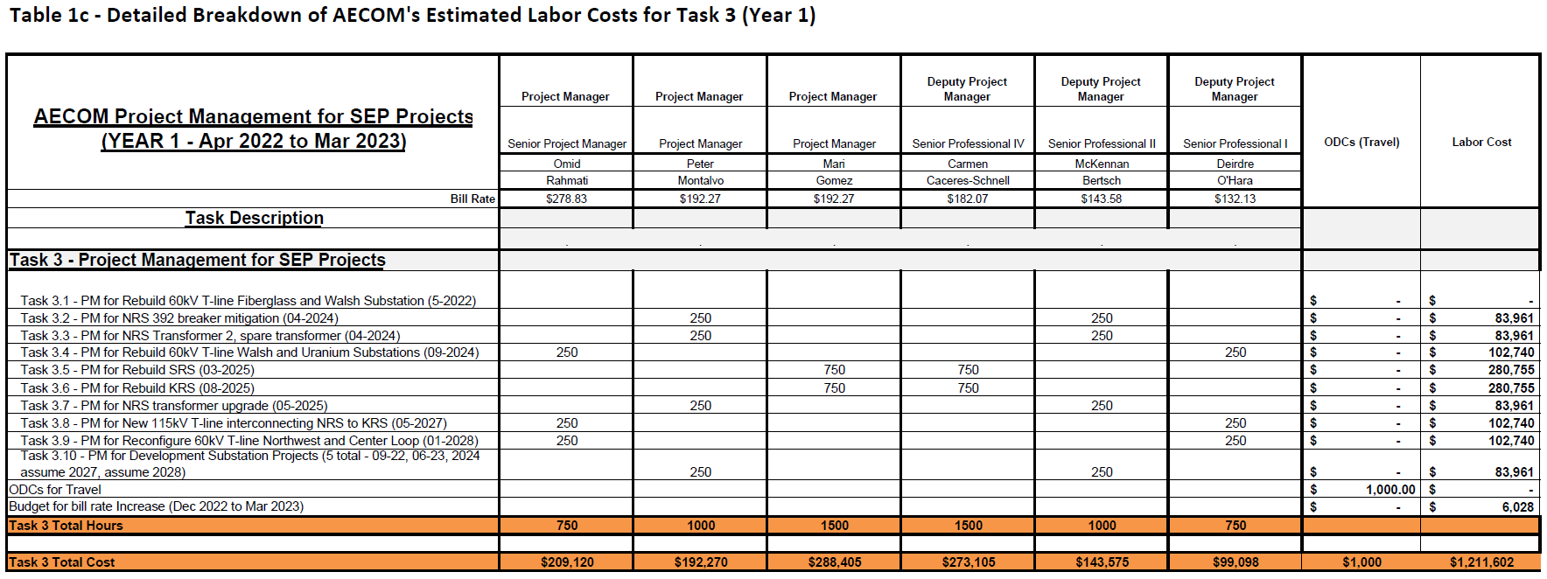

Table 3B: Detailed Breakdown of AECOM's Estimated Labor Costs for Task 3 (Year 2)
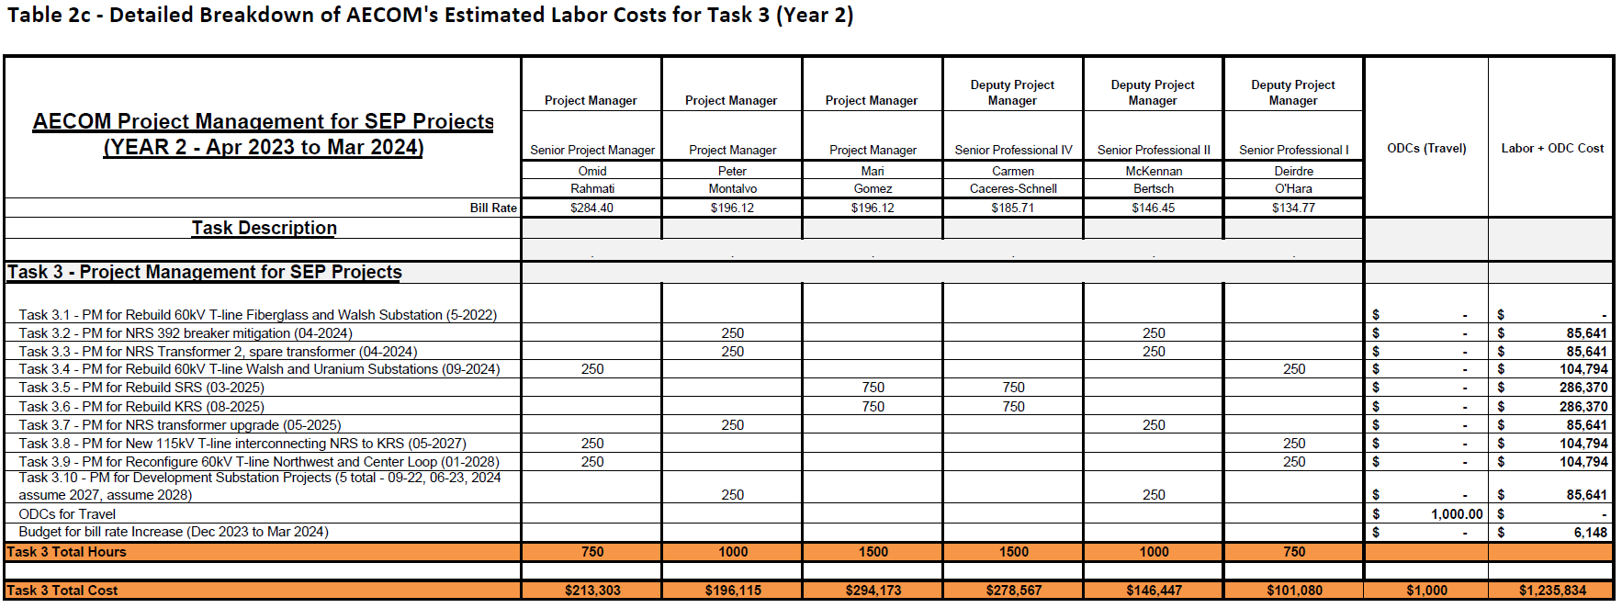

Table 3C: Detailed Breakdown of AECOM's Estimated Labor Costs for Task 3 (Year 3)
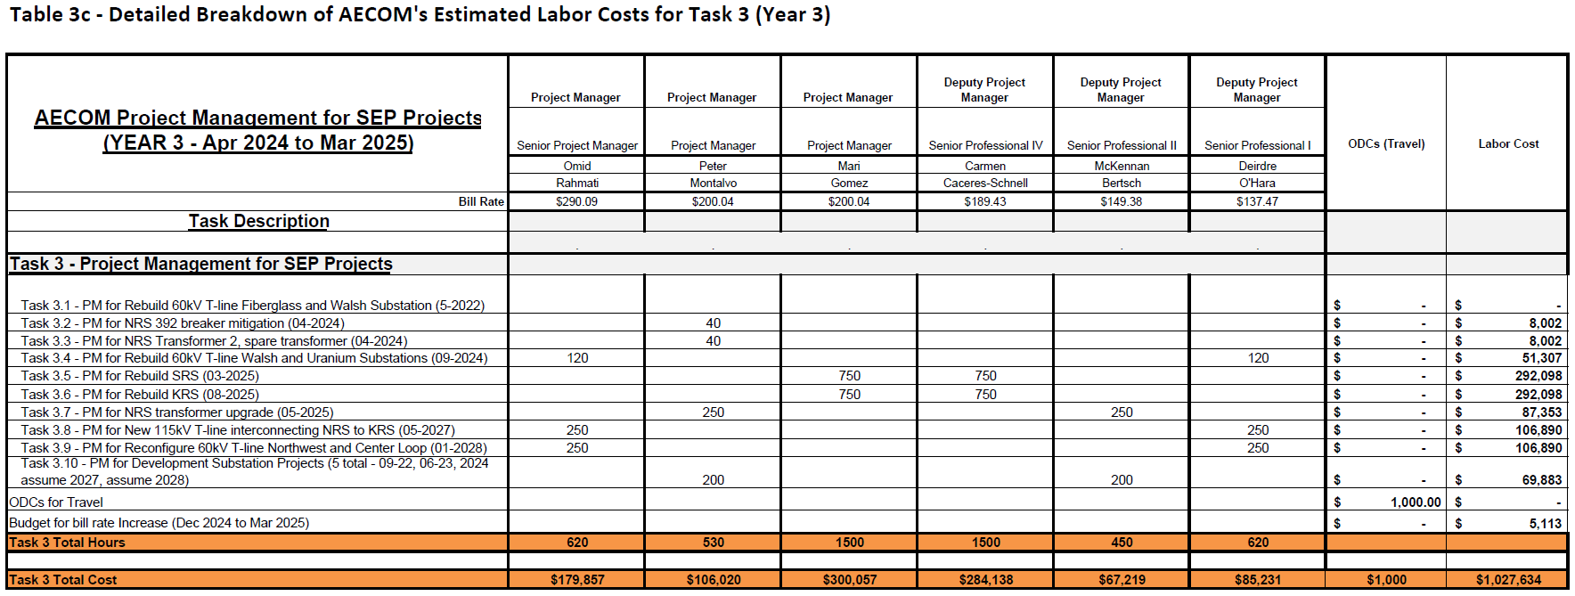

Table 3D: Detailed Breakdown of AECOM's Estimated Labor Costs for Task 3 (Year 4)
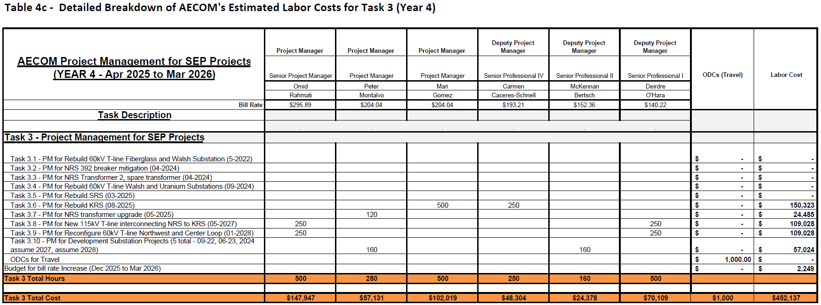

Table 3E: Detailed Breakdown of AECOM's Estimated Labor Costs for Task 3 (Year 5)
