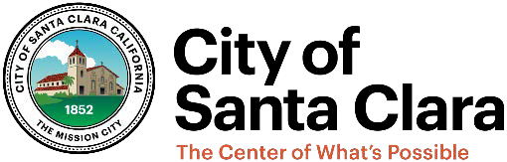

General Plan 2010-2035 Fact Sheet

Adoption Date of General Plan: November 6, 2010
Adoption Date of Housing Element: May 7, 2024; Certified by HCD, May 31, 2024

Consistency with the Office of Land Use and Climate Innovation General Plan Guidelines:
- Consistent, with changes incorporated into the Open Space Element per SB 1425
General Plan Amendments adopted in 2025
- Freedom Circle Focus Area Text Amendment – March 25, 2025
- Housing Element Sites Inventory Modification – April 29, 2025
- Multi-Jurisdictional Hazard Mitigation Plan – April 29, 2025
- Future Focus Area Deletions – May 27, 2025
- Open Space Element Update – December 16, 2025

Priorities for land use decision making that have been established by the local legislative body (e.g., passage of moratoria or emergency ordinances):
- Ordinance 2018, imposing a ban on all commercial cannabis activities, adopted May 12, 2020.

Advance Planning 2025 milestones:
- Incorporation of the Multi-Jurisdictional Hazard Mitigation Plan into the Safety Element
- Open Space Element Update Adoption

Ongoing Advance Planning Activities:
- El Camino Specific Plan
- Santa Clara Station Area Plan
- Tasman East Amendment

