Attachment 6
Sample Speed Humps and Speed Cushions

Speed Humps
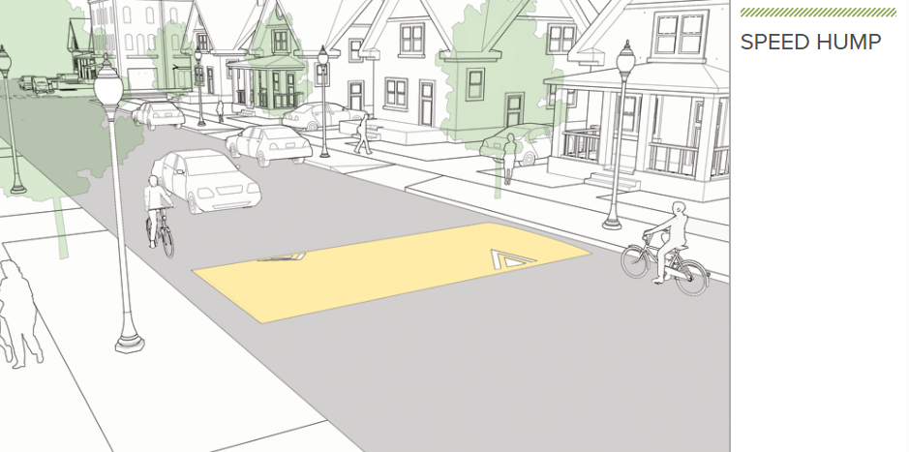
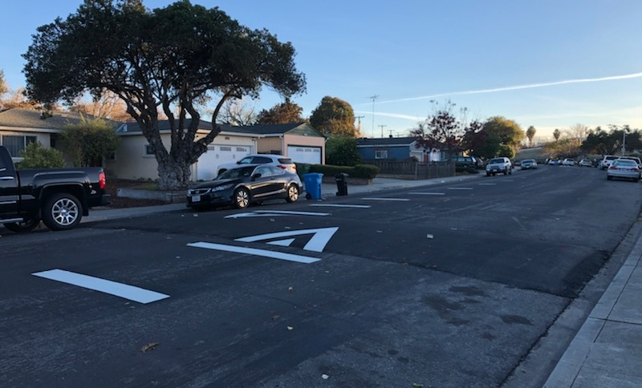Speed Hump on Briarwood Drive, Santa Clara, CA

Speed Cushions
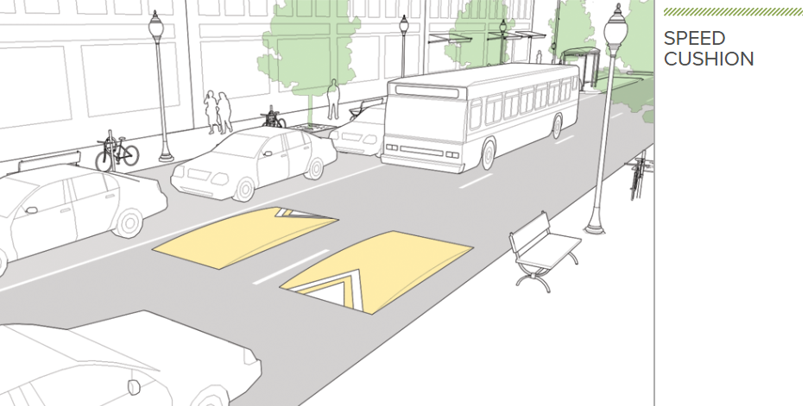
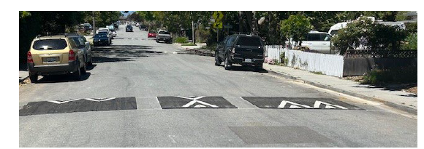
Speed cushions in Santa Cruz, CA
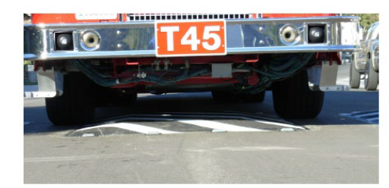
Fire truck driving over speed cushion

