SCSA

Santa Clara Stadium Authority

SANTA CLARA STADIUM AUTHORITY
FINANCIAL STATUS REPORT

Quarter Ending December 31, 2023

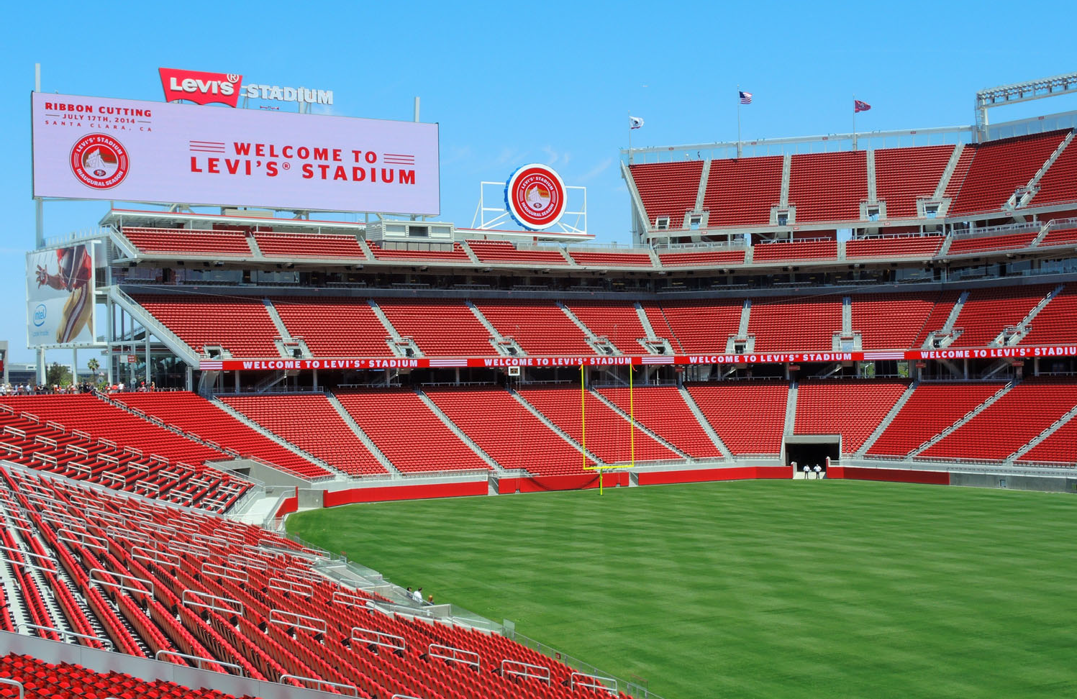

March 19, 2024

Table of Contents
Introduction 2
NFL Events 3
Non-NFL Events 6
Discretionary Fund 12
Stadium Builder Licenses 12
Santa Clara Stadium Authority Budget Status Reports 15
Operating Budget 15
Debt Service Budget 19
Capital Improvement Project Budget 23
City of Santa Clara Net General Fund Impact 26
Public Safety and Administrative Cost Reimbursement 26
Rents and Senior and Youth Fee 27
Other Revenue Impacts 27
Glossary 28

Introduction
This Santa Clara Stadium Authority (Stadium Authority) Financial Status Report provides information covering the third quarter of the Stadium Authority’s 2023/24 fiscal year (FY) which ended on December 31, 2023. Comparative data from prior fiscal years is also included.

In addition to these quarterly reports, the Stadium Authority produces annual financial statements. The FY 2022/23 financial statements were audited by an external audit firm and presented to the Stadium Authority’s Audit Committee on August 30, 2023 and approved by the Stadium Authority Board (Board) on September 19, 2023. The financial statements are published on the Stadium Authority’s website.
The Stadium Authority also prepares a detailed budget prior to the beginning of each fiscal year. The FY 2023/24 budget was adopted by the Board on March 7, 2023.
Stadium Authority finances are structured so that the City of Santa Clara (City) is not liable for the debts or obligations of the Stadium Authority. All services provided by the City, including administrative and public safety, to the Forty Niners Stadium Management Company, LLC (ManCo) or the Stadium Authority are fully reimbursed with Stadium Authority funds.
Methodology
Information provided in this report was based in part on documentation submitted by ManCo. Specifically, National Football League (NFL) and Non-NFL event statistics and financial information relating to ManCo expenses are provided by ManCo. Stadium Authority staff has access to select financial information submitted by ManCo provided through the Stadium Authority’s Financial Management System and event reports received for Non-NFL events. These reports are received 45 days after each event for events with attendance greater than 25,000. More detailed documents are received within 90 days after the close of the quarter. For all other financial information, a full detailed review and/or audit of source documentation has not been completed by the Stadium Authority for this report.

The information provided reflects the best known and available at the time of the writing of this report and is subject to further revision and review. Revisions may occur based on the timing of revenue and expenditure activity for events in this quarter that continue beyond the timing of this report. Consequently, the Board’s notation and filing of this report should not be considered an approval of the accuracy of the information in the report.

NFL Events
This section provides year-to-date and comparative data for NFL games categorized as pre-season and regular season games.

The San Francisco Forty-Niners (49ers) played a total of nine NFL games (two pre-season games and seven regular season game) at Levi’s® Stadium through the quarter ending December 31, 2023. There was a total of 617,452 tickets sold to these NFL games, an average of 68,606 per game. This is down by 810 or 1% when compared to the same period in the prior fiscal year. The ticket sales resulted in $11.5 million in NFL ticket surcharge revenue (10% of ticket sales) to the Stadium Authority. The average NFL ticket surcharge revenue was $1.3 million per game in the current year which is up by $127,000 or 11% from the same period in the prior fiscal year. A total of $216,000 of Senior and Youth Program Fees, which is based on $0.35 per NFL ticket sold, were collected through the end of the third quarter of the fiscal year. These fees were transferred to the City’s General Fund in support of such programs.

A total of 68,371 cars were parked in the permitted offsite parking lots generating $440,000 in offsite parking fees. The overall number of cars parked in the permitted offsite lots increased by an average of 167 cars per game or 2% when compared to the prior fiscal year.

There was an estimated $4.4 million of NFL event public safety costs in the current reporting period which is an average of $489,000 per game. This is an increase from the prior year average (through December 31, 2022) of $40,000. Of the $4.4 million NFL event public safety costs, $3.7 million or 84% are direct City costs and $724,000 or 16% are outside agency costs. $440,000 of the total NFL event public safety costs are covered by the offsite parking fees that were collected and the remaining are invoiced to ManCo. Reimbursements usually take between 3 to 6 months from the event date due to the timing of third-party invoices and payment from ManCo.

Statistics for the NFL games held at Levi’s® Stadium in the first three quarters of the 2023/24 fiscal year are shown in Table 1 and comparative data from all ten years of operations can be found in Table 2.

Table 1

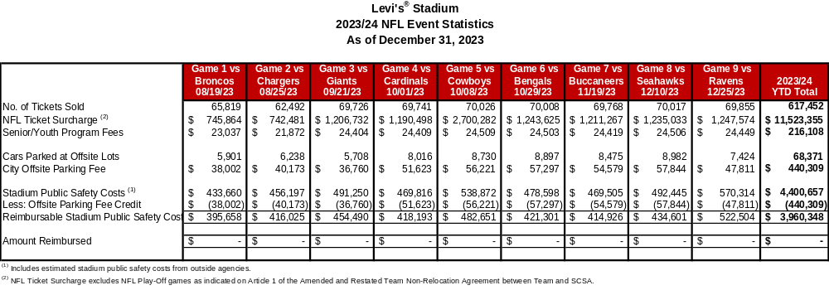

Table 2
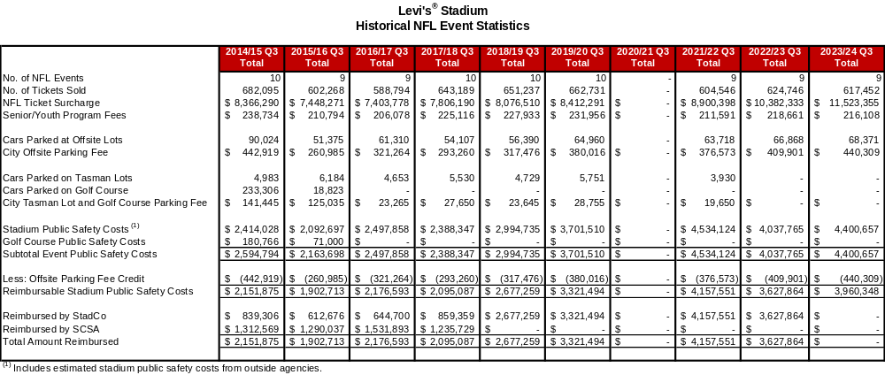

Non-NFL Events
This section provides year to date and comparative data for Non-NFL events categorized as events ranging from high school and college football games, international soccer matches, concerts, wedding fairs, and special events. During the current reporting period, there were a total of 397,940 tickets sold for the eight ticketed Non-NFL events that were held, resulting in $1.6 million Non-NFL event ticket surcharge revenue (from the $4 per ticket Non-NFL event surcharge). This is an increase in ticket surcharge revenue of $630,000 or 66% over the same period in the prior year. There was one additional ticketed Non-NFL events when compared to the same period in the prior year and the ticketed Non-NFL events in the current reporting period were larger-scale events resulting in the increase in the ticket surcharge revenue.

ManCo reports that there were also 37 smaller special events held at Levi’s® Stadium which is 19 events less than the same period of the prior fiscal year. The attendance at these events also decreased from 22,410 in the prior period to 18,433 in the current year, a 18% decrease. Examples of these special events include corporate events of various sizes, weddings, holiday parties, high school dances, etc.

In correlation with the Non-NFL events held during the current reporting period, there were 38,716 cars parked at these offsite lots and the City earned a total of $248,000 in related offsite parking fees, which is derived from the $6.13 per parking space fee for events taking place prior to July 2023 and $6.44 per parking space for all events thereafter. The revenues earned from this offsite parking fee supports public safety costs for Non-NFL events. The offsite parking fee invoices can take up to a few months to be fully paid.

Total Non-NFL event public safety costs were $3.3 million an increase of $764,000 from the prior year. As noted previously, this increase in cost is due to more large-scale events being held in the current year when compared to the prior year. Of these costs, $248,000 was covered by the offsite parking fee. The remaining $3.0 million was invoiced to ManCo which will be reimbursed to the City. Reimbursements usually take between 3 to 6 months from the event date due to the timing of third-party invoices and payment from ManCo.

Statistics for FY 2023/24 events are shown in Table 3 and comparative data from all ten years of operations are shown in Table 4.
Table 3
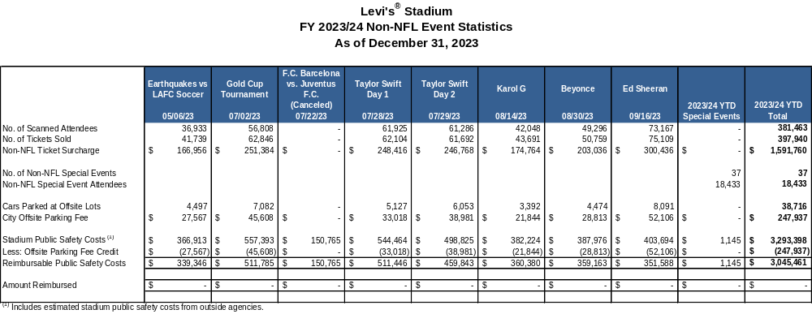

Table 4

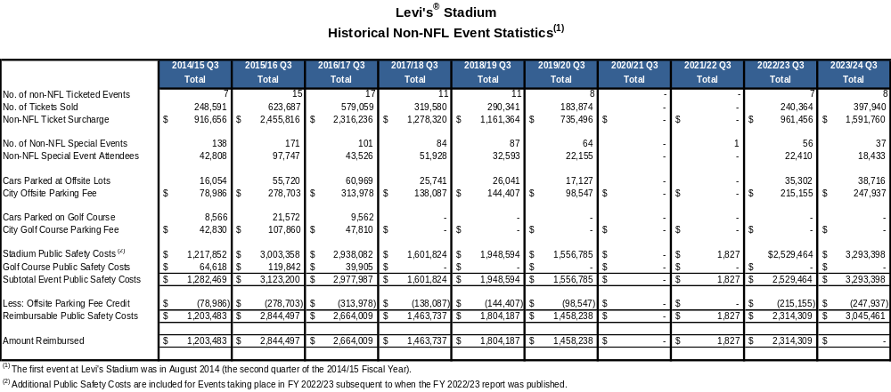

Table 5 summarizes ticketed Non-NFL revenues and expenditures by event reported by ManCo as of the report date. There were 8 ticketed Non-NFL events held in FY 2023/24 and generated an average net revenue of $738,000 per event. The inclusion of this information is to provide a greater level of transparency and provide the overall financial results of the Non-NFL events.

Table 5

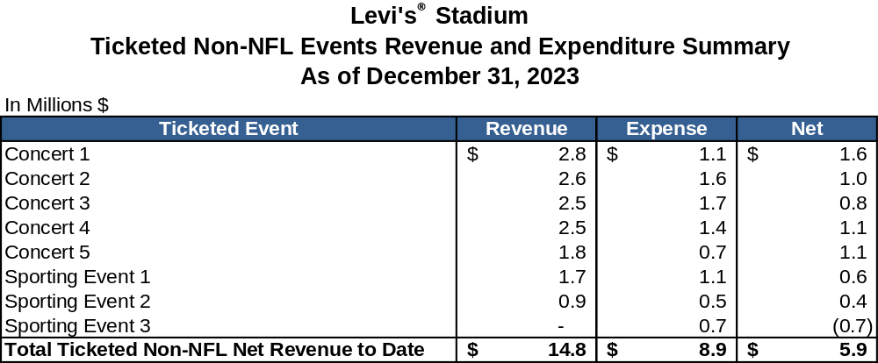

Table 6 and 7 show Non-NFL net revenue by event type and event revenue and expenses by category. For FY 2023/24, ManCo anticipates Non-NFL events to result in projected net revenues of $7.8 million, as cited in the documents provided for the FY 2024/25 Proposed Stadium Authority Budget. Through the third quarter of FY 2023/24, ticketed events and non-ticketed special events contributed $5.9 million and $1.2 million in net revenues, respectively. There was also additional interest income of $1.7 million earned on Non-NFL events cash reserves. Offset by $1.0 million of non-event specific other expenses, ManCo reported a net revenue of $7.8 million for the current reporting period.

Table 6
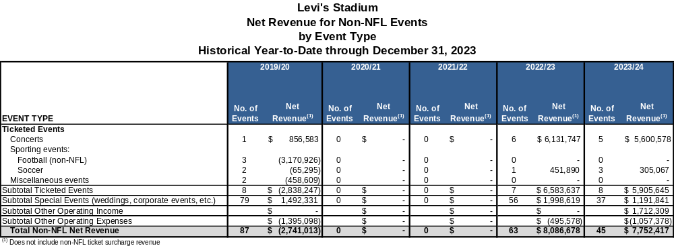

Table 7

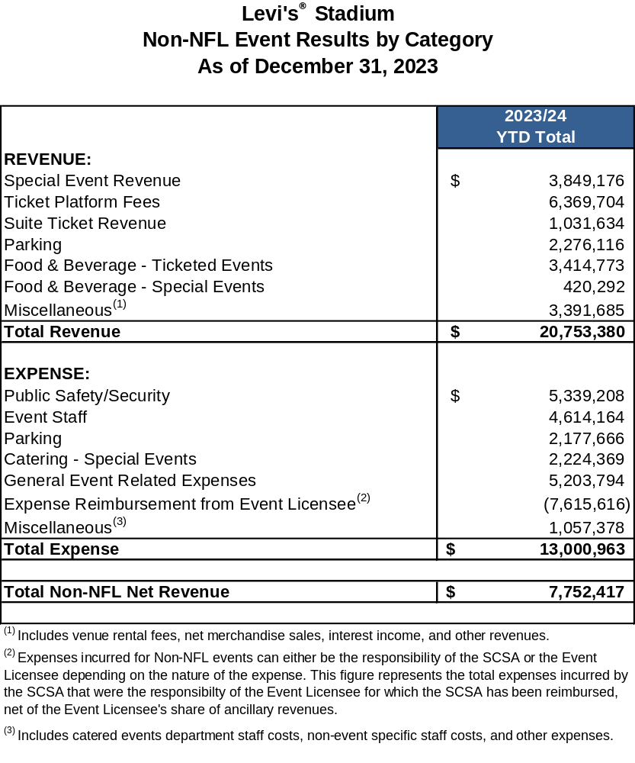

Discretionary Fund
The Discretionary Fund is funded by revenue equal to 50% of the Non-NFL event ticket surcharge of $4 per ticket. The eight ticketed Non-NFL events are projected to contribute approximately $796,000 to the Discretionary Fund in the reporting period. This is based on the estimated attendance provided by ManCo. At the time of this report, $796,000 has been collected for the current fiscal year. Table 8 shows the revenues and expenses in the Discretionary Fund since FY 2014/15. The balance at the time of this report is $2.5 million.

Table 8

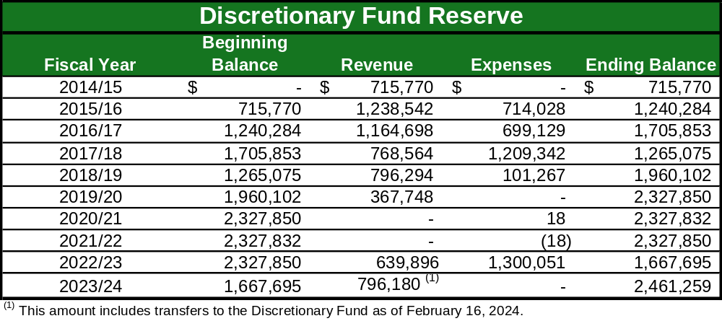

Stadium Builder Licenses
The total principal value of currently active Stadium Builder Licenses (SBLs) is $552.0 million and, as of December 31, 2023, 95.1% of the total principal value of all SBLs sold (i.e., $524.8 million) had been collected. Payment for the sale of SBLs are financed over 10 years.

SBL holders that finance their purchase pay an annual interest rate of 8.5% and payments are due by March 1st each year. The majority of SBL holders make their payments on time. For those that do not pay on time, SBL service staff, working for ManCo on the Stadium Authority’s behalf, contact the SBL holders and attempt to collect the full amounts owed. Ultimately, a SBL can be defaulted for non-payment. Once a SBL is defaulted, the SBL holder in default loses their right to buy season tickets as well as their priority rights to tickets to Non-NFL events, and forfeits any money they had invested in the SBL. Defaulted SBLs are then available for resale.

There is a total of 64,090 currently active SBLs, or 96.9% of the 66,136 total sellable SBL seats. This is an increase of 875 from the total active SBLs at the end of the prior fiscal year (March 31, 2023). The main reasons for the increase are due to sale of new SBLs and customer seat relocation program offset by default buy back. The customer seat relocation program allows customers to trade in their SBLs in return for others in a

different location as long as the total face value of the new seats is equal to or greater than the original seats.

During the current reporting period, 1,292 SBLs were sold for a total face value of $7.7 million. The customer seat relocation program resulted in an increase of $763,000 to the SBL face value, while netting 93 more SBLs. There were also 510 SBL defaulted with a face value of $3.6 million.

Additional details regarding currently active SBLs are noted in Table 9.

Table 9

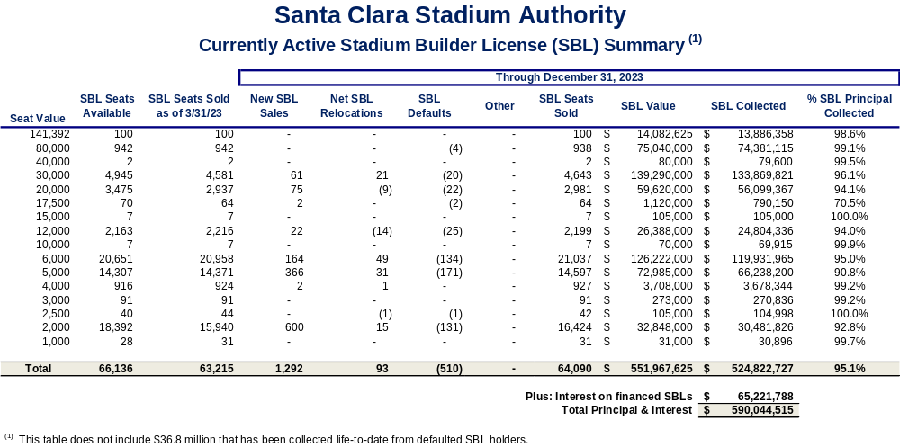

Santa Clara Stadium Authority Budget Status Reports

Operating Budget

With 75% of the fiscal year complete, total operating revenues for the third quarter of the 2023/24 Fiscal Year were $52.8 million representing 81% of the overall budget for revenues. During the current reporting period, the Stadium Authority collected $12.2 million in SBL proceeds or 97% of what was budgeted. All SBL proceeds are to be transferred to the debt service fund per applicable loan agreements. Stadium Authority also recognized $19.9 million in rent from StadCo, $11.5 million in NFL Ticket Surcharge, $3.7 million in Naming Rights, $3.1 million in interest, $1.6 million in Non-NFL ticket surcharge, and $408,000 in sponsorship (STR) revenue all of which are expected to meet budget this fiscal year.

Total Operating expenses were $16.4 million, or 70% of the annual budget. Shared Stadium Manager expenses were at 74% of the budget, or $10.3 million of the $13.9 million budgeted amount and SBL Sales and Service expenses were 75% of the budget or $1.7 million. The Stadium Authority pays for all utility costs from February 1st through July 31st and the tenant (StadCo) pays for utility costs from August 1st through January 31st (Tenant Season). Therefore, utility costs are 67% of the budget for the year, or $927,000. The current period covers 67% (four out of the six months) that the Stadium Authority is responsible for utility costs. Lastly, Stadium Authority G&A costs were tracking below budgeted levels at $2.0 million or 50% of the budget.

On August 31, 2022, the Stadium Authority entered into a settlement agreement with StadCo and ManCo over disputes regarding the operating and management expenses, shared expenses, and capital expenditures that were previously withheld. As part of the settlement, the Stadium Authority agreed to timely pay for the budgeted expense for its share of Shared Stadium Manager expenses and other expenses for the current fiscal year, with Stadium Authority reserving all rights to confirm or dispute charges paid. This settlement does not include Stadium Authority making payments to StadCo for NFL public safety costs and NFL-SBL buffet costs, which are part of the parties’ pending arbitrations.

Additional details are shown in Table 10.

Table 10
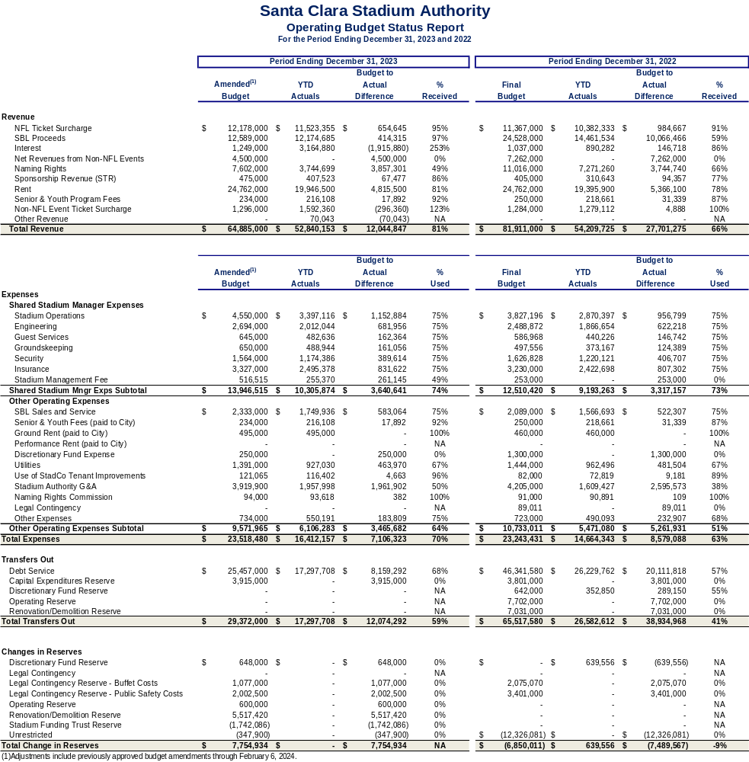

Operating Budget – Recommended Budget Adjustments
From time to time, budget adjustments may be necessary to align revenues or expenditures to actual or unexpected activity during the course of a fiscal year, known after the adoption of the Stadium Authority Budget.

On March 7, 2023, the Stadium Authority Board adopted the Santa Clara Stadium Authority FY 2023/24 Operating, Debt Service, and Capital Budget. Subsequent budget amendments were also adopted on November 14, 2023 and February 6, 2024. The following budget adjustments are recommended based on FY 2023/24 projected actuals reported in the proposed FY 2024/25 Operating, Debt Service, and Capital Budget which will go to the Board for adoption on March 12, 2024.

- Senior and Youth Program Fees – Two (2) additional NFL playoff games were held at Levi’s Stadium beyond the ten (10) regular season games resulting in the collection of additional Senior and Youth Program Fees (based on $0.35 per NFL game ticket). It is projected that the Stadium Authority will collect $250,000 of Senior and Youth Program Fees which is $16,000 higher than budgeted. A budget adjustment is needed to reflect the increase in the payment to the City’s’ General Fund by $16,000.

- Use of StadCo Tenant Improvements – The Stadium Authority is charged fees for the use of StadCo assets during Non-NFL events. Use of StadCo Tenant Improvements is projected to be higher than anticipated by $11,935. A budget adjustment is needed to reflect the increase in Use of StadCo Tennant Improvements of $11,935.

Additional details are shown in Table 11.
Table 11

Santa Clara Stadium Authority
2023/24 Operating Budget Adjustment

Item # | Line Item | Source of Funds | Use of Funds | Explanation
1 | Senior and Youth Program Fees | 16,000 |  | This action increases the Operating Budget for the Senior and Youth Program Fees by $16,000 due to higher anticipated number of NFL tickets sold.
1 | Senior and Youth Fees (paid to City) |  | $16,000 | This action increases the Operating Budget for the Senior and Youth Fees (paid to City) by $16,000 due to higher anticipated number of NFL tickets sold.
2 | Use of StadCo Tenant Improvements |  | $11,935 | This action increases the Operating Budget for the Use of StadCo Tenant Improvements by $11,935. Stadium Authority made use of more StadCo Tenant Improvements during Non-NFL events than anticipated.
2 | Ending Fund Balance – Renovation/Demolition Reserve |  | $(11,935) | This action decreases the Renovation/Demolition Reserve to offset action taken for the Use of StadCo Tenant Improvements. Any increase in revenues and expenses will impact the projected amount in the Renovation/Demolition Reserve since this is the current bucket being filled by current year excess revenues.
 | Total | $16,000 | $16,000

Debt Service Budget
The Stadium Authority’s FY 2023/24 debt service revenue budget of $2.7 million represents anticipated contributions from the Community Facilities District (CFD). The CFD levies and collects a special hotel tax on hotel rooms within the CFD. All collections from the special CFD hotel taxes are contributed to Stadium Authority to pay down the CFD Advance. The CFD Advance is payable solely from amounts received by the Stadium Authority from the CFD. During the first three quarters, $2.6 million was contributed by the CFD, or 97% of the annual budget. Of this amount, $2.0 million was collected and used to pay down the CFD Advance.

Total Stadium Authority debt service expenses for the current reporting period were
$25.1 million, or 90% of the budgeted amount. The debt service expenses for the CFD Advance and the Term A Loan were $2.1 million and $23.0 million, respectively.

As of December 31, 2023, the total outstanding amount of Stadium Authority debt had declined to $229.0 million. This is a reduction in principal of $16.3 million from the March 31, 2023 outstanding debt amount of $245.3 million.

Additional details are shown in Tables 12 and 13 and Chart 1.

Table 12

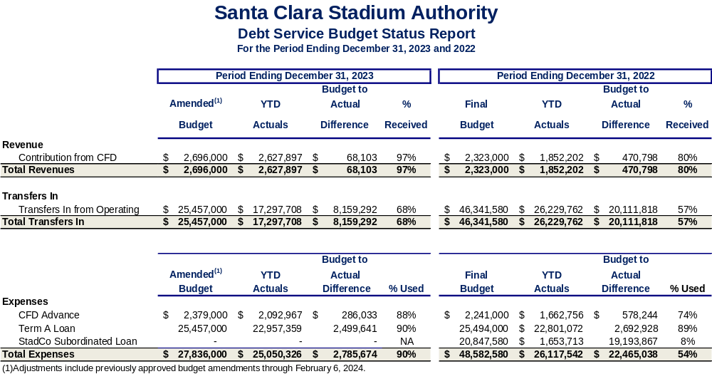

Table 13

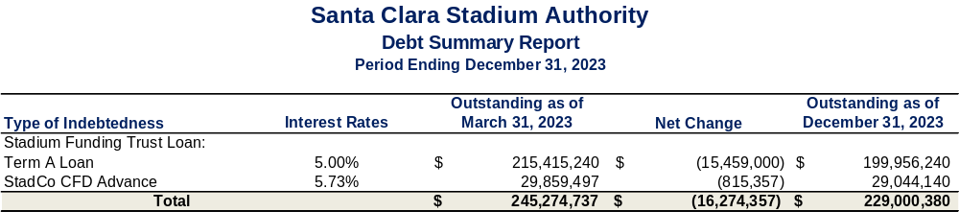

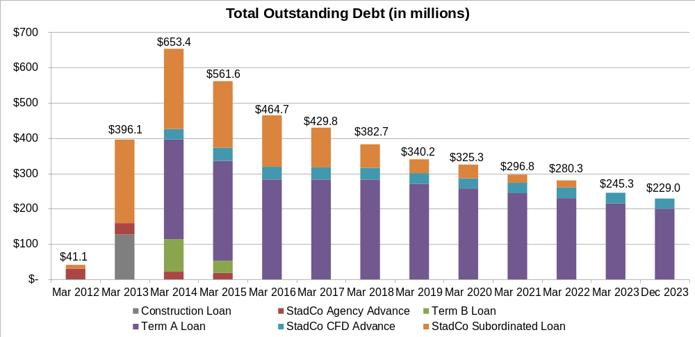
Chart 1

Debt Service Budget – Recommended Budget Adjustments
From time to time, budget adjustments may be necessary to align revenues or expenditures to actual or unexpected activity during the course of a fiscal year, known after the adoption of the Stadium Authority Budget.

On March 7, 2023, the Stadium Authority Board adopted the Santa Clara Stadium Authority FY 2023/24 Operating, Debt Service, and Capital Budget. Subsequent budget amendments were also adopted on November 14, 2023 and February 6, 2024. The following budget adjustments are recommended based on FY 2023/24 projected actuals reported in the proposed FY 2024/25 Operating, Debt Service, and Capital Budget which will go to the Board for adoption on March 12, 2024.

- Contribution from CFD - Due to a continued improvement in the economy post COVID, hotel stays have been higher than anticipated, therefore CFD revenue is projected to be higher which allows for additional debt payment on the CFD Advance. A budget adjustment of $521,000 is needed to reflect the increase in Contribution from CFD and the paydown of the CFD Advance.

Additional details are shown in Table 14.

Table 14

Santa Clara Stadium Authority
2023/24 Debt Service Budget Adjustment

Item # | Line Item | Source of Funds | Use of Funds | Explanation
1 | Contribution from CFD | $521,000 |  | This action increases the Contribution from CFD due to higher anticipated CFD revenues.
1 | CFD Advance Expense |  | $521,000 | This action increases the Debt Service Budget for the debt payment of the CFD Advance by $521,000. The expenditure for CFD Advance increased due to higher anticipated CFD revenues that will fund the pay down of debt.
 | Total | $521,000 | $521,000

Capital Improvement Project (CIP) Budget

As part of the Capital Expense (“CapEx”) Plan, the following projects have been completed as of the current reporting period:
      - Blackline Combustible Gas Indicators
      - Cooling Towers
      - LED Retrofit Project – Exterior Luminaire Light Fixtures
      - Lucas CPR Assist Device
      - Mobile Security Closed Circuit Television Pop Up Trailers
      - Security Control Situation Room Enhancements
      - Variable Frequency Drive(s)

The following projects were underway during the current reporting period:
      - Aesthetic Improvements – Premium Areas/Special Event Spaces
      - Beverage Distribution System
      - Bowl Camera Upgrade/Refurbishment
      - CO2 Monitoring & Sensors for Code Compliance
      - Concessions Cart Cabling for Portable Carts
      - Concrete Replacements
      - Enhance Stadium Security Coverage
      - General Areas/Coating Main Deck
      - High Voltage (480V Electrical Power Study, Assessments and Replacements – Phase 2
      - High Voltage (Primary Main Switch Gear Transformer, Battery & 12KV Main Circuit Breakers)
      - Main Kitchen Equipment
      - Medixsafe Narcotics Safe
      - Overhead Doors, Motors, Sensors and Track Replacements
      - New Seating – Bowl Padded Seat Replacement Project
      - Replacement of end of life IT Network equipment
      - Smoke Evacuation System – Fire Smoke Curtain Replacement
      - Stadium Event Signage
      - Updated Stadium Wayfinding Signage
      - Women’s Locker Room

The CIP Budget increased from $20.5 million to $21.0 million in the current reporting period due to a budget amendment that was adopted on November 14, 2023. A total of $5.9 million has been spent during the first three quarters of FY 2023/24, which amounts to 28% of the budget. The main reason that this is below budget is due to the timing of activity for Capital Expenditure projects. There has also been no activity on warranty work which makes up 7% of the CIP Budget.

On August 31, 2022, the Stadium Authority entered into a settlement agreement with StadCo and ManCo over disputes regarding the operating and management expenses, shared expenses, and capital expenditures that were previously withheld. As part of the settlement, in regard to Capital Expenditures, the Stadium Authority agreed to discontinue the temporary practice of withholding payment for Capital Expenditures subject to the review and approval of the prevailing wage documentation by Stadium Authority’s labor law compliance consultant. Under the Settlement Agreement, ManCo further confirmed its obligation to comply with applicable laws, including Prevailing Wage Laws, and ManCo also implemented its new internal Prevailing Wage Laws compliance policy and procedures. Accordingly, the Stadium Authority will process the invoice payments as they come in.

Additional details are shown below in Table 15.

Table 15

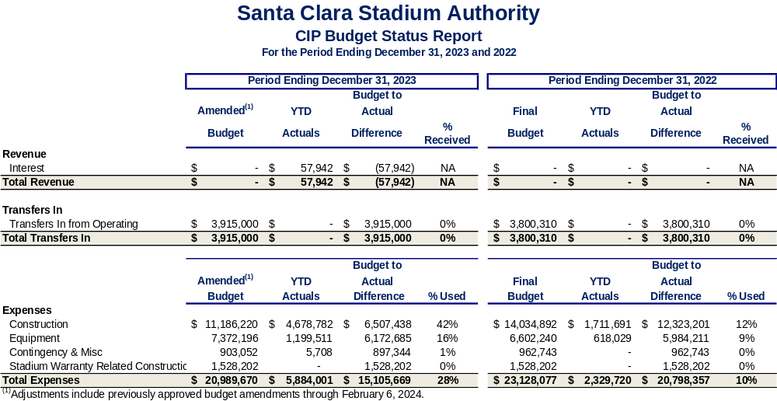

City of Santa Clara Net General Fund Impact
During the current reporting period there was a total of $1.4 million that was contributed to the General Fund as shown in Table 16. This section of the report also provides information on General Fund revenue and expenditure impacts resulting from the stadium.

Table 16

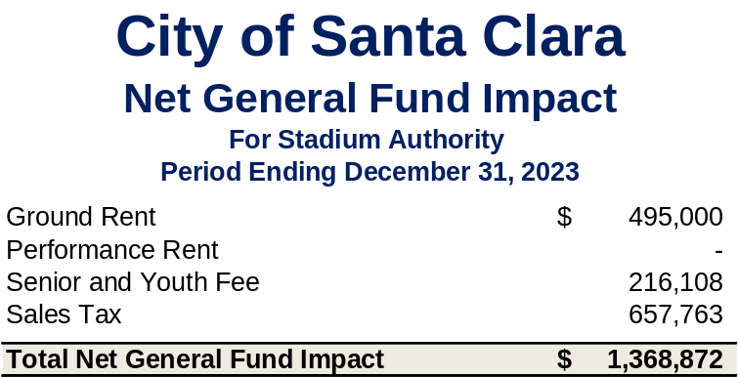

Public Safety and Administrative Cost Reimbursement
As described in earlier sections of this report, costs incurred by the City on NFL and Non- NFL events are tracked and billed to ManCo. Reimbursement is monitored and included in this report. An estimated total of $3.3 million in public safety costs were incurred in support of Non-NFL events that were held at Levi’s® Stadium in the current reporting period. These reimbursements come from a combination of payments from ManCo and the offsite parking fees that were collected. The City has not received the reimbursements as of the date of this report.

Public safety costs for NFL events continue to be above the annual public safety cap. Pursuant to the Amended and Restated Lease, the Stadium Authority was in discussion with StadCo to adjust the annual public safety cap to reflect the true cost of service, which is higher than the cap. An adjustment to the public safety cap is one of the outstanding claims that is currently at issue in the public safety costs arbitration with StadCo. As of the date of this report, ManCo, on behalf of StadCo, has paid outstanding FY 2022/23 NFL public safety costs for NFL events under protest, pending the public safety cost arbitration.

In addition to public safety costs, administrative costs are also tracked and billed to the Stadium Authority. These include the cost of providing overall stadium management, financial, human resource, legal, and other services to the Stadium Authority. Through the third quarter of FY 2023/24, a total of $1.3 million of administrative costs were incurred by the General Fund, which have been reimbursed to the City.

Rents and Senior and Youth Fee
As noted above, the City’s General Fund collected ground rent of $495,000. Additionally, the Senior and Youth Fee generated $216,000, of which the entire amount was forwarded to the City in support of senior and youth programs. The Stadium Authority expects to pay the City an additional $16,000 in Senior and Youth Fee before the end of the fiscal year for the two additional playoff games held. See the Glossary for more information on these revenues and how they are calculated.

Other Revenue Impacts
General Fund sales tax, property tax, and transient occupancy tax (TOT) collections have benefited from the direct and indirect economic activity related to stadium events.

Food and beverage concession sales and merchandise sales at Levi’s® Stadium are taxable, resulting in sales tax revenue for the City. The last three quarters of sales tax collections from Levi’s® Stadium transactions generated $658,000 for the City’s General Fund. In addition to the direct sellers at the Stadium, other businesses in Santa Clara are benefiting from the influx of people coming to attend one or more events at Levi’s® Stadium, resulting in potentially more sales tax collections for the General Fund.

In accordance with State Law, StadCo must pay possessory interest property tax based on their lease of Levi’s® Stadium from the Stadium Authority. This revenue is collected by the county and placed into the Redevelopment Property Tax Trust Fund (RPTTF). Amounts remaining in the RPTTF after paying any enforceable obligations of the Successor Agency are distributed to taxing entities in the same proportion as secured property taxes. The City’s proportion is approximately 10%.

Many stadium events bring travelers to the region, resulting in hotel stays which generate TOT collections for the City’s General Fund. Although it is impossible to say exactly what portion of the City’s TOT collections is due to the stadium, it is clear that hotels both inside and outside the City have benefited, resulting in increases in TOT collections in Santa Clara and our neighboring cities.

Glossary
This section of the report provides details behind key terms that are used in the body of this report.

Discretionary Fund – This is funded by half of the Non-NFL ticket surcharge (see Non-NFL Event Ticket Surcharge on Page 30) and has been used to cover NFL public safety costs above the public safety cost threshold in the first three fiscal years of operation and other items at the Stadium Authority’s discretion. Stadium Authority has been building this fund pending the outcome of the ongoing public safety cost litigation. Stadium Authority may transfer up to half of the balance of the Discretionary Fund over $1.0 million from the Discretionary Fund to the City’s General Fund if (1) adequate provision has been made for the replacement of and upgrades to capital improvements contemplated under the Public Safety Plan and (2) an equal amount is transferred from the Discretionary Fund to Stadium Authority’s operating fund to be included as Stadium Authority Revenue. (Source: The Amended and Restated Stadium Lease Agreement).

Ground Lease –The City has agreed to lease the land under Levi’s® Stadium to Stadium Authority for an initial term of 40 years. The fixed ground rent schedule is noted on the following page for the 40-year initial term. (Source: Ground Lease Agreement).

Table 17

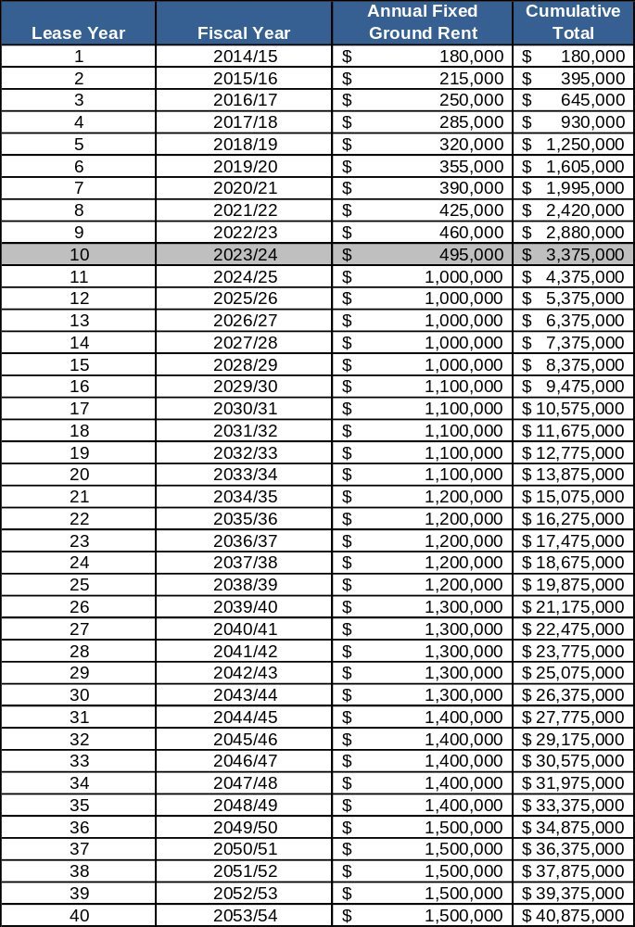

Net Non-NFL Event Revenue – ManCo provides management services for Levi’s® Stadium year-round. As such, ManCo is responsible for booking and scheduling all Non-NFL events on behalf of Stadium Authority. ManCo is required by the agreement to maintain complete and accurate books and records relating to the net income from the Non-NFL events. Those records are reviewed by Stadium Authority staff and/or outside consultants and audited by an independent auditor. After the completion of the fiscal year, the net revenues are paid to Stadium Authority by ManCo. (Source: Stadium Management Agreement)

NFL Ticket Surcharge – The Forty Niners Football Company, LLC (the Team) collects a 10% NFL ticket surcharge on the price of admission to all NFL games occurring in Levi’s® Stadium on behalf of Stadium Authority. (Source: Amended and Restated Non-Relocation Agreement)

Non-NFL Event Ticket Surcharge – Promoters or sponsors of any ticketed Non-NFL event that is held at Levi’s® Stadium are required to collect a $4 per ticket surcharge on behalf of Stadium Authority. One-half of this surcharge that is paid to Stadium Authority covers general stadium operations and the other half funds the Stadium Authority Discretionary Fund. (Source: Amended and Restated Stadium Lease Agreement)

Offsite Parking Fees – Parking lot operators who wish to operate a parking lot for sports or entertainment venues are required to go through the City’s permitting process. If approved, per the City’s Municipal Fee Schedule, these operators remit an offsite parking fee for each car that is parked for sports or entertainment events. This fee is designed to recover the public safety costs associated with these permitted offsite parking lots. Therefore, when invoicing for NFL or Non-NFL public safety costs for a particular event held at Levi’s® Stadium, the offsite parking fee that is collected for said event partly offsets the total public safety costs owed for that event. In the City’s FY 2023/24 (July 1, 2023 through June 30, 2024) the offsite parking fee is $6.44.

Performance-Based Rent – Stadium Authority pays the City performance-based rent on top of the fixed ground rent. The basic calculation for the performance-based rent is fifty percent (50%) of the net income from Non-NFL events for any given lease year less the sum of Performance-Based Rent Credits. The Performance-Based Rent Credits include (1) fifty percent (50%) of the fixed ground rent for the current lease year, (2) the amount, if any, that the Public Safety Costs exceed the Public Safety Cost Threshold for the current lease year, (3) following the Tax Allocation Termination Date, the amount of Received Possessory Interest Tax (PIT), and (4) the amount of any credit for Disproportionate Taxes for the current lease year. (Source: Ground Lease Agreement & Amended and Restated Stadium Lease Agreement)

Public Safety Costs – For each NFL and Non-NFL event held at Levi’s® Stadium, a public safety plan is developed and implemented. Multiple City departments provide staffing, materials, and supplies to support the public safety plan. Services are provided through a combination of City staff, contracts with other agencies (California Highway Patrol, County Sheriff’s Office, and City of Sunnyvale) and some vendor provided services.

The Amended and Restated Stadium Lease Agreement section 7.5 states that the tenant is responsible for reimbursing the City for the public safety costs attributed to NFL events at Levi’s® Stadium. Additionally, Article 5 of the Stadium Management Agreement notes that ManCo is responsible for paying Non-NFL event expenses on behalf of the Stadium Authority. Therefore, the cost of providing public safety services are tracked through the City’s financial system and invoices are sent to ManCo. All of these costs are reimbursed to the City of Santa Clara.

Senior and Youth Program Fees – During the lease terms, StadCo collects City of Santa Clara Senior and Youth Program Fees on behalf of Stadium Authority. The fee is $0.35 per NFL game ticket up to a maximum of $250,000 per lease year. (Source: Amended and Restated Stadium Lease Agreement)

Stadium Management Fee – ManCo receives an annual base management fee to manage Levi’s® Stadium. The fee was $400,000 in the first lease year and increases by 3% annually. This annual base management fee is split 50/50 between StadCo and Stadium Authority since ManCo manages the Stadium year-round for both entities. In addition to the base management fee, ManCo receives a stadium marketing and booking fee (incentive fee) which is based on a percentage of the amount that the net income from Non-NFL events exceeds the marketing and booking fee benchmark. (Source: The Stadium Management Agreement)

