Share your feedback on our 4th of July Community Celebration
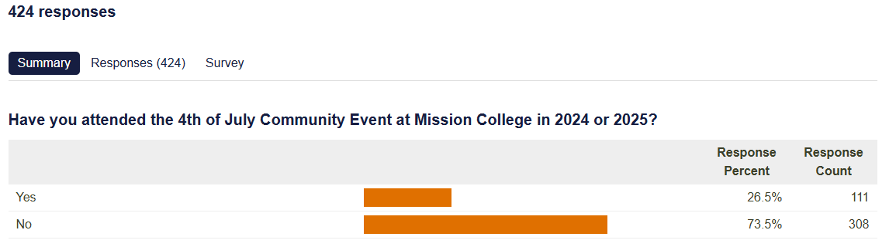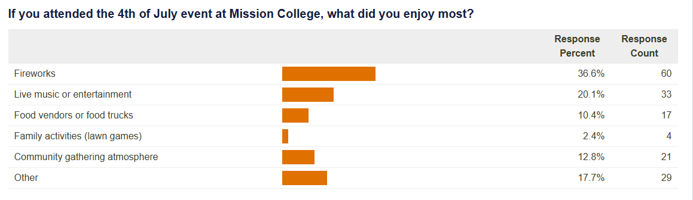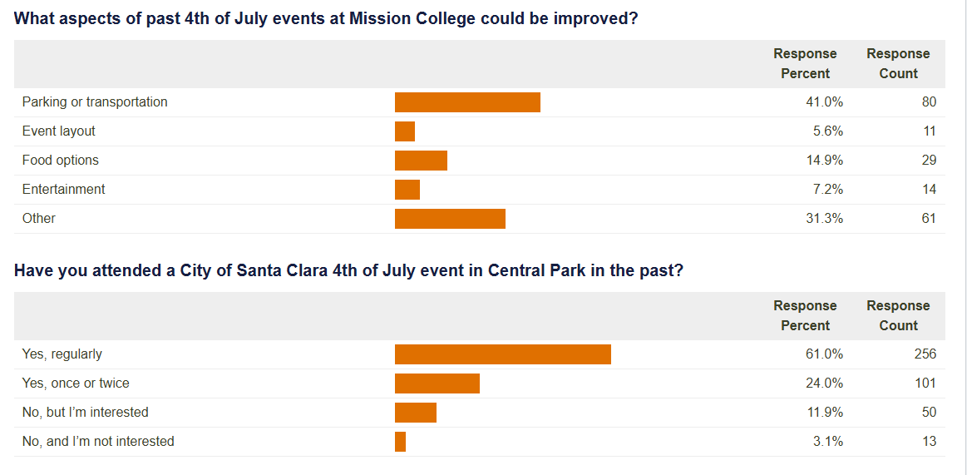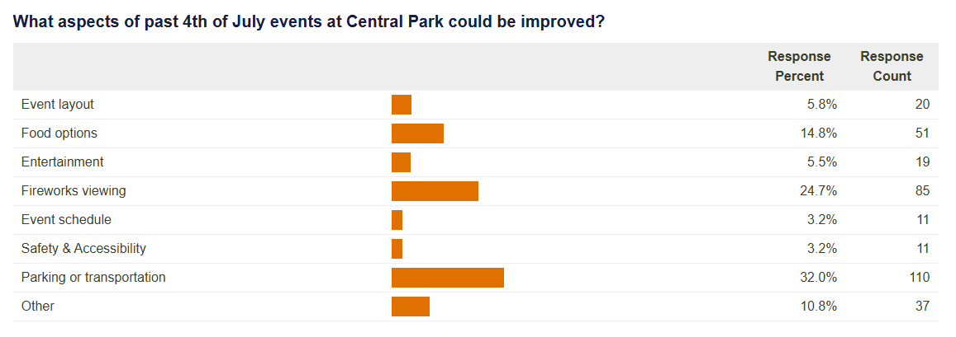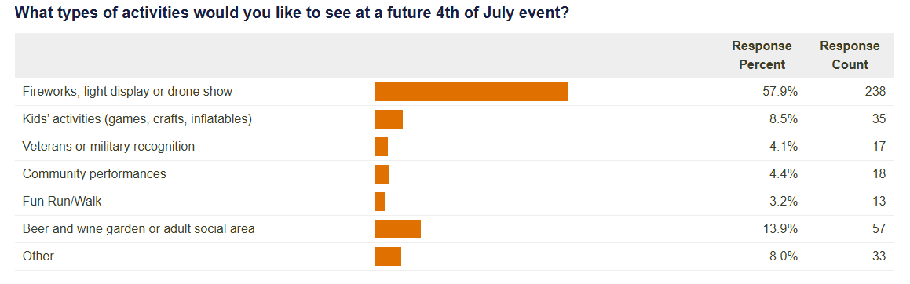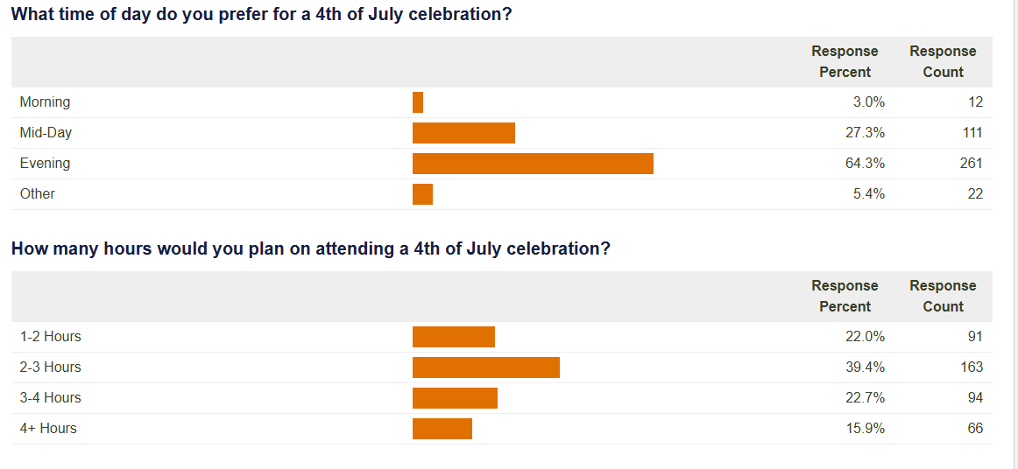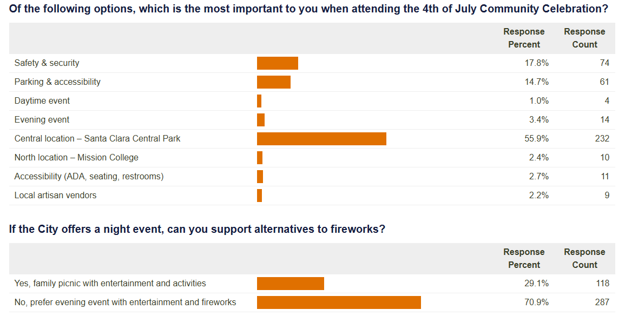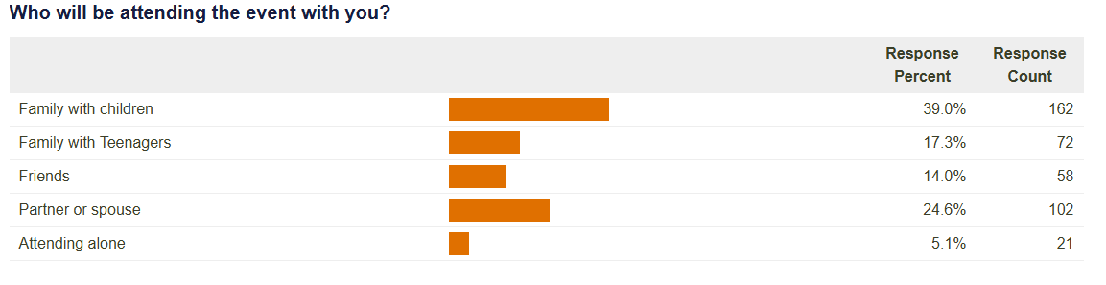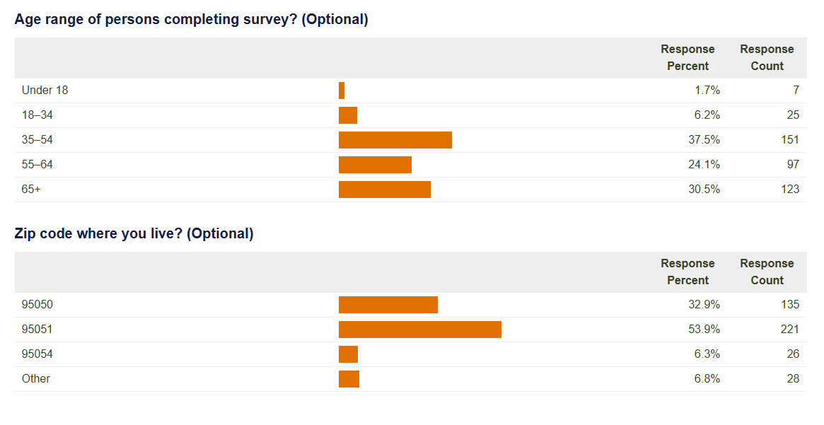

Additional comments regarding the City’s 4th of July celebration?
Answered
132
Skipped
292
Hide Word Cloud
Bring back Central Park Mission college location was get out Drone show fireworks entertainment Parking traffic event Go years other Do firework display one activities why also great family more TOO please People from area community see so make food 4th celebration year America s like picnic Santa Clara day fun July survey only all Music were far than add
Bring it back to Central Park
Mission college location was a nightmare to get out. Central Park was way better.
Drone show would be an acceptable alternative to fireworks
Central Park best location with our own DRONE show, local entertainment similar
to street dance
Ring fireworks back to central park
Parking and traffic is really important for evening event with kids
Forget Mission College. Go back to what you had years ago-bbq chicken with other options available. Just have free parking available.
Do not cancel the city’s firework display. It is one of the best city activities that we have. I don’t know why we’re even considering that. The fact that it’s even being raised as a question makes me concerned that our city’s priorities are out of place. Recognizing veterans would also be great, as would family activities.
Event was much more accessible in Central Park. Bring it back there!!
Event at Central Park used to be great
Central Park was the best. We have family that live out of state, where fireworks are legal. And they still talk about the firework shows at Central Park being the best they’ve ever seen
NO FIREWORKS. TOO DANGEROUS.
MAYBE drone display instead for 250th Anniversary.
Central Park is better!
Bring it back to Central Park please
People from other area stop on streets and parking in our neighborhoods
I miss when it was at Central Park
Drone show can substitute the fireworks
Bring it back to central park please.
More fireworks
This is a great community building activity. I live to see so make people gathering together to enjoy the park, the fireworks, the food, and the entertainment.
Will NEVER go to mission college for this event !
To me good fireworks have always been the Main Event on any 4th celebration. My family looked forward to this every year and though I am older, I still do !!
Don't skimp on America's 250th!
Keep it at central
Why with so many high tech (and lately data center) companies, the city cannot get sponsors to do a fireworks and drone show (like what Intel, etc used to sponsor in years past)? Also is kettle corn and other vegetarian meal/snack options under discussion--please!
Return to Central Park. Gives it a real community event feel.
Fireworks or drones, not a family picnic
Mission college is a terrible idea
Loved it at Central Park.
Bring it back to central park where should.
I have lived in Santa Clara for over 50 year and have so enjoyed the fireworks at Central Park, our entire family would make a day of it, and lately there has not been the fireworks , and it’s a huge part of the fun for our friends and family, Santa Clara says it doesn’t have any money, but yet I see so much money being spent at the 49er stadium and other things, I find it sad , We have such an amazing city, please bring back the fireworks on 4th of July
Given hate crimes in this political climate, the city should definitely do some type of bag check & security to ensure safety.
This survey is broken. It's set for only 1 selection per question. I'd like to see all of those activities. Entertainment is the #1 most important to us when attending an event.
Parking nightmare, exiting took 1 hr at Mission College. Fun celebration but too much traffic leaving due to Great America attendees leaving at same time.
Bring it back to Central Park or a more central location with easy access to freeways and city streets so it doesn’t get so congested or provide shuttles.
Stop fire works, waste of tax dollars and air pollution. Instead start drone or laser show. The fireworks are the same for the last 50+ years. Nothing has changed.
Why only one choice above.
Move it back for a mid-day event to include fireworks or drone show!
Drone show would be of interest
BRING BACK 4TH OF JULY TO CENTRAL PARK
Music is important!
Mission college is a terrible place for this event
Like some daytime activities--picnic, music, breakfast, vendors, art plus music and fireworks or laser show. In walking distance.
We would love to have fireworks back at central park.
How is it possible that this city has insufficient funds for fireworks in consideration of the massive increase in tax revenues from a variety of sources over the last 25 years? Aside from corruption at worst, gross mismanagement at best?
Bay Area begins a trend. Keeping environment into consideration, Having Light-shows along with Sound-simulations, may also be a reasonable alternative.
Would like to see a drone show instead of fireworks
There were long security lines and traffic was horrible after the event
I miss having Fireworks (or a drone show) at Central Park. Central Park feels like part of the community that many residents can walk to. Mission College is just too far and doesn't feel like it's in the heart of our community.
Please return tye event to the beloved small town event of years past.
clean up Gilmore goose poop park. The walkway has needed improvement for a long time.
No more fireworks, too polluting! Look at light and drone shows instead. Offer beer, wine and food vendors, more like a 4th of July arts and crafts festival. Thanks
Bring it back to Central Park.
All of the questions provided multiple choice answers, but did not allow for selection of more than one. For example, we may want to see more than one type of activity at a 4th of July event, but could only select one. And when it asks how important the following are (question above), it only lets you select somethingm, not rank the importance of each. There are some flaws in teh survey that need to be fixed to gather good input.
We were so happy when they moved the event to mission college. It was too disruptive when it was at Central Park. Out of town visitors were rude. Traffic was a nightmare.
Like idea of firework alternative
Prefer the celebration is back at Central Park.
your survey should be multiple choice. Music line up during the day. Very Patriotic this year, encourage everyone to wear Red White and Blue, Flags everywhere! Old time picnic fun, pie eating contest, balloon toss, etc. Rotary BBQ and Beer booths, miss the BBQ kick off event.
Yes, First use a survey where we can answer in positive to more than one option. Two you’re dealing with large crowds so parking can be a nightmare. Simple fun games for kids and youth are by far the top favorites followed by artistic artisans or food creators. Also We don’t want California politics and California style political lecturing, at all, it’s hard enough to be living in a state run by an incredibly arrogant, intolerant and corrupt single party.
Less fireworks or eliminate fireworks. Instead: put up festive banners, have local political groups along the back side of Central Park, add food trucks, add food vendors, add farmers market, add local artisans, add children games, add speeches by local dignitaries and politicians and veterans, add book readings of important Americans, add cultural activities showcasing the multicultural aspects of the City (dancing, cooking demonstrations for instance), Add star gazing at the back side of Central Library. Add City history booth, display fire trucks and police vehicles for public information, Have a City services booth with all types of information available. Make it an all day event, with lots of seating and tables for those who purchase food. Keep the library open or have a booksellers area so that people can bring books to trade with each other; have a bicycle repair station staffed with volunteers and a bicycle parts swap area. I think the City could afford to do all these things if we cut back on the fireworks that are very expensive (maybe only a dozen bursts rather than the hundred or more in the usual show). Consider having an safe area for sparklers so that young persons can try them. In short, I have only attended the fireworks display and I view it from Kiely Blvd; it's too crowded to get any closer to the firework display and the trees along Kiely obscure the fireworks; so, I'm not a big fan of the firework program and, again, the money could be better spent on creating a more variety in that community event, with all the suggestions I made above. By the way, many who attend the City fireworks display I think are from out of town; not sure this is the objective of the City (issues also with traffic and crowd control in particular). The group I go with are mostly from out of town and I only meet with them infrequently throughout the year, but I usually hear from them around the 4rth in order to attend the City's firework display--they park their car at my home in order to attend the firework program, further contributing to the air pollution in the City. If you want to continue with the fireworks display, why not have a small fireworks display at Levis Stadium where there is public transit available for attendees and food vendors inside the stadium? thank you for the opportunity to comment on this event.
Whoever made this survey needs to figure out how to do multiple-select questions and other formats. Why ask "How important are the following..." if there's no way to rank?
It seems a waste of resources to try to do our own event rather than partner with other agencies like Mission City College and Great America. The Mission City College location has far mor space for parking, and the firework display will likely be better with three groups sharing costs than anything the city will do on its own. Make the fiscally responsible choice and continue partnering with other groups on this event.
Adding a drone show from Central Park would be fantastic!
Looking forward to the 4th of July at Central Park this year.
Establishing the importance of Democracy, Freedom, and the Constitution
I would like a nice show in the sky
Central Park location is the best, it was our family tradition to go yearly, we have lived her 22 years. That all stopped when it was moved to Mission City, a cold, hard feeling place. Park celebration is American, not a cold hard parking lot. Fireworks is a true celebration of American Liberty, not a drone show. Why is the city trying to ruin a great American City. First moving the 4th of July celebration to Mission College and keeping it there, then selling Great America park, so much destruction of our beloved city. Help keep Santa Clara great, move the 4th of July , 250 years of Freedom back to the Park.
2025 fireworks were not visible from the venue
Keep it at a central location and have a walk or run for the whole community to take part. Maybe a parade in Central Park area? Drone show would be great addition but not a necessity. Have a lot of food and entertainment options!
Bring it back to Central Park. More family and old fashioned fun. Bake offs pie eating contest and such. Make it more about family and fun than money.Lets try and bring back some of the fun.
As I remember, what is now the Santa Clara Art & Wine Festival started 50 years ago as part of the City's Bicentennial celebration. I would like to see an all-day festival--entertainment, food, local organizations, Santa Clara history. I would like to see the roles of immigrants in the building of the country displayed and emphasized. I would like to see community and democratic ideals given more focus than wars and military achievements (but I'm okay with fireworks).
4TH OF JULY IS ALL ABOUT THE FIREWORKS! HOW YOU CAN SAFELY HAVE FIREWORKDS THAT CAN BE SEEN BROADLY BY THE SANTA CLARA COMMUNITY IS OF PARAMOUNT IMPORTANCE.
You have to have fireworks!
Fireworks are a waste of the city's money, put that money into parks and schools
You could modernize from fireworks to drones.
Traditionally celebration was located at Central Park.
Central Park is part of the community. People can walk to it It’s part of the neighborhood. Has lots shade from trees and other events going on. This represents Santa Clara
A drone show would be amazing
I really enjoyed the Central Park day when it had the fireworks. Everyone loved the fireworks there! Then it stopped because of budget cuts or Covid, or whatever, not completely sure. I strongly hope that you bring back the fireworks to Central Park ... so much fun!!!
I miss the fireworks. I know, I know, expensive and not safe during summer. But I still miss 'em.
drone show would be good why not at the stadium ?
Bring the event back to central park with a drone show instead of fire works
Traffic near Great America’s fireworks is crazy without the city adding an event. I’d much prefer a Central Park event. I think drone shows are the future (no fall-out zone needed)!!
The previous question was hard to answer because I support a drone show. But a picnic only (even with a good band) wouldn’t be enough. I think there needs to be a show, but a drone show would be a great alternative to fireworks.
Have not traveled to see Fireworks since they left Central Park.
Walking to see the firework show and not having to worry about parking was ideal!!!!
Please bring back the fireworks at Central
Fireworks are the definition of a city 4th of July celebration. It is shameful that we've had to go to other cities for fireworks the past couple of years.
I prefer evening event but would support other if at Central Park location and didn’t have to drive and park. Also, your survey is flawed as it only lets people select one answer on the questions, I commonly would have selected multiple responses. If you only want one answer ( for instance what activities I want) then your data is flawed.
Best celebrations have always been at Central Park with fireworks!!
Missed the celebrations that happened in Central Park with evening fireworks. Mission College event not the same experience.
I liked the community feeling I had when July 4th was held at Central Park I usually came for the entertainment before the fireworks. I even liked walking down Kiely to El Camino after event ended. It gave me a feeling of a small town.
I was able to walk or ride my bike to central park, cutting down on gas and traffic getting there. If I wanted to see Great America firework, I would drive to Great America
I really miss the event at Central Park with evening fireworks
I typically view from my home. Since relocated I haven't seen it.
Without the Central Park event I’ve been taking the kids to great America to enjoy the show and music closer rather than mission college.
No fireworks or drone show and we will never attend!
Would have preferred a survey where you could select more than just one selection for certain questions.
Alternative could be a Drone Show
I don't know why you moved it from Central Park to Mission College. Mission College was a hassle. Security getting in was BS too. Big line, not enough security people there.
Please no fireworks as someone with a veteran partner and dogs
We do picnics, entertainment, live music, fodo trucks for multiple other celebrations (art and wine festival, music in central park, etc), but fireworks is once a year event. People can also enjoy other activities on their own at their home, other places in bay area, but not fireworks. July is perfect weather to be outside at 930 in night, unlike cold and rainy on December 31st. Please bring back fireworks at central park on 4th of july.
I'd support an alternative to fireworks if it were a drone show or light show or something in the sky.
We loved the old celebrations at Central Park with the All City Picnic, Food Trucks, Entertainment and then Fireworks. The Mission College location was nice, but the fireworks viewing and exiting the parking lot were absolutely horrible. Please bring back Fireworks to Central Park. Parking was a challenge, but much better experience for our family with being able to view the Fireworks so easily and not getting stuck in gridlock when leaving the event. We attended Mission in 2024 and although we live 5 minutes away, it took us almost an hour to get home afterward due to how badly the traffic flowed. The Mission College location was also horrible for viewing fireworks, we couldn't see them from where we were sitting and once we moved, the fireworks from Great America were too far away to actually view well.
Substitute fireworks for drone air display
Drone show!
A DJ concert with laser light show
should make one area for all autistic children to be able to enjoy along with their parents or siblings/
BEERDOGs
I know fireworks are expensive but it is only 1x a year. Maybe it prevents folks from buying illegal fireworks.
A drone show would be more preferable to fireworks. Less air pollution and noise.
dislike fireworks!!!
Too far away at Mission College. Central Park has nice new playground and lawn areas. We like to ride our bikes over and won't go to Mission college
Santa Clara is a big, sprawling city. Consider a Levi's Stadium picnic and open house featuring community agencies, social/city services, and local businesses.
I hope 4th of July returns to Central Park next year..
Mission College has zero city personality.
Thank you for having the 4th of July celebration every year!
MY family and I really miss the Central Park 4th of July. The mission college is just not the same and it’s far. We have all been going to Central Park for year. A beer garden, vendors and crafts would make this so worth it. The live music is always amazing
Dance area with shade for live music
Growing up in Santa Clara 4th of July at Central Park was the place to be! Bring it back let’s have our kids grow up with the same memories we had
More convenient mass transportation (bus ride more frequently ) if the event held in mission college
A lot of people were disappointed no alcohol. I would like to see more activities for my toddlers, ages 3 and 5.
What is 4th of July without fireworks?
Need a great band that will get people moving.
More recognition of the service men and women and family activities with focus on USA history
Bring it back to central park
Please make the fiscally responsible choice - combined event with combined budgets instead of paying the whole cost on our own of a smaller stand alone event.
Disappointed it moved from Central Park. Hope you bring it back
Would be nice to be able to bring our dog; not sure if dogs are allowed. Probably not with the fireworks as they are not safe for dogs who get scared of the noise. Or else have a designated part of the celebration that is relatively "noise free" so people with dogs can enjoy.
Fireworks at Great America are not a good alternative to the Central Park fireworks of the past.
If the city is going to say "fireworks" please don't try to foist Great America or some other event off on us and tell us it's a fireworks show. The trees and the distance blocked the show from Great America. I worry the city will erect large TV screens to show fireworks shows from other areas. Which will effectively kill the event - if that's the intent.
Please bring back the all day city picnic where family and friends can get together and enjoy the day and entertainment and fireworks at night
Biggest thing is safety by far is the most important thing. Keep the rift rafts out and make it a fun place for family and friends.
The event should return to Central Park with an awesome fireworks show. Food should also include non-food truck items that aren’t as expensive…nachos, strawberry shortcake, burgers/hot dogs/veggie burgers, dessert
This survey only lets one option selected (as least on a mobile decide). Ideal: late afternoon/early evening picnic celebration with fireworks show afterwards
We only went to mission college once to watch a specific group perform. Overall that location feels too far out of the way with less to do at the event.
I am unable to attend due to lack of enough handicapped parking, parking too far from event and not enough handicapped accessibility within the event. If i can go then I would go with my teenage daughter, adult kids and young grandkids. We are also very low income (we all are either disabled or students).
We have always loved the fireworks at Central Park and have missed having them at Central Park. This past year at Great America traffic was especially bad.

