ATTACHMENT 5
Cultural Commission Recommended Location

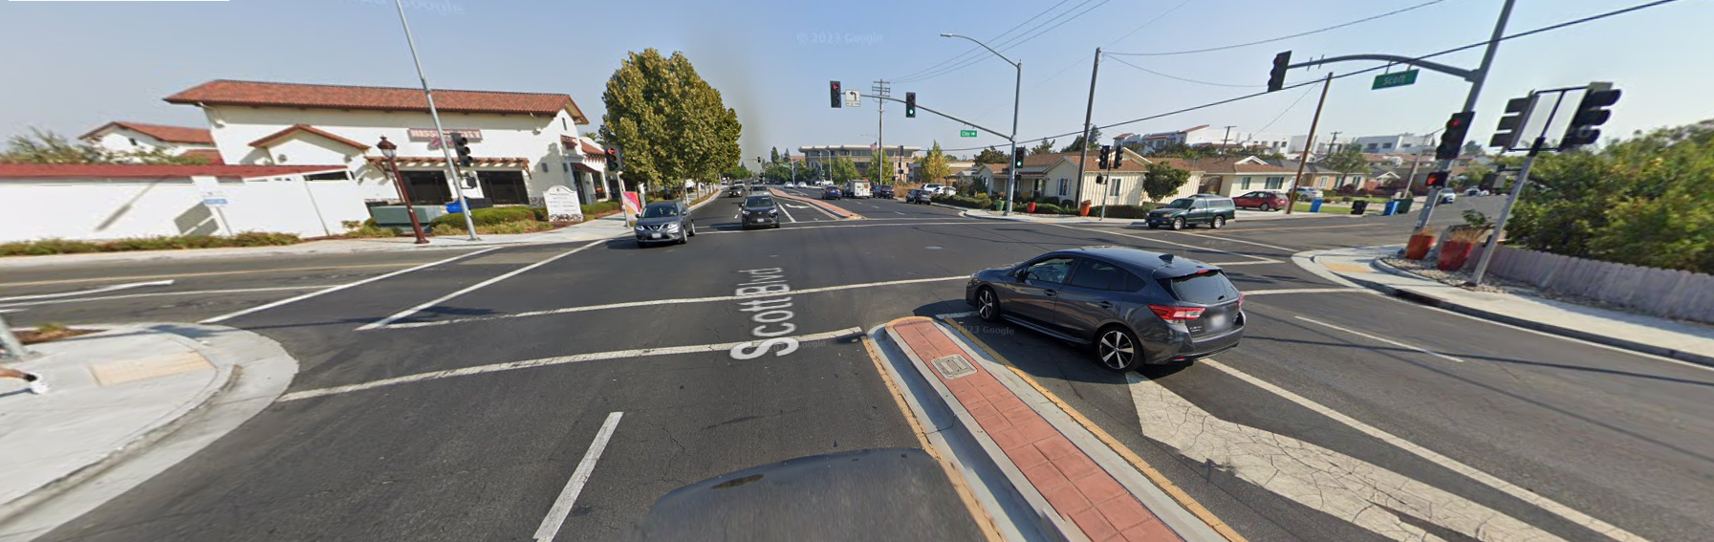
Southern Crosswalk at Scott Boulevard and Anna Drive
