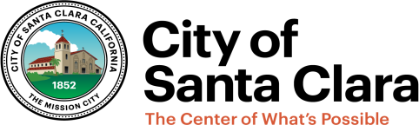
January 15, 2022

Mark Balderston

Human Resources

Dear Mark:
Congratulations! This is to confirm our offer of employment for the As-needed position of Temporary Employee (Electric Utility Electrician Technician) in the Electric Department with the City of Santa Clara. This appointment is pursuant to the City Council Resolution for Exception to the 180-Day Waiting Period to Hire a Retired Annuitant as a Temporary Extra Help Employee (Government Code Section 7522.56 and 21224).

Below are a few key provisions for your offer of employment:

- Effective Date: Thursday, January 27, 2022

- Salary: As approved by the resolution, your hourly pay rate is $84.76 per hour.

- Employment Status: As-needed employment is not to be considered permanent. Under CalPERS regulations and the City of Santa Clara practices, as-needed rehired annuitants are not permitted to work more than 960 hours per fiscal year (July 1 through June 30). If you reach 960 hours during the fiscal year, your assignment will end. If you have been previously employed by a CalPERS employer and have funds on deposit with CalPERS, you will be enrolled in CalPERS and Social Security upon your first date of as-needed employment with the City of Santa Clara.

- New Hire Orientation: New hire orientation will be conducted via Zoom. All employees are required to show documentation which proves their identity and their eligibility to work in the United States. A list of acceptable documentation can be found at http://uscis.gov/i-9- central/acceptable-documents. Please bring I-9 employment verification identification with you on your first day of employment; original documents are required.

Please sign and date this offer letter and return it to me by January 26, 2022. If you have questions, please contact the Human Resources Department at (408) 615-2080.

Sincerely,

Ashley Lancaster
Human Resources Division Manager

I accept the terms and conditions of my employment with the City of Santa Clara.

Mark Balderston Date

cc: Chris Karwick, Assistant Director of Electric Utilities

1500 Warburton Avenue ● Santa Clara, CA 95050 ● Phone: 408-615-2080 ● Fax: 408-985-0667 ● www.SantaClaraCA.gov

