2901 Tasman Drive
Water Supply Assessment
City of Santa Clara Water and Sewer Utilities

for Compliance with California Water Code Section 10910
Approved by City Council
Resolution # TBD

TABLE OF CONTENTS

1. INTRODUCTION 2

2. WATER DEMAND 3

3. WATER SUPPLIES 5
3.1 Water Sources 5
3.2 Groundwater 7
3.3 Recycled Water 12

4. WATER SUPPLY PROJECTIONS 14
4.1 Supply Volumes 14
4.2 Projected Water Supply 15
4.3 Water Supply Reliability 16

5. PROPOSED PROJECT WATER DEMANDS 23
5.1 Water Demand to be Met by Recycled Water 23
5.2 Summary of Existing and Estimated Water Demands 23
5.3 Projected Water Demand for Other Proposed Projects 24

6. Conclusion 25

INTRODUCTION
Senate Bill 610 (2001) codified at Water Code Section 10910 et seq, requires detailed information on water supply availability for certain projects that meet or exceed the following criteria:
- A residential development of more than 500 dwelling units
- A proposed shopping center or business establishment employing more than 1,000 persons or having more than 500,000 square feet of floor space.
- A proposed commercial office building employing more than 1,000 persons or having more than 250,000 square feet of floor space.
- A proposed hotel or motel, or both, having more than 500 rooms.
- A proposed industrial, manufacturing, or processing plant, or industrial park planned to house more than 1,000 persons, occupying more than 40 acres of land, or having more than 650,000 square feet of floor area.
- A mixed-use project that includes one or more of the projects specified in this subdivision.
- A project that would demand an amount of water equivalent to, or greater than, the amount of water required by a 500 dwelling-unit project.
2901 Tasman Drive(“Project”), a project located in the City of Santa Clara (“City”) is subject to a Water Supply Assessment (“WSA” or “Assessment”) in accordance with the California Water Code and the California Environmental Quality Act. The proposed Project plans to redevelop 10.14 acres of land covering APNs 104-49-025 & 104-49-026. The project proposes to construct a new 12-story office building, a new 2-story amenity building, and a new 8-story parking structure. The City of Santa Clara’s City Council approved and adopted an Urban Water Management Plan in 2021 (“UWMP” or “2020 UWMP”). The 2020 UWMP did not specifically include or address this Project since it was proposed and evaluated after the adoption of the UWMP. However, the UWMP included projected increases in water demand due to densification and intensification of both residential and non-residential land uses. Projected uses within the proposed development are described in further detail in the Projected Water Demand for the Proposed Project section.
This Assessment relies on the data contained in and used to develop the 2020 UWMP to analyze the availability of the City’s water supply to serve the Project along with existing and planned future uses. Unless noted, all figures in this Assessment are in acre-feet (AF) and are for total water demand or supply, i.e. both potable and recycled water.
The findings of this Assessment will be submitted to the City Council for approval and included in the environmental review process. The City’s approval, denial, conditional approval or any act on this Assessment does not guarantee that the Project will be approved and does not obligate the City to approve, deny, conditionally approve, take any action, or make any decision on the Project application.

WATER DEMAND
The Demand Study projections were developed using the Demand Side Management Least Cost Planning Decision Support System model (DSS Model) developed by Maddaus Water Management for long-term projections. The DSS Model (also “end use” model type) projected long-term demand based on expected service area growth for population and employment. The model also considers conservation measures using benefit-cost analysis and benefit-to-cost ratio as economic indicators. Demands were also projected based on savings from the plumbing code and active conservation programs. Another model used in the study was the Econometric Model, which was used to develop future rebound water demands associated with short term effects. The Econometric Model projects future demands based on historical post-drought recovery demands considering factors such as economy, rate increases, conservation activity and weather.
The basic methodology of the DSS Model required forecasting demands based on customer billing data categorized by user type. The model was calibrated by comparing water use data with available demographic data to characterize water usage for each user type in terms of number of users per account and per capita water use. In order to calibrate the volume of water allocated to specific end uses in each customer category, published data on average per capita indoor water use and average per capita end uses were combined with the number of water users. After calibration was completed, the projected population and employment projections were incorporated. The population and employment projection data in models utilized 2019 ABAG data provided by the City’s Community Development Department. The 2020 UWMP demand projections are inclusive of passive water conservation savings.
The resulting projected water demand by category is shown in Table 2-1 and only includes potable water demands.

Table 2-1 Retail: Demands for Potable Water - Projected
Use Type | Additional  Description | Projected Water Use  Report to the Extent that Records are Available
Use Type | Additional  Description | 2025 | 2030 | 2035 | 2040 | 2045 (opt)
Single Family |  | 4,683 | 4,893 | 5,076 | 5,206 | 5,336
Multi-Family |  | 4,458 | 4,659 | 4,833 | 4,957 | 5,080
Commercial |  | 6,184 | 6,461 | 6,704 | 6,875 | 7,046
Industrial |  | 1,748 | 1,826 | 1,895 | 1,943 | 1,991
Institutional/Governmental | Institutional | 672 | 702 | 729 | 747 | 766
Institutional/Governmental | Municipal | 560 | 585 | 607 | 623 | 638
Losses | 6.0% Losses (5-yr average) | 1,168 | 1,221 | 1,267 | 1,299 | 1,331
TOTAL |  | 19,473 | 20,348 | 21,111 | 21,649 | 22,189
NOTES: Total sum may not be exact due to rounding.
Table 2-2 shows total water demands including both potable and recycled water. Recycled water demands were estimated based on anticipated growth in recycled water use due to new development (landscape irrigation, data centers, dual plumbing), including proposed infrastructure upgrades to supply new developments, and historical demand.
Table 2-2 Retail: Total Gross Water Demands (Potable and Non-Potable)
 | 2020 | 2025 | 2030 | 2035 | 2040 | 2045 (opt)
Potable Water Demand  From Table 2-1 | 18,302 | 19,473 | 20,348 | 21,111 | 21,649 | 22,189
Recycled Water Demand | 3,499 | 4,570 | 5,489 | 6,586 | 7,908 | 9,488
TOTAL WATER DEMAND | 21,801 | 24,043 | 25,836 | 27,697 | 29,557 | 31,676
NOTES: Units of volume in AF.

Table 3 calculates projected changes in water demand during each 5-year planning horizon through 2045. The Project’s proposed water demand will be analyzed against this table to determine whether demands fall within growth projections in the 2020 UWMP.
Table 3 – Projected Changes in Water Demands (AF) – 2020 UWMP
 | 2021-2025 | 2026-2030 | 2031-2035 | 2036-2040 | 2041-2045
Single Family | 225 | 210 | 183 | 130 | 130
Multi-Family | -264 | 201 | 174 | 124 | 123
Commercial | 877 | 277 | 243 | 171 | 171
Industrial | 138 | 78 | 69 | 48 | 48
Institutional | 110 | 30 | 27 | 18 | 19
Municipal | 215 | 25 | 22 | 16 | 15
Recycled | 1,071 | 919 | 1,097 | 1,322 | 1,580
Losses | -131 | 53 | 46 | 32 | 32
Total | 2,241 | 1,793 | 1,861 | 1,861 | 2,118

WATER SUPPLIES

Water Sources
The City relies on four water supply sources; surface water from San Francisco Public Utilities Commission (SFPUC), treated surface water from Santa Clara Valley Water District (Valley Water), groundwater, and recycled water. Surface water from the two wholesalers, SFPUC and Valley Water, provides less than half of the City’s water supply, averaging about 40% since 2015. City owned- and operated-wells provide approximately 60%. Since a portion of the City’s water supply is reliant on SFPUC and Valley Water, the City is directly affected by the water supply conditions faced by each wholesaler. Additionally, the City water system is separated into three interconnected zones (Zone 1, 2 and 2A) in order to provide optimum pressures throughout the City. The zones and water source by area are shown in Figure 3-1 on the next page.
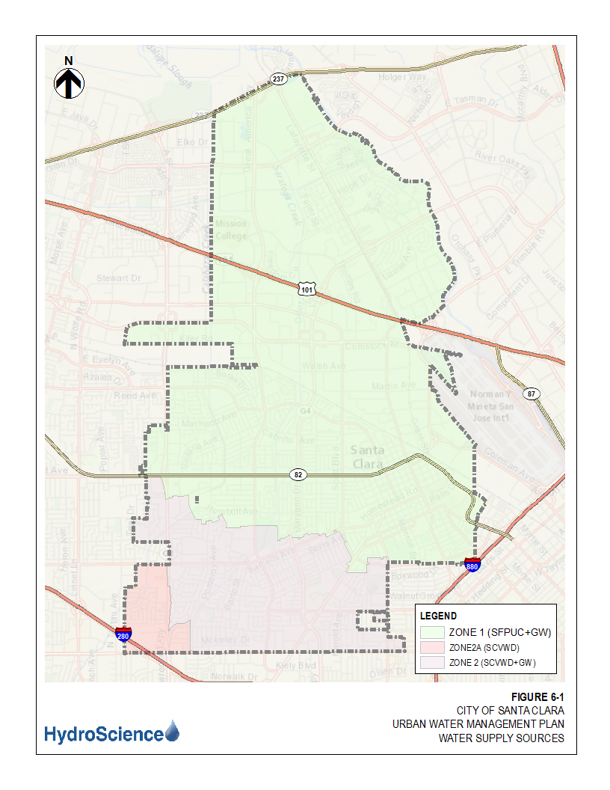
Figure 3-1: Pressure Zones and Water Source by Area

Groundwater
The City’s source of groundwater is supplied by the Santa Clara subbasin (DWR Basin 2-9.02). The Santa Clara subbasin is part of the Santa Clara Valley Basin which is divided into four subbasins, including the Santa Clara subbasin. The Santa Clara subbasin extends from the Coyote Narrows near Metcalf Road to the southern San Francisco Bay as the northern boundary. It is bounded on the west by the Santa Cruz Mountains and on the east by the Diablo Range. The two mountain ranges converge at the Coyote Narrows to form the southern limit of the subbasin. The Santa Clara subbasin covers a surface area of 189,581 acres. The subbasin is further divided into two groundwater management areas based on differences in hydrogeology, land use and water supply management: Santa Clara Plain and Coyote Valley with the City overlaying the Santa Clara Plain (Figure 3-2).
Figure 3-2: Map of Santa Clara Plain Groundwater Basin
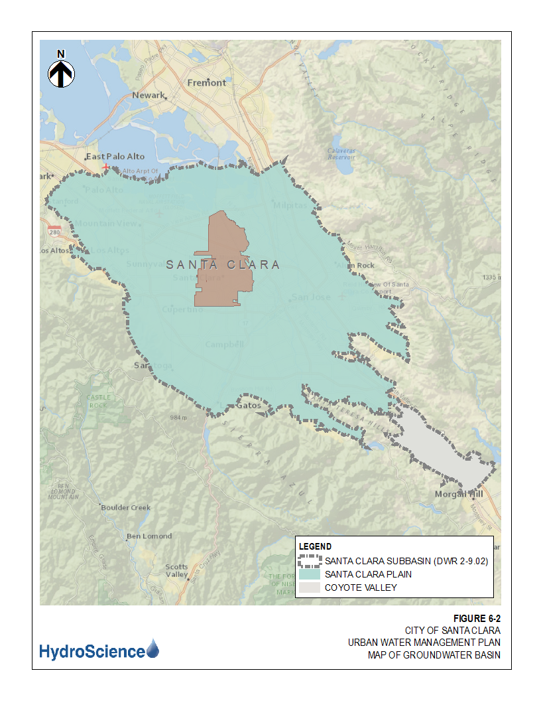
The Santa Clara subbasin is designated as a high-priority subbasin. Basin prioritization was previously based on the 2015 Sustainable Groundwater Management Act (SGMA) Basin Prioritization program, which included overlying population, projected growth, number of public wells, number of total wells, irrigation acreage, groundwater reliance, and documented groundwater impacts as criteria for basin priority designation. The current version, updated in 2019, includes the addition and emphasis of “adverse impacts on local habitat and local streamflows” as a specific component for the designation of basin priority. This component only adds a maximum of two points toward the total points used to designate subbasin priority. With a total of 24.5 points, the Santa Clara subbasin falls above the minimum threshold of 21 points for high-priority designation. This also signifies that even without the addition of the new criteria used in the 2019 SGMA Basin Prioritization process, the Santa Clara subbasin has increased (negative impact) in another area.
Valley Water manages the groundwater supply in Santa Clara County and works with various water retailers in the area to prevent subsidence and overdraft of the basin to ensure reliable water supplies. The Santa Clara Valley Basin is not adjudicated or currently listed as overdrafted. This can be attributed to Valley Water’s network of imported surface water supplies, groundwater recharge system, water supply long-term planning, and aggressive conservation efforts through community outreach and rebate programs. The Santa Clara Valley Basin is shown in Figure 6-3 and is the largest of three interconnected groundwater basins occupying approximately 246,000 acres of the 835,000 acres of Santa Clara County.
Development and agricultural needs in the 1920s increased the water demand within the Santa Clara Valley. This increased extraction of groundwater led to subsidence in several of the aquifers. The Santa Clara Valley Water Conservation District (currently Santa Clara Valley Water District and referred to as Valley Water) was originally formed in 1929 to alleviate land surface subsidence and stop groundwater overdraft. The rapid development of Santa Clara County occurred again in the 1960s and the corresponding increased demand on the water supply again resulted in groundwater level decline, land subsidence and observed saltwater intrusion of shallow aquifers adjacent to San Francisco Bay.
The continued overdrafting of the basin resulted in a significant lowering of the groundwater table, significant subsidence of the land in the northern portion of the valley and compaction of several aquifers. When an aquifer is compacted the storage capacity of the aquifer can be substantially reduced. Once lost, storage capacity cannot be regained.
Figure 3-3: Map of Santa Clara Valley Basin
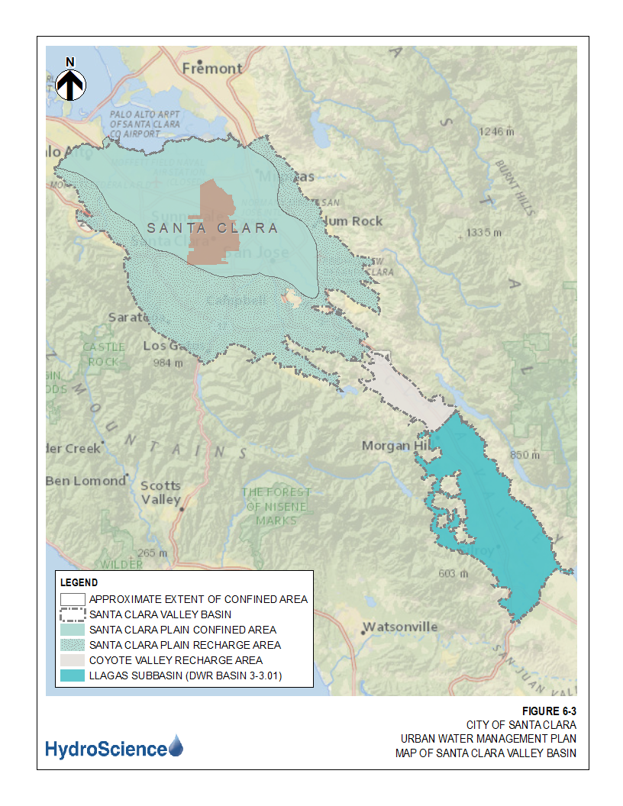

To avoid any further subsidence and loss of aquifer capacity, Valley Water has attempted to operate the basin to maintain or increase groundwater storage through managed recharge with local supplies augmented with imported raw water. In the late 1960s Valley Water’s conjunctive management of surface water and groundwater effectively halted overdrafting and resulting subsidence. Valley Water is currently using projected supply, carryover capacity and anticipated demand to predict potential water shortages. The 2016 Santa Clara Valley Water District Groundwater Management Plan (GMP) describes the groundwater recharge program in detail.
The Santa Clara subbasin currently provides about 60% of the City’s potable water supply. The City’s wells are strategically distributed around the City adding to the reliability of the water system and minimizes the possibility of localized subsidence due to overdrafting. To minimize the possibility of long-term overdraft conditions, the City monitors groundwater levels and meters the groundwater pumping for all City owned production wells. To further ensure that no overdrafting is occurring the City operates a recycled water system and requires new development along the recycled water distribution system to use recycled water for approved irrigation and industrial uses. The City also encourages and promotes water conservation to minimize groundwater usage.
The allowable withdrawal or safe yield of groundwater by the City is dependent upon multiple factors including withdrawals by other water agencies, quantity of water recharged and the carry over storage from the previous year. Valley Water’s current (2019) groundwater report shows the City as being the second highest user of groundwater pumping, at 17%, for the Santa Clara Plain subbasin designated as North County (Zone W-2).
Table 4 shows the City’s annual groundwater pumping volumes in acre-feet from 2016 to 2020. In 2020 a total of 10,835 AF was pumped from the current production wells within the City. In 2020, groundwater from wells accounted for 49.7% of all water used in the City (including recycled water) and 59.2% of the total potable water supply.
Table 4: Retail Groundwater Volume Pumped – Potable
Groundwater Type | Location or Basin Name | 2016 | 2017 | 2018 | 2019 | 2020
Alluvial Basin | Santa Clara Valley | 10,115 | 12,224 | 10,658 | 9,779 | 10,835
TOTAL |  | 10,115 | 12,224 | 10,658 | 9,779 | 10,835
NOTES: Units of volume in AF.

Recycled Water
Recycled water within the City is supplied from the jointly owned San Jose-Santa Clara RWF through South Bay Water Recycling (SBWR). This recycled water meets the requirements of the CCR Title 22, Division 4. The City and all users of recycled water must ensure that a number of regulatory requirements specified in CCR Title 22 are met. CCR Title 22 specifies the types of use and the conditions under which the use of recycled water is allowed. SBWR provides oversight, promotes recycled water, operates the recycled water distribution system, and provides technical guidance to recycled water customers.
The existing recycled water distribution system was laid out to maximize service to large potential recycled water customers. Recycled water is currently used within the City for irrigation at parks, landscape street medians, multi-family residential units and schools. Several industries use recycled water in industrial processes, cooling towers and for toilet flushing in dual plumbed buildings.
The recycled water distribution system is shown in Figure 3-4.
It is the purpose and intent of the City Council to require the use of recycled water for all non-potable uses where recycled water is made available per Santa Clara City code Article IV, Regulation of Recycled Water Service and Use, Section 13.15.160. Recycled Water should be utilized for this project to the maximum extent possible to supplant the use of potable water. Utilization of recycled water for approved uses is addressed during the development application process in order to promote sustainability and conservation of the City’s potable water supply. Expansion of the existing recycled water system may be required to serve future uses as deemed necessary.
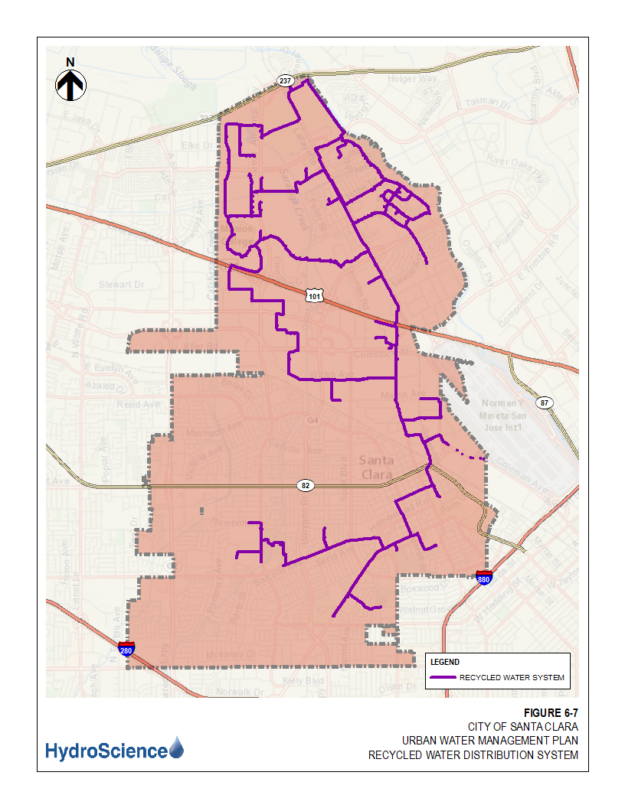
Figure 3-4: Recycled Water Distribution System

WATER SUPPLY PROJECTIONS

Supply Volumes
Historically, groundwater has been the predominant source of water used to meet water demand in the City. Since the last UWMP, the amount of recycled water used within the City has risen steadily. In 2020 recycled water represented 19% of total water sales. Purchased treated water from SFPUC and Valley Water represented 34% of the water portfolio during this period. There are efforts to minimize reliance on purchased water and maximize resources. Table 5 shows the volume of water supplied for 2020.
Table 5: Water Supplies — Actual
Water Supply | Additional Detail on Water Supply | 2020
Water Supply | Additional Detail on Water Supply | Actual Volume | Water Quality | Total Right or Safe Yield (opt)
Purchased or Imported Water | Valley Water | 3,982 | Drinking Water | 4,560
Purchased or Imported Water | SFPUC | 3,485 | Drinking Water | 5,041
Groundwater  (not desalinated) | Wells | 10,835 | Drinking Water | 23,048
Recycled Water | SBWR | 3,499 | Recycled Water | --
Total |  | 21,801 |  | 32,649
NOTES: Purchased water from Valley Water is based on current contractual amount (total right). Purchased water from SFPUC is based on current contract allocation (total right). Groundwater safe yield is system capacity.

Projected Water Supply
Table 5-1A and Table 5-1B below show the City’s projected potable water supplies for 2025 to 2045. Table 5-1A accounts for the possibility of an interruption of the City’s SFPUC water supply.
Table 5-1A: Water Supplies — Projected
Water Supply | Additional Detail on Water Supply | Projected Water Supply
Water Supply | Additional Detail on Water Supply | 2025 |  | 2030 |  | 2035 |  | 2040 |  | 2045 (opt)
Water Supply | Additional Detail on Water Supply | Reasonably Available Volume |  | Reasonably Available Volume |  | Reasonably Available Volume |  | Reasonably Available Volume |  | Reasonably Available Volume
Purchased or Imported Water | Valley Water | 4,560 |  | 4,560 |  | 4,560 |  | 4,560 |  | 4,560
Purchased or Imported Water | SFPUC | 5,041 |  | 0 |  | 0 |  | 0 |  | 0
Groundwater (not desalinated) | Wells | 23,048 |  | 23,048 |  | 23,048 |  | 23,048 |  | 23,048
Recycled Water | SBWR | 4,570 |  | 5,489 |  | 6,586 |  | 7,908 |  | 9,488
Total |  | 37,219 |  | 33,097 |  | 34,194 |  | 35,516 |  | 37,096
NOTES: Assumes interruption of SFPUC water supply after 2028.
Table 5-1B: Water Supplies — Projected
Water Supply | Additional Detail on Water Supply |  | Projected Water Supply
Water Supply |  |  | 2025 |  | 2030 |  | 2035 |  | 2040 |  | 2045 (opt)
Water Supply |  |  | Reasonably Available Volume |  | Reasonably Available Volume |  | Reasonably Available Volume |  | Reasonably Available Volume |  | Reasonably Available Volume
Purchased or Imported Water | Valley Water |  | 4,560 |  | 4,560 |  | 4,560 |  | 4,560 |  | 4,560
Purchased or Imported Water | SFPUC |  | 5,041 |  | 5,041 |  | 5,041 |  | 5,041 |  | 5,041
Groundwater (not desalinated) | Wells |  | 23,048 |  | 23,048 |  | 23,048 |  | 23,048 |  | 23,048
Recycled Water | SBWR |  | 4,570 |  | 5,489 |  | 6,586 |  | 7,908 |  | 9,488
Total |  |  | 37,219 |  | 38,138 |  | 39,235 |  | 40,557 |  | 42,137
NOTES: Assumes no interruption of SFPUC water supply after 2028.

Water Supply Reliability
The water service reliability assessment requires the comparison of supply and demand projections for three scenarios: (1) a normal year, (2) a single dry year, and (3) five consecutive dry years. The percent of total annual supply available for each scenario is based on projected availability of water supplies identified and cutbacks determined by the City’s wholesalers. Because allowable groundwater pumping is based only on the sustainable yield, groundwater supply availability is not expected to decrease during dry years. Additionally, recycled water is not dependent on climatic effects and is assumed to be unaffected by any drought conditions.
Table 6 presents the base years for each of the three conditions described above as well as the corresponding percentages of average water supply available during each year under these conditions.

Table 6: Basis of Water Year Data (Reliability Assessment)
Year Type | Base Year | Available Supplies if Year Type Repeats
Year Type | Base Year | Quantification of available supplies is provided in this table as either volume only, percent only, or both.
Year Type | Base Year | Volume Available | % of Average Supply
Average Year | 2020 | 32,649 | 100%
Single-Dry Year | 1977 | 31,293 | 96%
Consecutive-Dry Years 1st Year | 1988 | 31,293 | 96%
Consecutive-Dry Years 2nd Year | 1989 | 31,529 | 97%
Consecutive-Dry Years 3rd Year | 1990 | 29,686 | 91%
Consecutive-Dry Years 4th Year | 1991 | 29,686 | 91%
Consecutive-Dry Years 5th Year | 1992 | 29,686 | 91%
NOTES: All City water sources combined. Base years represent the year for which Valley Water’s analysis is based. Volume available and percent of average supply is calculated based on the combination of available sources.
Using the water supply and demand projections and the portion of supplies available during normal year, single dry year, and five consecutive dry year conditions summarized above, this section presents the comparison between projected supply and projected demand for each condition in five-year increments through 2045.
The City relies on imported water from Valley Water and the SFPUC. The City’s contract with the SFPUC is interruptible and may be unavailable after 2028. The SFPUC is scheduled to decide whether to make the City a permanent customer by December 2028. If the SFPUC supplies are interrupted, the City may need to increase use of Valley Water supplies.
In December 2018, the State Water Resources Control Board (SWRCB) adopted amendments to the Water Quality Control Plan for the San Francisco Bay/Sacramento-San Joaquin Delta Estuary Bay-Delta Plan (BDP) to establish water quality objectives to maintain the health of the Bay-Delta ecosystem. The SWRCB is required by law to regularly review this plan. The adopted Bay-Delta Plan was developed with the stated goal of increasing salmonid populations in three San Joaquin River tributaries (the Stanislaus, Merced, and Tuolumne Rivers) and the Bay-Delta. The BDP requires the release of 30-50% of the “unimpaired flow” on the three tributaries from February through June in every year type. In SFPUC modeling of the new flow standard, it is assumed that the required release is 40% of unimpaired flow.
If the Bay-Delta Plan is implemented, the SFPUC will be able to meet the projected water demands presented in this UWMP in normal years but would experience supply shortages in single dry years or multiple dry years. Implementation of the Bay-Delta Plan will require rationing in all single dry years and multiple dry years. The SFPUC has initiated an Alternative Water Supply Planning Program to ensure that San Francisco can meet its Retail and Wholesale Customer water needs, address projected dry years shortages, and limit rationing to a maximum 20% system-wide in accordance with adopted SFPUC policies. This program is in early planning stages and is intended to meet future water supply challenges and vulnerabilities such as environmental flow needs and other regulatory changes; earthquakes, disasters, and emergencies; increases in population and employment; and climate change. As the region faces future challenges – both known and unknown – the SFPUC is considering this suite of diverse non-traditional supplies and leveraging regional partnerships to meet Retail and Wholesale Customer needs through 2045.
Due to the uncertainty of the interruptible supply from the SFPUC, the City has analyzed supply reliability under two primary scenarios:
    - Scenario 1: supply interruption due to contract termination in 2028.
    - Scenario 2: continued SFPUC supply beyond 2028.
Table 7-1A/B through Table 7-3A/B presents the service supply reliability assessment for each condition.
During normal water years, there are no reductions in supplies to retailers due to BDP implementation and water supplies should be adequate to meet projected demands in the 2025 to 2045 planning period as shown in the tables.
Table 7-1A: Normal Year Supply and Demand Comparison - (Scenario 1)
 | 2025 | 2030 | 2035 | 2040 | 2045 (Opt)
Supply totals  (autofill from Table 6-9A) | 37,219 | 33,097 | 34,194 | 35,516 | 37,096
Demand totals  (autofill from Table 4-3) | 24,043 | 25,836 | 27,697 | 29,557 | 31,676
Difference | 13,176 | 7,261 | 6,497 | 5,959 | 5,420
NOTES: Assumes SFPUC supply does not exist beyond 2028 and BDP implementation in 2023.
Table 7-1B: Normal Year Supply and Demand Comparison - (Scenario 2)
 | 2025 | 2030 | 2035 | 2040 | 2045 (Opt)
Supply totals  (autofill from Table 6-9B) | 37,219 | 38,137 | 39,235 | 40,557 | 42,136
Demand totals  (autofill from Table 4-3) | 24,043 | 25,836 | 27,697 | 29,557 | 31,676
Difference | 13,176 | 12,301 | 11,538 | 11,000 | 10,460
NOTES: Assumes continued allocation from SFPUC beyond 2028 and BDP implementation in 2023.
During a single dry year, the City projects no reduction in supplies from groundwater.
SFPUC has indicated that during a single critical dry year it will follow the Tier 2 reduction plan described later in this document. Under Scenario 1, the City can expect up to a 36% cutback in SFPUC supply through 2028 before supply termination. Under Scenario 2, the City can expect up to a 46% cutback in a single-dry year through 2045.
During a single critical dry year, there are no projected shortfalls in total available water supplies independent of whether the City receives or does not receive SFPUC water after contract negotiations with SFPUC in 2028.
Table 7-2A: Single Dry Year Supply and Demand Comparison
 | 2025 | 2030 | 2035 | 2040 | 2045 (Opt)
Supply totals | 35,404 | 33,097 | 34,194 | 35,516 | 37,096
Demand totals | 24,043 | 25,836 | 27,697 | 29,557 | 31,676
Difference | 11,361 | 7,261 | 6,497 | 5,959 | 5,420
NOTES: Assumes SFPUC supply does not exist beyond 2028 and reduced allocation from SFPUC due to BDP in 2023.
Table 7-2B: Single Dry Year Supply and Demand Comparison
 | 2025 | 2030 | 2035 | 2040 | 2045 (Opt)
Supply totals | 35,404 | 36,323 | 37,420 | 38,692 | 39,818
Demand totals | 24,043 | 25,836 | 27,697 | 29,557 | 31,676
Difference | 11,361 | 10,486 | 9,723 | 9,135 | 8,141
NOTES: Assumes continued allocation from SFPUC beyond 2028 and reduced allocation from SFPUC due to BDP in 2023.
During a multiple dry year event, the City projects no reduction in supplies from groundwater. Valley Water is expected to continue to manage groundwater recharge for the sub-basin.
Based on supply reductions to the SFPUC RWS, during multiple dry years under Scenario 1, the City can expect a reduction of up to 45% by 2028. Under Scenario 2, the City can expect a cutback as much as 54% of normal by the 4th and 5th years of a dry consecutive period beginning in 2045.
Table 7-3A: Multiple Dry Years Supply and Demand Comparison
 |  | 2025 | 2030 | 2035 | 2040 | 2045 (Opt)
First year | Supply totals | 35,404 | 33,097 | 34,194 | 35,516 | 37,096
First year | Demand totals | 24,043 | 25,836 | 27,697 | 29,557 | 31,676
First year | Difference | 11,361 | 7,261 | 6,497 | 5,959 | 5,420
Second year | Supply totals | 34,951 | 33,097 | 34,194 | 35,516 | 37,096
Second year | Demand totals | 24,043 | 25,836 | 27,697 | 29,557 | 31,676
Second year | Difference | 10,908 | 7,261 | 6,497 | 5,959 | 5,420
Third year | Supply totals | 34,951 | 33,097 | 34,194 | 35,516 | 37,096
Third year | Demand totals | 24,043 | 25,836 | 27,697 | 29,557 | 31,676
Third year | Difference | 10,908 | 7,261 | 6,497 | 5,959 | 5,420
Fourth year | Supply totals | 34,951 | 33,097 | 34,194 | 35,516 | 37,096
Fourth year | Demand totals | 24,043 | 25,836 | 27,697 | 29,557 | 31,676
Fourth year | Difference | 10,908 | 7,261 | 6,497 | 5,959 | 5,420
Fifth year | Supply totals | 34,951 | 33,097 | 34,194 | 35,516 | 37,096
Fifth year | Demand totals | 24,043 | 25,836 | 27,697 | 29,557 | 31,676
Fifth year | Difference | 10,908 | 7,261 | 6,497 | 5,959 | 5,420
NOTES: Assumes SFPUC supply does not exist beyond 2028 and reduced allocation from SFPUC due to BDP in 2023.

Table 7-3B: Multiple Dry Years Supply and Demand Comparison
 |  | 2025 | 2030 | 2035 | 2040 | 2045 (Opt)
First year | Supply totals | 35,404 | 36,323 | 37,420 | 38,692 | 39,818
First year | Demand totals | 24,043 | 25,836 | 27,697 | 29,557 | 31,676
First year | Difference | 11,361 | 10,486 | 9,723 | 9,135 | 8,141
Second year | Supply totals | 34,951 | 35,869 | 36,916 | 38,238 | 39,818
Second year | Demand totals | 24,043 | 25,836 | 27,697 | 29,557 | 31,676
Second year | Difference | 10,908 | 10,033 | 9,219 | 8,681 | 8,141
Third year | Supply totals | 34,951 | 35,869 | 36,916 | 38,238 | 39,818
Third year | Demand totals | 24,043 | 25,836 | 27,697 | 29,557 | 31,676
Third year | Difference | 10,908 | 10,033 | 9,219 | 8,681 | 8,141
Fourth year | Supply totals | 34,951 | 35,869 | 36,916 | 37,936 | 39,414
Fourth year | Demand totals | 24,043 | 25,836 | 27,697 | 29,557 | 31,676
Fourth year | Difference | 10,908 | 10,033 | 9,219 | 8,379 | 7,738
Fifth year | Supply totals | 34,951 | 35,869 | 36,715 | 37,936 | 39,414
Fifth year | Demand totals | 24,043 | 25,836 | 27,697 | 29,557 | 31,676
Fifth year | Difference | 10,908 | 10,033 | 9,018 | 8,379 | 7,738
NOTES: Assumes continued allocation from SFPUC beyond 2028 and reduced allocation from SFPUC due to BDP in 2023.
Given the supply and demand comparison presented previously, the results of the supply reliability assessment can be summarized as follows:
  - Normal Year – The City can anticipate meeting all water demands through 2045 under normal year supply conditions given the stated assumptions.
  - Single Dry Year – The City can anticipate meeting all water demands through 2045 under single dry year supply conditions given the stated assumptions.
  - Five Consecutive Dry Years – The City can anticipate meeting all water demands through 2045 under consecutive five dry-year supply conditions given the stated assumptions.
As shown in the tables above, the City would be able to increase the amount of groundwater pumped to meet reasonably anticipated deficiencies from other sources, thus supply is projected to be sufficient to meet demand out to 2045. The Santa Clara groundwater basin is not adjudicated, which means the right to pump groundwater from the basin has not been given by judgment of a court or board.
For each of the five-year increments presented above, the five-year dry period indicates that supplies will be able to meet demands through increased groundwater pumping and implementation of drought conservation programs. The City will be able to address the projected demands without rationing.

PROPOSED PROJECT WATER DEMANDS
2901 Tasman Drive represents an increase in water demand of 121.4 AF/yr over the historic water demand across the proposed Project area. Historic water usage at the original Project development was considered in the 2020 UWMP, therefore this Assessment will only address the City’s ability to meet the increased water demand. Average historical usage was calculated using the Project’s existing water demand from 2016-2020. The proposed increase, tabulated in Table 9 of this section, is within the modeled 2020 UWMP growth projections (Table 3 of this Assessment).

Water Demand to be Met by Recycled Water
Recycled water is currently available at the proposed Project location. As such, the Project will be required to connect to the existing recycled water system. Santa Clara City Code, Chapter 13.15, Article IV - Regulation of Recycled Water Service and Use, Section 13.15.160 states that “(a) It is the purpose and intent of the City Council to prohibit the use of potable water for landscape irrigation where recycled water is made available and meets all applicable standards.” It also states that “(b) It is also the purpose and intent of the City Council to require the use of recycled water for all other non-potable uses where recycled water is made available, meets all applicable standards for those uses and is determined to be suitable and economically feasible therefor.” The Assessment has determined that the existing recycled water system is available to serve 2901 Tasman Drive and pending approval by South Bay Water Recycling, recycled water should be utilized for this project to the maximum extent possible to supplant the use of potable water. Utilization of recycled water for approved uses and requirements is addressed during the development application process in order to promote sustainability and conservation of the City’s potable water supply. Expansion of the recycled water system to serve future uses may be required as deemed necessary.
The Project shall implement all applicable recycled water uses on-site including those not specifically addressed in this Assessment. The project shall make every effort to offset the use of potable water. All recycled water line extensions for on-site use and demand would require City, South Bay Water Recycling, and State Water Resources Control Board - Division of Drinking Water approval.

Summary of Existing and Estimated Water Demands
A summary of the existing and estimated water demands for the Focus Area are found in Table 8. The existing and estimated water demands are further broken down in Table 9 into projected annual demand increases based on construction timelines submitted by the Applicant.
 | Table 8 – Existing and Estimated Water Demand per Year
 | Status | Water Source | Development | Units | Gal/Day | Acre-Ft/Yr
Office | Proposed | Potable | 1,070,344 | Sq ft. | 117,737.8 | 131.9
Irrigation | Proposed | Recycled | 74,524 | Sq ft. | 5,738.4 | 6.4
Historic | Existing |  | Commercial |  | (15,044.6 ) | (16.9)
Total Demand (increase per year) |  |  |  |  | 108,431.6 | 121.4

Table 9 – Project Water Demand Increase (Acre-Ft/Yr)
 | 2021-2025 | 2026-2030 | 2031-2035 | 2036-2040 | 2041-2045
Office | 131.9 | 0.0 | 0.0 | 0.0 | 0.0
Irrigation | 6.4 | 0.0 | 0.0 | 0.0 | 0.0
Historic | (16.9) | 0.0 | 0.0 | 0.0 | 0.0
Total | 121.4 | 0.0 | 0.0 | 0.0 | 0.0

Projected Water Demand for Other Proposed Projects
Table 10 and Table 11 show a summary of the projected water demand changes by user category. If the timeframe for a project to be built spans several years, the earliest possible date was used to calculate the changes in Table 11. The use categories of Single Family, Multi-Family, Commercial, Industrial, Institutional, and Municipal match the use categories used in the development of the 2020 UWMP. Recycled water is also included as a category. The values in Table 10 and Table 11 below summarize the projected changes in water demand for each user category and the planning period in which the change is expected to occur. If a proposed project resulted in a change of use, such as a commercial building being converted to single-family residential housing, the existing water demand was subtracted from the corresponding category and the new water demand was added to the category for the new use. Table 11 summarizes proposed water demands for Projects assessed since the adoption of the 2020 UWMP. Since this is the first Project since adoption of the 2020 UWMP, Table 10 has no demand reported.
Table 10 – Changes in Water Demand (excluding 2901 Tasman)
 | 2021-2025 | 2026-2030 | 2031-2035 | 2036-2040 | 2041-2045
Single Family | 0.0 | 0.0 | 0.0 | 0.0 | 0.0
Multi-Family | 0.0 | 0.0 | 0.0 | 0.0 | 0.0
Commercial | 0.0 | 0.0 | 0.0 | 0.0 | 0.0
Industrial | 0.0 | 0.0 | 0.0 | 0.0 | 0.0
Institutional | 0.0 | 0.0 | 0.0 | 0.0 | 0.0
Municipal | 0.0 | 0.0 | 0.0 | 0.0 | 0.0
Recycled | 0.0 | 0.0 | 0.0 | 0.0 | 0.0
Total | 0.0 | 0.0 | 0.0 | 0.0 | 0.0

Table 11 – Changes in Water Demand (Including 2901 Tasman)
 | 2021-2025 | 2026-2030 | 2031-2035 | 2036-2040 | 2041-2045
Single Family | 0.0 | 0.0 | 0.0 | 0.0 | 0.0
Multi-Family | 0.0 | 0.0 | 0.0 | 0.0 | 0.0
Commercial | 115.0 | 0.0 | 0.0 | 0.0 | 0.0
Industrial | 0.0 | 0.0 | 0.0 | 0.0 | 0.0
Institutional | 0.0 | 0.0 | 0.0 | 0.0 | 0.0
Municipal | 0.0 | 0.0 | 0.0 | 0.0 | 0.0
Recycled | 6.4 | 0.0 | 0.0 | 0.0 | 0.0
Total | 121.4 | 0.0 | 0.0 | 0.0 | 0.0

Conclusion
This Assessment analyzed the impacts of changes in contractual limitations on water supply, proposed development projects, and other additional factors that have occurred since the original 2020 UWMP was developed and adopted. Based on the analysis contained in this Assessment, the City of Santa Clara Water Utility has determined that supplies would be sufficient to provide service for the proposed Project. The City Manager declared a Local Emergency for Extreme Drought Conditions on July 12, 2021 and the City Council ratified on July 13, 2021. The City has also implemented a Water Shortage Contingency Plan Stage 2 which requires up to 20% reduction in water usage. As such, the project may be subject to water supply or capacity fees, additional water efficiency standards, and establishment of annual water budgets. Additionally, alternative water supplies must be utilized to the maximum extent possible. Supplies such as recycled water (see Water Demand to be Met by Recycled Water section, page 23), rainwater/stormwater capture and reuse, greywater reuse, reclaiming wastewater onsite or other water supplies might need to be developed to offset potable water demand for this project.

Bay Area Water Supply and Conservation Regional Water Demand and Conservation Projections, June 2020
https://water.ca.gov/-/media/DWR-Website/Web-Pages/Programs/Groundwater-Management/Bulletin-118/Files/2003-Basin-Descriptions/2_009_02_SantaClaraSubbasin.pdf
Department of Water Resources, SGMA 2019 Basin Prioritization Results – https://water.ca.gov/Programs/Groundwater-Management/Basin-Prioritization
Department of Water Resources, California’s Groundwater Interim Update 2016, DWR Bulletin 118
Valley Water 2016 Groundwater Management Plan
https://s3.us-west-2.amazonaws.com/assets.valleywater.org/2016%20Groundwater%20Management%20Plan.pdf
2019 Valley Water Annual Groundwater Report.

