City of SantaClara

Commendation

WHEREAS, parks and recreation is an integral part of communities promoting health and wellness, improving the physical and mental health of people who live near parks; and

WHEREAS, parks and recreation encourages physical activities by providing space for popular sports, hiking trails, swimming pools and many other activities designed to promote active lifestyles; and

WHEREAS, parks and recreation is a leading provider of healthy meals, nutrition services and education activities; and

WHEREAS, park and recreation programming and education activities, such as out-of-school time programming, fine and performing arts, youth sports and environmental education, are critical to childhood development enhancing self-esteem and positive self-image; and

WHEREAS, parks and recreation increases a community’s economic prosperity through increased property values, expansion of the local tax base, increased tourism, the attraction and retention of businesses, and crime reduction; and

WHEREAS, our parks and natural recreation areas ensure the ecological beauty of our community and provide a place for children and adults to connect with nature and recreate outdoors.

NOW, THEREFORE, I, LISA M. GILLMOR, by virtue of the authority vested in me as Mayor, and on behalf of the City of Santa Clara, do hereby proclaim July 2025, as
Parks and Recreation Month

Given under my hand and the Seal of the City of Santa Clara, California, this 8th day of July 2025.
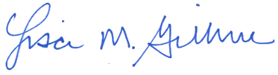
LISA M. GILLMOR
MAYOR, CITY OF SANTA CLARA
  ALBERT GONZALEZ    COUNCILMEMBER , DISTRICT 1 | 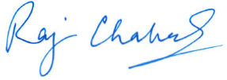  RAJ CHAHAL  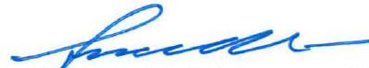  COUNCILMEMBER, DISTRICT 2 | 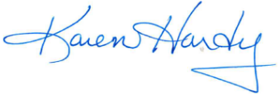  KAREN HARDY  COUNCILMEMBER, DISTRICT 3
KEVIN PARK  COUNCILMEMBER, DISTRICT 4 | SUDS JAIN  COUNCILMEMBER, DISTRICT 5 |   KELLY G. COX  COUNCILMEMBER, DISTRICT 6

