SCSA

Santa Clara Stadium Authority

SANTA CLARA STADIUM AUTHORITY
FINANCIAL STATUS REPORT

Quarter Ending June 30, 2024

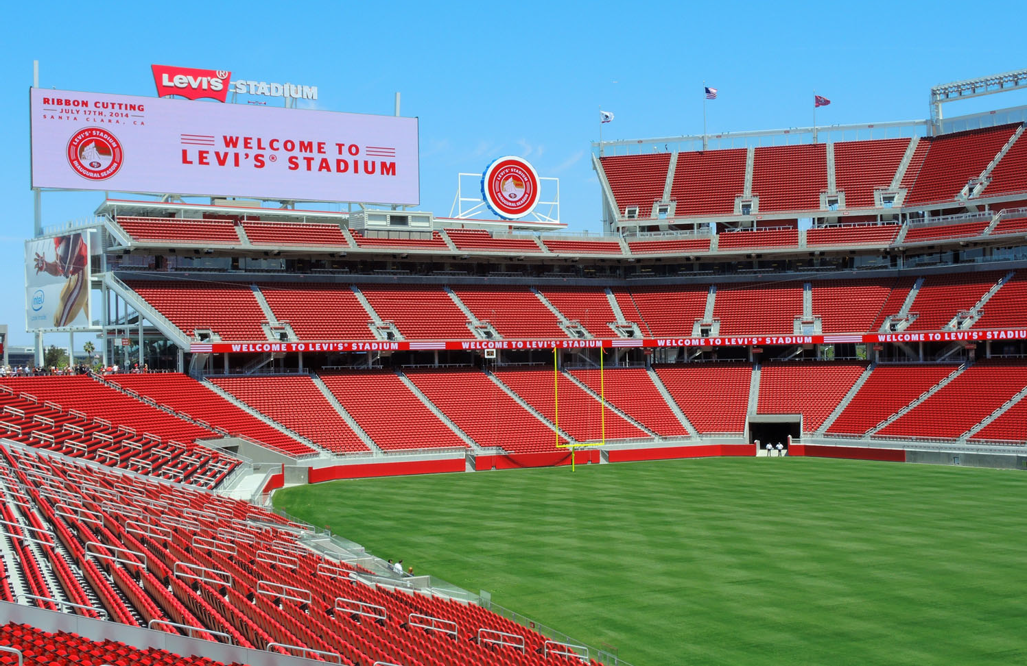

October 22, 2024
Table of Contents
Introduction 2
NFL Events 3
Non-NFL Events 3
Discretionary Fund 9
Stadium Builder Licenses 9
Santa Clara Stadium Authority Budget Status Reports 12
Operating Budget 12
Debt Service Budget 16
Capital Improvement Project Budget 21
City of Santa Clara Net General Fund Impact 24
Public Safety and Administrative Cost Reimbursement 24
Rents and Senior and Youth Fee 25
Other Revenue Impacts 25
Glossary 26

Introduction
This Santa Clara Stadium Authority (Stadium Authority) Financial Status Report provides information covering the first quarter of the Stadium Authority’s 2024/25 fiscal year (FY) which ended on June 30, 2024. Comparative data from prior fiscal years is also included.

In addition to these quarterly reports, the Stadium Authority produces annual financial statements. The FY 2023/24 financial statements were audited by an external audit firm and presented to the Stadium Authority’s Audit Committee (Audit Committee) on September 3, 2024 and September 17, 2024 and approved by the Stadium Authority Board (Board) on September 24, 2024. The financial statements are published on the Stadium Authority’s website.
The Stadium Authority also prepares a detailed budget prior to the beginning of each fiscal year. The FY 2024/25 budget was adopted by the Board on March 12, 2024.
Stadium Authority finances are structured so that the City of Santa Clara (City) is not liable for the debts or obligations of the Stadium Authority. All services provided by the City, including administrative and public safety, to the Forty Niners Stadium Management Company, LLC (ManCo) or the Stadium Authority are fully reimbursed with Stadium Authority funds.
Methodology
Information provided in this report was based in part on documentation submitted by ManCo. Specifically, National Football League (NFL) and Non-NFL event statistics and financial information relating to ManCo expenses are provided by ManCo. Stadium Authority staff has access to selected financial information submitted by ManCo provided through the Stadium Authority’s Financial Management System and event reports received for Non-NFL events. These reports are received 45 days after each event for events with attendance greater than 25,000. More detailed documents are received within 90 days after the close of the quarter. For all other financial information, a full detailed review and/or audit of source documentation has not been completed by the Stadium Authority for this report.

The information provided reflects the best known and available at the time of the writing of this report and is subject to further revision and review. Revisions may occur based on the timing of revenue and expenditure activity for events in this quarter that continue beyond the timing of this report. Consequently, the Board’s notation and filing of this report should not be considered an approval of the accuracy of the information in the report.

NFL Events
This section provides fiscal year to date and comparative data for NFL games categorized as pre-season and regular season games. There were no NFL games held during the first quarter of FY 2024/25. Levi’s® Stadium hosted the first 49ers pre-season game of the 2024 season on August 18, 2024, which will be included in the report for the second quarter.

Non-NFL Events
This section provides year to date and comparative data for Non-NFL events categorized as events ranging from high school and college football games, international soccer matches, concerts, wedding fairs, and special events. During the current reporting period, there were a total of 158,662 tickets sold for the four ticketed Non-NFL events that were held, resulting in $635,000 Non-NFL event ticket surcharge revenue (from the $4 per ticket Non-NFL event surcharge). This is an increase in ticket surcharge revenue of $471,000 or 287% over the same period in the prior year. Compared to the one sporting event that took place in the same period in the prior year there were four ticketed Non-NFL events in the current reporting period, resulting in the increase in ticket surcharge revenue.

ManCo reports that there were also 20 smaller special events held at Levi’s® Stadium which is two events less than in the same period in the prior fiscal year. The attendance at these events also decreased from 12,632 in the prior period to 12,341 in the current year, a 3% decrease. Examples of these special events include corporate events of various sizes, weddings, holiday parties, high school dances, etc.

In correlation with the Non-NFL events held during the current reporting period, there were 15,048 cars parked at offsite lots and the City earned a total of $97,000 in related offsite parking fees, which is derived from the $6.44 per parking space fee that supports public safety costs associated with the permitted offsite parking lots. The offsite parking fee invoices can take up to a few months to be fully paid. The City has received $63,000 of the offsite parking fees as of the date of this report.

Total Non-NFL event public safety costs were $1.5 million an increase of $1.1 million from the prior year. The increase in cost is due to more events being held in the current year when compared to the prior year. Of these costs, $97,000 was covered by the offsite parking fee. The remaining $1.4 million was invoiced to the ManCo of which $1.1 million has been reimbursed to the City. Reimbursements usually take between 3 to 6 months from the event date due to the timing of third-party invoices and payment from ManCo.

Statistics for FY 2024/25 events are shown in Table 1 and comparative data from the last five years of operations are shown in Table 2. Additional historical data can be found in the Appendix.
Table 1
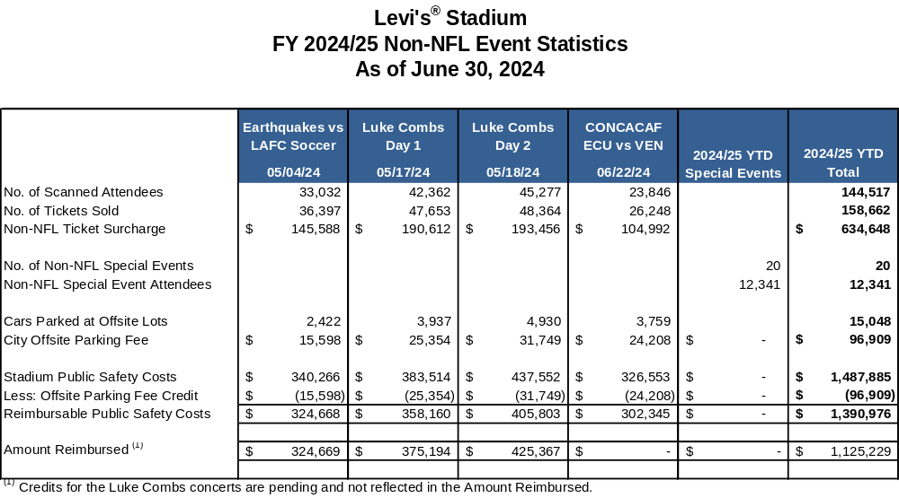

Table 2
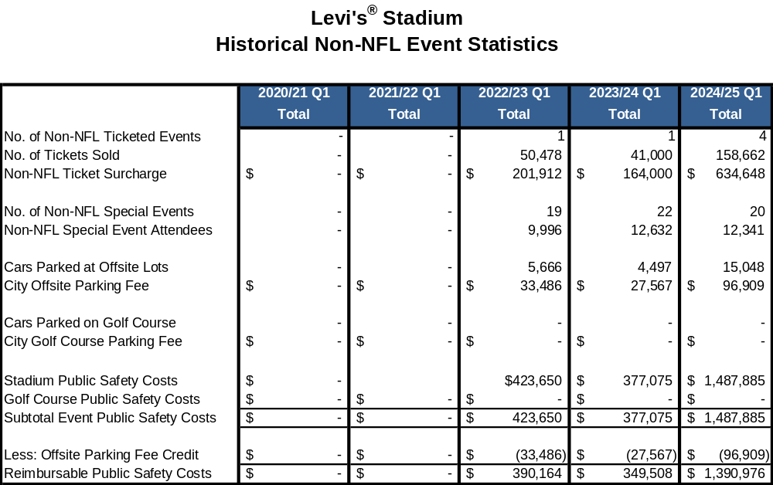

Table 3 summarizes ticketed Non-NFL revenues and expenditures by event reported by ManCo as of the report date. There were 4 ticketed Non-NFL events held in the first quarter of FY 2024/25 and generated an average net revenue of $664,000 per event. The inclusion of this information is to provide a greater level of transparency and provide the overall financial results of the Non-NFL events.

Table 3

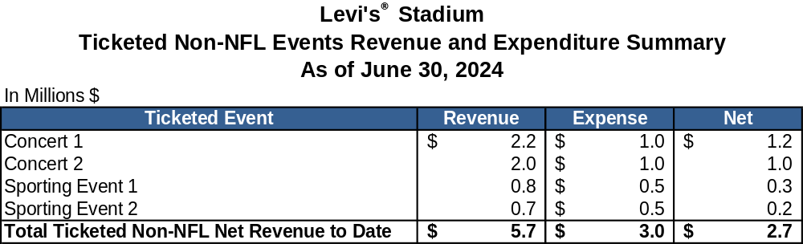

Table 4 and 5 show Non-NFL net revenue by event type and event revenue and expenses by category. For FY 2024/25, ManCo anticipates Non-NFL events to result in estimated net revenue of $6 million, as cited in the FY 2024/25 Adopted Stadium Authority Budget. In the first quarter of FY 2024/25, ticketed events and non-ticketed special events contributed $2.7 million and $643,000 in net revenue, respectively. There was also additional interest income of $618,000 earned on Non-NFL events cash reserves. Offset by $407,000 of non-event specific other expenses, ManCo reported a net revenue of $3.5 million for the current reporting period.

Table 4

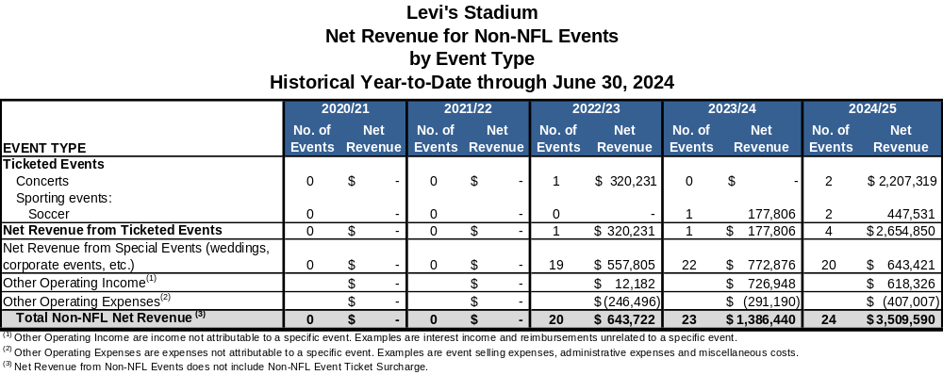

Table 5

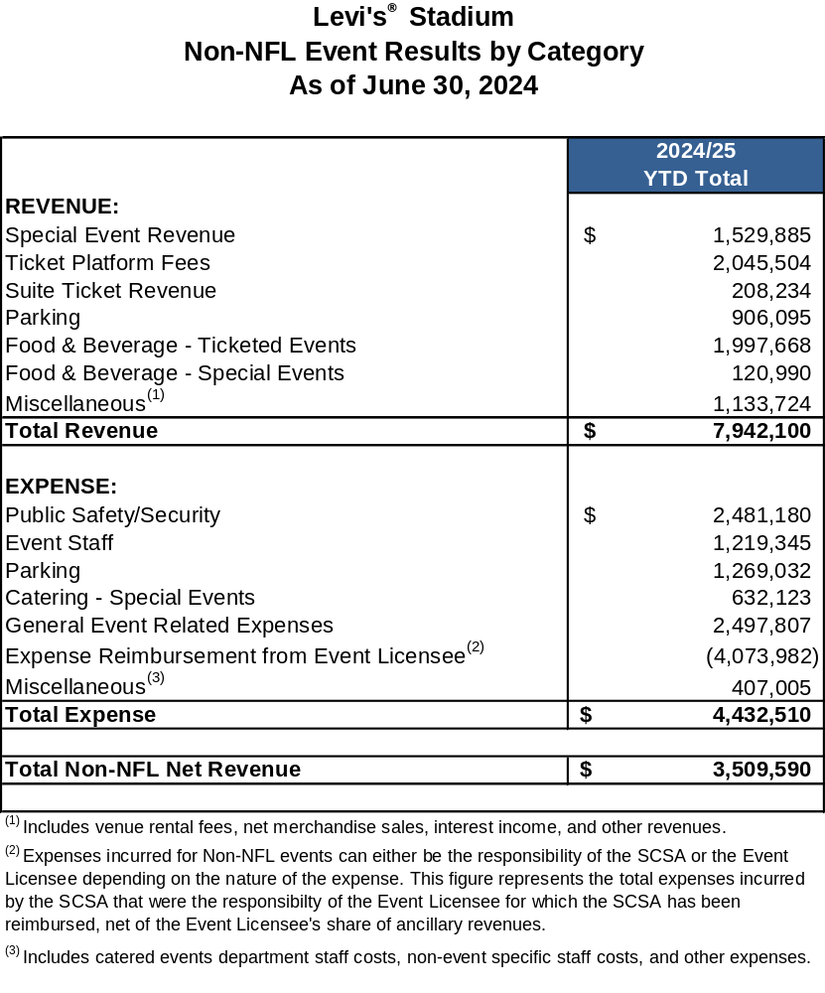

Discretionary Fund
The Discretionary Fund is funded by revenue equal to 50% of the Non-NFL event ticket surcharge of $4 per ticket. The four ticketed Non-NFL event is projected to contribute approximately $317,000 to the Discretionary Fund in the reporting period. This is based on the estimated attendance provided by ManCo. Table 6 shows the revenues and expenses in the Discretionary Fund for the last five years. Additional historical data can be found in the Appendix. The balance at the end of this reporting period was $2.8 million.

Table 6

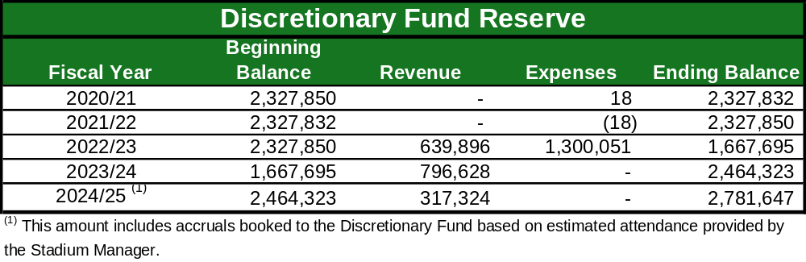

Stadium Builder Licenses
The total principal value of currently active Stadium Builder Licenses (“SBLs”) is $557 million and, as of June 30, 2024, 95% of the total principal value of all SBLs sold (i.e., $530.4 million) had been collected. Payment for the sale of SBLs are financed over 10 years.

SBL holders that finance their purchase pay an annual interest rate of 8.5% and payments are due by March 1st each year. The majority of SBL holders make their payments on time. For those that do not pay on time, SBL service staff, working for ManCo on the Stadium Authority’s behalf, contact the SBL holders and attempt to collect the full amounts owed. Ultimately, a SBL can be defaulted for non-payment. Once a SBL is defaulted, the SBL holder in default loses their right to buy season tickets as well as their priority rights to tickets to Non-NFL events, and forfeits any money they had invested in the SBL. Defaulted SBLs are then available for resale.

There is a total of 65,967 currently active SBLs, or 99.7% of the 66,156 total sellable SBL seats. This is an increase of 974 from the total active SBLs at the end of the prior fiscal year (March 31, 2024). The main reasons for the increase are due to sale of new SBLs and customer seat relocation program offset by default buy back. The customer seat relocation program allows customers to trade in their SBLs in return for others in a different location as long as the total face value of the new seats is equal to or greater than the original seats.

During the current reporting period, 697 SBLs were sold for a total face value of $4.1 million. The customer seat relocation program resulted in an increase of $962,000 to the SBL face value, while netting 668 more SBLs. There were also 391 SBL defaulted during the quarter with a face value of $2.8 million.

Additional details regarding currently active SBLs are noted in Table 7.

Table 7

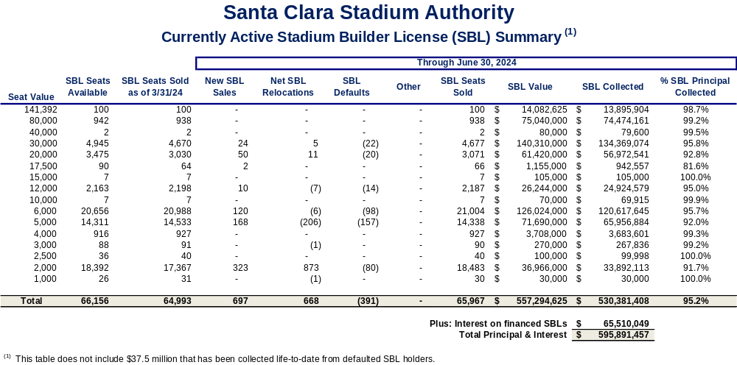

Santa Clara Stadium Authority Budget Status Reports

Operating Budget

With 25% of the fiscal year complete, total operating revenues for the first quarter of the 2024/25 Fiscal Year were $8.4 million representing 13% of the overall budget for revenues. The primary reasons that revenue is below 25% (par level through three months) is because non-NFL event revenue is recorded at the end of the fiscal year in accordance with Article 5 of the Stadium Management Agreement, and the NFL ticket surcharge revenue is recorded in second quarter when the NFL season starts. In addition, the first SBL proceeds in the amount of $4 million was received in the second quarter instead of in June 2024 this year. During the current reporting period, the Stadium Authority recognized $6.2 million in rent from StadCo, $635,000 in Non-NFL ticket surcharge, and $238,000 in sponsorship (STR) revenue.

Total Operating expenses were $6.7 million, or 15% of the annual budget. Shared Stadium Manager expenses were at 25% of the budget, or $3.3 million of the $13.6 million budgeted amount and SBL Sales and Service expenses were 18% of the budget or $612,000. The Stadium Authority pays for all utility costs from February 1st through July 31st and the tenant (StadCo) pays for utility costs from August 1st through January 31st (Tenant Season). Therefore, utility costs are 50% of the budget for the year, or $744,000. The current period covers 50% (three out of the six months) that the Stadium Authority is responsible for utility costs. Lastly, Stadium Authority G&A costs were tracking below budgeted levels at $781,000 or 19% of the budget.

Additional details are shown in Table 8.

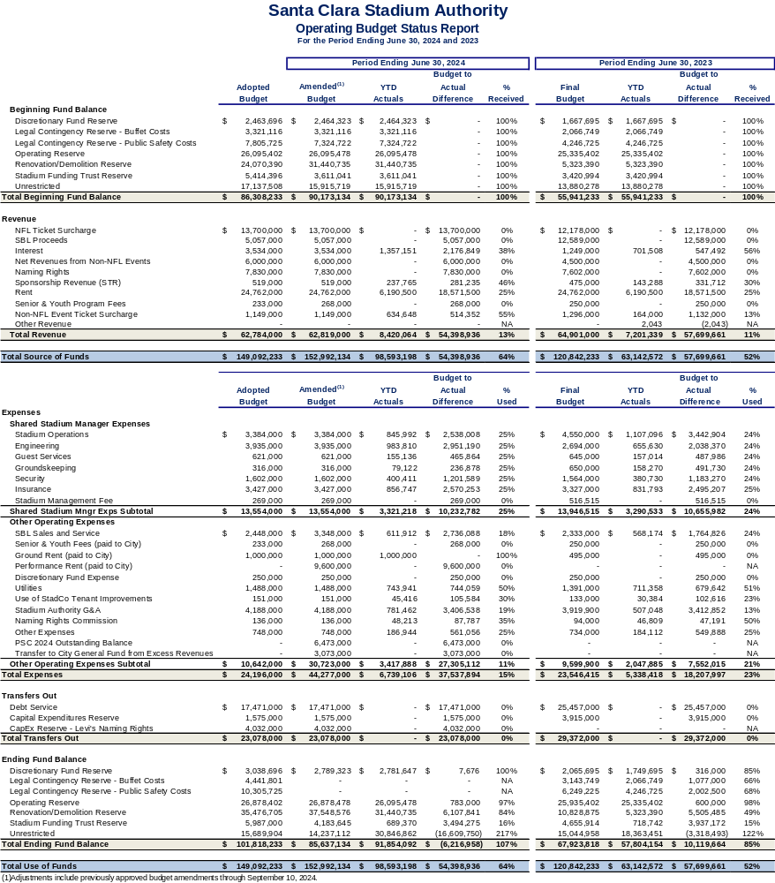
Table 8

Operating Budget – Recommended Budget Adjustments
From time to time, budget adjustments may be necessary to align revenues or expenditures to actual or unexpected activity during the course of a fiscal year, known after the adoption of the Stadium Authority Budget.

On March 12, 2024, the Stadium Authority Board adopted the Santa Clara Stadium Authority FY 2024/25 Operating, Debt Service, and Capital Budget. The following budget adjustments are recommended:

- Performance Rent – The Performance-Based rent owed to the City is described in the Ground Lease and the Amended and Restated Stadium Lease. As outlined in the agreements, the City can receive Performance-Based rent for each Lease Year equal to 50% of net revenue from Non-NFL events less the sum of the Performance-Based Rent Credits. Performance-Based Rent was budgeted at $9.6 million related to: (1) FY 2022/23 of $4.2 million, (2) FY 2023/24 of $2.9 million (projection) and (3) FY 2024/25 of $2.5 million (budget). FY 2023/24 Non-NFL event net revenue was higher than projected resulting in an increase to Performance-Based rent owed to the City of $225,000. Therefore, a budget amendment of $225,000 is needed to reflect this increase.

- Stadium Authority G&A – The Stadium Authority G&A expense budget of $4.2 million included $395,000 for legal expenses. Due to unanticipated legal costs, the City Attorney’s Office requests an appropriation of $100,000 bringing the total budgeted for legal expenses to $495,000.

Additional details are shown in Table 9.

Table 9

Santa Clara Stadium Authority
2024/25 Operating Budget Adjustment

Item # | Line Item | Source of Funds | Use of Funds | Explanation
1 | Performance Rent (paid to the City) |  | $225,000 | This action increases the Operating Budget for Performance Rent due to higher net Non-NFL Event revenues than forecasted.
2 | Stadium Authority G&A |  | $100,000 | This action increases the Operating Budget for Stadium Authority G&A due to unanticipated legal costs.
1 & 2 | Ending Fund Balance – Unrestricted |  | ($325,000) | This action decreases the Unrestricted fund balance to offset the action recommended for the Performance Rent and Stadium Authority G&A.
 | Total | $0.00 | $0.00

Debt Service Budget
The Stadium Authority’s FY 2024/25 debt service revenue budget of $2.8 million represents anticipated contributions from the Community Facilities District (CFD). The CFD levies and collects a special hotel tax on hotel rooms within the CFD. All collections from the special CFD hotel taxes are contributed to Stadium Authority to pay down the CFD Advance. The CFD Advance is payable solely from amounts received by the Stadium Authority from the CFD. During the first quarter, $843,000 was contributed by the CFD, or 30% of the annual budget. Of this amount, $476,000 was collected and used to pay down the CFD Advance.

Total Stadium Authority debt service expenses for the current reporting period were
$10.6 million, or 54% of the budgeted amount. The debt service expenses for the CFD Advance, and the Term A Loan were $886,000, and $9.7 million respectively.

As of June 30, 2024, the total outstanding amount of Stadium Authority debt had declined to $220.9 million. This is a reduction in principal of $7.8 million from the March 31, 2024 outstanding debt amount of $228.7 million.

Additional details are shown in Tables 10 and 11 and Chart 1.

Table 10
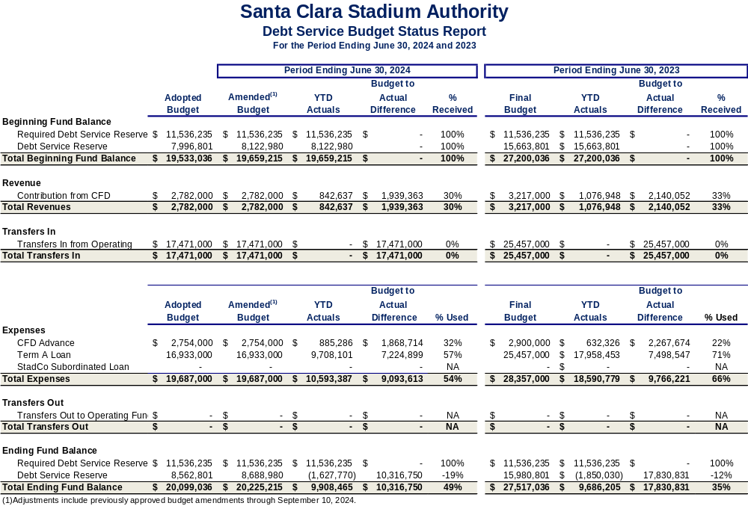
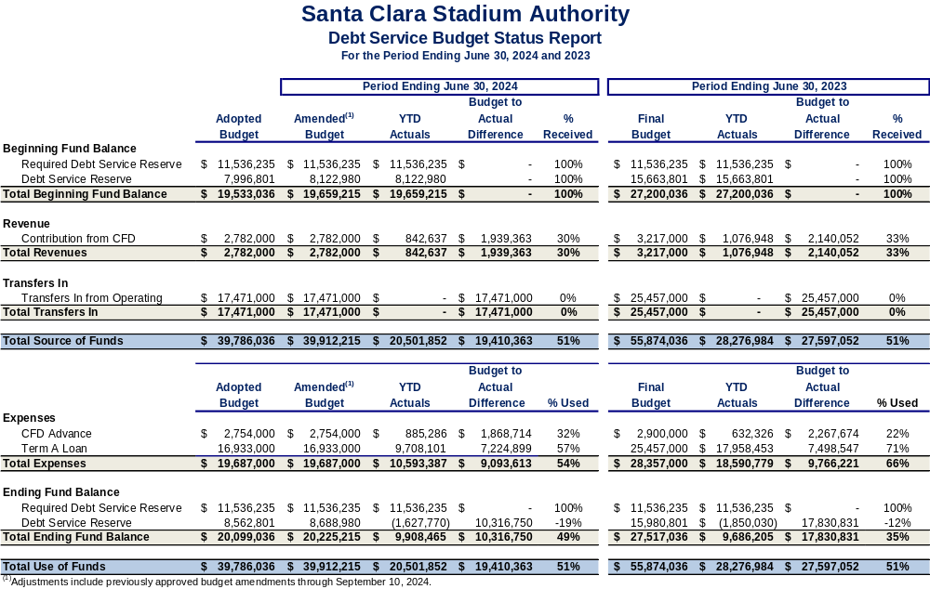

Table 11

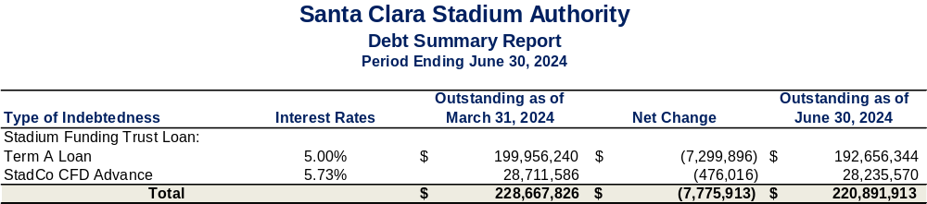

Chart 1

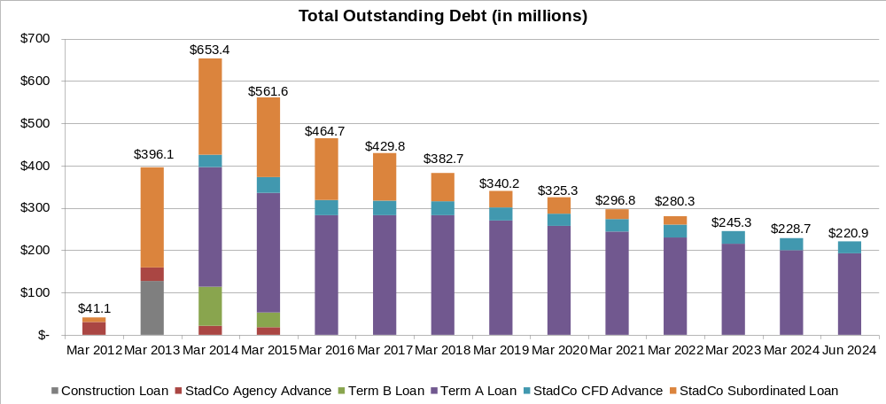

Capital Improvement Project (CIP) Budget
As part of the Capital Expense (“CapEx”) Plan, the following projects were underway during the current reporting period:

      - Aesthetic Improvements – Premium Areas/Special Event Spaces
      - CO2 Monitoring & Sensors for Code Compliance
      - Concrete Replacements
      - D7 Tactical Decon Spray
      - Enhance Stadium Security Coverage
      - Field Turf Equipment
      - Fingerprinting Equipment
      - General Areas/Coating Main Deck
      - Levi’s Naming Rights Signage Refurbishment
      - Lighting System – Field / Sport Lighting LED Retrofit
      - Main Kitchen Equipment
      - Overhead Doors, Motors, Sensors and Track Replacements
      - Plumbing and Plumbing Fixtures
      - Radio Booth Cabling
      - RAID 8 Multi Agent Detection Kit
      - Replacement of end of life IT Network equipment (2022/23 Carryover)
      - Security General Allowance
      - Smoke Evacuation System – Fire Smoke Curtain Replacement
      - Street Signage
      - Women’s Locker Room

A total of $1.4 million has been spent in the first quarter of FY 2024/25, which amounts to 6% of the budget. The main reason that spend is below budget is due to the timing of activity for Capital Expenditure projects. There has also been little activity on warranty work which makes up 7% of the CIP Budget.

Additional details are shown below in Table 12.

Table 12

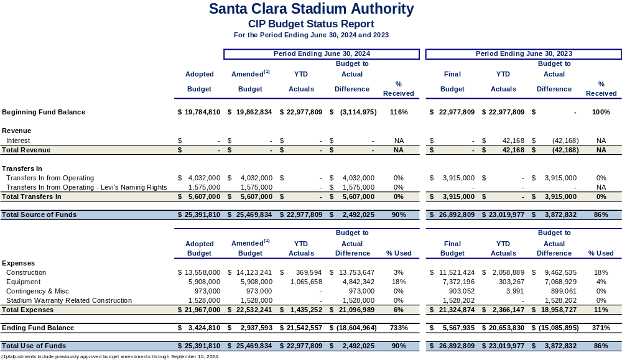

City of Santa Clara Net General Fund Impact
During the current reporting period there was a total of $1.1 million that was contributed to the General Fund as shown in Table 13. Senior and Youth Fee and the Tasman Lot Parking Fee are both related to NFL games of which there were none in the first quarter. This section of the report also provides information on General Fund revenue and expenditure impacts resulting from the stadium.

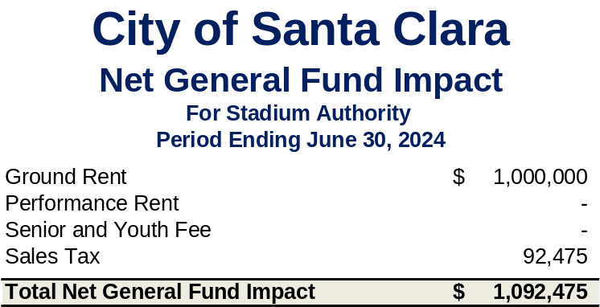
Table 13

Public Safety and Administrative Cost Reimbursement
As described in earlier sections of this report, costs incurred by the City on NFL and Non- NFL events are tracked and billed to ManCo. Reimbursement is monitored and included in this report. A total of $1.5 million in public safety costs were incurred in support of Non-NFL events that were held at Levi’s® Stadium in the current reporting period. These reimbursements come from a combination of payments from ManCo and the offsite parking fees that were collected. The City has received $1.1 million in reimbursements from ManCo as of the date of this report.

Public safety costs for NFL events continue to be above the annual public safety cap. Pursuant to the Amended and Restated Lease, the Stadium Authority was in discussion with StadCo to adjust the annual public safety cap to reflect the true cost of service, which is higher than the cap. On May 23, 2024, the Stadium Authority entered into a settlement agreement with StadCo and ManCo over disputes regarding public safety and buffet costs. As a result of the settlement, the public safety cap will be adjusted to increase the per game and annual threshold beginning in FY 2024/25. Under the settlement agreement, credits that were issued from public safety costs paid in excess of the annual public safety costs threshold were redefined as Public Safety Costs 2024 Outstanding Balance and will be partially reimbursed to StadCo with litigation contingency funds and partially over time through excess revenues.

In addition to public safety costs, administrative costs are also tracked and billed to the Stadium Authority. These include the cost of providing overall stadium management, financial, human resource, legal, and other services to the Stadium Authority. In the first quarter of FY 2024/25, a total of $598,000 of administrative costs were incurred by the General Fund, which have been reimbursed to the City.

Rents and Senior and Youth Fee
As noted above, the City’s General Fund did not collect any rents or Senior and Youth fees in the current reporting period. See the Glossary for more information on these revenues and how they are calculated.

Other Revenue Impacts
General Fund sales tax, property tax, and transient occupancy tax (TOT) collections have benefited from the direct and indirect economic activity related to stadium events.

Food and beverage concession sales and merchandise sales at Levi’s® Stadium are taxable, resulting in sales tax revenue for the City. The last quarter of sales tax collections from Levi’s® Stadium transactions generated $92,000 for the City’s General Fund. In addition to the direct sellers at the Stadium, other businesses in Santa Clara are benefiting from the influx of people coming to attend one or more events at Levi’s® Stadium, resulting in potentially more sales tax collections for the General Fund.

In accordance with State Law, StadCo must pay possessory interest property tax based on their lease of Levi’s® Stadium from the Stadium Authority. This revenue is collected by the county and placed into the Redevelopment Property Tax Trust Fund (RPTTF). Amounts remaining in the RPTTF after paying any enforceable obligations of the Successor Agency are distributed to taxing entities in the same proportion as secured property taxes. The City’s proportion is approximately 10%.

Many stadium events bring travelers to the region, resulting in hotel stays which generate TOT collections for the City’s General Fund. Although it is impossible to say exactly what portion of the City’s TOT collections is due to the stadium, it is clear that hotels both inside and outside the City have benefited, resulting in increases in TOT collections in Santa Clara and our neighboring cities.

Glossary
This section of the report provides details behind key terms that are used in the body of this report.

Discretionary Fund – The Amended and Restated Stadium Lease Agreement describes the Non-NFL event ticket surcharge which is imposed by the Stadium Authority. All promotors or sponsors of ticketed Non-NFL events are required to collect a Non-NFL event ticket surcharge of $4 per ticket on behalf of the Stadium Authority. One-half of these proceeds are used to cover Stadium Authority operating and maintenance costs. The other one-half of the proceeds are deposited in the Stadium Authority’s discretionary fund. If at any time the discretionary fund balance exceeds $1 million, then in consultation with ManCo, the Stadium Authority will determine if provision has been made for replacement and improvement of capital improvements contemplated under the public safety plan. If not, then funds will be reserved in the discretionary fund for such purposes. If adequate provision has been made for these items and the balance of the discretionary fund still exceeds $1 million, then up to half of the amount over $1 million can be transferred to the General Fund, in which event an equal amount will also be transferred from the discretionary fund to the Stadium Authority operating fund and will be included as revenue available to pay Stadium Authority expenses.

Ground Lease – The Ground Lease Agreement has an initial term of 40 years commencing on the date of substantial completion which was July 31, 2014. The amount of annual base ground rent that is payable by the Stadium Authority to the City is noted in the chart 2.

Chart 2

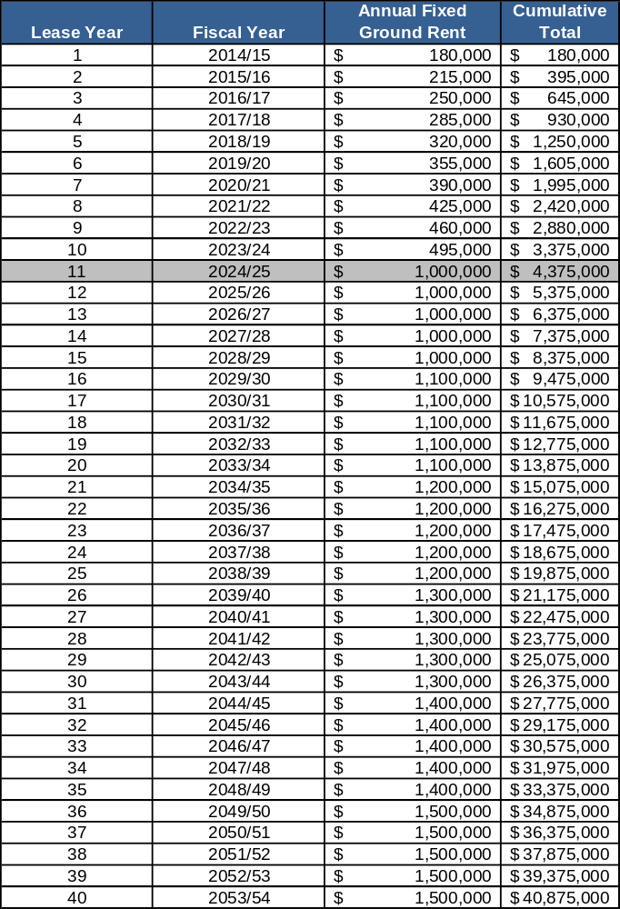

Net Non-NFL Event Revenue – Net Non-NFL event revenue is remitted by ManCo to the Stadium Authority on a yearly basis. This is done annually because the final reconciliation of the Non-NFL event revenues and expenses does not occur until after the conclusion of each fiscal year.

NFL Ticket Surcharge – The Amended and Restated Non-Relocation Agreement states that the Team will collect a 10% NFL ticket surcharge on the price of admission to all NFL games on behalf of Stadium Authority.

Non-NFL Event Ticket Surcharge – The Stadium Lease Agreement requires that the promoter or sponsor of any Non-NFL event collect a Non-NFL event ticket surcharge of
$4 per ticket. The Lease Agreement sets aside one-half of the Non-NFL event ticket surcharge for stadium operating and maintenance costs and one-half for discretionary expenses of the Stadium Authority.

Offsite Parking Fees – Parking lot operators who wish to operate a parking lot for sports or entertainment venues are required to go through the City’s permitting process. If approved, per the City’s Municipal Fee Schedule, these operators remit an offsite parking fee for each car that is parked for sports or entertainment events. This fee is designed to recover the public safety costs associated with these permitted offsite parking lots. Therefore, when invoicing for NFL or Non-NFL public safety costs for a particular event held at Levi’s® Stadium, the offsite parking fee that is collected for said event partly offsets the total public safety costs owed for that event. In the City’s FY 2023/24 (July 1, 2023 through June 30, 2024) the offsite parking fee is $6.44.

Performance-Based Rent – The Amended and Restated Stadium Lease Agreement and the Ground Lease Agreement both describe the performance-based rent that is due to the City. (It is calculated as 50% of the net income from Non-NFL events less performance-based rent credits. The performance-based rent credits include 50% of the fixed ground rent for the current lease year.)

Public Safety Costs – For each NFL and Non-NFL event held at Levi’s® Stadium, a public safety plan is developed and implemented. Multiple City departments provide staffing, materials, and supplies to support the public safety plan. Services are provided through a combination of City staff, contracts with other agencies (California Highway Patrol, County Sheriff’s Office, and City of Sunnyvale) and some vendor provided services.

The Amended and Restated Stadium Lease Agreement section 7.5 states that the tenant is responsible for reimbursing the City for the public safety costs attributed to NFL events at Levi’s® Stadium. Additionally, Article 5 of the Stadium Management Agreement notes that ManCo is responsible for paying Non-NFL event expenses on behalf of the Stadium Authority. Therefore, the cost of providing public safety services are tracked through the City’s financial system and invoices are sent to ManCo. All of these costs are reimbursed to the City of Santa Clara.

Senior and Youth Program Fees – The First Amendment to Amended and Restated Stadium Lease Agreement requires that StadCo collect a Senior and Youth Program Fee of $0.40 per NFL ticket sold on behalf of the Stadium Authority. Per section 7 of the Ground Lease Agreement between the City and the Stadium Authority, the Stadium Authority remits this fee to the City as additional rent to support senior and youth programs in the City.

Stadium Management Fee – ManCo receives an annual base management fee to manage Levi’s® Stadium. The fee was $400,000 in the first lease year and increases by 3% annually as detailed in the table below. This annual base management fee is split 50/50 between StadCo and the Stadium Authority since ManCo manages the stadium year-round for both entities. In addition to the base management fee, ManCo also receives a stadium marketing and booking fee (incentive fee) which is based on a percentage of the amount that the net income from Non-NFL events exceeds the marketing and booking fee benchmark. The marketing and booking fee benchmark was $5 million in the first lease year and also increases by 3% annually as detailed in the table below. The annual stadium management fee for each of the first eleven lease years are noted in the chart 3 below.

Chart 3
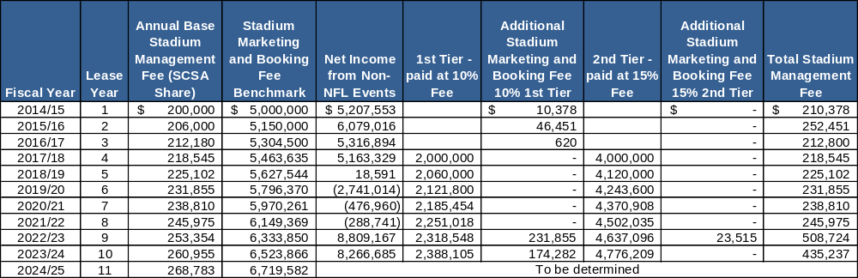

Appendix
This section of the report provides additional historical data for the tables referenced in the body of this report.

Table 14

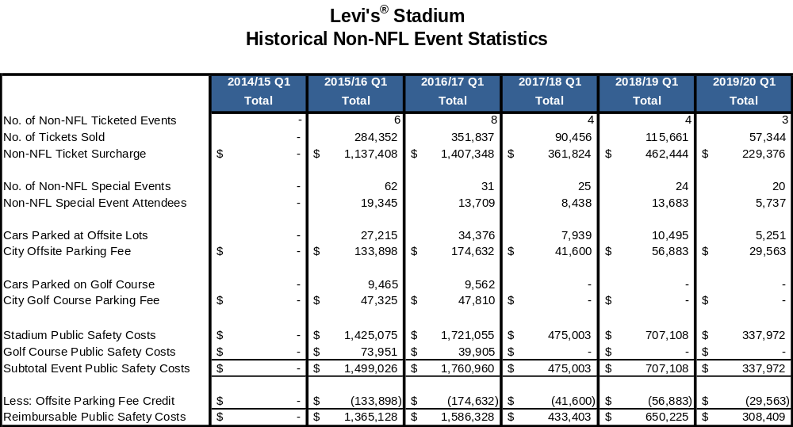

Table 15
